I was able to compile the client and server, but the main branch version of the server wasn’t compatible with the protocol version of the client.



I got the tag v1.4.2, which was compatible with the same client protocol (1098), but I had to fix several bugs to make it work. After that, I didn’t have much more time since I work full-time. However, I think that to accomplish the results in the video, I would have to bypass the pathfinding algorithm and only teleport to the mouse click coordinates.

In the server, I will have to remove the velocity limitations to allow the character to teleport as well as walking animations and events (client side). In the client, I will also have to instantiate several player sprites from the player's origin location to the teleport destination with decreasing alpha from the destination to the origin. Additionally, I will need to create an event that would be called when the player arrives at the destination to make the sprites disappear, also from the origin to the destination.

**Client compilation**

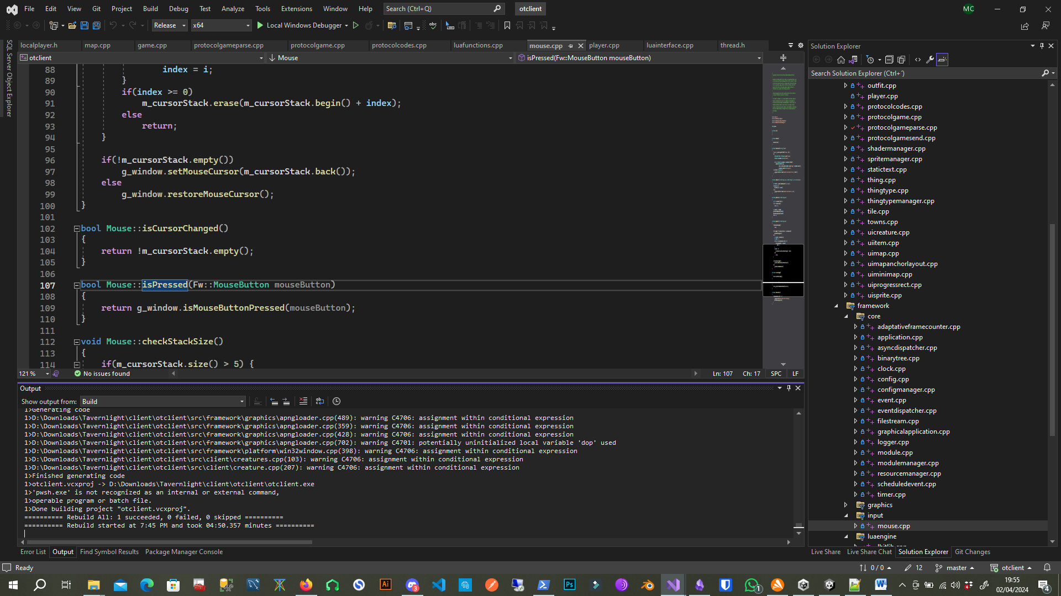

**The Forgotten Server tag V1.4.2**

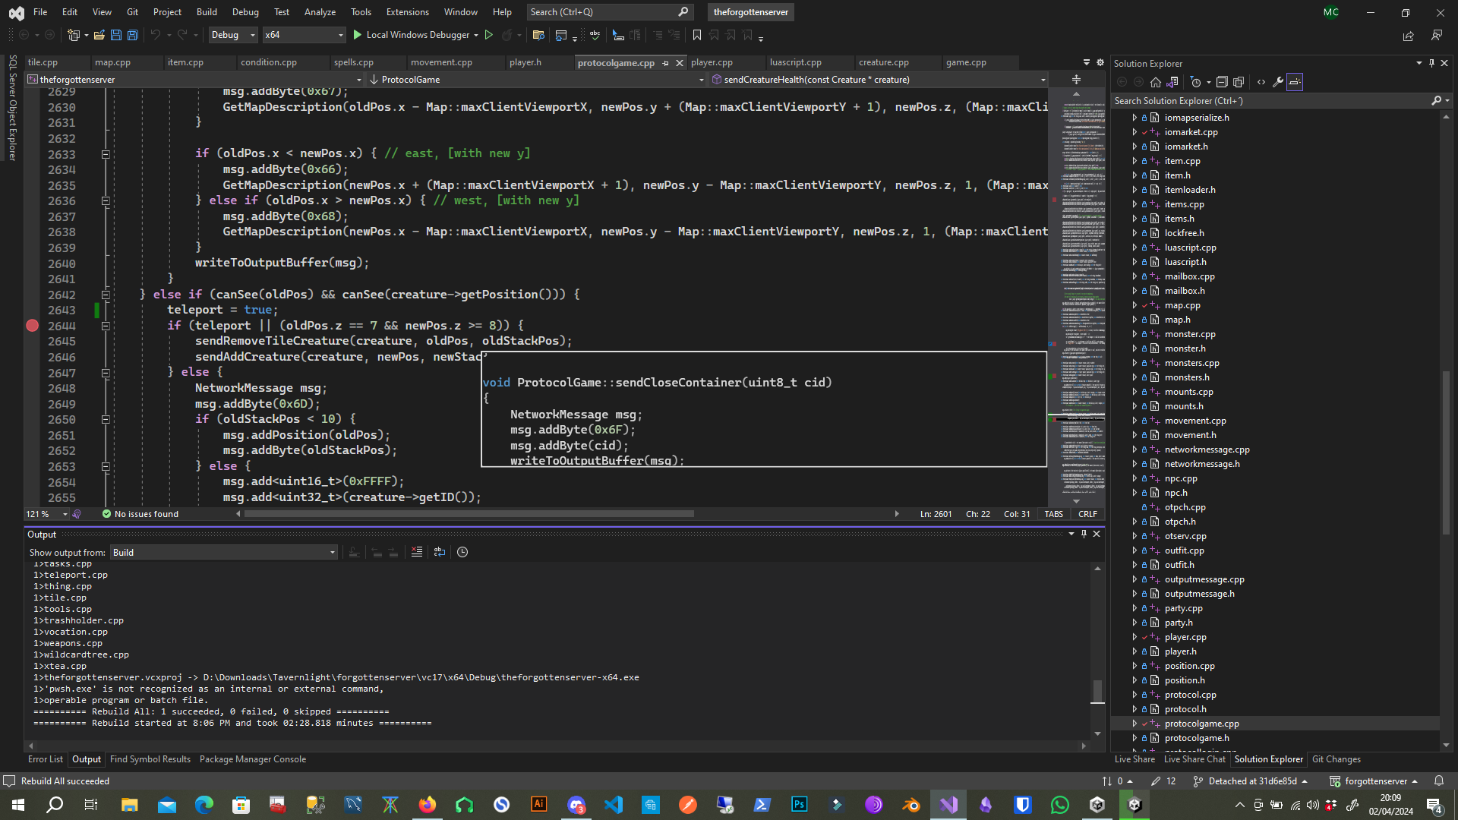

I can provide a video of the client server working if needed.