Ocars Website Testing
Testing : Majd AL-Manaseer
Date : 18/nov/2025
User Testing :

Front End testing :

- Show icon in employee section doesn’t work

When testing the admin account,and when click on show icon in employee section, a white page appears .

2-Some fields can be string value and can be no specific numbers limit In
When testing the admin account or user account, and adding data in any tab , and fill the inputs, we can adding a string value and this is cant be like phone number field and ID Card number field , It must allow adding numbers only. And we can adding value without limited of numbers . so I also added a screenshot for this issue.

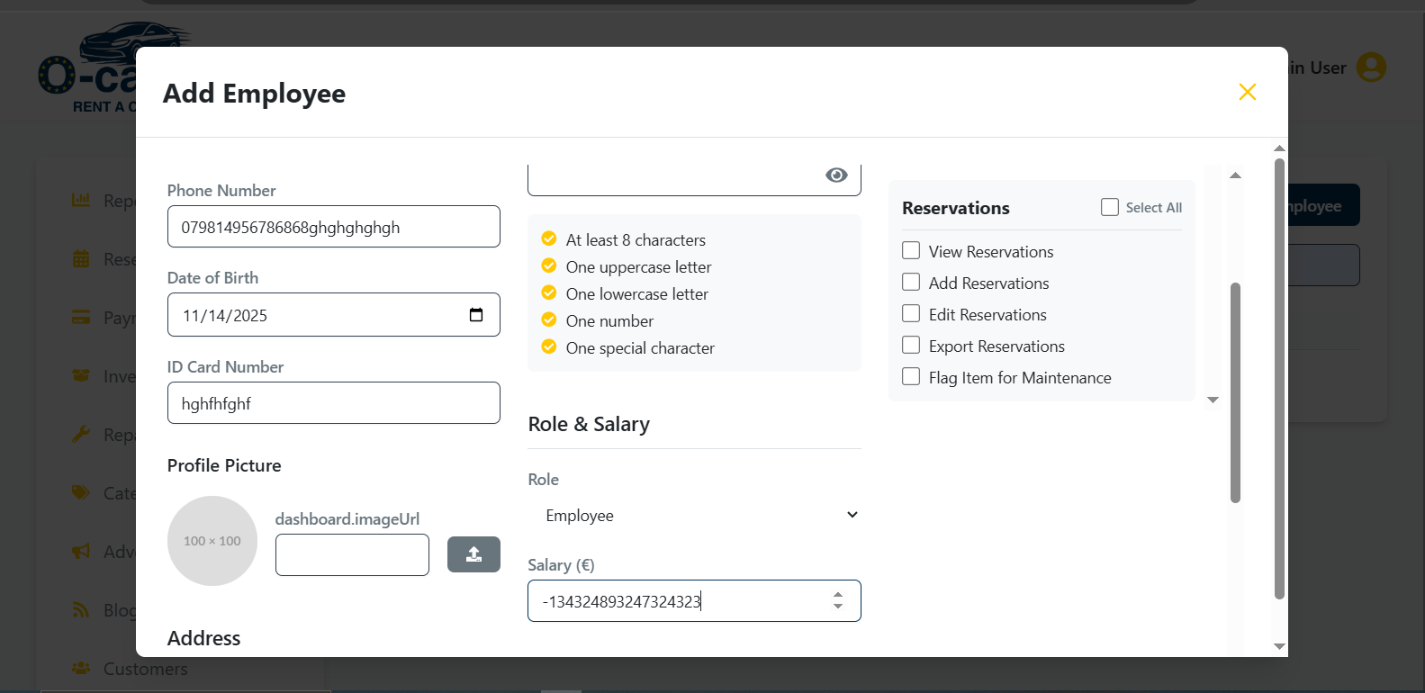

- Salary and cost can be in the negative and No specific limited In
When testing the admin account, and adding data in some fields in some tabs, then click on add new employee button , and fill the salary fieled whe can add a negative value, and there is no specific salary limit, and even fractional salaries cannot be added,and this is not logically.so I also added a screenshot for this issue.

- there is no syntax of email
When testing the admin account, and adding new customer, then click on add new customer button , and fill the email fieled the fieled Users can submit values that do not contain the required @ symbol or a valid domain (e.g., example.com). This could lead to invalid email entries in the system and may affect communication or user account functionality. does not currently perform syntax validation.so I also added a screenshot for this issue.
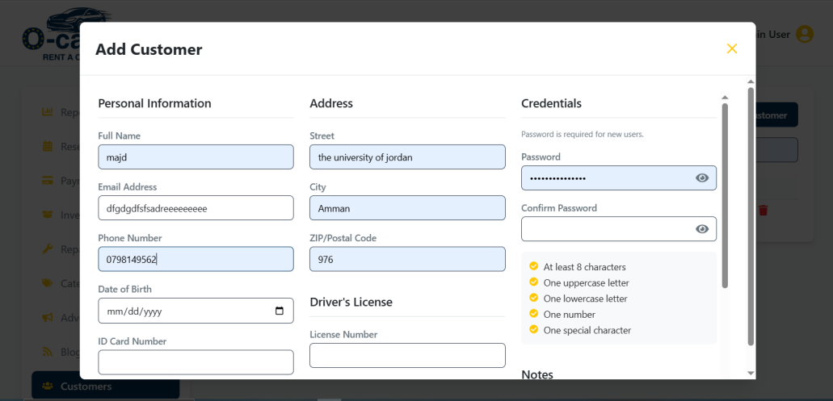
- Driver's License Expiration Date It might be expired.
When testing the admin account, and adding new customer, then click on add new customer button , and fill the Driver's License Expiration Date , We can select a date before the current date, which indicates that the driver's license has expired.. so I also added a screenshot for this issue.
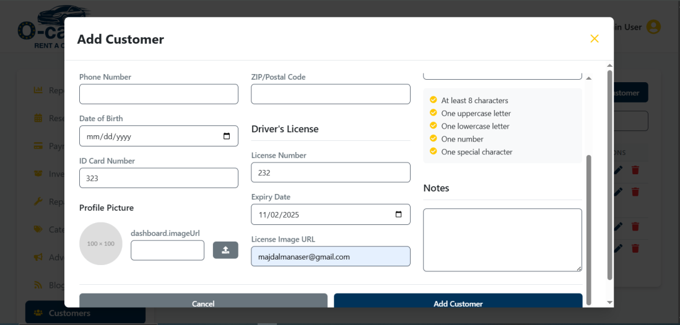

6-Date Due and Date Actual before Date

When testing the admin account and adding a new repair order , We can set the Date Due and Date Actual to a date before the Date. logically, the date the car was registered should be before the car delivery deadline. Notice in the screenshot I added that we entered a date in the Date Due and Actual Date that precedes the Date.
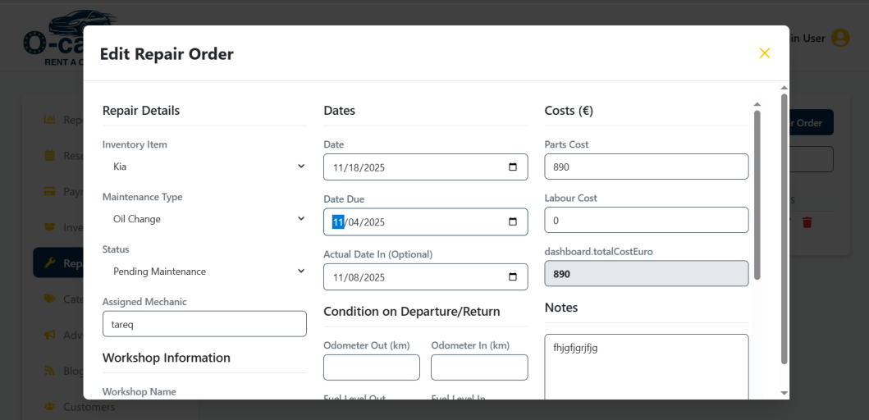

- Not all cars appear in the All tab on the Browse page.
When testing the website, clicking the All button on the Browse page does not display all available cars.

