Testing : Majd AL-Manaseer
Date :1/Dec/2025
User Testing :

Back End testing :

- Some results of search don’t appear
When testing the application as a user, and performing a search with valid keywords, some expected results do not appear in the search results. sometimes, results include only partial matches or unrelated items.based on the observed behavior, it appears that this issue is likely caused by a backend search logic problem. However, backend access was not available during testing, so the root cause could not be fully verified.also I added a screnshots about this issue.
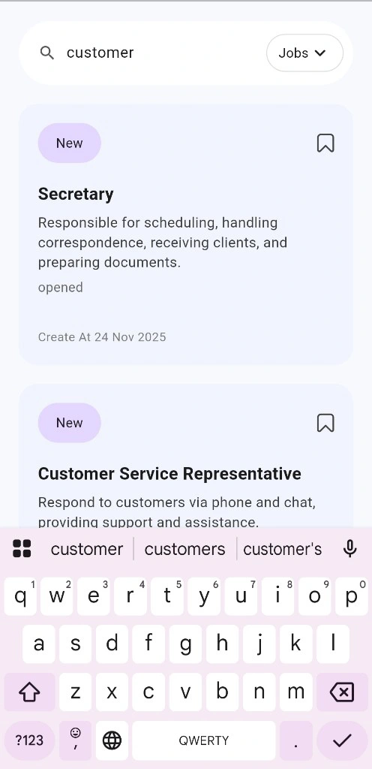

- Search box in Home page soesnt work .
When testing the application as a user, we observed that the search box in the Home Page doesn’t work.typing a keyword shows no results and triggers no action, indicating that the search box is not connected to any search function.based on the observed behavior, it appears that this issue is likely caused by a backend search logic problem. However, backend access was not available during testing, so the root cause could not be fully verified.also I added a screnshots about this issue.
