# **UML Design Class Diagrams and Sequence Diagram**

**System Name:** fitwell

**Semester:** B 2025

**Submitted by Group:** majd aslih 324935360

**GitHub Repository URL: ____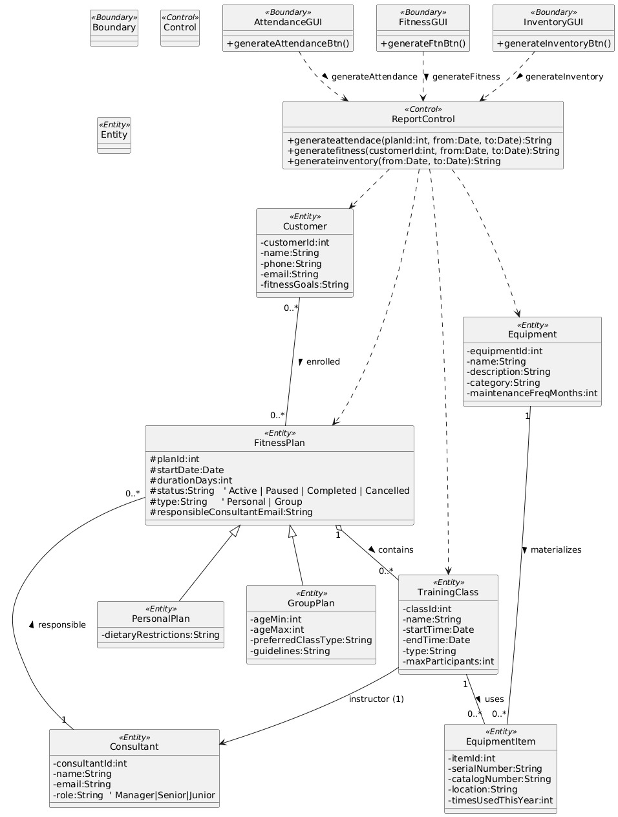____________________________**

# **Assumptions:**

This is an optional section for essential assumptions; Please provide concise information aimed at clarifying key aspects for the exercise evaluator; Ensure that the content does not replicate details already presented in the system description narrative.

# 

**I can write in hand because visual paradigm license is expired when the course is over**

**3.1.a Design Class Diagram of** fitwell

Verify readability of the figure. For each diagram, the relevant screenshots must be presented (the titles can be reproduced if needed).

**Screenshot:**

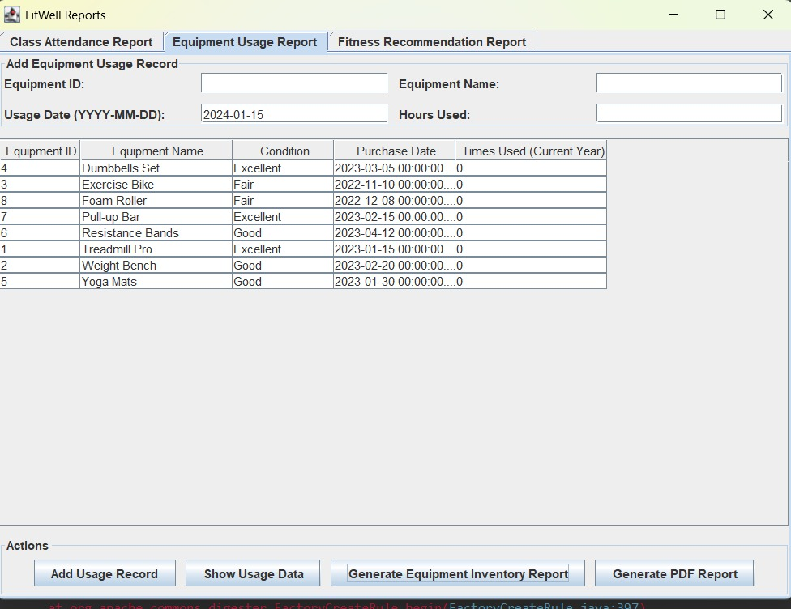

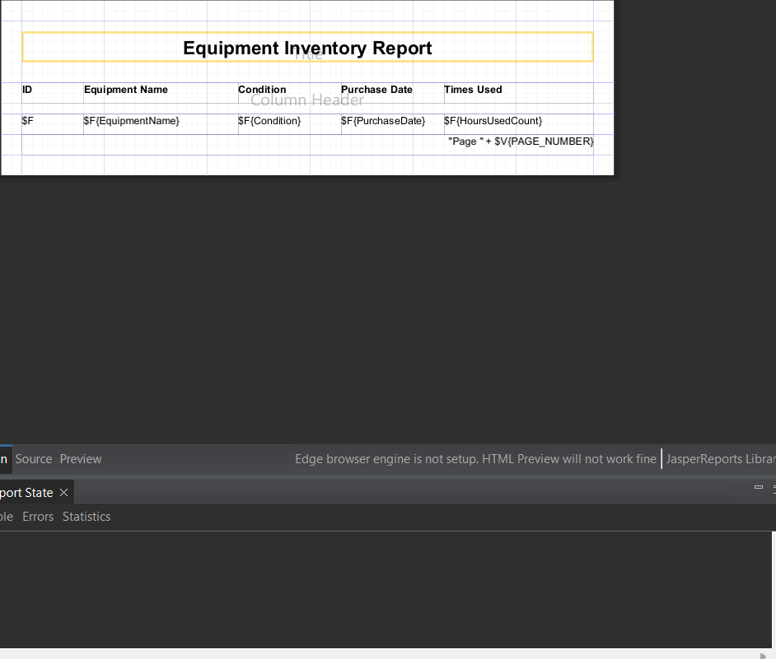

**Diagram:**



**3.1.b Sequence Diagram of** **:**

Verify readability of the figure.

