2025 WiSe – Reinforcement Learning – Coding Assignment

Team 9 – Anthropomorphic Finger: Largest Ellipse

This document describes your team-specific coding assignment for the final examination. Each team is required to design, implement, analyse, and present a Reinforcement Learning solution for a realistic control or decision-making problem.
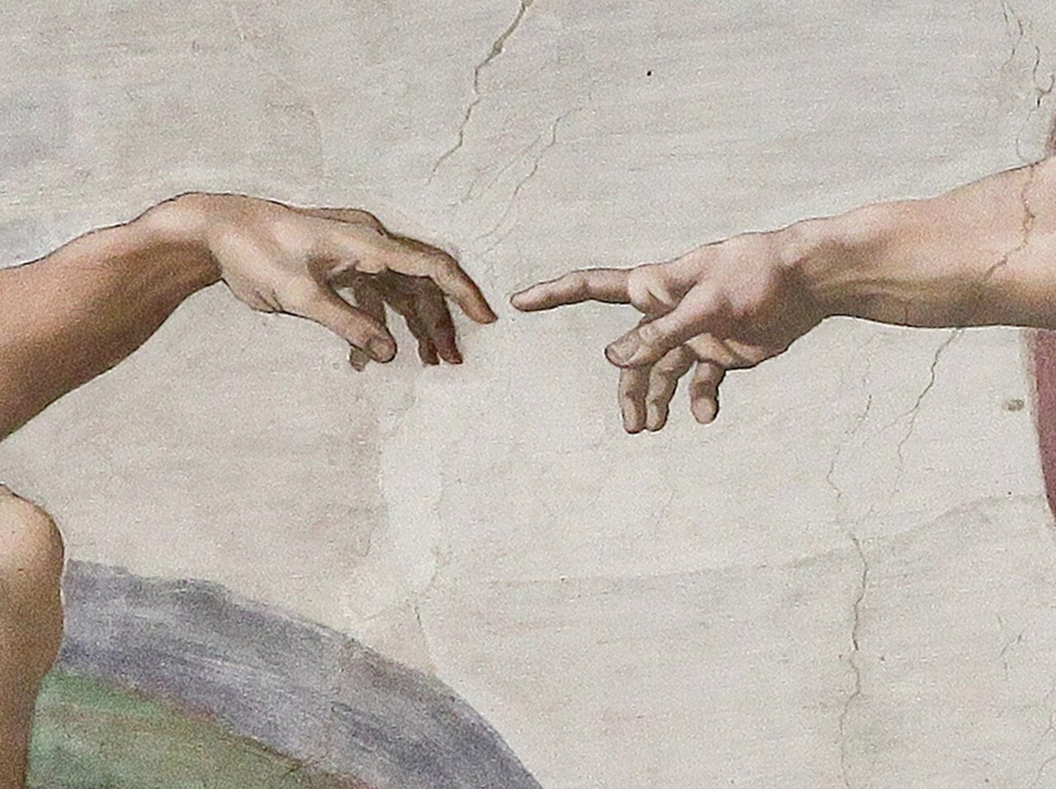
The assignment is intentionally open with respect to modelling details. You are expected to make reasonable engineering assumptions, justify them clearly, and demonstrate a deep understanding of both the environment design and the selected Reinforcement Learning algorithm.
Important methodological note:
For all tasks, you are explicitly expected to perform your own background research to obtain realistic specifications and parameters. All sources, assumptions, and simplifications must be documented and explained during the presentation.
Important:
• You must implement your own environment in Python: Define what the actions and what the states are.
• Your code must be runnable independently by the examiners.
• You will be asked to explain, modify, and re-run parts of your code during the oral exam.
Deliverables:
• Source code (environment, algorithm, training, evaluation)
• Presentation slides (coding task + assigned scientific paper)
• All materials must be uploaded before the examination.

Evaluation criteria – Coding assignment:
0. Environment and algorithm uploaded and executable
1. Clear summary of the problem and solution approach
2. Demonstration of environment behaviour with example rollouts
3. Reward function definition and justification
4. Definition of test scenarios prior to training
5. Code documentation and structure
6. Demonstration of good policy performance
7. Quantitative figures of merit and hyperparameter studies
8. Ability to modify code live and explain performance changes

Algorithm: Actor–Critic with Antagonist
This task models an anthropomorphic index finger as a planar three-joint robot with fixed link lengths, 5 cm, 2.5 cm and 2.5 cm. All joints have a mobility of +/- 90°. This assignment extends the anthropomorphic finger model to continuous shape optimisation. Your objective is to learn a policy that generates the largest possible ellipse within the reachable workspace.
Ellipse parameters should be estimated from the generated trajectory, and the enclosed area should be maximised. Robustness against disturbances introduced by the antagonist must be demonstrated and discussed.

