Maintenance Guide

System architecture
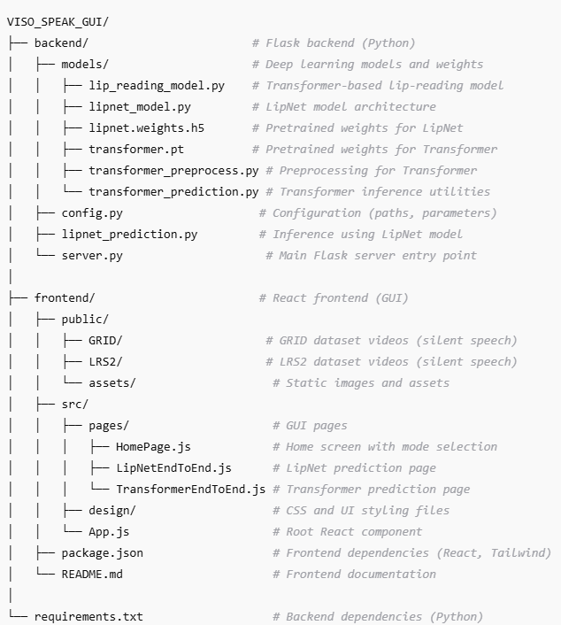

System Environment
Hardware Requirements
- GPU: At least 15 GB VRAM (NVIDIA L4, A100, or RTX 3090/4090).
- RAM: Minimum 32 GB system memory (higher is better for dataset preloading).
- Storage:
  - Uncompressed preprocessed data in .pt format: ~1.2 TB for 80,000 videos.
  - Compressed .npz batches: ~400 GB for the same dataset.
- CPU: Multi-core processor for parallel preprocessing (8+ cores recommended).

Software Dependencies
- Python 3.10+
- Core Libraries: torch, torchvision, tensorflow, keras
- Video/Audio Processing: opencv-python, mediapipe, librosa
- Data Handling: numpy, pandas, scipy
- Web API: Flask, flask-cors
- Visualization/Testing: matplotlib, seaborn, jiwer, tqdm
- Frontend: React + Tailwind (managed separately via package.json)
Full dependency list is maintained in requirements.txt (backend) and package.json (frontend)

Installation
Backend Setup
Cd backend
pip install -r requirements.txt
python server.py
Frontend Setup
cd frontend
npm install
npm start

Model Setup
Download and place the pretrained models in the correct locations:
LipNet Model:
- Download lipnet.weights.h5
- Place in: backend/models/lipnet.weights.h5
Transformer Model:
- Download the latest transformer.pt checkpoint
- Place in: backend/models/transformer.pt

Dataset

Dataset Overview
- Primary Dataset: LRS2 (Lip Reading Sentences 2)
  - Contains thousands of short clips of people speaking sentences.
  - Each clip has an accompanying alignment file indicating word timing.

Obtaining LRS2
- Must be requested directly from the University of Oxford via MIT’s dataset portal.
- The request involves:
  - Completing a research usage form.
  - Waiting for approval (can take days/weeks).
  - Downloading video (.mp4) and alignment (.txt) files.

Storage & Preprocessing
- Store raw dataset in Google Drive or local storage.
- Preprocessing steps:
  - Frame Extraction – Convert videos to frame sequences at 25 FPS.
  - Lip ROI Cropping – Use MediaPipe FaceMesh for accurate mouth region detection.
  - Normalization – Convert to grayscale and normalize pixel values.
  - Alignment Processing – Convert .txt alignments into viseme tokens.
  - Batch Compression – Save 32 videos per .npz file to reduce storage (~400 GB compressed vs 1.2 TB uncompressed).

Additional Notes
- Ensure compliance with LRS2 license (research only).
- The dataset can be extended with GRID or custom datasets for additional robustness.

Training Pipeline (Colab-Based)
Colab Setup
- Training script (transformer_train.ipynb) optimized for Google Colab L4/A100 GPUs:
  - Mixed precision for faster computation and lower memory usage.
  - Dynamic RAM buffer for streaming .npz batches (50 GB preload).
  - Batch size scales automatically with GPU memory.
Training Process
- Mount Google Drive and link preprocessed .npz data.
- Stream batches from Drive to RAM, then to GPU for training.
- Train Transformer-based viseme prediction model:
  - Encoder-Decoder architecture.
  - Input: (T, 112, 112, 1) video tensors.
  - Output: viseme sequence with boundary markers.
- Save model checkpoints (epoch_X.pt) to Drive after each epoch.
Current Training Status
- Trained on ~80,000 videos (subset due to financial limits).
- Storage usage:
  - ~1.2 TB uncompressed (.pt)
  - ~400 GB compressed (.npz)
Future Training Recommendations
- Train on the full LRS2 dataset (or augment with others) for better accuracy.
- Use higher VRAM GPUs (e.g., A100 or H100) for large-scale training.
Improving Accuracy (Future Enhancements)
Word-Level and Sentence-Level Accuracy
- Current focus: viseme prediction and boundary detection.
- Proposed improvements:
  - Fuzzy search for phoneme-to-word mapping from CMU Dictionary.
  - Replace beam search with GPT-4o or similar NLP for:
    - Word filtering.
    - Contextual sentence reconstruction.
    - Better handling of names and numbers.
Hybrid Model Approach
- Combine predictions from Transformer (visemes) and LipNet (sentence) using ensemble methods.

Deployment & Maintenance
Backend
- Flask API:
  - transformer_prediction.py → viseme prediction & boundary metrics.
  - lipnet_prediction.py → sentence-level prediction.
Frontend
- React GUI:
  - Preloaded dataset selection (no manual video upload).
  - Displays Transformer (visemes) vs LipNet (sentences) predictions.
Updating Models
- Retrain models with larger datasets.
- Replace weight files (transformer.pt, lipnet.weights.h5) in models/.
- Update config.py if file paths change.

Notes
- Colab is mainly used for training/preprocessing due to free GPU availability.
- For inference, only backend + frontend setup is required locally.
- Always ensure compliance with dataset usage policies.

Using the Application
- Open your browser and navigate to http://localhost:3000 after starting both backend and frontend servers.

