User Guide
VisoSpeak is a visual speech recognition application capable of predicting spoken sentences or viseme sequences from silent videos. It provides two modes:
LipNet Model (End-to-End Prediction)
- Generates complete sentence predictions directly from video input
- Character-level output with high accuracy for constrained vocabularies
- Ideal for controlled environments and specific use cases
Transformer Model (Viseme-Based Prediction)
- Predicts viseme sequences (visual phonemes) with special tokens
- Uses advanced attention mechanisms for better temporal modeling
- Provides boundary detection and accuracy metrics
This guide explains how to use our system.

Using the website
- Open your browser and navigate to our website
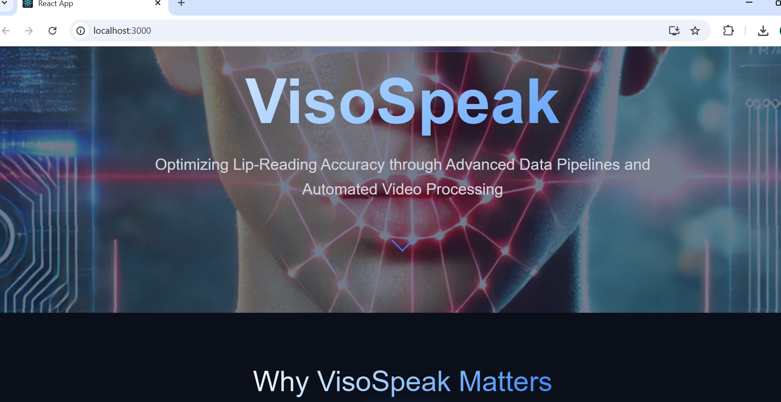

- From the homepage, select either LipNet or Transformer mode:
  - LipNet Mode – Predicts a complete sentence directly.
  - Transformer Mode – Predicts a viseme sequence with boundary accuracy visualization.
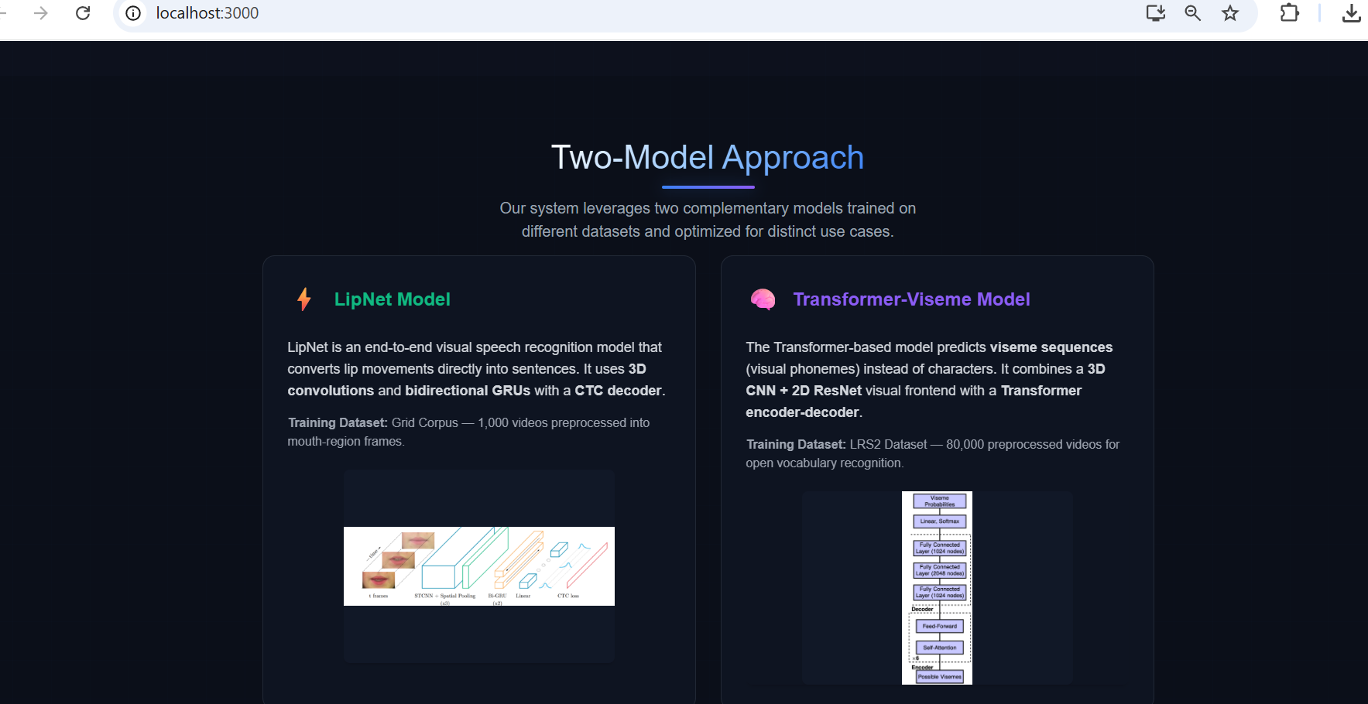

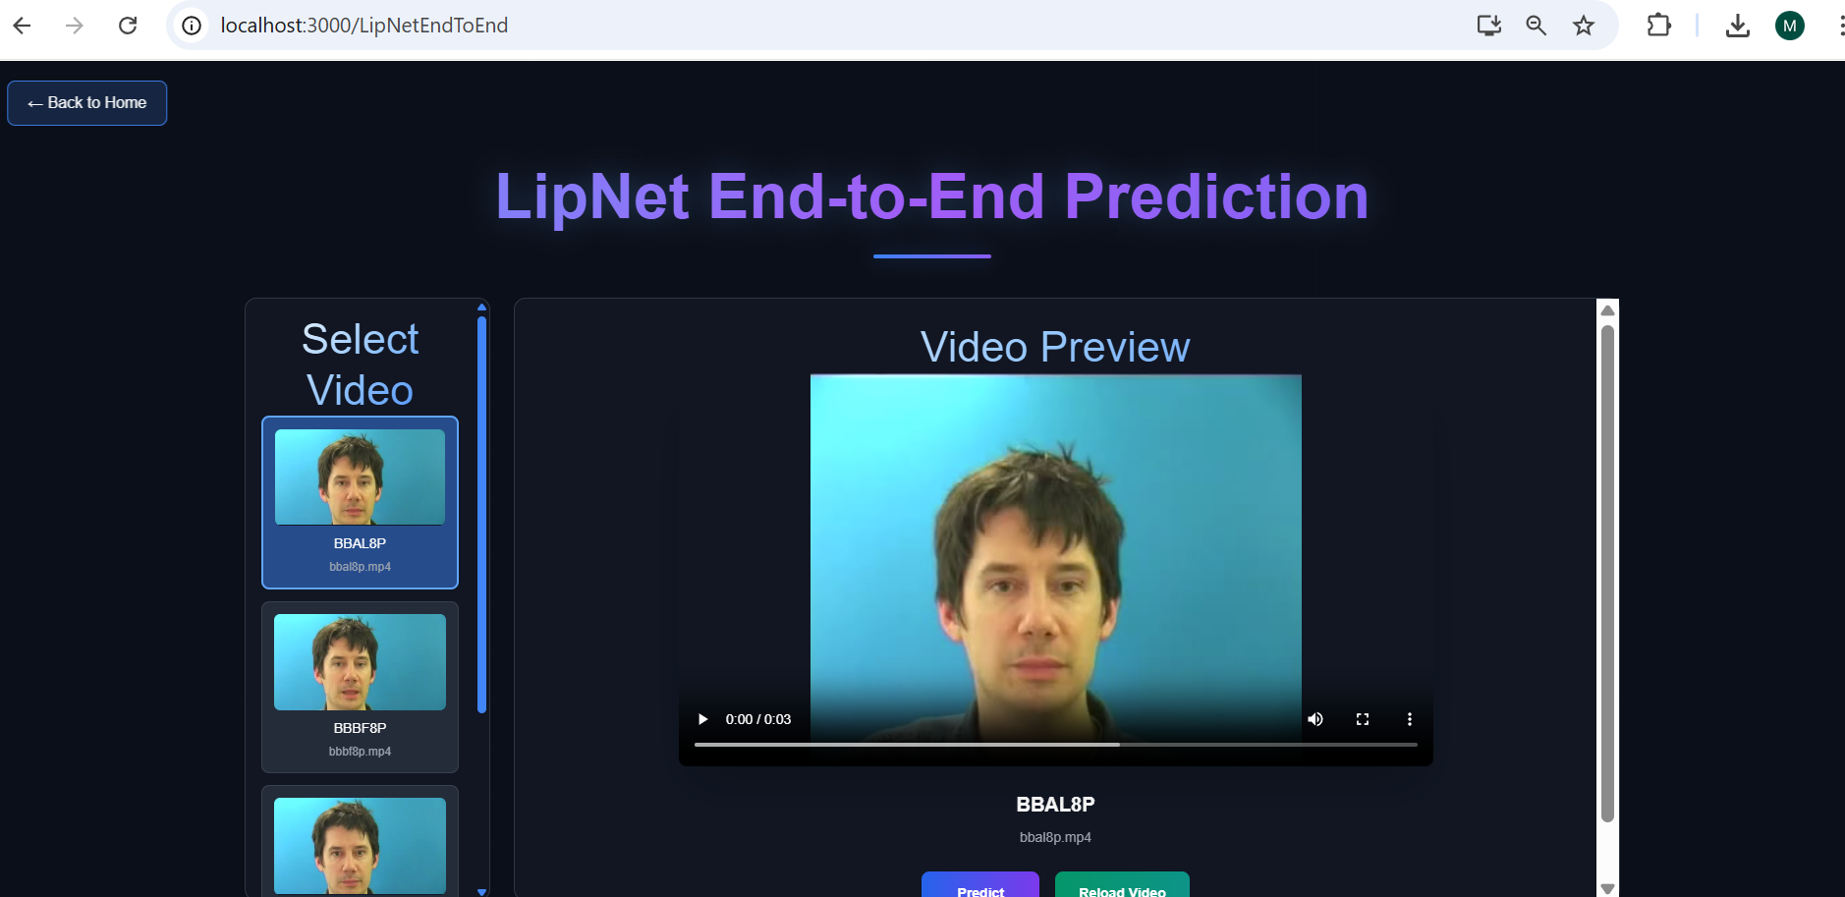
- Select a silent .mp4 video from the preloaded dataset list provided on the interface (no upload required).
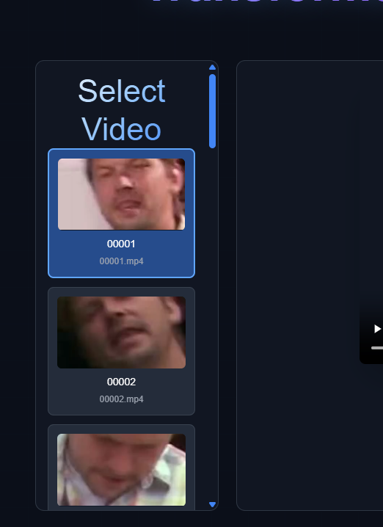 | 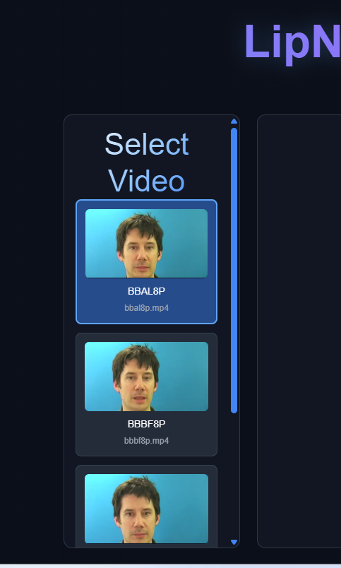

- Press Predict

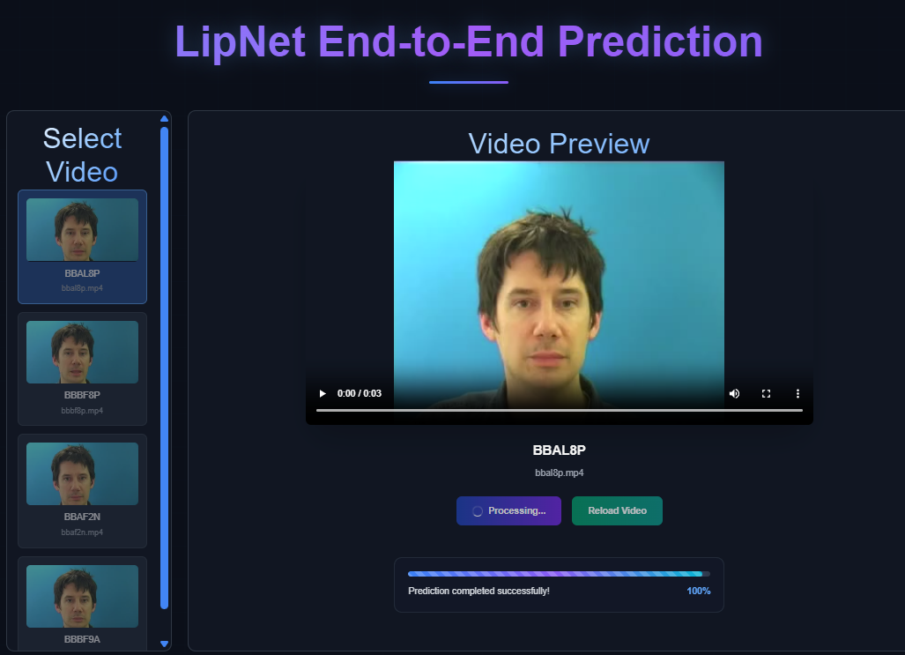
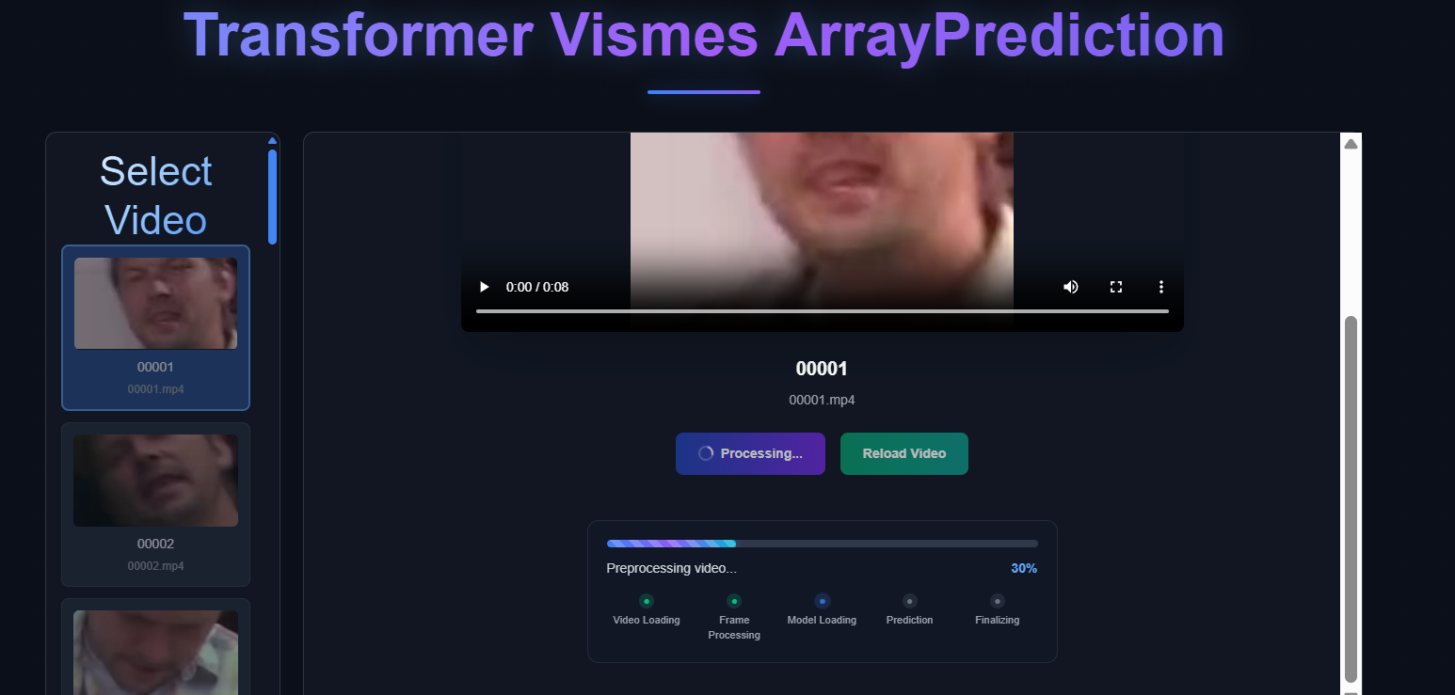
- View Prediction results
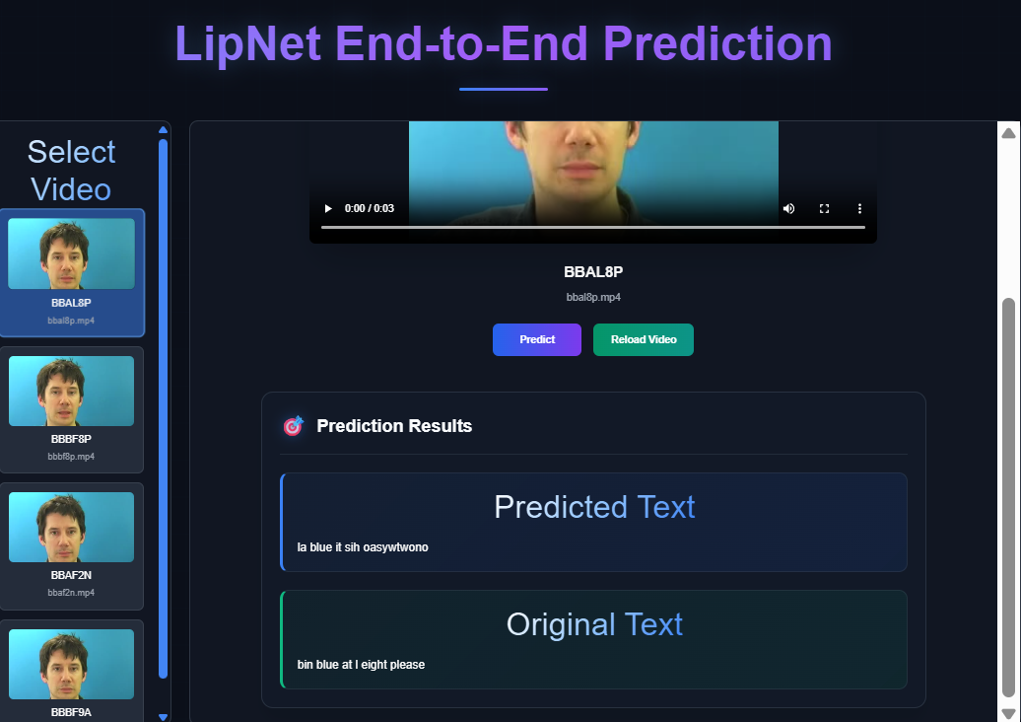
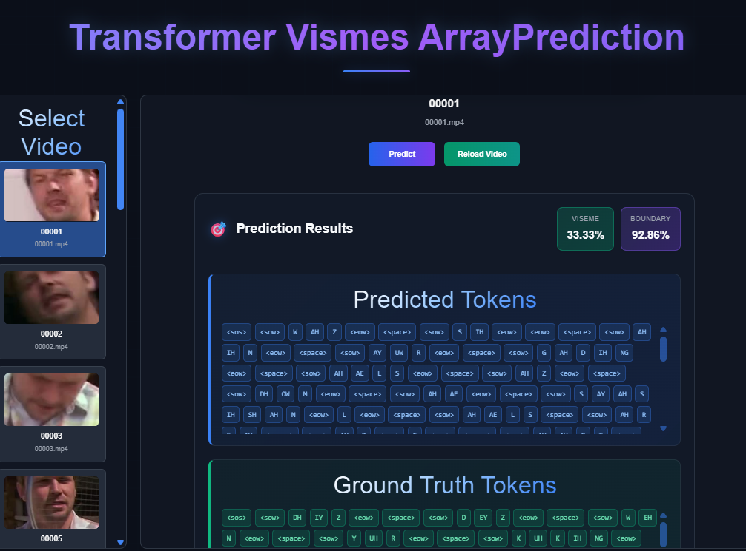
- To test another video, simply select a different video from the list.
