

Human Migration Data Visualization Report

*How many migrants are there? Where are they coming from?
And where are they going?
*Information about each country

Majed Abu Mokh

305005480

Project Website

http://majedabu.github.io/migration.visualization/#/PRY/departures

6.9.2017

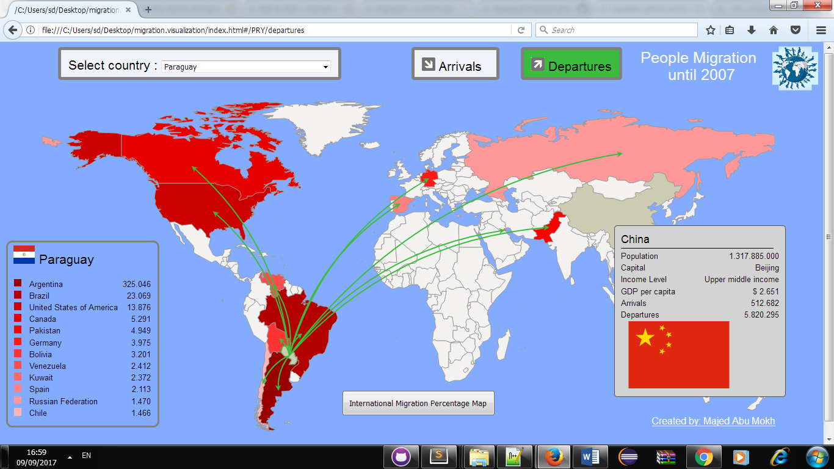
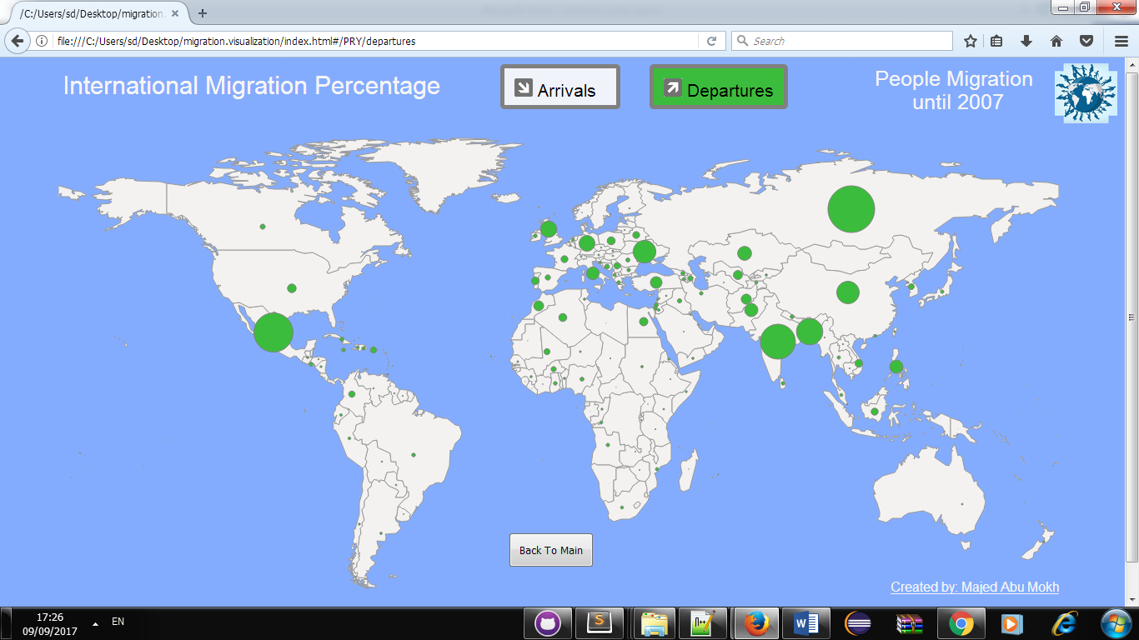
WHAT ?

Dataset:
1: A csv file: global_migrant_origin_database_version_4.csv, containing all the migrations number from country to country. It is really just a matrix of country-to-country migrations number, addressable by country code.
2: Code_to_world_path.json, a geojson file containing the borders data of all countries in the world, addressable by the countries code ISO 639 format (ex: BEL -> Belgium).
3: The world bank data, which provide indicators, like AIDS prevalence, for every country in the world, addressable by year and country code(json).
4: The google geolocation API, to find out the "central" coordinates of a country (the point to which arrows will be pointing when pointing to a country)(json)
5: Svg Flag Image For each Country

Dataset Type:
JSON,SVG & CSV Files.

Data Source:

* Global_migrant_origin_database (Versio 4 Updated 2007)

* The World Bank (4 Different API)

* SVG Flags

* Google Maps Geolocation API

DATA Fields:

All the data extracted by python scripts and saved to json files

global_migrant_origin_database_version_4.csv
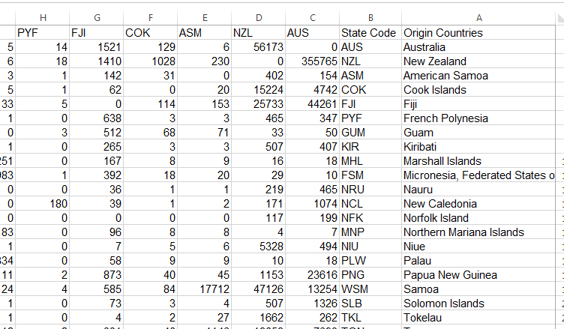

From world bank(ex-> USA):

Income level and capital

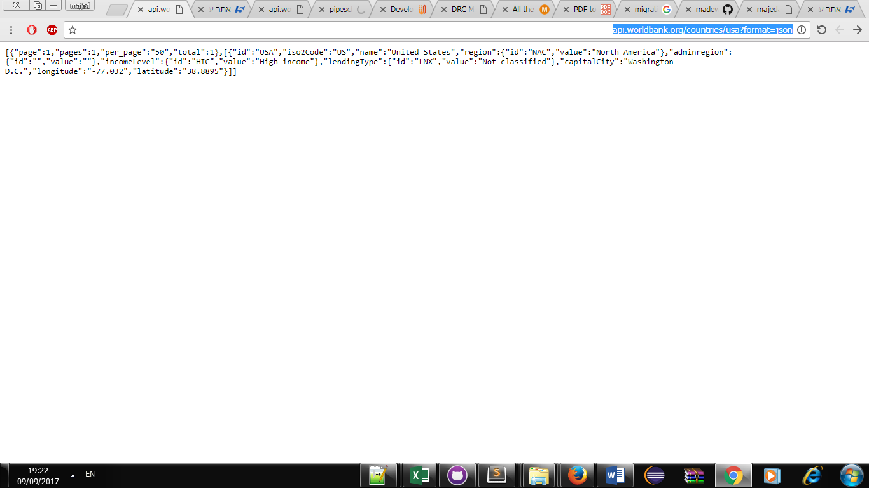

GDP per captia
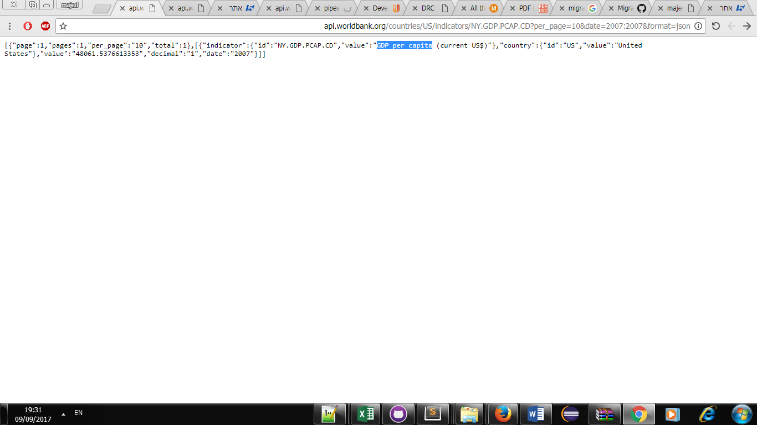
Total Population
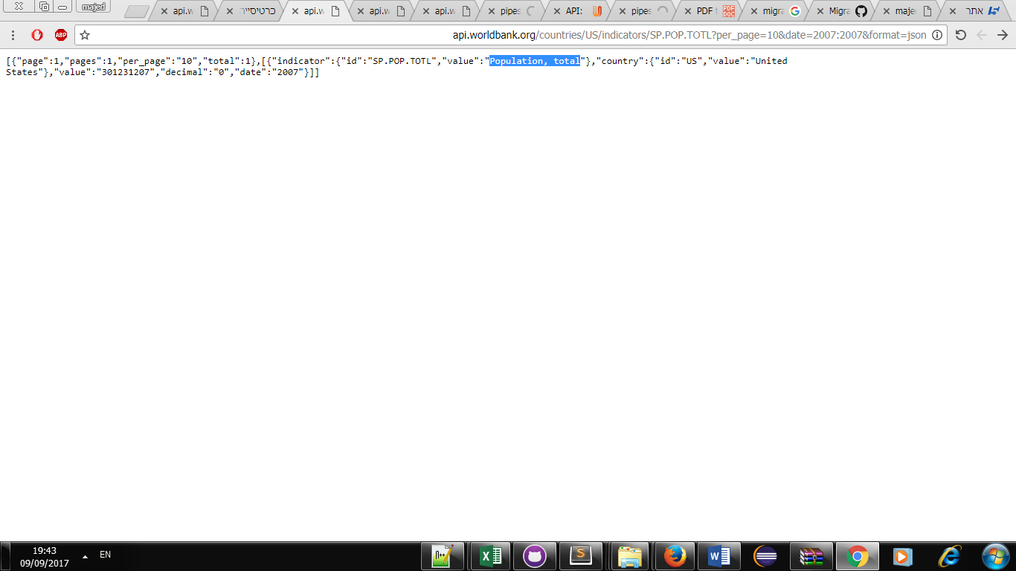
The process used to generate the json data files:
- Run parser_.py, which, from global_migrant_origin_database_version_4.csv (provided), will generate two files:
  - code_to_name.json: a json object allowing to find the full English name of country corresponding to a country code in ISO 639 format (ex:USA-> United States)
  - geoloc.json: a json object containing the dump of all geolocalization requests sent to Google.
- Run load_arrivalis_departures which from global_migrant_origin_database_version_4_with_total.csv will generate two files:
  - code_to_arrivals.jsom //for each country the total arrivals
  - code_to_departures.json ////for each country the total departures
- Run arrowcomputer.py, which, from the matrixes of migrations data generated by parser_.py from the csv file and the coordinates in geoloc.json, will generate two file per country in the 'generated' directory. Those file contains ten svg paths, one per "arrow" to be drawn on the map when clicking on the country, each one associated with the corresponding migrations number. There are two files per country: one for the incoming migrants and the other for the outgoing migrants, called for example for the USA: inUSA.json and outUSA.json. Arrowcomputer2.py also generates in the process the file code_to_coordinates.json, which is a json object/dictionary allowing to find for each country code, the corresponding central coordinates. (the map size specified in geojsontosvg.py is used to compute the size and positioning of the arrows).
- Run geojsontosvg.py, which, from world.json and a map size (specified directly in the file), will generate the file world_svg_paths.json, which is a json object allowing to get, for each full English country name , the borders in as svg paths.
- Run worlBankDataGetter.py to download the indicators data from the world bank api and store them in json files : GDP per capita (GDP.json), and population size (POP.json),Country capital (capital.json) ,Income Level (incomeLevel.json)

More information about the main data " Global Migrant Origin Database "

The global data base of the Development Research Centre on Migration, Globalisation and Poverty (Migration DRC) consists of a 226x226 matrix of origin-destination stocks by country and economy. The data are generated by disaggregating the information on migrant stock in each destination country or economy as given in its census. The reference period is the 2000 round of population censuses, so the data do not refer to precisely the same time period. They are stocks not population flows in a strict sense but are, for international migration, the equivalent of “lifetime migration” in studies of internal migration. Four versions of the database are currently available, giving increasing levels of completeness, but decreasing levels of accuracy as the missing data are added via assumption and interpolation with each successive version. Users of the higher numbered versions should be aware of the limitations that this imposes. The four versions are described in the table below. In the first three versions, information is reported on both place of birth and citizenship, compiled in separate matrices (see tabs on each sheet), to maintain the clear distinction between the data, which are clearly based on different concepts. Version 4 combines the two concepts to create a single complete bilateral matrix of stocks.

SOFTWARE DEVELOPMENT TOOLS:

- Raphael
- Hasher
- Python
- HTML
- JavaScript
- CSS
- JQuery
- D3
- Json
Main Fields :


By Pressing the yellow bottom" Arrivals" it will show the 12 countries by order (number of immigrants) that arrived to the chosen country, pointed by yellow arrows.
The Darker the color "More Red" The more immigrants arrived from this country.
Ex->Russ
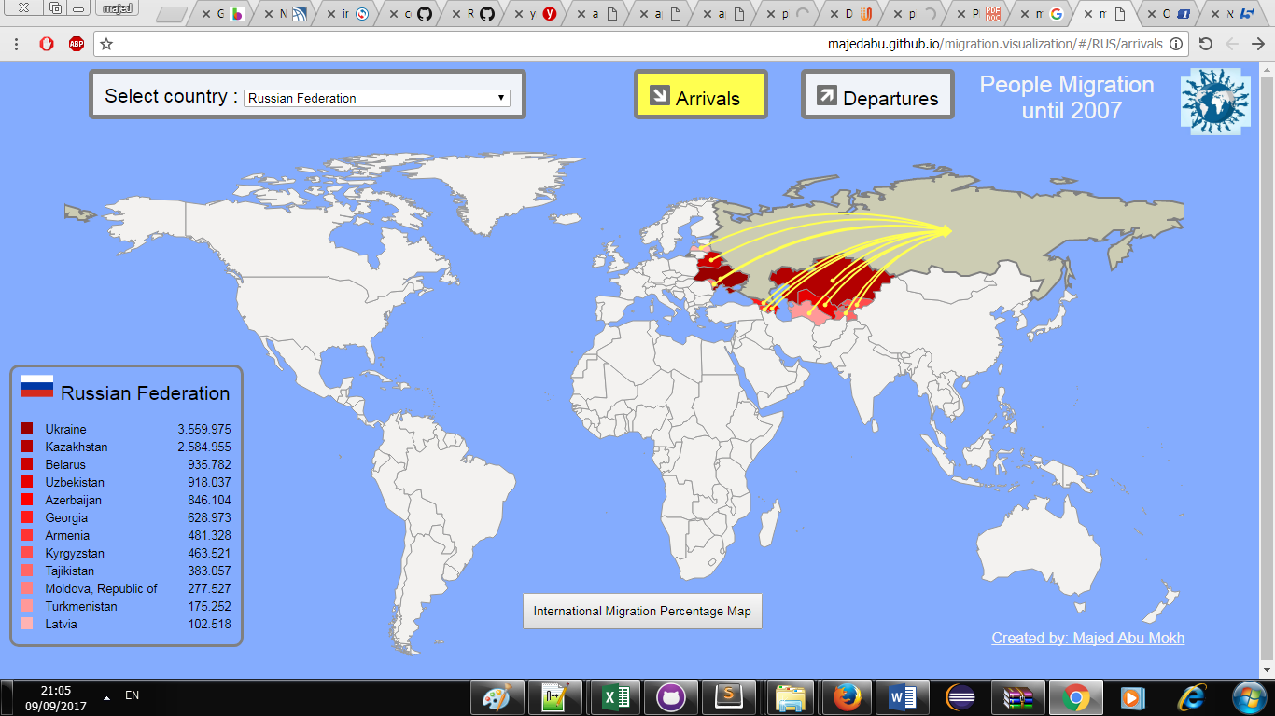

" The Darker the color "More Red" The more immigrants arrived from this country."



By Pressing the green bottom "Departures" it will show the 12 countries by order (number of immigrants) that depart to the countries, pointed by green arrows.
The Darker the color "More Red" The more immigrants depart to this country.
Ex-> Italy
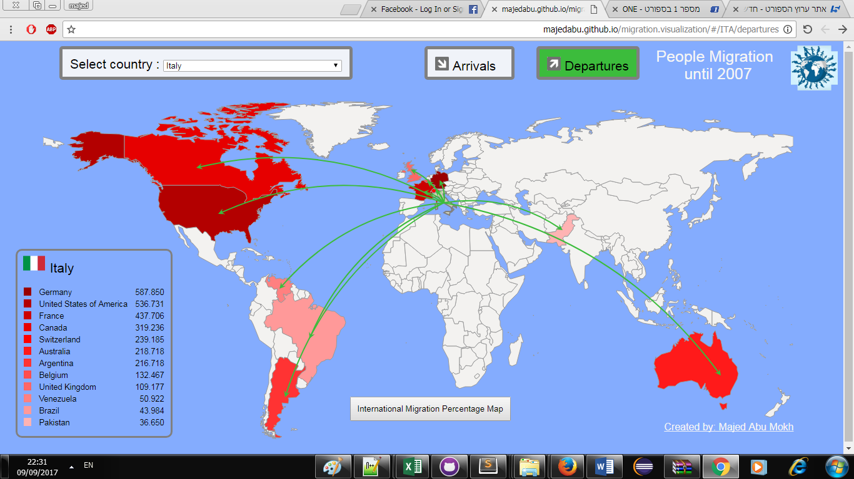

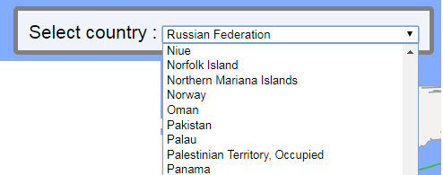

User can select country by choosing from the menu OR click in the map.

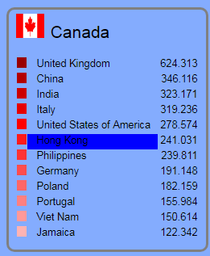

The Darker the color "More Red" The more immigrants arrived/depart from/to the country.
The user can also click on each one of them and will display their data(it will be the current country)

Fields Displayed on point hover :

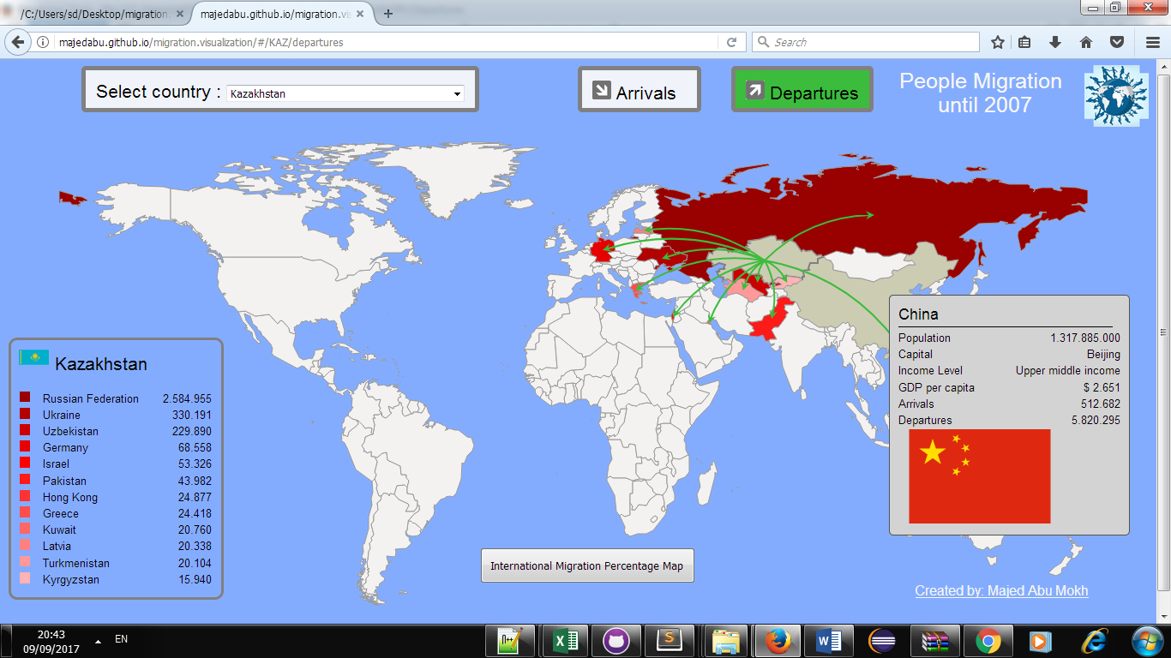
title: String
Name of the Country

Capital: String
Country capital
Income level: String

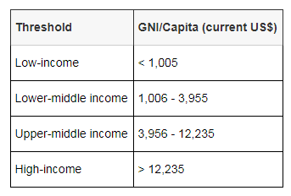

GDP per captia: number
GDP per capita is a measure of a country's economic output that accounts for population. It divides the country's gross domestic product by its total population. That makes it the best measurement of a country's standard of living. It tells you how prosperous a country feels to each of its citizens.
Arrivals: number
The total Arrivals for a country

Departures : number
The total Departures for a country

Flag : Svg image
The Natoinal flag for a country

WHY ?

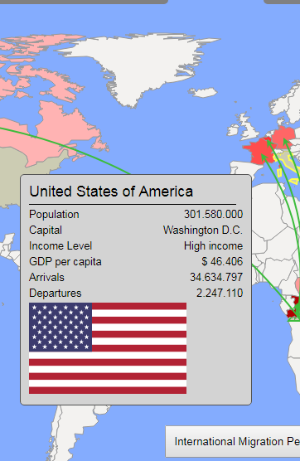
Discover association: user can discover if there is an association between Income level , GDP per captia and the number of arrivals and departures . For example, in the USA, the Income level and the GDP are high
->>high number of arrivals & low number of departures.

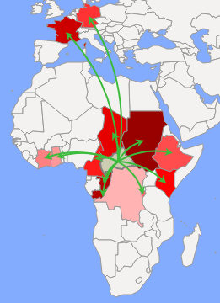
Enjoy: User will enjoy displaying the data, responsive design, eye candy UI, simple and minimalist design and colors.

Tracing :
According to the map, the user can see for each country where each migrates prefer to immigrates
*For example, in many countries - immigrants immigrate to nearby countries.

Compare Countries: User can compare between different countries that have historical relation .

HOW ?
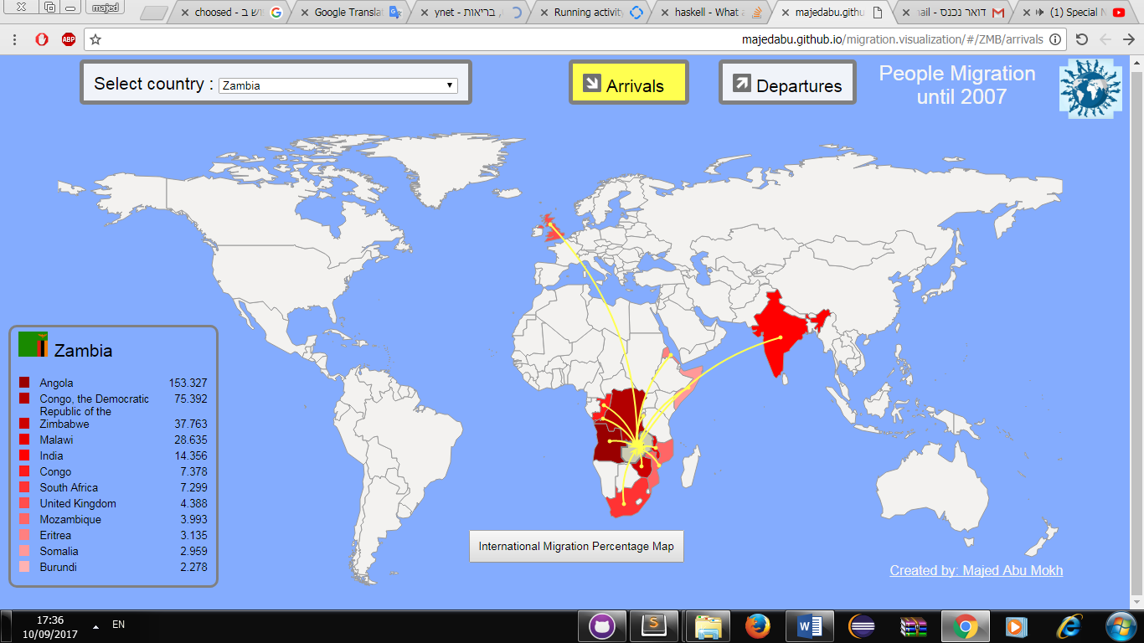

Color of chosen countries: I used 12 different colors (most light red to most dark red) to show the different degree of migrators number for each country.

Motion: I choose to use arrow (green for Departures ,Yellow for arrivals) to help the user distinguish between Arrivals and departures migrated countries, it also shows the distance between the countries.
Mouse hover for each country to show the " popup" Important information for each hover country.

Legend: showing the estimated numbers of migrators from departures or arrivals countries in order.

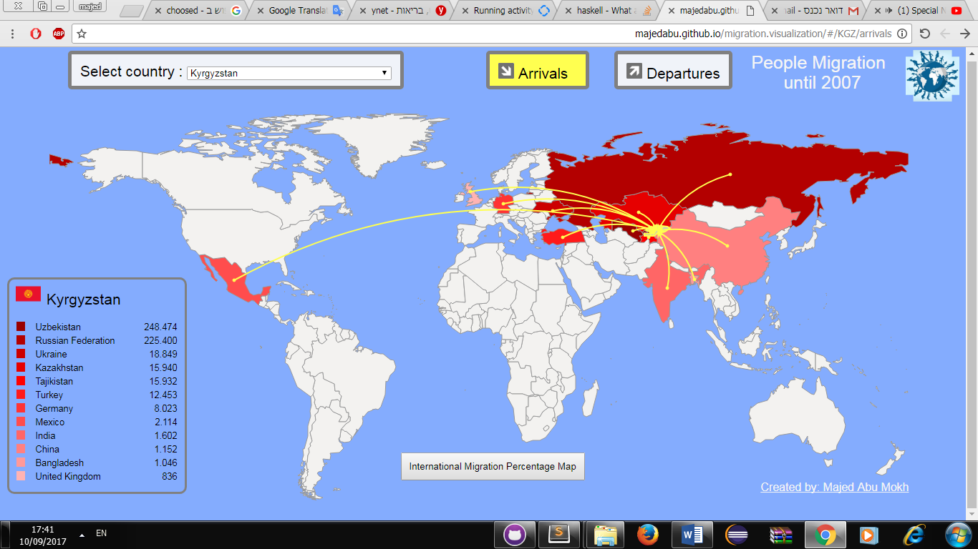
Background color: I choose one color for the map, light blue, I tried different colors until i decided it is the most suitable in our case, for the country I choose light gray color, which seems like Google maps.
It doesn’t interface with the arrows displayed color or the popup(country information),
it makes the map clear and simple.

7

User tasks:

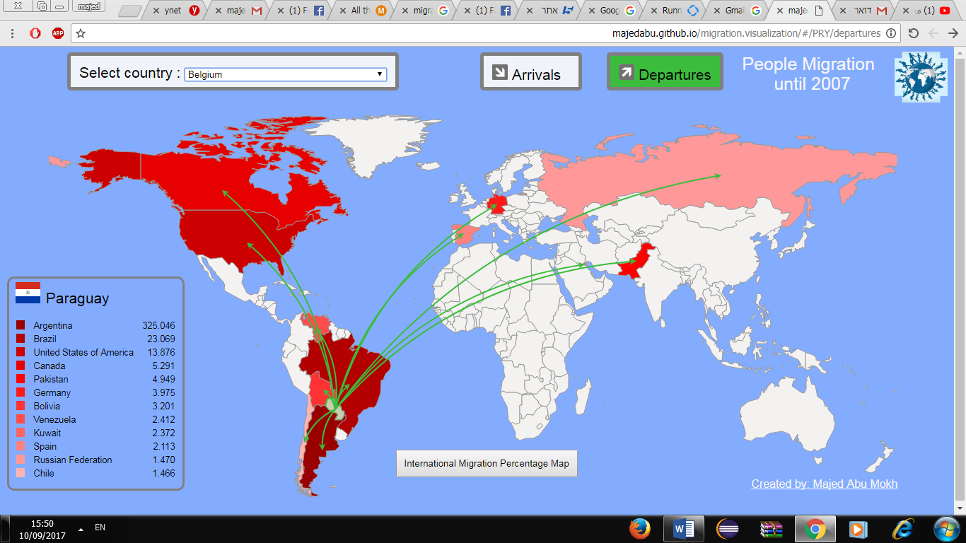
Explore: When the user enters the site, he can see the visualization immediately, so he can simply start exploring the human migration for each country. With the legend ON by default(Paraguay), it is easier to understand what the arrows means, color of the chosen country (light red to dark red) .

The main view of the website.( Paraguay Deprtures arrow)

Bonus

By Pressing the bottom" International migration percentage map" it will show World map migration percentage (circles) for each country

Arrivals:
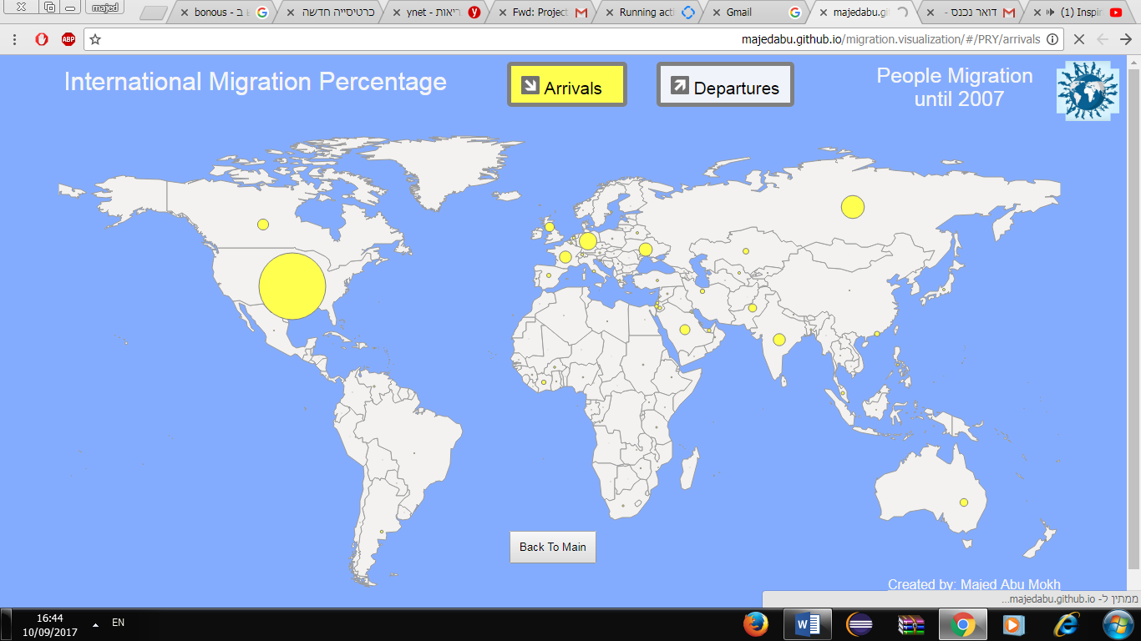
Radius of circles = total arrivals for a country divided by the max total arrivals in the world (USA – 34 millions) then multiplied by a constant(alpha=40)
We can see that most immigrates prefer USA-Canada-Germany-France-India-Saudi Arabia
All these countries share a "high" level income and GDP per captia
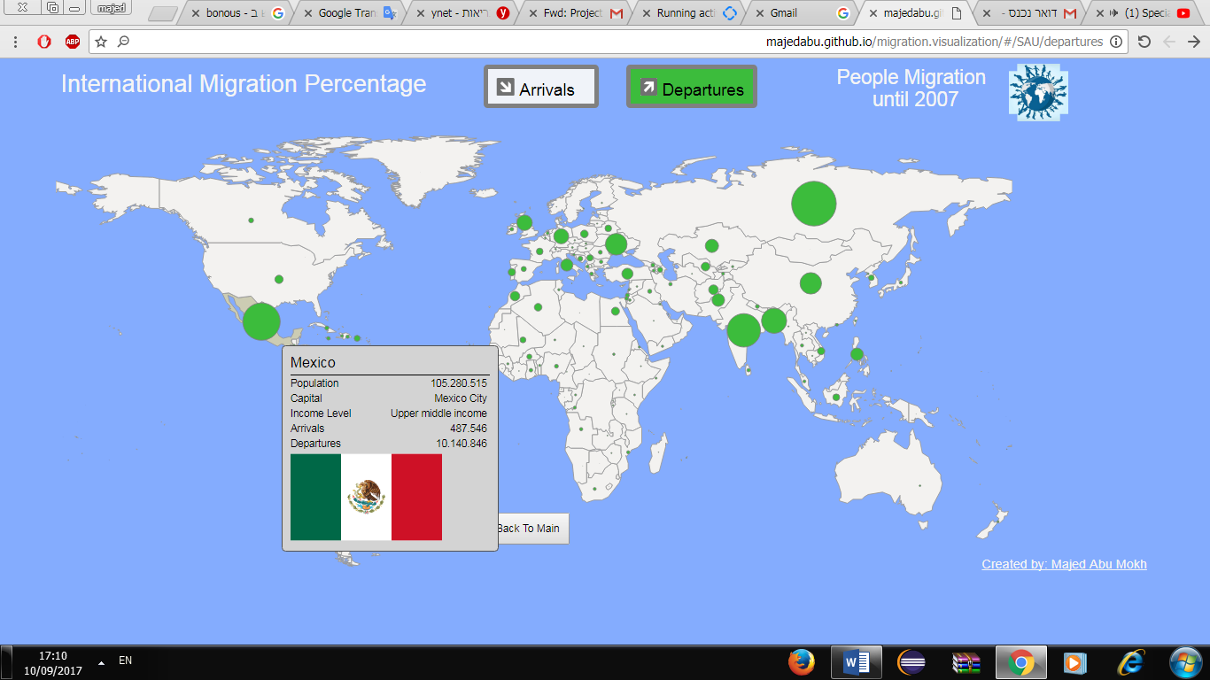

Departures:
Radius of circles = total arrivals for a country divided by the max total Departures in the world (Russia – 12 millions) then multiplied by a constant(alpha=40)

Final Thoughts :

I got a beautiful visualization with many useful tools that user can use, so big efforts were made to make it as simple as possible.

The project gave us a lot of knowledge in the visualization methods, what is good and what is bad for the human eye, what is more suitable for different kinds of data, how to make large data sets smaller (filtering), it also gave us more experience in javascript.

On the other side, I think a 3d map is better for this kind of visualization, as my 2d map is stretched in north and south, I could also add more features like zoom out, zoom in for the map.

I’ve tried during the development process to get a feedback from
students and friends on how to improve the User Experience as much as
possible, but always there is a place for improving.

Thanks !

Majed Abu Mokh ☺

