# summary

Aperiodic antenna arrays are necessary for wideband beam scanning applications. However, their design is complicated by mutual coupling between antenna elements.

This work demonstrates the effects of coupling between antenna elements with simulated results, presents a novel technique to efficiently analyze the coupling in aperiodic arrays, and finally presents results from the synthesis and full wave simulation of pseudorandom wideband arrays.

# antenna element coupling

Examine the effects of mutual coupling on the radiation pattern and input impedance of different radiating antenna elements. Determine the sensitivity of canonical antenna designs to proximity of neighboring elements.

* Dipole
* Patch
* Equiangular Spiral
* Horn/Vivaldi

**Status**:

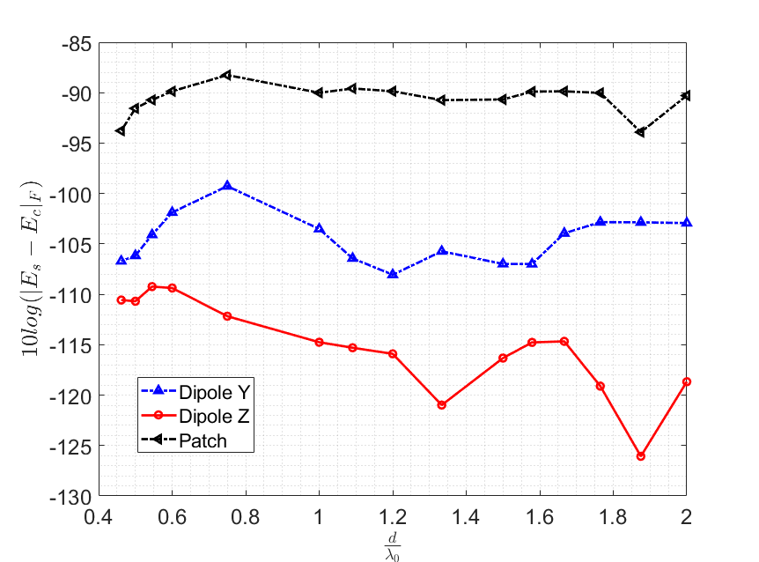

This plot shows far field distortion compared to a single element for an element surrounded by a ring of terminated elements separated by a distance *d*.

**TODO:** make similar plot from results of same experiment showing S11 instead of far field.

Key results will be some measure of pattern distortion (residual difference from isolated element pattern) and change in input impedance as a function of element separation distance.

# Subarray tesselation to simulate aperiodic arrays

Analyze the accuracy of subarray tessellation technique to simulate aperiodic arrays. Determine radius of influence and nearest neighbors to include in simulation subarray and achieve satisfactory accuracy for evaluating the array performance.

**Status**: Continuation of results presented at ACES, more test cases have been run and observed convergence to the full array simulation results. Implemented multi-threaded computation of far field patterns constructed from subarray simulations, calculates total array radiation patterns, and automatically computes beamwidth and sidelobe levels. Analyzing far field results to compare with S parameter residual results.

Diagonal elements of s-matrix only

Log of error, 10x not necessary, express error as percentage

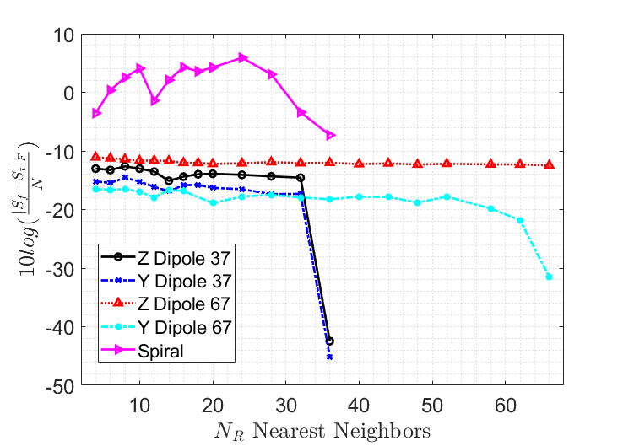

# Comparison of Aperiodic Array Synthesis

Taylor one parameter distribution gives excitation coefficients as a function of radial element position.

Hypothesis: use the distribution as a probability density function and realize samples as radial coordinate of element positions in spherical coordinates. Theta is random.

How to realize random samples of an arbitrary pdf?

-rejection sampling:

Taylor distribution f(x) gives the probability that an element is at radius x. We can generate samples from a uniform distribution g(x) that is scaled to the domain of f(x). If g(x) > f(x) the sample is rejected, otherwise it is accepted as a random sample of f(x).

Then, use the results from section 2 to identify minimum acceptable spacing of elements for a realization of the array using actual antenna elements. Accommodate the minimum acceptable spacing by keeping *r* of each element fixed and optimizing theta vector to minimize element coupling.

