Docker-01

Docker-Intro and Commands

1: Setup a virtual machine using Ubuntu image.
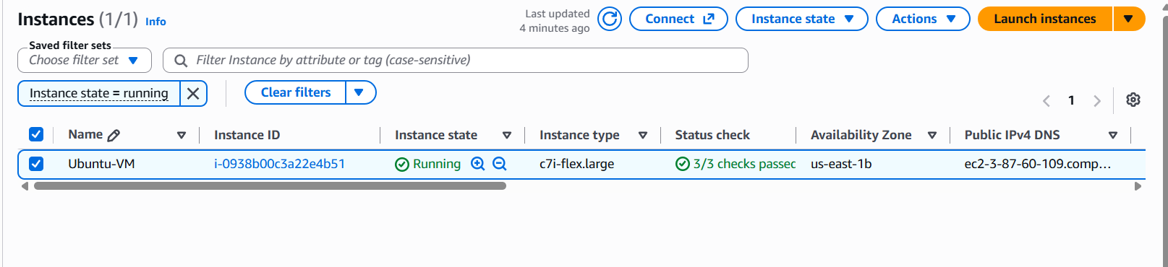
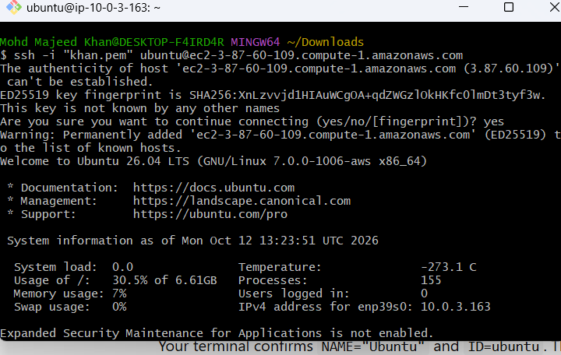
2: Install docker on ec2.
Task 2: Install Docker on EC2
Objective: Install Docker on an Ubuntu EC2 instance, start the service, and verify that containers can run.
Step 1: Update package lists
sudo apt update
Purpose: Refreshes the package list so Ubuntu knows which software packages are available.
Step 2: Install Docker
sudo apt install -y docker.io
Purpose: Installs Docker and its required dependencies.
- sudo — runs the command with administrator privileges.
- apt — Ubuntu's package manager.
- install — installs a package.
- -y — automatically answers yes to installation prompts.
- docker.io — Docker package available from Ubuntu's repository.
Step 3: Start Docker
sudo systemctl start docker
Purpose: Starts the Docker service immediately.
Step 4: Enable Docker at startup
sudo systemctl enable docker
Purpose: Configures Docker to start automatically when the EC2 instance boots.
Remember:
- start = start now.
- enable = start automatically at boot.
Step 5: Check Docker version
docker --version
Purpose: Confirms that Docker is installed and displays its version.
Example output:
Docker version 29.1.3
Step 6: Check Docker service status
sudo systemctl is-active docker
Purpose: Checks whether the Docker service is running.
Expected output:
active
Step 7: Test Docker using a sample container
sudo docker run hello-world
Purpose: Verifies that Docker can download an image, create a container, and run it.
Expected output:
Hello from Docker!
If the image is not available locally, Docker downloads it from Docker Hub automatically.
Command revision table
Command | Use
sudo apt update | Refresh package lists
sudo apt install -y docker.io | Install Docker
sudo systemctl start docker | Start Docker now
sudo systemctl enable docker | Enable automatic startup
docker --version | Check installed version
sudo systemctl is-active docker | Check whether Docker is running
sudo docker run hello-world | Test Docker with a container
Final result
Docker was installed successfully on Ubuntu EC2. The Docker service is active, automatic startup is enabled, and the hello-world container ran successfully.
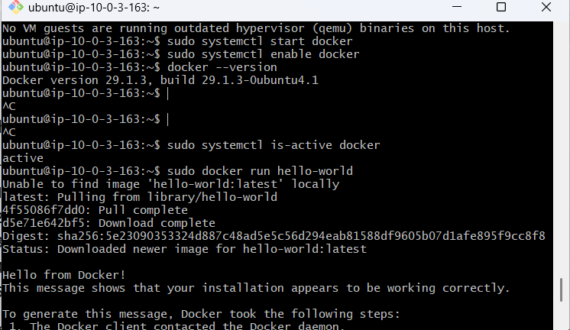
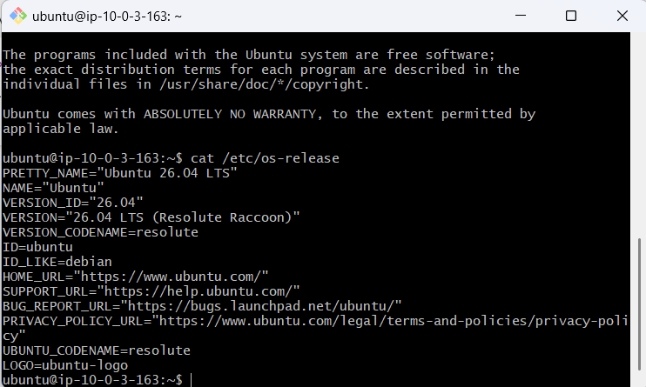

3: Pull 5 docker images. (nginx, Apache tomcat, ubuntu, Jenkins, SonarQube)
- Pull the Nginx image: Command is docker pull nginx
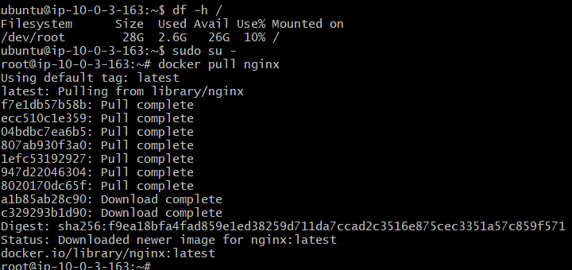
docker pull tomcat:
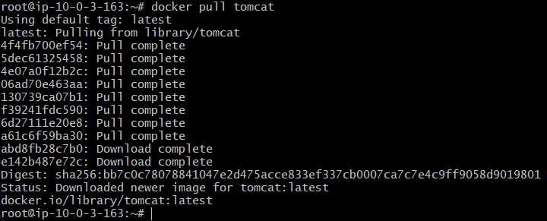
- Pull the Ubuntu image : Command is docker pull ubuntu
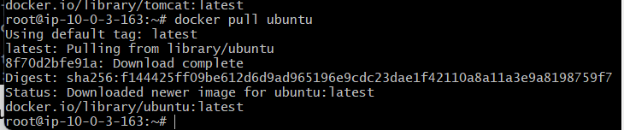
- Pull the Jenkins image : command is docker pull jenkins/jenkins
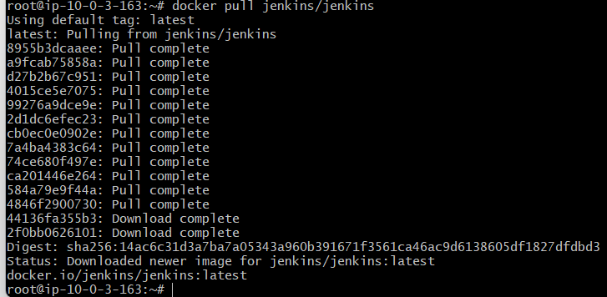
Pull the SonarQube image: command is docker pull sonarqube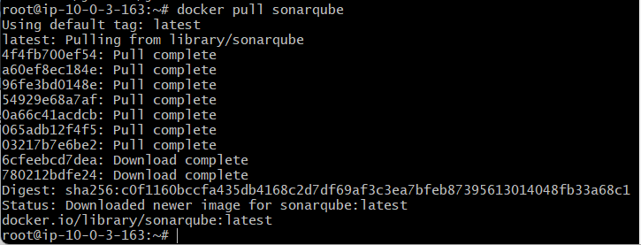
docker images
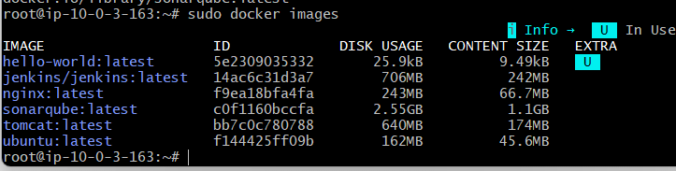
4: Run nginx container and expose on port 81.
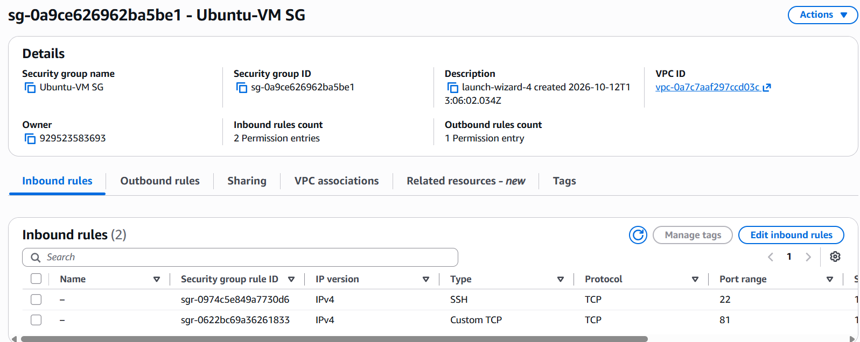
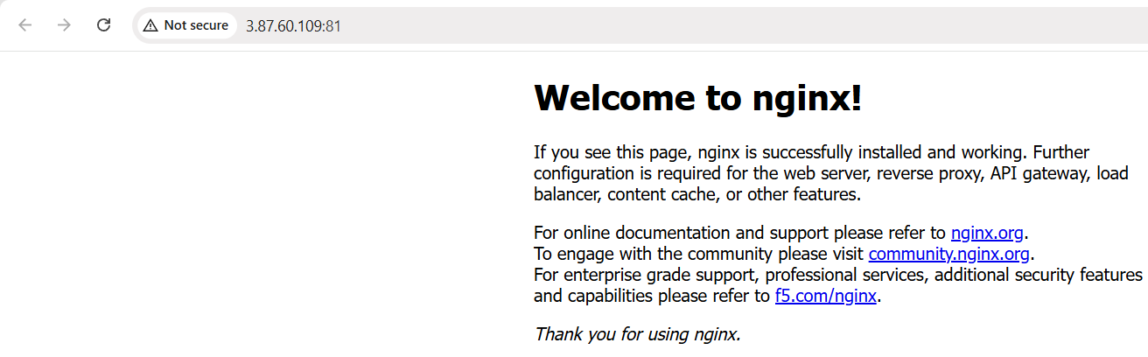
5: Delete the Apache tomcat image from local
docker rmi tomcat:latest
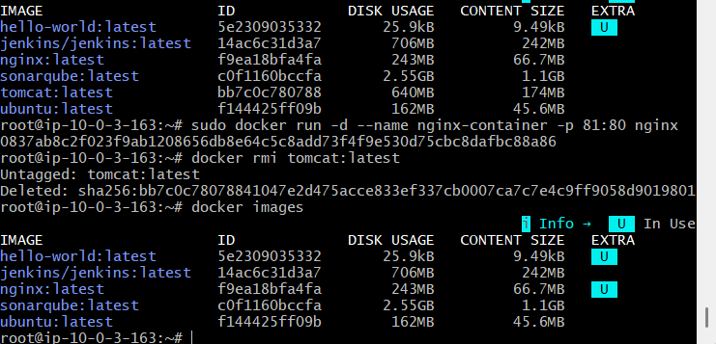
6: Inspect the Jenkins image, SonarQube image.
sudo docker image inspect jenkins/jenkins:latest
sudo docker image inspect sonarqube:latest
These commands display detailed image metadata, including image ID, architecture, environment settings, and configuration.
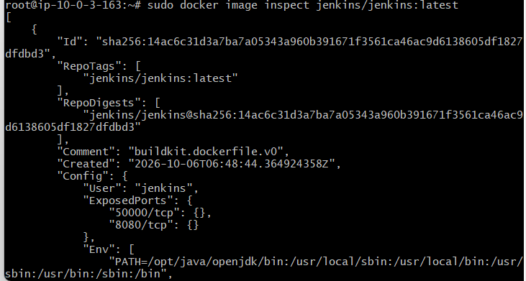

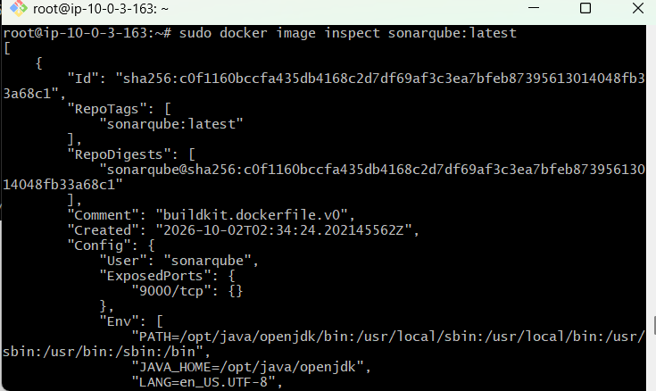

7: Run Jenkins container and run one sample job.

Step 1: Create a Docker volume
docker volume create jenkins_home
Purpose: Stores Jenkins data persistently.
Step 2: Run the Jenkins container
docker run -d \
--name jenkins-container \
-p 8080:8080 \
-p 50000:50000 \
-v jenkins_home:/var/jenkins_home \
--restart unless-stopped \
jenkins/jenkins:latest
Purpose: Starts Jenkins in the background and maps port 8080 for browser access.
Step 3: Verify the container
docker ps
Expected: jenkins-container shows as Up.
Step 4: Get the initial password
docker exec jenkins-container cat /var/jenkins_home/secrets/initialAdminPassword
Open http://YOUR-EC2-PUBLIC-IP:8080, enter the password, install suggested plugins, and create your administrator account. Ensure the EC2 security group allows inbound TCP port 8080 from your IP.
Step 5: Create a sample job
- In Jenkins, click New Item.
- Enter docker-sample-job.
- Select Freestyle project and click OK.
- Under Build Steps, choose Add build step → Execute shell.
- Enter:
echo "Hello from Jenkins!"
echo "Running a sample Jenkins job on Docker"
- Click Save → Build Now.
- Open the build number and select Console Output.
Step 6: Verify success
Expected output:
Hello from Jenkins!
Running a sample Jenkins job on Docker
Finished: SUCCESS
Result: Jenkins container ran successfully, and the sample job completed with SUCCESS.

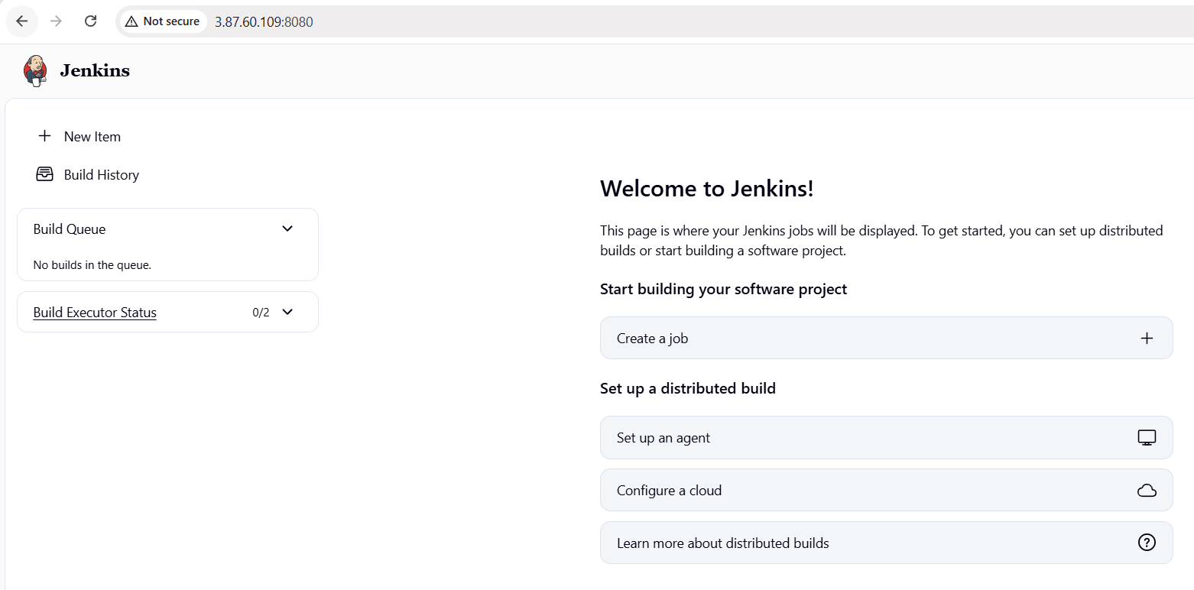
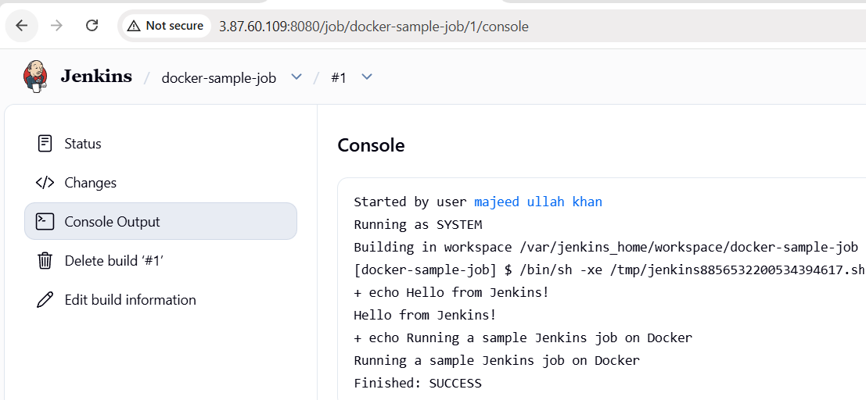
Important commands to remember
Command | Purpose
docker images | List local images
docker ps | List running containers
docker ps -a | List all containers
docker image inspect jenkins/jenkins:latest | Inspect image details
docker logs jenkins-container | View Jenkins logs
docker volume ls | List Docker volumes
docker rmi tomcat:latest | Remove the local Tomcat image

