Docker-02

Docker-Volumes and Docker file

1: Create a tomcat container on 8080 and deploy sample application in tomcat.
Step 1: Pull Tomcat image
docker pull tomcat:10.1-jdk21
Step 2: Run Tomcat container
Jenkins was already using port 8080, so we used host port 8081.
docker run -d --name tomcat-container -p 8081:8080 tomcat:10.1-jdk21
Step 3: Verify the container
docker ps
Step 4: Create the sample application
mkdir -p /tmp/sample-app
cd /tmp/sample-app
Create the HTML page:
cat > index.html <<'EOF'
<html>
<body>
<h1>Hello from Tomcat!</h1>
<p>My sample application is deployed successfully.</p>
</body>
</html>
EOF
Step 5: Create the WAR file
Since jar was not installed on EC2, we used the Tomcat container's Java utility.
docker cp index.html tomcat-container:/tmp/index.html
docker exec tomcat-container jar cf /tmp/sample-app.war -C /tmp index.html
docker cp tomcat-container:/tmp/sample-app.war /tmp/sample-app/sample-app.war
Step 6: Deploy the application
docker cp /tmp/sample-app/sample-app.war tomcat-container:/usr/local/tomcat/webapps/
Step 7: Check logs
docker logs --tail 50 tomcat-container
Step 8: Configure AWS Security Group
Allow inbound TCP port 8081 from My IP.
Step 9: Test in browser
http://YOUR-EC2-PUBLIC-IP:8081/sample-app/
Expected result: Hello from Tomcat!
404 error fixes: The Tomcat root URL had no application available. We deployed sample-app.war into the webapps directory and opened the correct /sample-app/ URL.
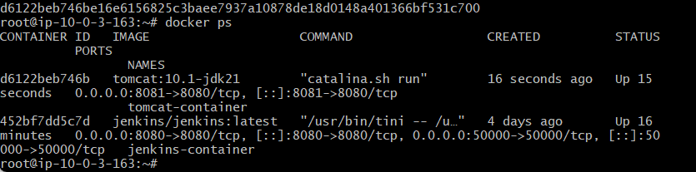
ERROR:
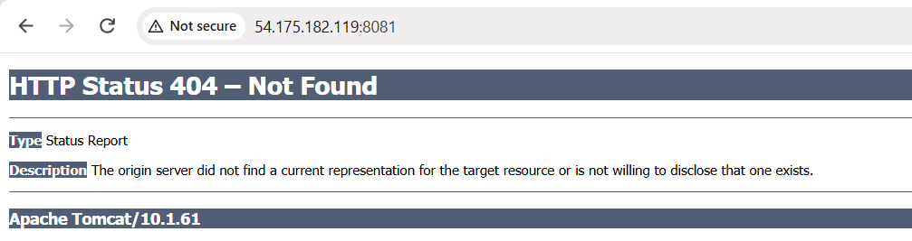
What exactly did we do to fix it?
1. Created an HTML page
Created index.html containing “Hello from Tomcat!”
2. Packaged the application
Prepared the HTML file as sample-app.war, using the jar utility inside the Tomcat container because jar was not installed on the EC2 host.
3. Deployed the WAR file
Copied sample-app.war into:
/usr/local/tomcat/webapps/
4. Opened the correct URL
http://YOUR-EC2-PUBLIC-IP:8081/sample-app/
Tomcat deployed the WAR file under the /sample-app/ context path, and the browser displayed our HTML page.

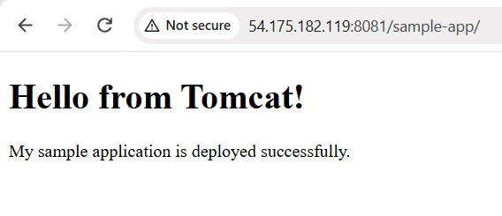
2: Create volume and deploy tomcat container on port 8081
Steps and Commands
Step 1: Check running containers
docker ps
Step 2: Create a Docker volume
docker volume create tomcat_data
Purpose: Stores application files separately from the container.
Step 3: Run the Tomcat container with port mapping and volume
docker run -d --name tomcat-container -p 8081:8080 -v tomcat_data:/usr/local/tomcat/webapps tomcat:10.1-jdk21
- -d — Runs in the background.
- --name — Names the container.
- -p 8081:8080 — Maps EC2 port 8081 to Tomcat port 8080.
- -v — Attaches the Docker volume.
- tomcat:10.1-jdk21 — Tomcat image.
Step 4: Verify the container and volume
docker ps
docker volume ls
docker inspect tomcat-container - Displays detailed information about the Tomcat container.
Purpose: Confirms the container is running and the volume is attached.
Step 5: Check the sample WAR file
ls -lh /tmp/sample-app/sample-app.war
Step 6: Deploy the application
docker cp /tmp/sample-app/sample-app.war tomcat-container:/usr/local/tomcat/webapps/
Purpose: Copies the application into Tomcat's deployment directory.
Step 7: Test in the browser
Open:
http://54.175.182.119:8081/sample-app/
Expected output:
- Hello from Tomcat!
- My sample application is deployed successfully.
Final Result
- Docker volume tomcat_data created.
- Tomcat container running on port 8081.
- Sample application deployed and tested successfully.

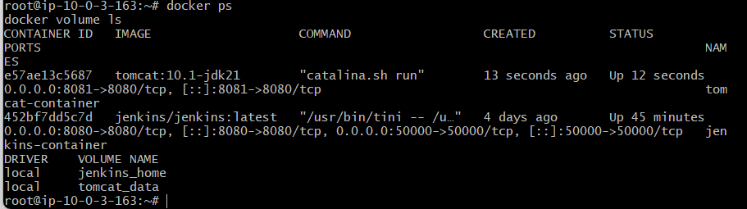
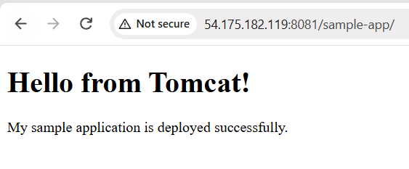
3: Limit the nginx container to 500 MB
Step 1: Check containers
docker ps -a
Purpose: Find the Nginx container name and status.
Step 2: Set the memory and swap limits
docker update --memory 500m --memory-swap 500m nginx-container
Purpose:
- --memory 500m — Limits RAM to 500 MiB.
- --memory-swap 500m — Sets the combined RAM and swap limit to 500 MiB.
Step 3: Verify the limits
docker inspect nginx-container --format='Memory={{.HostConfig.Memory}} MemorySwap={{.HostConfig.MemorySwap}}'
Expected output:
Memory=524288000 MemorySwap=524288000
Result: Nginx's memory limit is configured to 500 MiB, with no additional swap allowance.

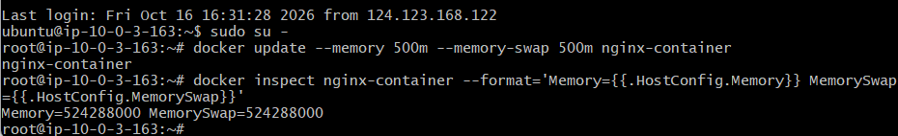
4: Create a sample docker file using below instructions.
- Base module as amazonlinux:latest
- Maintainer you name
- Install nginx
- COPY one index.html file to image
- Expose on port 80
- Command to start the nginx container
Step 1: Create a project folder
mkdir -p /root/task4
cd /root/task4
This folder will contain the Dockerfile and index.html files needed to build your image.
Step 2: Create the index.html file
cat > index.html <<'EOF'
<!DOCTYPE html>
<html>
<head>
<title>My Docker App</title>
</head>
<body>
<h1>Hello from Amazon Linux Docker!</h1>
<p>My custom Nginx image is working successfully.</p>
</body>
</html>
EOF
This is the sample webpage that Nginx will serve when we access the container
Step 3: Create the Dockerfile
cat > Dockerfile <<'EOF'
FROM amazonlinux:latest
LABEL maintainer="Majeed"
RUN dnf install -y nginx && dnf clean all
COPY index.html /usr/share/nginx/html/index.html
EXPOSE 80
CMD ["nginx", "-g", "daemon off;"]
EOF
This Dockerfile follows all six requirements:
Instruction | Purpose
FROM amazonlinux:latest | Uses Amazon Linux as the base image
LABEL maintainer="Majeed" | Identifies the maintainer
RUN dnf install -y nginx | Installs Nginx
COPY index.html ... | Copies the webpage into the image
EXPOSE 80 | Documents the container's web port
CMD ["nginx", "-g", "daemon off;"] | Starts Nginx in the foreground
Step 5: Build the Docker image
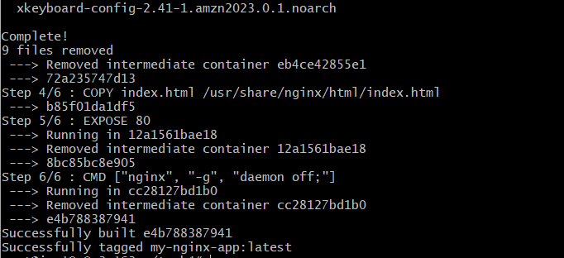
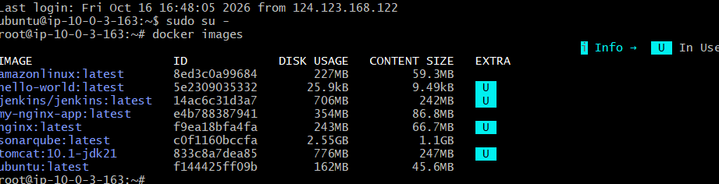
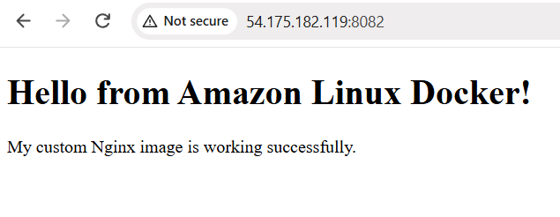
5: Push image to Docker hub
Objective: Upload your custom Nginx Docker image from your local system to Docker Hub so that it can be downloaded and used on other machines.
Step-by-step procedure
Step 1: Create a Docker Hub repository
- Open Docker Hub.
- Sign in with your account.
- Create a repository named my-nginx-app.
- Set visibility to Public.
- Click Create.
Why? A repository is where Docker Hub stores your Docker images.
Step 2: Save the image on EC2
Connect to your EC2 Ubuntu instance and run:
sudo docker save -o /tmp/my-nginx-app.tar my-nginx-app:latest
Make the file readable for transfer:
sudo chmod 644 /tmp/my-nginx-app.tar
Why? docker save exports your image into a TAR archive that can be transferred to another computer.
Step 3: Transfer the image to Windows
Open Git Bash on your Windows computer and navigate to the folder containing your khan.pem key.
Run:
scp -i "khan.pem" ubuntu@54.175.182.119:/tmp/my-nginx-app.tar .
Why? scp securely copies the TAR file from EC2 to your local computer.
Step 4: Load the image into Docker Desktop
In Git Bash, run:
docker load -i my-nginx-app.tar
Verify the image:
docker images
You should see my-nginx-app:latest.
Why? docker load imports the saved image into your local Docker engine.
Step 5: Tag the image
Run:
docker tag my-nginx-app:latest majeedullah/my-nginx-app:latest
Verify:
docker images
You should see the tagged image:
majeedullah/my-nginx-app:latest
Why? Docker Hub uses your username and repository name to identify where the image should be uploaded.
Step 6: Sign in to Docker Hub
Ensure Docker Desktop is signed in to your majeedullah account.
If necessary, use Docker Desktop's profile menu to sign in again.
Why? Docker Hub must authenticate your account before allowing you to upload an image.
Step 7: Push the image to Docker Hub
Run in Git Bash:
docker push majeedullah/my-nginx-app:latest
Successful output includes:
latest: digest: sha256:...
Why? docker push uploads your local image to your Docker Hub repository.
Step 8: Verify the uploaded image
Open your repository:
majeedullah/my-nginx-app on Docker Hub
Confirm that the latest tag is available.
You can now download the image on another computer using:
docker pull majeedullah/my-nginx-app:latest
Short notes for revision
Command | Purpose
docker save | Export an image to a TAR file
scp | Transfer the TAR file from EC2 to Windows
docker load | Import the image into Docker
docker tag | Assign a Docker Hub repository name
docker login | Authenticate with Docker Hub
docker push | Upload the image to Docker Hub
docker pull | Download an image from Docker Hub
Task 5 completion checklist
- Created public Docker Hub repository.
- Saved the custom image from EC2.
- Transferred the image to Windows.
- Loaded the image into Docker Desktop.
- Tagged the image with the Docker Hub username.
- Pushed the image successfully.
- Confirmed the image digest was returned.
Final status: Task 5 completed successfully.

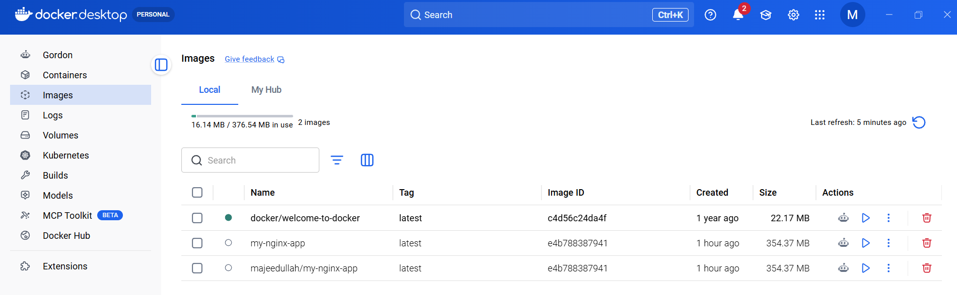
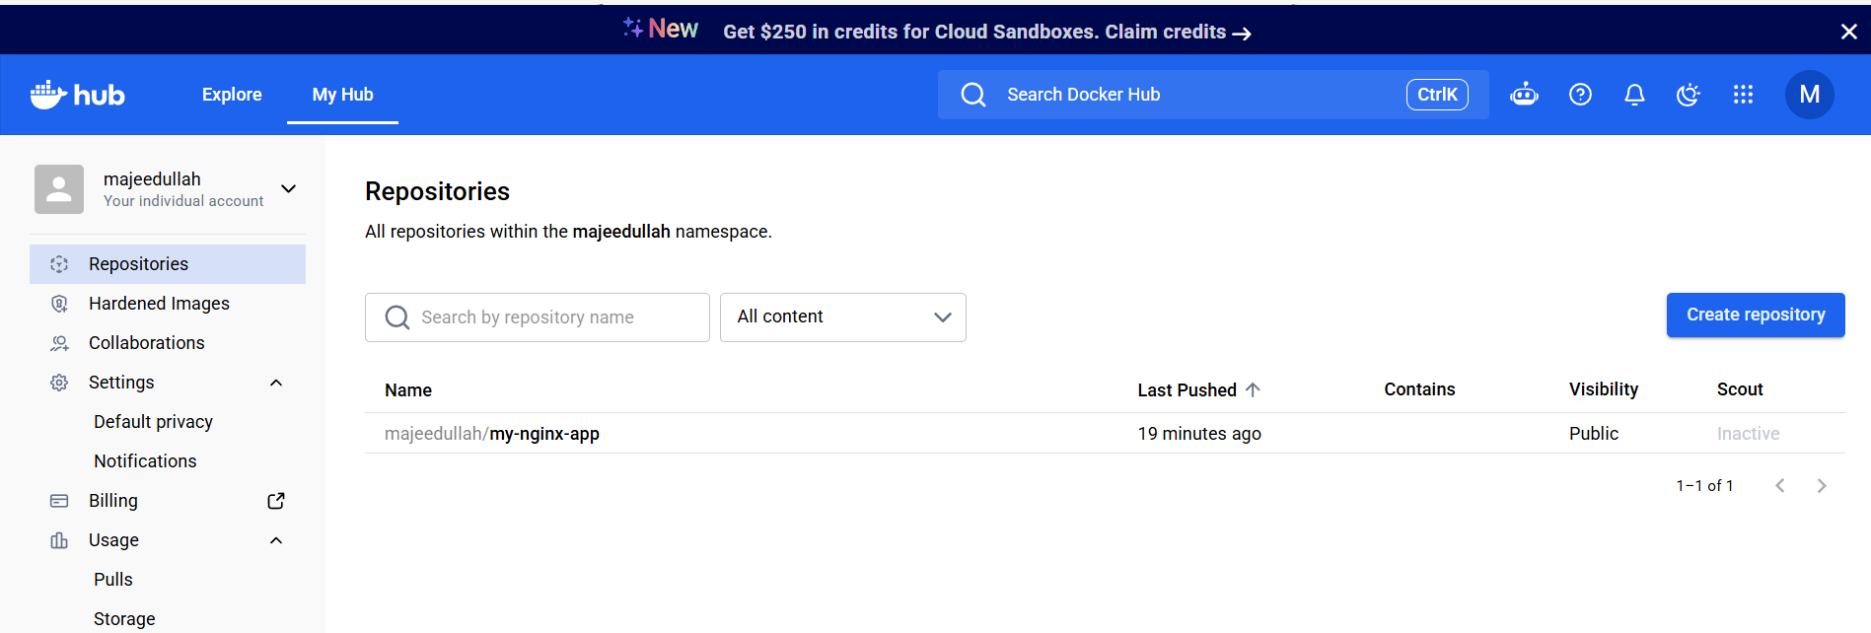
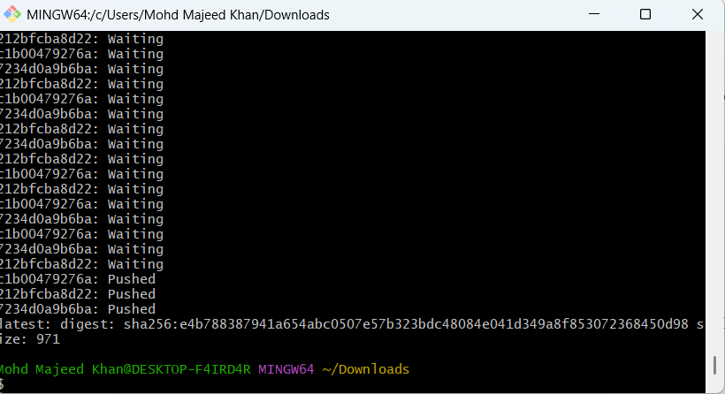
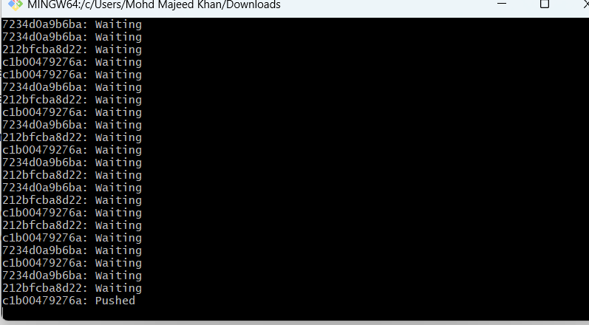
6: push image to AWS ECR
Objective: Upload your custom Docker image my-nginx-app to Amazon Elastic Container Registry (ECR).
AWS ECR is a private container image registry where you can store Docker images and later use them with services such as EC2, ECS, and EKS
Steps performed
Step 1: Create ECR repository
- Open AWS Console → Amazon ECR → Create repository.
- Repository name: my-nginx-app
- Repository type: Private
- Region: us-east-1
Step 2: Configure AWS CLI
aws configure
Enter your IAM access key, secret access key, region us-east-1, and output format json.
Step 3: Verify AWS account
aws sts get-caller-identity
Confirmed account ID: 929523583693.
Step 4: Log in to ECR
aws ecr get-login-password --region us-east-1 | docker login --username AWS --password-stdin 929523583693.dkr.ecr.us-east-1.amazonaws.com
Expected output: Login Succeeded
Step 5: Tag the Docker image
docker tag my-nginx-app:latest 929523583693.dkr.ecr.us-east-1.amazonaws.com/my-nginx-app:latest
Step 6: Push the image
docker push 929523583693.dkr.ecr.us-east-1.amazonaws.com/my-nginx-app:latest
The image layers were pushed successfully.
Step 7: Verify
Open AWS Console → ECR → my-nginx-app → Images. Confirm the latest tag is present.
Short notes
Command | Purpose
aws configure | Configure AWS CLI credentials
aws sts get-caller-identity | Verify AWS identity
aws ecr get-login-password | Authenticate with ECR
docker tag | Tag image with ECR repository URI
docker push | Upload image to ECR
Result: Task 6 completed successfully. The custom Docker image is stored in your private AWS ECR repository.
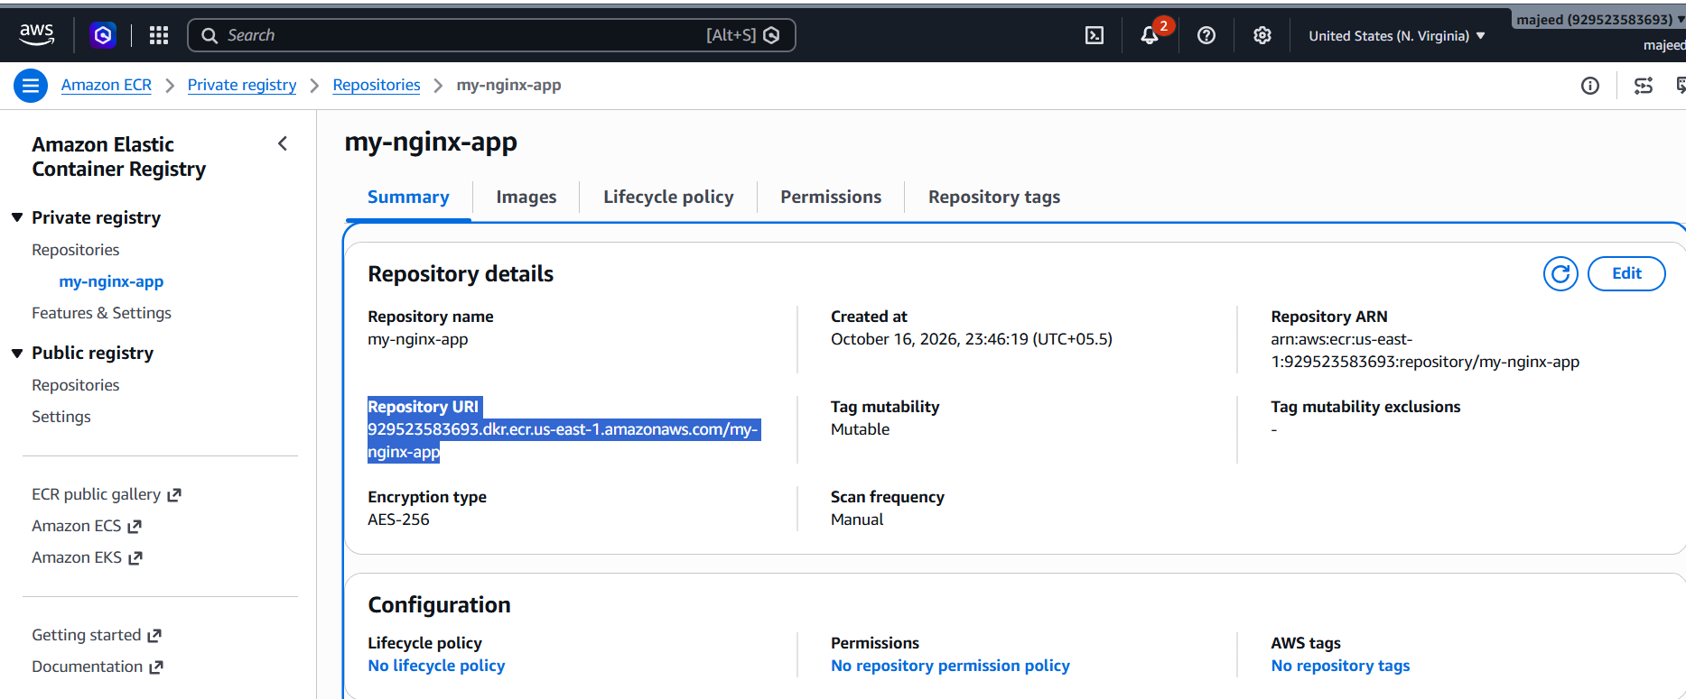
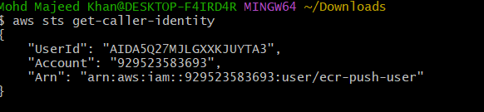
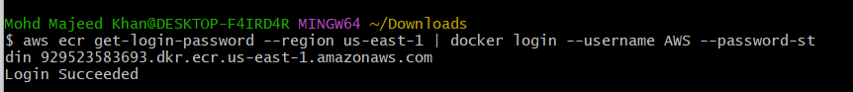
What this does: It uses your AWS CLI credentials to authenticate Docker with your private ECR registry.
Tag your Docker image
docker tag my-nginx-app:latest 929523583693.dkr.ecr.us-east-1.amazonaws.com/my-nginx-app:latest
This gives your existing image the ECR repository address.
Step 8: Push the image
Run:
docker push 929523583693.dkr.ecr.us-east-1.amazonaws.com/my-nginx-app:latest

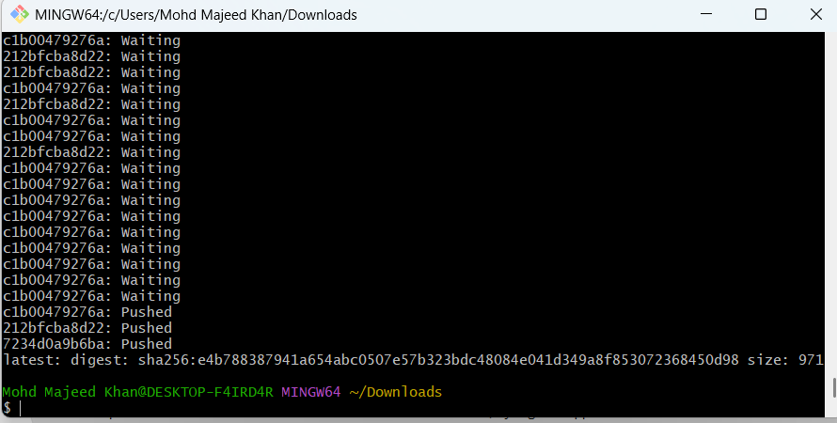

Important commands to remember
- Docker Hub: docker push username/image:tag
- AWS ECR: docker push account-id.dkr.ecr.region.amazonaws.com/repository:tag

