Docker-03

Docker-Alpine Image Network and Docker-Compose

1: Create an image from running container.
created a new Docker image from running Jenkins container using docker commit.
- docker commit creates a new Docker image from the filesystem changes of an existing container. It allows us to save container modifications as an image for future use.
Steps
Step 1: Check running containers
docker ps
Identify the running container name. In our task, it was jenkins-container.
Step 2: Create a new image
docker commit jenkins-container jenkins-custom:v1
- docker commit — creates an image from a container.
- jenkins-container — existing container name.
- jenkins-custom — new image name.
- v1 — image tag (version).
Step 3: Verify the image
docker images
Confirm that jenkins-custom:v1 appears in the list.
Step 4: Inspect the image
docker image inspect jenkins-custom:v1

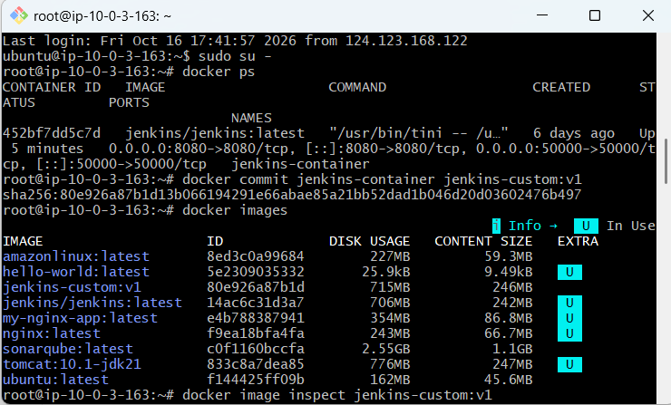
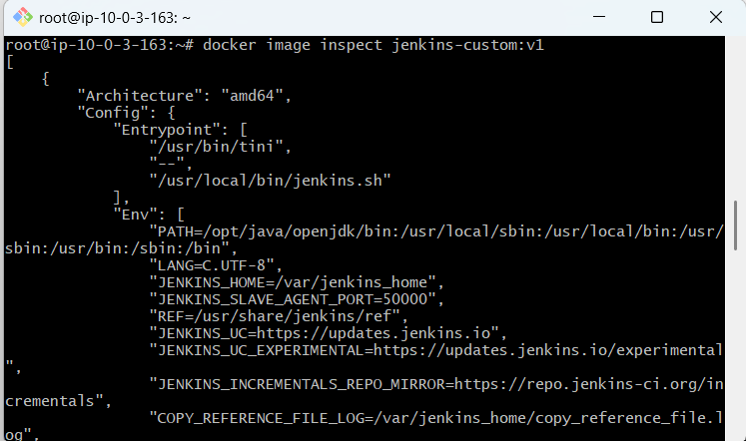

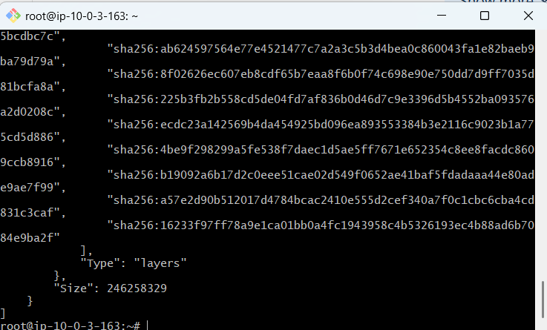

2: Copy image from local machine to docker server and load the image
Objective: Transfer a Docker image from the source EC2 server to a destination EC2 server and load it into Docker.
Step-by-step procedure
Step 1: Save the Docker image on the source server
docker save -o /home/ubuntu/jenkins-custom.tar jenkins-custom:v1
- docker save saves a Docker image as a TAR file.
- -o specifies the output file name.
Step 2: Give the Ubuntu user access to the file
chown ubuntu:ubuntu /home/ubuntu/jenkins-custom.tar
This allows the Ubuntu user to access the saved image file.
Step 3: Download the image to your local machine
Run this command in Windows Git Bash, not inside the EC2 server:
scp -i "khan.pem" ubuntu@<SOURCE-PUBLIC-DNS>:/home/ubuntu/jenkins-custom.tar .
Verify the downloaded file:
ls -lh jenkins-custom.tar
Step 4: Copy the image to the destination server
Run this command in Windows Git Bash:
scp -i "khan.pem" jenkins-custom.tar ubuntu@<DESTINATION-PUBLIC-DNS>:/home/ubuntu/
Step 5: Install Docker on the destination server
If Docker is not installed, run:
sudo apt update
sudo apt install -y docker.io
Verify:
docker --version
Step 6: Load the Docker image
On the destination server, run:
sudo docker load -i /home/ubuntu/jenkins-custom.tar
Expected output:
Loaded image: jenkins-custom:v1
Step 7: Verify the image
sudo docker images
Expected image details:
Repository | Tag | Image ID
jenkins-custom | v1 | 80e926a87b1d

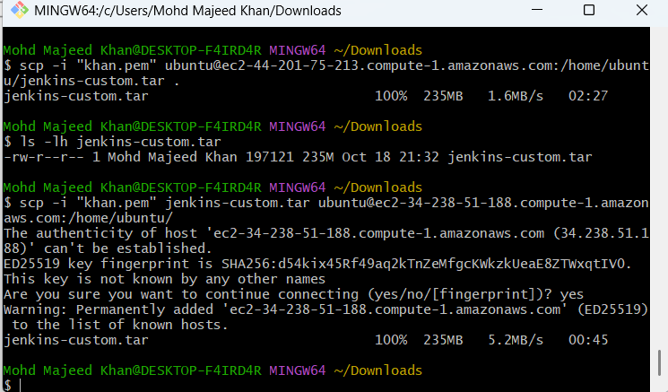
Short notes for Task 2
- docker save -o jenkins-custom.tar jenkins-custom:v1 — saves an image as a TAR file.
- scp — securely copies the TAR file between machines.
- docker load -i jenkins-custom.tar — imports the image into another Docker server.
- docker images — verifies the imported image.
Result: The jenkins-custom: v1 image was successfully transferred from the source EC2 server to the destination EC2 server and verified.

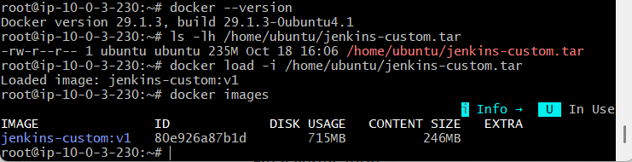

3: Create Docker image using alpine and customize with tomcat.
Steps performed
Step 1: Create a directory
mkdir alpine-tomcat
cd alpine-tomcat
Purpose: Creates a separate directory to store the Dockerfile.
Step 2: Create the Dockerfile
nano Dockerfile
Add the following configuration:

FROM alpine:3.22

RUN apk add --no-cache openjdk17-jre wget tar

ENV CATALINA_HOME=/opt/tomcat
ENV PATH="${CATALINA_HOME}/bin:${PATH}"

RUN wget -q https://archive.apache.org/dist/tomcat/tomcat-10/v10.1.49/bin/apache-tomcat-10.1.49.tar.gz \
-O /tmp/tomcat.tar.gz \
&& mkdir -p ${CATALINA_HOME} \
&& tar -xzf /tmp/tomcat.tar.gz --strip-components=1 -C ${CATALINA_HOME} \
&& rm /tmp/tomcat.tar.gz

EXPOSE 8080

CMD ["catalina.sh", "run"]
Save with Ctrl + O, press Enter, and exit with Ctrl + X.
Step 3: Build the custom image
docker build -t alpine-tomcat:v1 .
Purpose: Builds a custom image using Alpine Linux, Java 17, and Tomcat 10.1.49.
Step 4: Verify the image
docker images
Confirm that alpine-tomcat:v1 appears in the list.
Step 5: Verify Java and Tomcat
docker run --rm alpine-tomcat:v1 java -version
docker run --rm alpine-tomcat:v1 catalina.sh version
Purpose: Confirms that Java and Tomcat are installed correctly.
Step 6: Run the container
docker run -d --name tomcat-container -p 8080:8080 alpine-tomcat:v1
Purpose: Starts Tomcat in the background and maps port 8080 on EC2 to port 8080 inside the container.
Step 7: Verify the container and logs
docker ps
docker logs tomcat-container
Confirm the container is running and the logs show that the Tomcat server started.
Step 8: Access Tomcat in the browser
Open:
http://3.87.1.251:8080
The Apache Tomcat welcome page confirms successful deployment.
Short notes for revision
Command / instruction | Purpose
FROM alpine:3.22 | Selects the base image
RUN apk add | Installs Java and required tools
ENV | Sets environment variables
wget | Downloads the Tomcat archive
tar | Extracts Tomcat files
EXPOSE 8080 | Documents Tomcat's intended port
CMD | Starts Tomcat when the container launches
docker build | Creates the custom image
docker run | Creates and starts the container
docker logs | Displays container logs
Final result
- Base image: Alpine Linux 3.22
- Java: OpenJDK 17
- Tomcat: Apache Tomcat 10.1.49
- Custom image: alpine-tomcat:v1
- Container: tomcat-container
- Port: 8080
- Status: ✅ Successfully completed and verified in the browser.
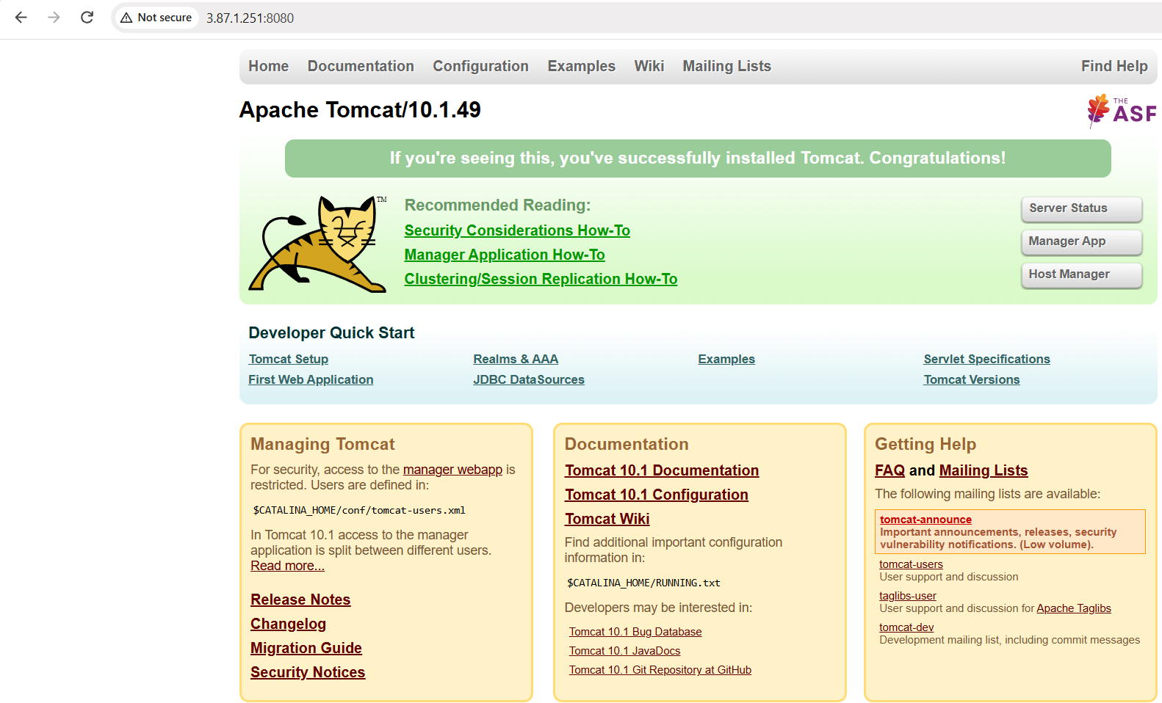

4: Create single stage and multi stage docker file using this source code: https://github.com/betawins/multi-stage-example.git
Objective: Build and compare single-stage and multi-stage Docker images using the source code from https://github.com/betawins/multi-stage-example.git.
Step 1: Clone the source code
git clone https://github.com/betawins/multi-stage-example.git
cd multi-stage-example
Why? Downloads the application source code and Docker-related files from GitHub.
Step 2: Create the single-stage Dockerfile
Create a file named Dockerfile.single:
nano Dockerfile.single
Add this content:
FROM maven:3.9-eclipse-temurin-8
WORKDIR /app
COPY . .
RUN mvn clean package -DskipTests
EXPOSE 8080
CMD ["java", "-jar", "target/multi-stage-example-0.0.1-SNAPSHOT.jar"]
Save with Ctrl + O, press Enter, then exit using Ctrl + X.
Explanation:
- FROM — selects an image with Maven and Java.
- WORKDIR — sets the working directory.
- COPY — copies source code into the image.
- RUN — builds the application JAR.
- EXPOSE — documents the application port.
- CMD — starts the Java application.
Step 3: Build the single-stage image
docker build -f Dockerfile.single -t spring-single:v1 .
Verify:
docker images | grep spring
Result: spring-single:v1 — approximately 669 MB.
Step 4: Create the multi-stage Dockerfile
Create the file:
nano Dockerfile.multi
Add:
# Stage 1: Build the application
FROM maven:3.9-eclipse-temurin-8 AS builder

WORKDIR /app

COPY pom.xml .
COPY .mvn .mvn
COPY mvnw .

RUN chmod +x mvnw

COPY src src

RUN mvn clean package -DskipTests

# Stage 2: Run the application
FROM eclipse-temurin:8-jre

WORKDIR /app

COPY --from=builder /app/target/multi-stage-example-0.0.1-SNAPSHOT.jar app.jar

EXPOSE 8080

CMD ["java", "-jar", "app.jar"]
Save and exit Nano.
Explanation:
- Stage 1 — Builder: Uses Maven and Java to compile the application and create the JAR file.
- Stage 2 — Runtime: Uses a Java runtime image to run the JAR.
- COPY --from=builder copies the built JAR from the first stage into the second stage.
This avoids including Maven and the full source code in the final runtime image.
Step 5: Build the multi-stage image
docker build -f Dockerfile.multi -t spring-multi:v1 .
Verify both images:
docker images | grep spring
Your results:
Image | Size
spring-single:v1 | 669 MB
spring-multi:v1 | 426 MB
The multi-stage image is 243 MB smaller, approximately a 36% reduction.
Step 6: Run the multi-stage container
docker run -d --name spring-multi-container -p 8081:8080 spring-multi:v1
Why? Runs the application in the background and maps host port 8081 to application port 8080.
Step 7: Verify the container
Check the running container:
docker ps
Check the application logs:
docker logs spring-multi-container
Your logs confirmed:
Tomcat started on port(s): 8080
Started MultiStageExampleApplication
Test the application:
curl http://localhost:8081/actuator/health
If the health endpoint is enabled, it should return a status such as UP. The root URL returning 404 is not by itself a failure; the application may not define a root endpoint.

- Single-stage Docker image built successfully.
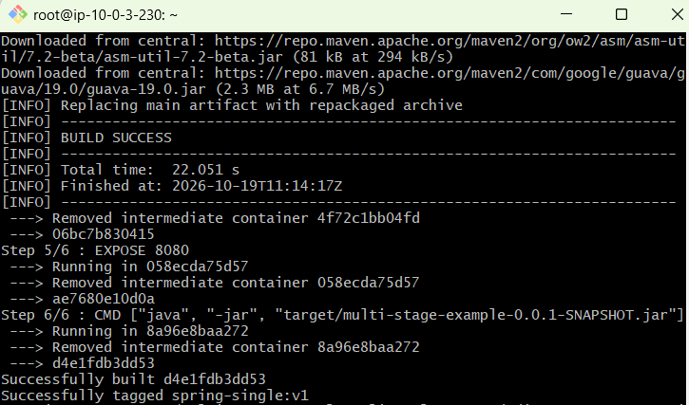
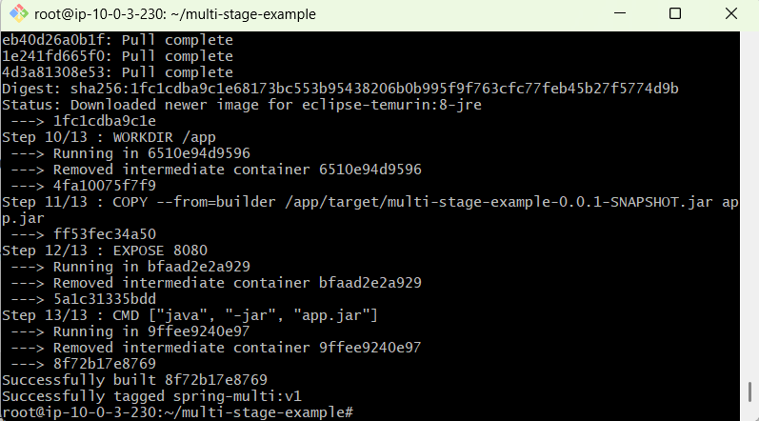
Step 1: Compare image sizes
Image | Size
spring-single:v1 | 669 MB
spring-multi:v1 | 426 MB
Your multi-stage image is 243 MB smaller — approximately 36% smaller than the single-stage image.
Why? The multi-stage image copies only the built application into a Java runtime image, leaving Maven and other build tools behind.

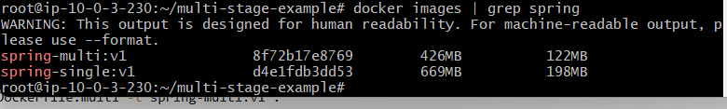
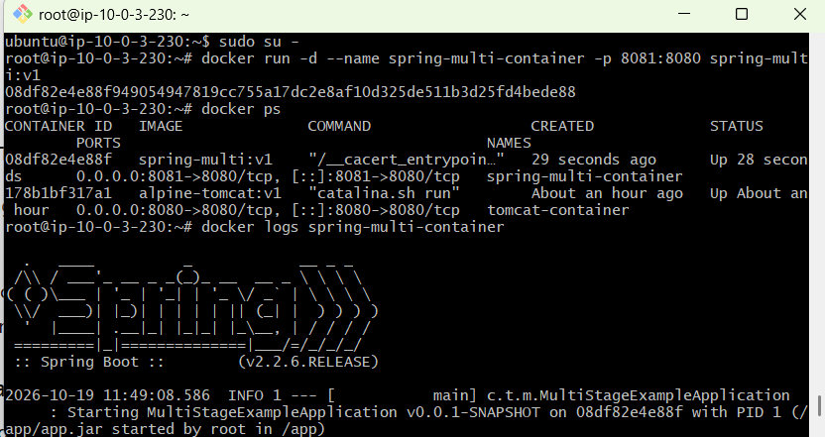
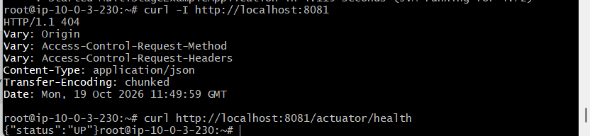

Important commands
# Build single-stage image
docker build -f Dockerfile.single -t spring-single:v1 .

# Build multi-stage image
docker build -f Dockerfile.multi -t spring-multi:v1 .
# Compare image sizes
docker images | grep spring
# Run multi-stage container
docker run -d --name spring-multi-container -p 8081:8080 spring-multi:v1
# Check container and application logs
docker ps
docker logs spring-multi-container
Final conclusion
Task 4 is completed. Both images were built successfully, and the multi-stage container started successfully. The multi-stage approach reduced the image size from 669 MB to 426 MB by keeping build tools out of the final runtime image.

5: Install docker compose and execute sample application.
Objective: Install Docker Compose and execute a sample application.
Steps performed
- Verified Docker installation
docker --version
- Installed Docker Compose
- apt update
apt install -y docker-compose-v2
- Verified Docker Compose
docker compose version
Installed version: 2.40.3+ds1-0ubuntu1
- Created a project directory
- mkdir -p /root/compose-task
cd /root/compose-task
- Created compose.yaml
- services:
- web:
- image: nginx:latest
- container_name: compose-nginx
- ports:
- - "8082:80"
restart: unless-stopped
- Started the application
docker compose up -d
- Verified the application
- docker compose ps
curl http://localhost:8082
Result: The default Welcome to nginx! HTML page was returned.

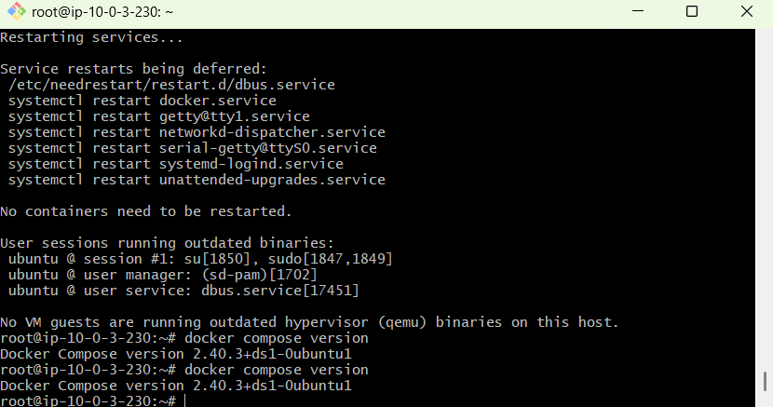
Docker Compose is installed successfully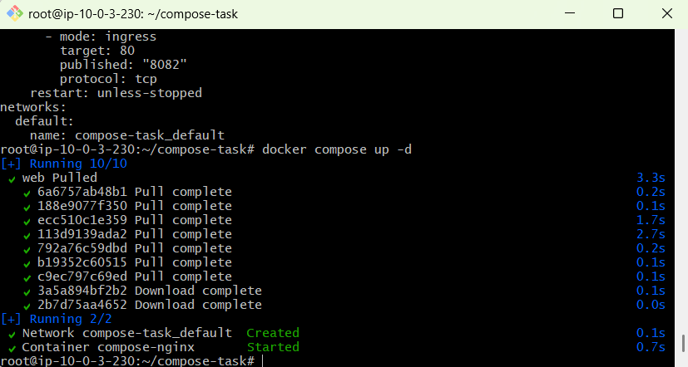
Execute the sample application
Run:
docker compose up -d
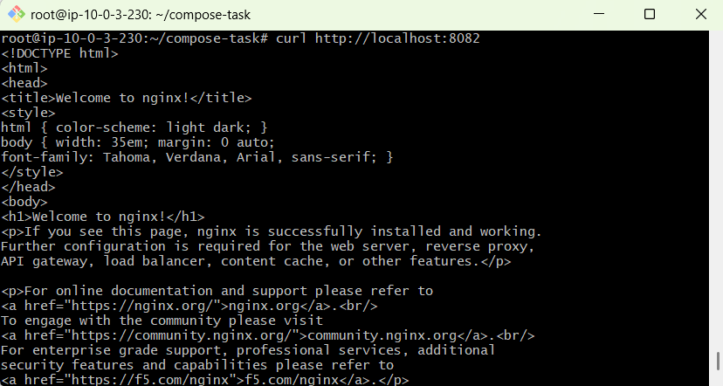
6: Implement solution to scan images when pushed to docker registry.
Objective: Automatically scan Docker images for security vulnerabilities when they are pushed to a Docker registry.
Steps performed
Step 1: Install Docker Scout
Installed Docker Scout CLI on the EC2 server and verified the installation.
docker scout version
Step 2: Log in to Docker Hub
Logged in using the Docker Hub username majeedullah.
docker login --username majeedullah
Step 3: Scan the Nginx image
Scanned the local Nginx image and viewed its vulnerability summary.
docker scout quickview nginx:latest
Step 4: Create a Docker Hub repository
Created the repository spring-multi under the Docker Hub account majeedullah.
Step 5: Push the application image
Pushed the image to Docker Hub with tag v1.
docker push majeedullah/spring-multi:v1
Step 6: View vulnerabilities on Docker Hub
Opened the spring-multi repository, selected tag v1, and viewed the vulnerability counts displayed for the pushed image.
Repository: majeedullah/spring-multi
Short notes
- Docker Scout: A tool used to analyze Docker images for known security vulnerabilities.
- Docker Hub: A registry used to store and share Docker images.
- Vulnerability scanning: Identifies known security issues in image components and dependencies.
- Image tag: v1 identifies the pushed image version.
- Security benefit: Helps developers identify vulnerable packages before deploying containers.
Result: The image was pushed successfully to Docker Hub, and vulnerability results are visible for tag v1.

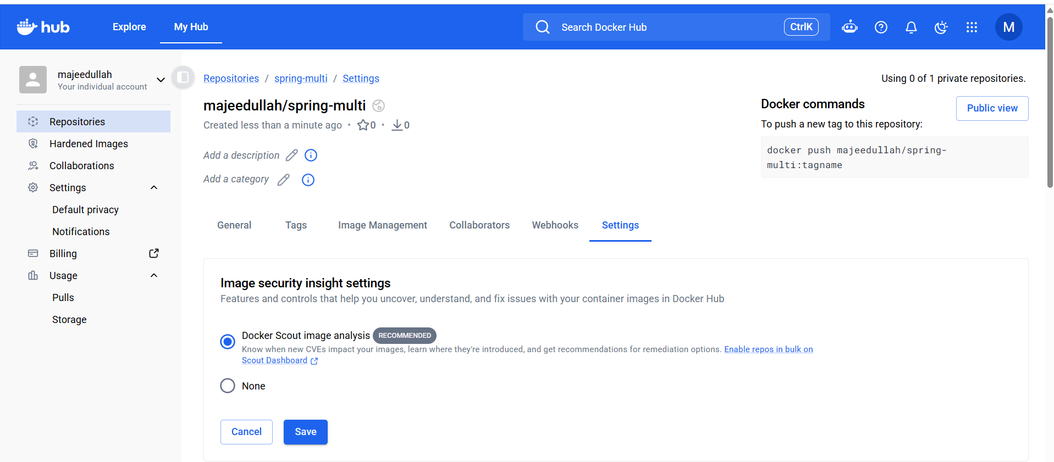
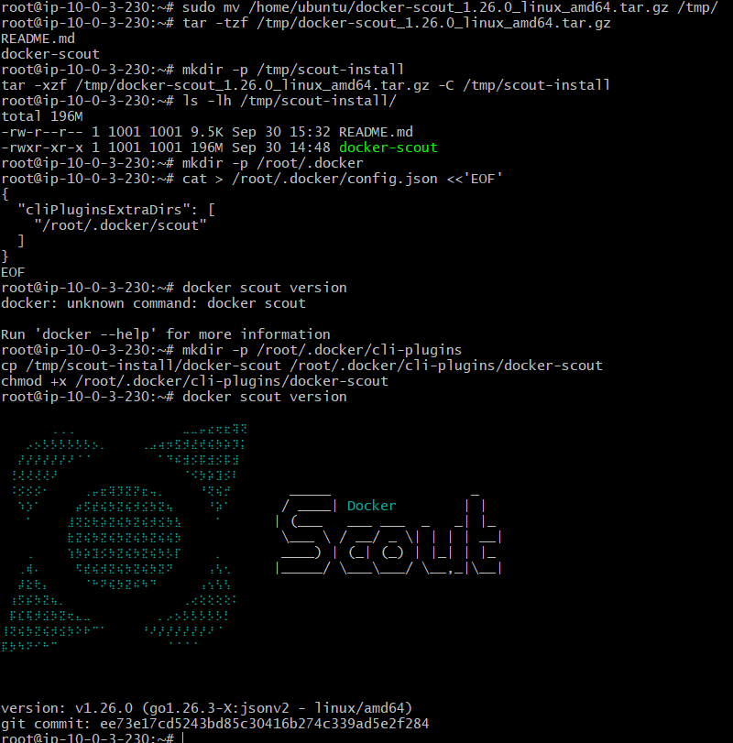
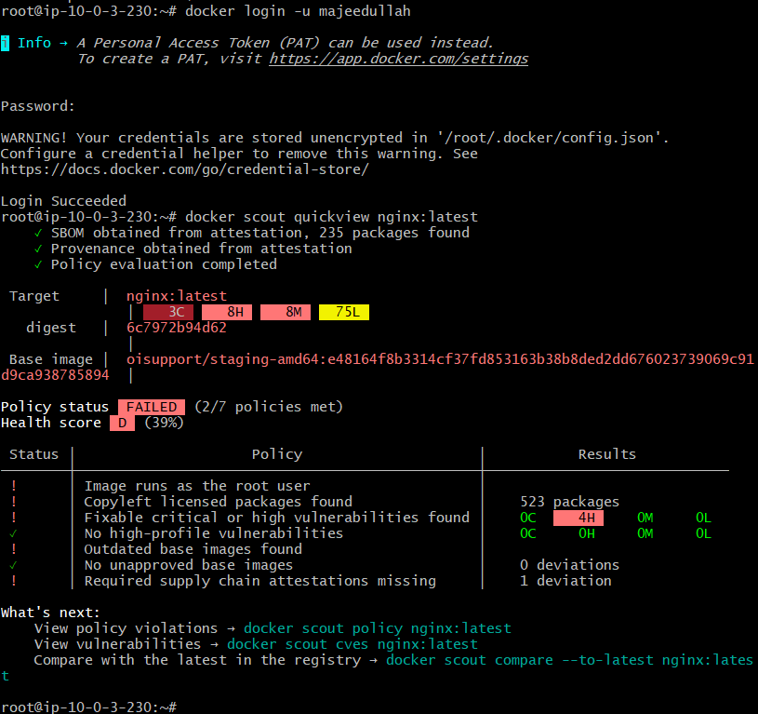
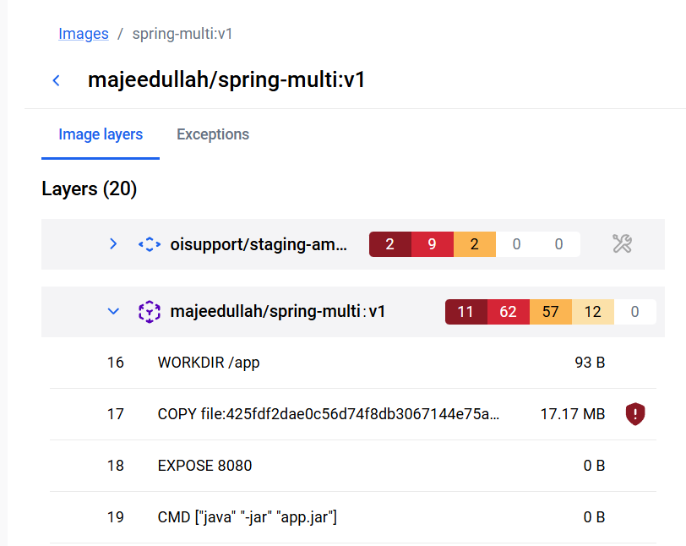
Error : 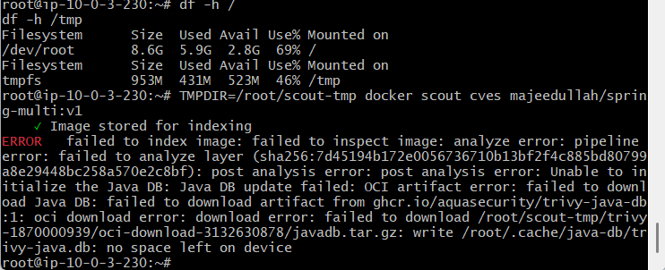
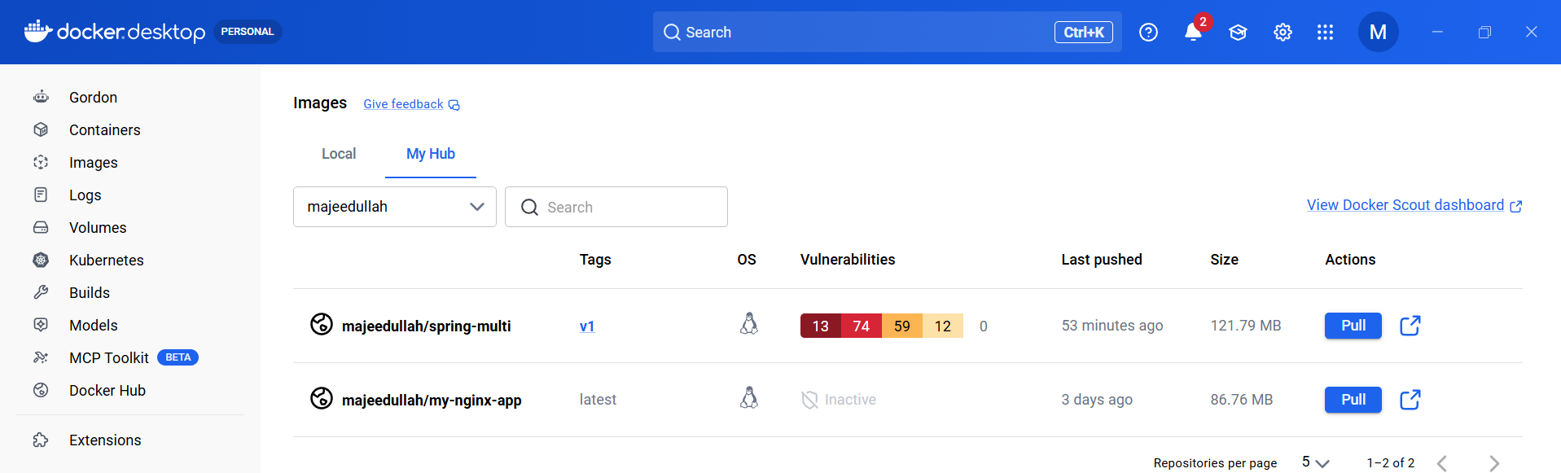
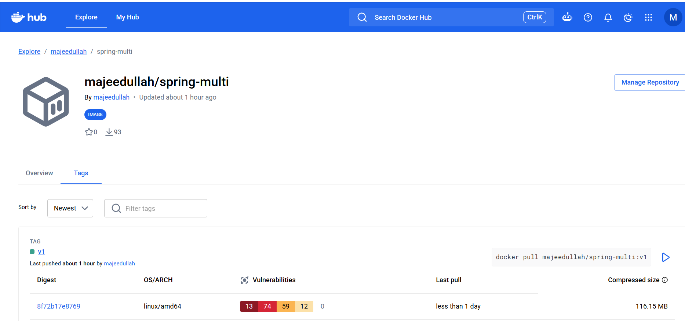

7: Implement solution to scan images when pushed to AWS ECR
1. Objective
To push a Docker image to Amazon Elastic Container Registry (ECR) and automatically scan it for known vulnerabilities whenever an image is pushed.
2. Step-by-step procedure
Step 1: Create an ECR repository
- Open AWS Console → Amazon ECR → Private registry → Repositories.
- Click Create repository.
- Repository name: spring-multi
- Keep image tag mutability as Mutable.
- Keep encryption as AES-256.
- Click Create repository.
Step 2: Enable image scanning
- Open Private registry → Features & Settings.
- Select Basic scanning (free).
- Select Scan on push all repositories.
- Click Save.
Purpose: AWS automatically initiates vulnerability scanning when images are pushed to ECR.
Step 3: Configure EC2 IAM permissions
- Open IAM → Roles.
- Open the existing EC2 role, instanceRole.
- Attach the AWS-managed policy AmazonEC2ContainerRegistryPowerUser.
- Go to EC2 → Instances → Docker-Destination-Server → Actions → Security → Modify IAM role.
- Attach instanceRole to the instance.
Purpose: This allows the EC2 instance to authenticate with ECR and push Docker images.
Step 4: Verify AWS credentials
Run on the EC2 terminal:
aws sts get-caller-identity
Confirm that AWS returns the account and assumed-role information.
Step 5: Log in to ECR
aws ecr get-login-password --region us-east-1 | docker login --username AWS --password-stdin 929523583693.dkr.ecr.us-east-1.amazonaws.com
Expected output:
Login Succeeded
Step 6: Tag the Docker image
docker tag spring-multi:v1 929523583693.dkr.ecr.us-east-1.amazonaws.com/spring-multi:v1
Purpose: Adds the ECR repository address to the local image tag so Docker knows where to push it.
Step 7: Push the image to ECR
docker push 929523583693.dkr.ecr.us-east-1.amazonaws.com/spring-multi:v1
The push completed successfully and returned an image digest.
Step 8: Verify the image and scan results
- Open Amazon ECR → Repositories → spring-multi → Images.
- Confirm that image tag v1 is present.
- Open the image's scanning and vulnerability details.
- Verify that the scan status is Complete.
Final scan results:
Severity | Findings
Critical | 0
High | 0
Medium | 0
Low | 0
Informational | 0
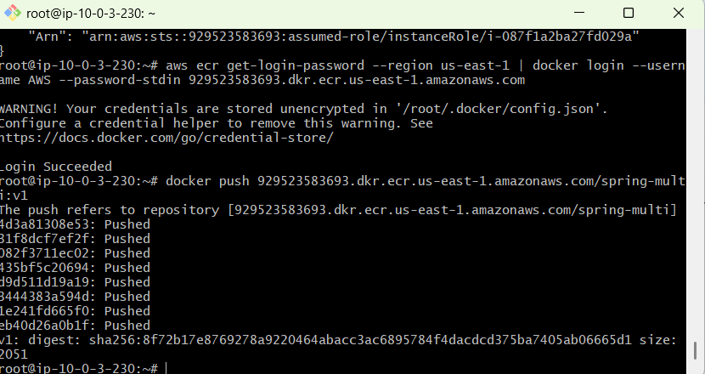
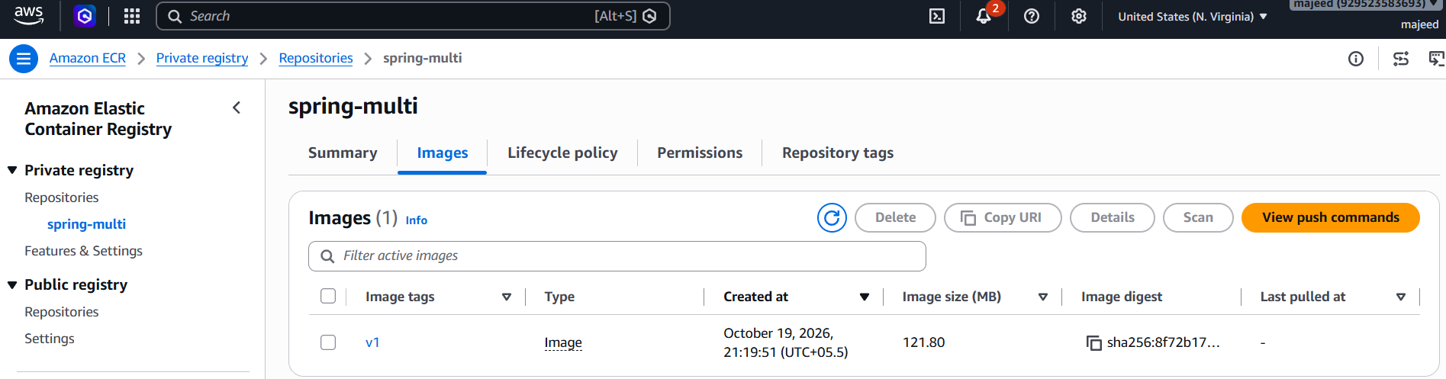
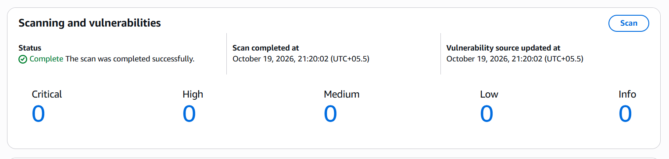

8: Create a Jenkins pipeline to create a docker image and push the image to Docker hub
1. Objective
To create a Jenkins Pipeline that automatically builds a Docker image and pushes it to Docker Hub.
2. Steps performed
Step 1: Configure Docker access for Jenkins
- Installed the Docker CLI inside the Jenkins container.
- Connected Jenkins to the EC2 host's Docker daemon using /var/run/docker.sock.
- Preserved existing Jenkins data using the jenkins_home volume.
Step 2: Create Docker Hub access token
- Logged in to Docker Hub.
- Generated a Personal Access Token with Read & Write permissions.
Step 3: Add credentials in Jenkins
- Opened Manage Jenkins → Credentials.
- Added a Username with password credential.
- Username: majeedullah
- ID: dockerhub-creds
- Password: Docker Hub access token.
Step 4: Create a Pipeline job
- Clicked New Item.
- Job name: dockerhub-image-pipeline
- Selected Pipeline and clicked OK.
Step 5: Configure the pipeline script
The pipeline contains these stages:
- Checkout: Clones the hiring-app GitHub repository.
- Build Docker Image: Creates a custom Nginx image using a Dockerfile.
- Login to Docker Hub: Authenticates using Jenkins Credentials.
- Push Image to Docker Hub: Uploads the image to the repository.
- Logout from Docker Hub: Ends the Docker Hub login session.
Step 6: Run the pipeline
- Saved the script.
- Clicked Build Now.
- Opened Console Output.
- Verified the result: Finished: SUCCESS.
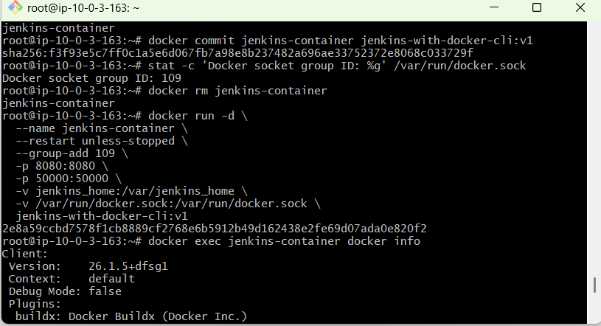
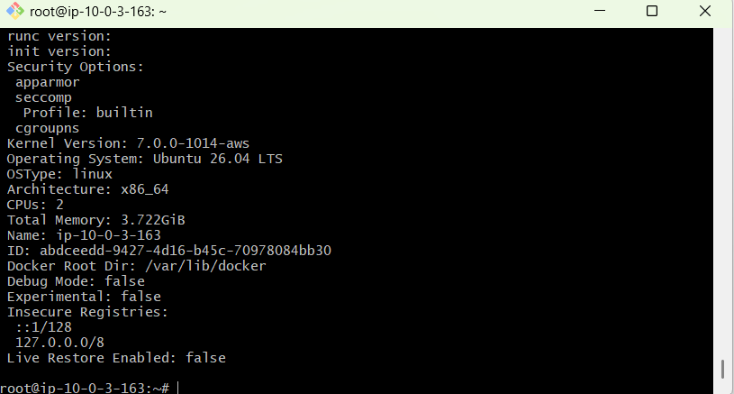
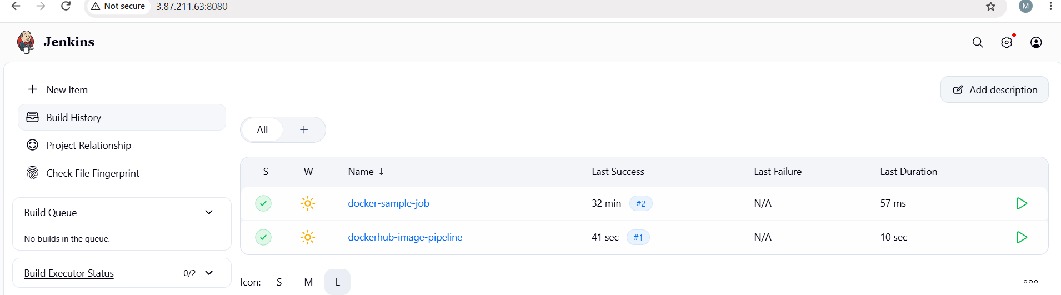

Paste this pipeline script
In the Script text box, paste the following code:

pipeline {
agent any

environment {
DOCKERHUB_USER = 'majeedullah'
IMAGE_NAME = 'spring-multi'
IMAGE_TAG = 'jenkins-v1'
}

stages {
stage('Checkout') {
steps {
git branch: 'main',
url: 'https://github.com/betawins/hiring-app.git'
}
}

stage('Build Docker Image') {
steps {
sh '''
cat > Dockerfile <<'EOF'
FROM nginx:alpine
RUN echo '<h1>Docker image built by Jenkins</h1>' > /usr/share/nginx/html/index.html
EXPOSE 80
EOF
docker build -t ${DOCKERHUB_USER}/${IMAGE_NAME}:${IMAGE_TAG} .
'''
}
}

stage('Login to Docker Hub') {
steps {
withCredentials([
usernamePassword(
credentialsId: 'dockerhub-creds',
usernameVariable: 'DOCKER_USER',
passwordVariable: 'DOCKER_TOKEN'
)
]) {
sh '''
echo "$DOCKER_TOKEN" | docker login \
--username "$DOCKER_USER" \
--password-stdin
'''
}
}
}

stage('Push Image to Docker Hub') {
steps {
sh 'docker push ${DOCKERHUB_USER}/${IMAGE_NAME}:${IMAGE_TAG}'
}
}

stage('Logout from Docker Hub') {
steps {
sh 'docker logout'
}
}
}
}
-------------------------------------------------------------------------------------------------

