Jenkins-01

1: Install Jenkins and run Jenkins on port number 8081.
Task 1 – Jenkins Installation and Configuration
Objective
Install Jenkins on an AWS EC2 instance and configure Jenkins to run on port 8081.
Configuration Steps
1. Create EC2 Instance
- Created an AWS EC2 instance using Amazon Linux 2023.
- Configured the required security group.
- Allowed SSH access through port 22.
- Allowed Jenkins access through port 8081.
2. Connect to EC2
Connected to the EC2 instance using SSH.
3. Install Java
Installed Amazon Corretto Java using yum.
sudo yum install java-17-amazon-corretto -y
Jenkins required Java 21 for the installed version, so Java 21 was also installed and selected.
sudo yum install java-21-amazon-corretto -y
sudo alternatives --config java
Verified the Java version:
java -version
4. Install Jenkins
Added the Jenkins repository and installed Jenkins using yum.
sudo yum install jenkins -y
5. Configure Jenkins Port
Configured Jenkins to run on port 8081 using a systemd override configuration.
Configuration:
[Service]
Environment="JENKINS_PORT=8081"
Reloaded the systemd configuration:
sudo systemctl daemon-reload
6. Start Jenkins
Started the Jenkins service:
sudo systemctl start jenkins
Verified the service:
sudo systemctl status jenkins --no-pager
The service showed:
Active: active (running)
7. Verify Port 8081
Verified that Jenkins was listening on port 8081:
sudo ss -lntp | grep 8081
The output confirmed that Java was listening on:
*:8081
8. Access Jenkins
Opened Jenkins in a web browser using:
http://<EC2-Public-IP>:8081
9. Unlock Jenkins
Retrieved the initial administrator password:
sudo cat /var/lib/jenkins/secrets/initialAdminPassword
Used this password on the Jenkins Unlock Jenkins page.
10. Install Suggested Plugins
Selected Install suggested plugins during the Jenkins initial setup.
11. Create Administrator User
Created the first Jenkins administrator account by providing:
- Username
- Password
- Full Name
- Email Address
12. Verify Installation
Jenkins displayed:
“Jenkins is ready!”
This confirmed that the Jenkins installation and initial configuration were completed successfully.
Observations
- Jenkins was successfully installed on the AWS EC2 instance.
- Java 21 was configured as the active Java version.
- Jenkins was successfully configured to run on port 8081.
- Jenkins service was in an active/running state.
- Jenkins was accessible through the web browser.
Result
Jenkins was successfully installed and configured on AWS EC2 and is running on port 8081.

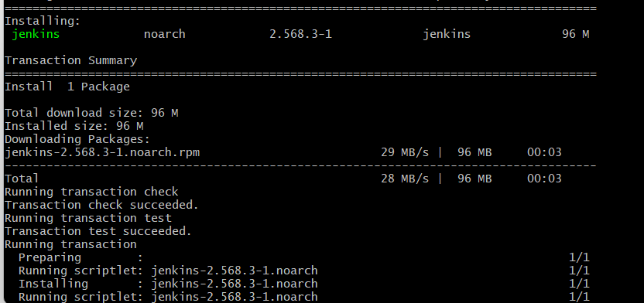
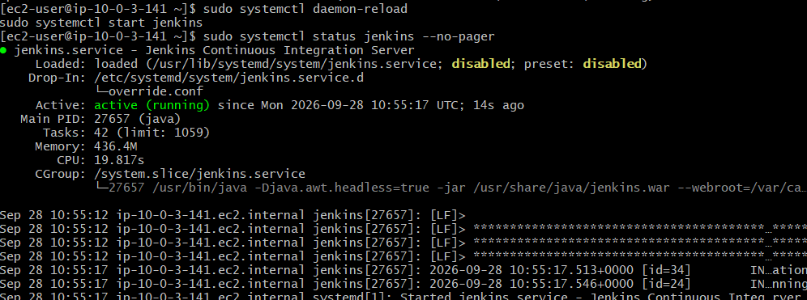
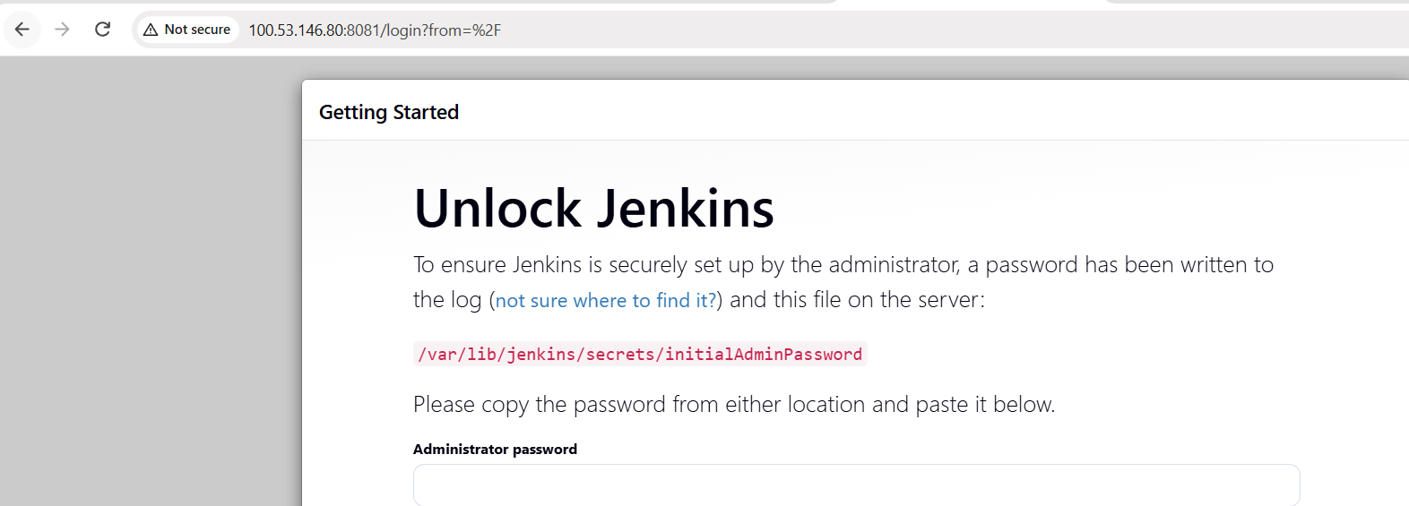
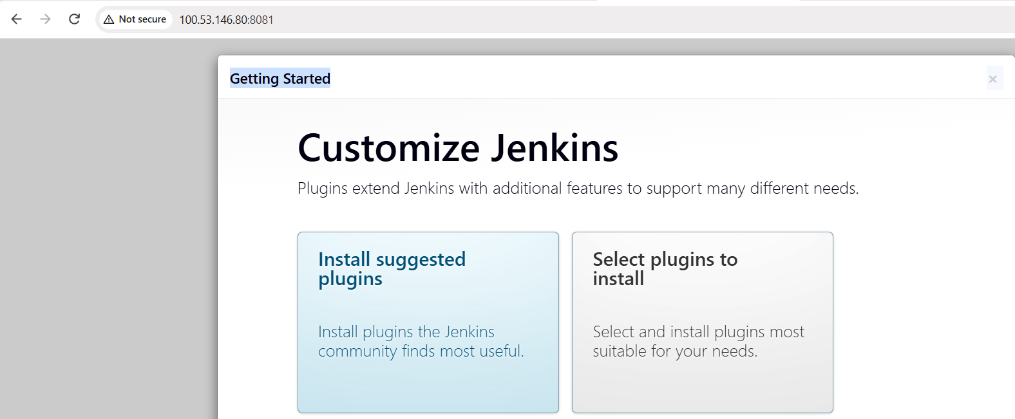
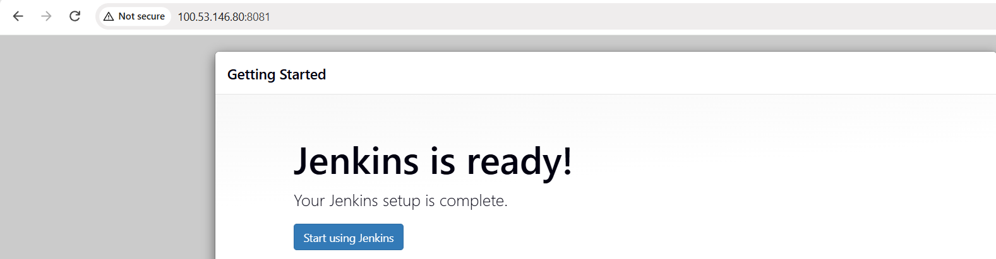
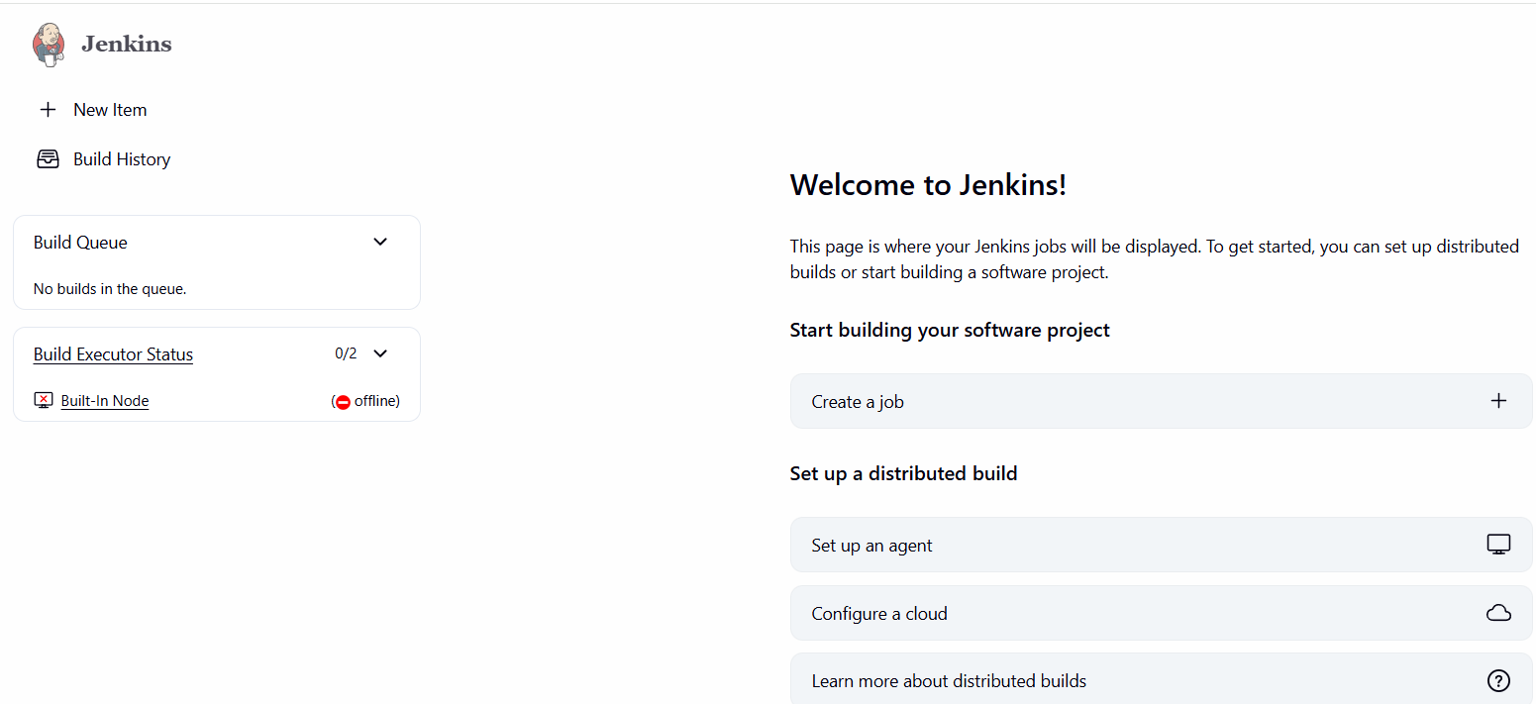

2: Secure Jenkins server

Objective
Secure the Jenkins server by restricting network access, enabling Jenkins security features, running Jenkins with a dedicated user, and configuring automatic startup.
Configuration Steps
1. Restrict Jenkins Port Access
Updated the EC2 Security Group inbound rules.
- Jenkins port: 8081
- Source: My IP
- IP: 103.203.172.230/32
This allows Jenkins access only from the configured IP address.
2. Restrict SSH Access
Updated the SSH inbound rule.
- SSH port: 22
- Source: My IP
- IP: 103.203.172.230/32
This restricts SSH access to the configured IP address.
3. Verify Jenkins CSRF Protection
Opened:
Manage Jenkins → Security
Under CSRF Protection, verified that the Default Crumb Issuer is configured.
CSRF protection helps protect Jenkins from unauthorized requests originating from another website.
4. Verify Jenkins Service User
Connected to the EC2 instance and checked the Jenkins process:
ps -ef | grep '[j]enkins'
The output showed that Jenkins is running under the dedicated:
jenkins
user.
Jenkins is therefore not running as the root user.
5. Enable Jenkins Automatic Startup
Enabled Jenkins to start automatically when the EC2 instance starts or reboots:
sudo systemctl enable jenkins
Verified the configuration:
sudo systemctl is-enabled jenkins
Output:
enabled
6. Verify Jenkins Service
Verified that the Jenkins service is running:
sudo systemctl status jenkins --no-pager
The service was confirmed as:
Active: active (running)
Observations
- Jenkins access is restricted to the configured IP address.
- SSH access is restricted to the configured IP address.
- CSRF protection is configured using the Default Crumb Issuer.
- Jenkins runs using the dedicated jenkins user.
- Jenkins is configured to start automatically after system reboot.
- Jenkins service is running successfully on port 8081.
Result
Jenkins server security configuration was successfully completed. Network access, Jenkins security settings, service-user configuration, and automatic startup were verified successfully.

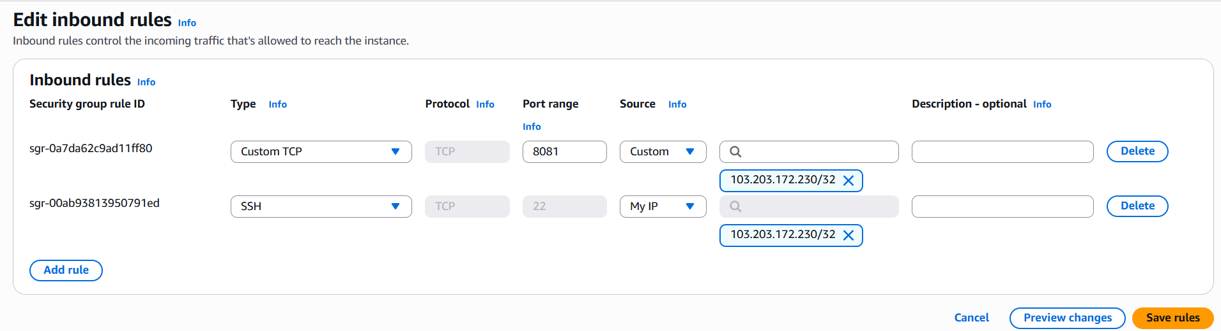
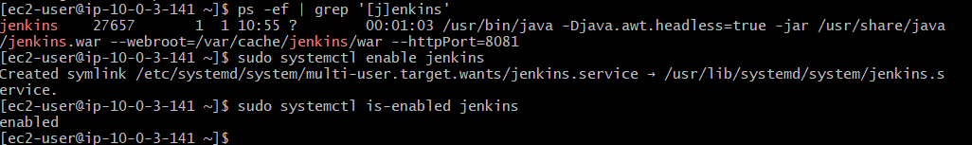

3: Create users called DevOps, Testing in Jenkins with Limited access
Objective
Create separate Jenkins users named DevOps and Testing and provide them with limited access instead of administrator privileges.
Configuration Steps
1. Open Jenkins User Management
Logged in to Jenkins using the administrator account.
Navigated to:
Manage Jenkins → Users
2. Create DevOps User
Created a new Jenkins user with the following details:
- Username: DevOps
- Full Name: DevOps User
- Password: Configured during user creation
The DevOps user was successfully created.
3. Create Testing User
Created another Jenkins user:
- Username: Testing
- Full Name: Testing User
- Password: Configured during user creation
The Testing user was successfully created.
4. Configure Matrix-Based Security
Navigated to:
Manage Jenkins → Security
Under Authorization, selected:
Matrix-based security
This allows permissions to be assigned individually to specific users.
5. Add Users to the Permission Matrix
Added the following users to the authorization matrix:
- DevOps
- Testing
6. Configure DevOps Permissions
Provided limited permissions to the DevOps user:
- Overall → Read
- Job → Read
- Job → Build
- Job → Workspace
- View → Read
Administrator permissions were not provided.
7. Configure Testing Permissions
Provided more restricted permissions to the Testing user:
- Overall → Read
- Job → Read
- View → Read
Build, configuration, delete, credentials, and administrator permissions were not provided.
8. Save Security Configuration
Saved the Matrix-based security configuration.
9. Verify DevOps Access
Logged out from the administrator account and logged in using the DevOps account.
The DevOps user was able to access the Jenkins dashboard but did not have access to Manage Jenkins.
10. Verify Testing Access
Logged out from the DevOps account and logged in using the Testing account.
The Testing user was able to access the Jenkins dashboard but did not have administrator access.
Observations
- Separate Jenkins users were successfully created.
- Matrix-based security was used to control user permissions.
- DevOps was given limited job build and workspace permissions.
- Testing was given read-only job access.
- Neither user was granted administrator privileges.
- Both users were able to log in successfully.
Result
DevOps and Testing users were successfully created in Jenkins with limited and different levels of access using Matrix-based security.

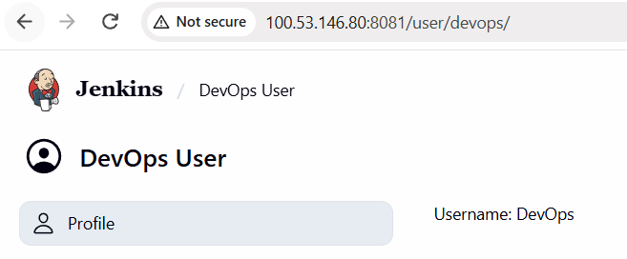
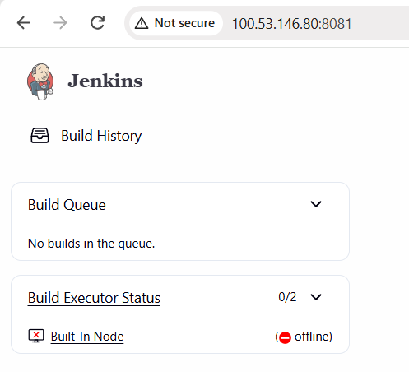
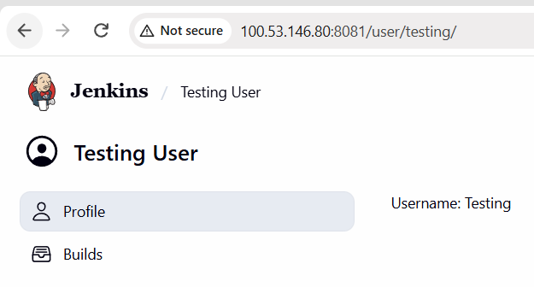

4: Configure labels and restrict the jobs to execute based on label only.
Objective
To configure a Jenkins node with a specific label and restrict a Jenkins job so that it can execute only on nodes matching that label.
This demonstrates how Jenkins uses labels to control where jobs are executed.

Architecture
Jenkins
|
|
Built-In Node
|
Label: linux-node
|
|
label-test-job
|
Label Expression:
linux-node
|
▼
Job Executes Only
on Matching Node
Flow
Jenkins Job → Label Expression (linux-node) → Matching Jenkins Node → Job Execution

Configuration Steps
1. Open Jenkins Nodes
Logged in to Jenkins using the administrator account.
Navigated to:
Manage Jenkins → Nodes → Built-In Node → Configure

2. Configure Node Label
In the Labels field, configured:
linux-node
The Built-In Node was therefore identified with the label:
linux-node

3. Configure Node Usage
Under Usage, selected:
Only build jobs with label expressions matching this node
This ensures that unrestricted jobs are not automatically assigned to this node.
Only jobs whose label expression matches linux-node can execute on this node.

4. Create a Test Job
Created a Jenkins Freestyle project:
label-test-job

5. Restrict the Job to the Label
In the job configuration:
General → Restrict where this project can be run
Enabled the option and entered:
linux-node
Jenkins confirmed:
Label linux-node matches 1 node.
This confirms that the job is restricted to the node having the linux-node label.

6. Configure Build Step
Added:
Build Steps → Execute shell
Configured the following commands:
echo "This job is running on the linux-node label"
hostname
whoami
These commands were used to verify that the job was actually executed on the Jenkins node.

7. Resolve Node Availability
Initially, the Built-In Node was offline because Jenkins reported:
Disk space is below threshold of 1.00 GiB.
Only 451.88 MiB out of 456.62 MiB left on /tmp.
The /tmp filesystem was checked from the EC2 instance:
df -h /tmp
The result showed approximately:
457M total
452M available
Since /tmp was a small tmpfs filesystem, the Jenkins Free Temp Space node monitor was configured so that it would not mark the node temporarily offline based on this threshold.
The Built-In Node then became available for job execution.

8. Execute the Job
Executed:
label-test-job → Build Now
The job successfully ran against the node matching the linux-node label.

Verification / Console Output
The successful build produced the following output:
Started by user majeed ullah khan
Running as SYSTEM
Building in workspace /var/lib/jenkins/workspace/label-test-job

This job is running on the linux-node label

ip-10-0-3-141.ec2.internal

jenkins

Finished: SUCCESS
Verification Details
Item | Result
Job | label-test-job
Node Label | linux-node
Hostname | ip-10-0-3-141.ec2.internal
Execution User | jenkins
Build Result | SUCCESS
Workspace | /var/lib/jenkins/workspace/label-test-job

Screenshots
Screenshot 1 – Node Label
Capture the Built-In Node page showing:
- Built-In Node
- Label: linux-node
- Node status
Screenshot 2 – Job Label Restriction
Capture the label-test-job → Configure page showing:
- Restrict where this project can be run enabled
- Label Expression: linux-node
- Jenkins message that linux-node matches 1 node
Screenshot 3 – Successful Build
Capture the Console Output of Build #2 showing:
This job is running on the linux-node label
ip-10-0-3-141.ec2.internal
jenkins
Finished: SUCCESS
This is the main verification screenshot.

Observations
- A Jenkins node can be assigned one or more labels.
- A Jenkins job can be restricted to execute only on nodes matching a specified label.
- The linux-node label was successfully assigned to the Built-In Node.
- label-test-job was restricted to the linux-node label.
- Jenkins successfully matched the job to the labeled node.
- The console output confirmed that the job executed successfully on the EC2 Jenkins server.
- The job executed under the jenkins user rather than the root user.

Result
Task 4 was successfully completed.
A Jenkins node was configured with the label linux-node, and the job label-test-job was restricted to execute only on nodes matching that label.
The successful console output confirmed that the label-based job execution worked as expected.
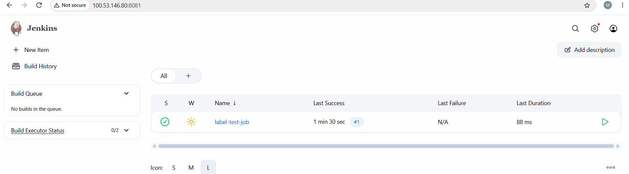
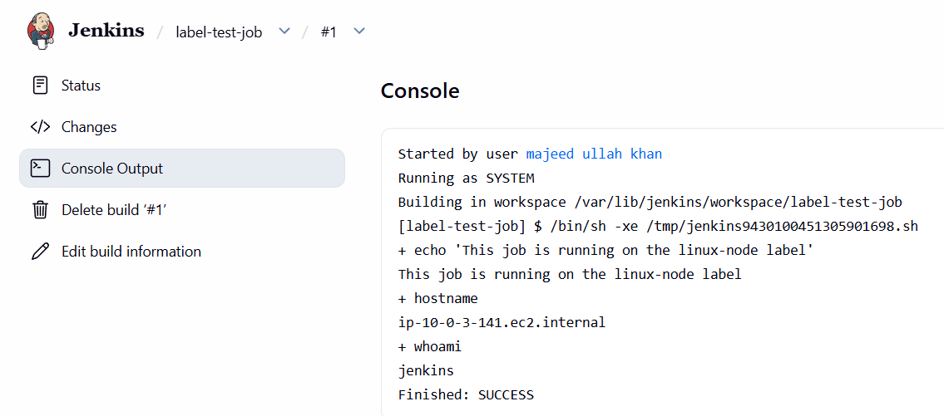
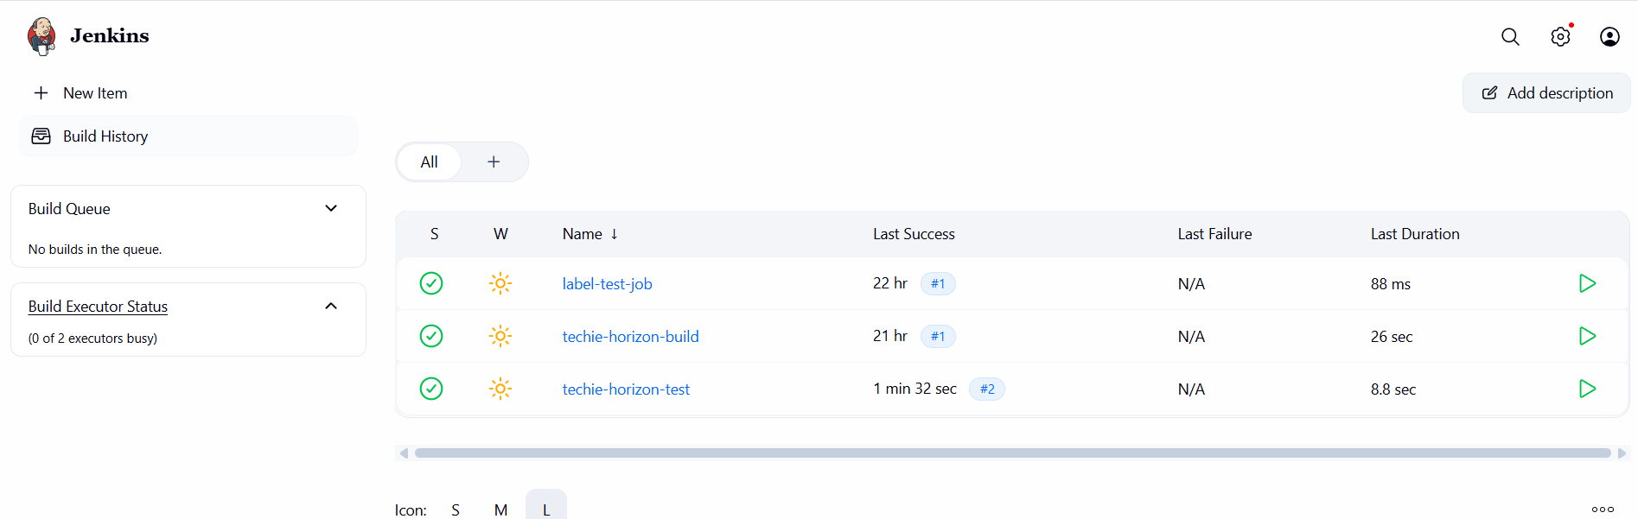
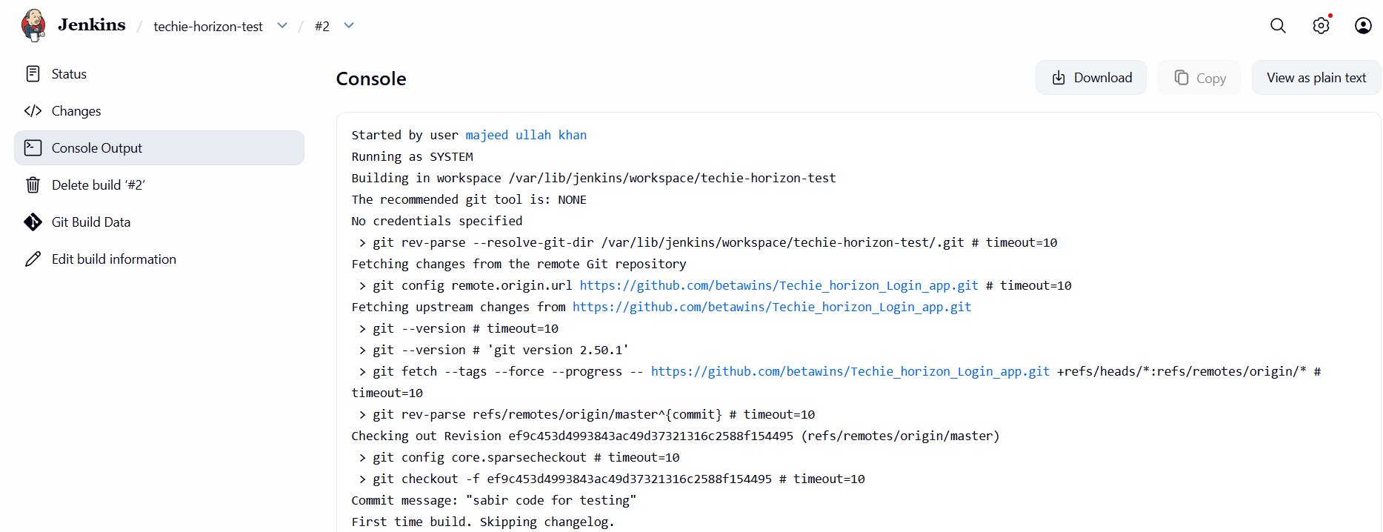
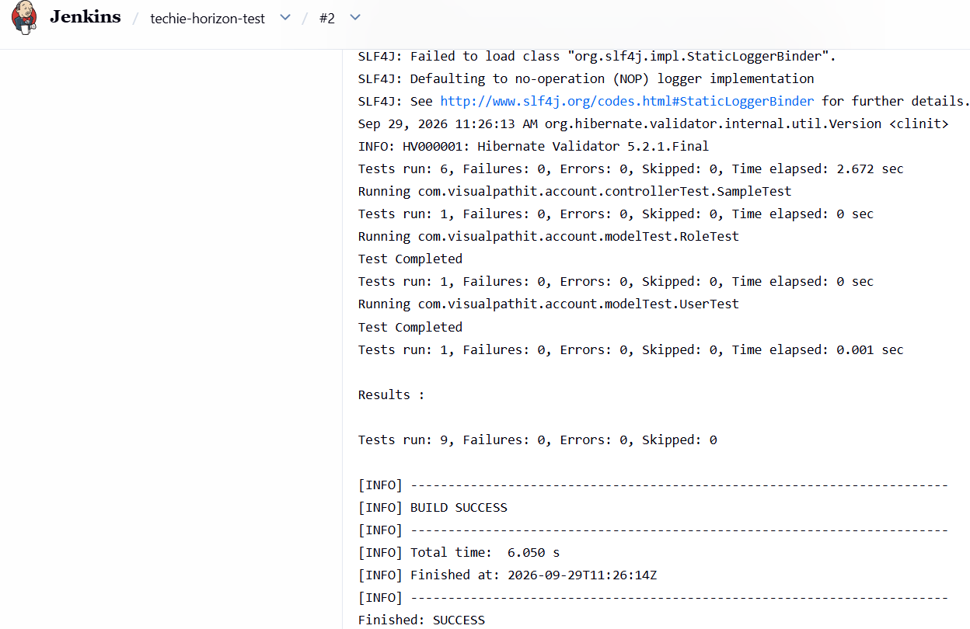

5: Create Three sample jobs using the below URL.
https://github.com/betawins/Techie_horizon_Login_app.git
Jenkins – Three Sample Jobs
Objective
Create three sample Jenkins jobs using the Techie Horizon Login App GitHub repository.
Source Repository:
https://github.com/betawins/Techie_horizon_Login_app.git
Configuration Steps
1. Create Build Job
- Open Jenkins Dashboard.
- Click New Item.
- Create a Freestyle project named techie-horizon-build.
- Select Git under Source Code Management.
- Enter the GitHub repository URL.
- Configure the required branch.
- Add the required build step.
- Click Save.
- Click Build Now.
- Verify that Build #1 completed successfully.
2. Create Test Job
- Click New Item.
- Create a Freestyle project named techie-horizon-test.
- Configure the same GitHub repository.
- Configure the required branch.
- Add the test/build step.
- Click Save.
- Click Build Now.
- Verify that Build #2 completed successfully.
3. Create Deploy Job
- Click New Item.
- Create a Freestyle project named techie-horizon-deploy.
- Select Git under Source Code Management.
- Enter the Techie Horizon Login App repository URL.
- Configure the required branch.
- Add an Execute shell build step.
- Configure the deployment commands.
- Click Save.
- Click Build Now.
- Verify that Build #1 completed successfully.
Result
All three Jenkins sample jobs were created and executed successfully:
- techie-horizon-build – SUCCESS
- techie-horizon-test – SUCCESS
- techie-horizon-deploy – SUCCESS
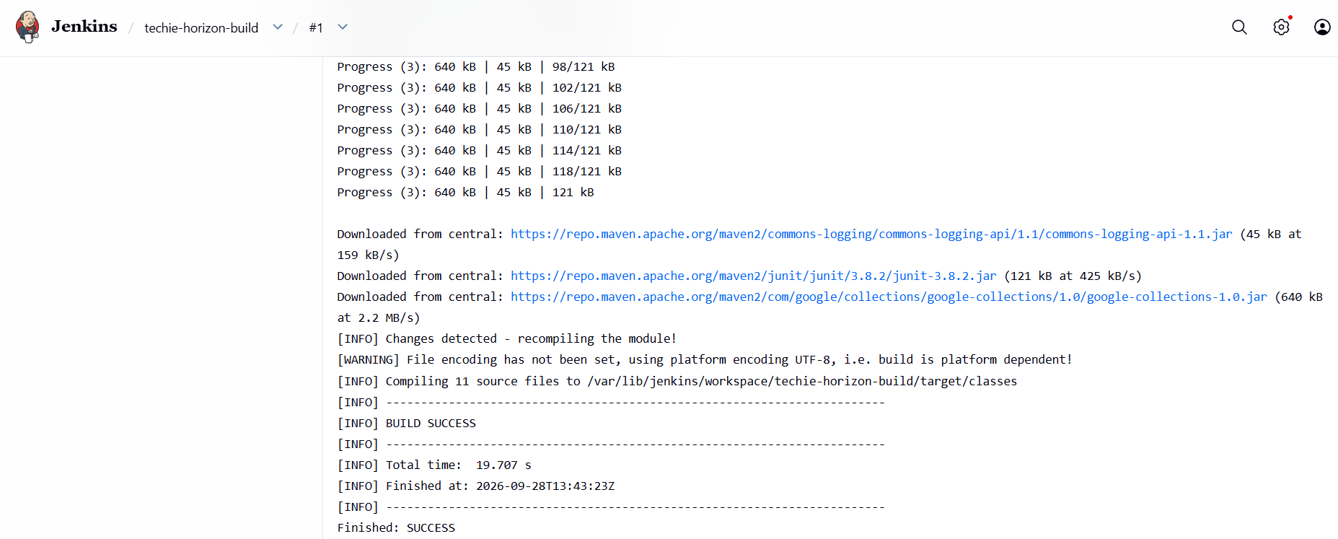
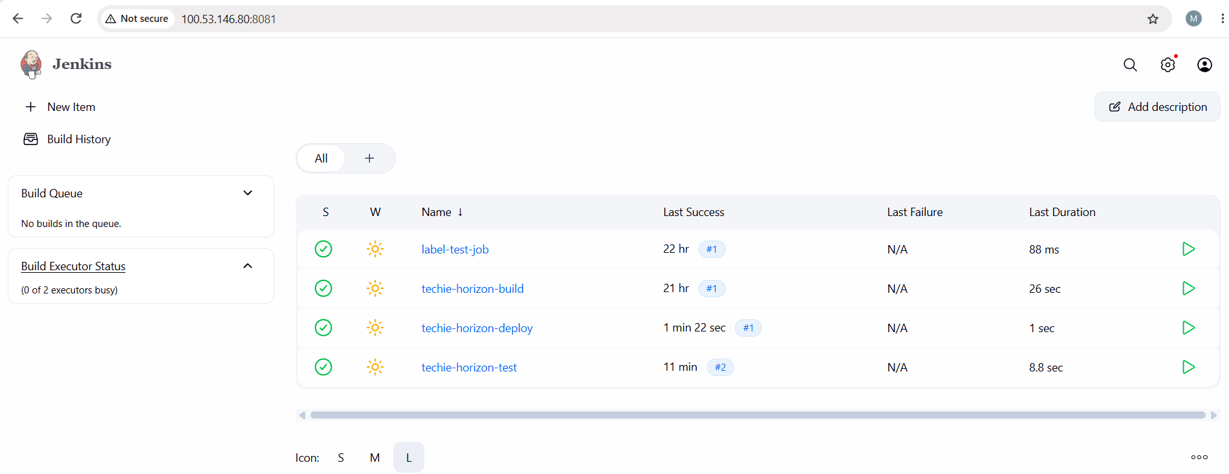
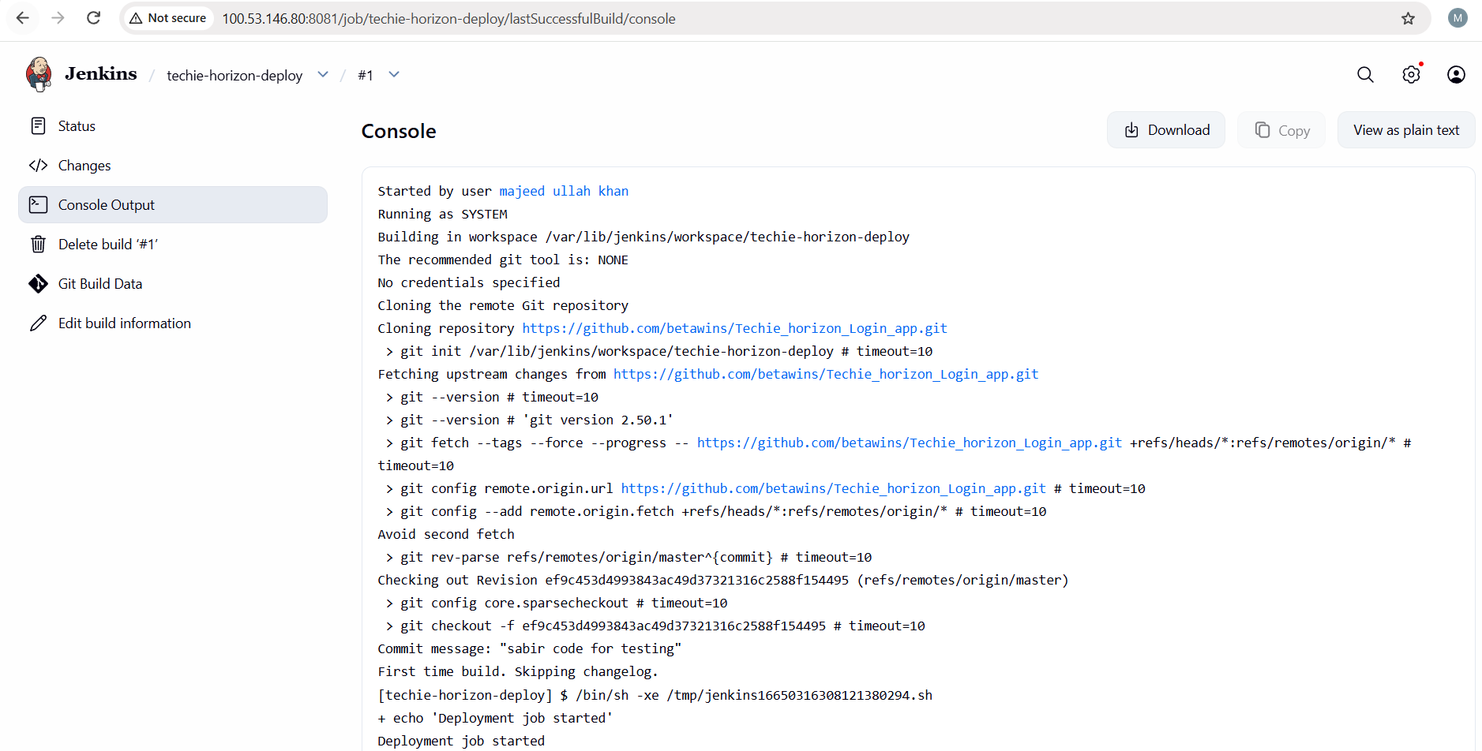
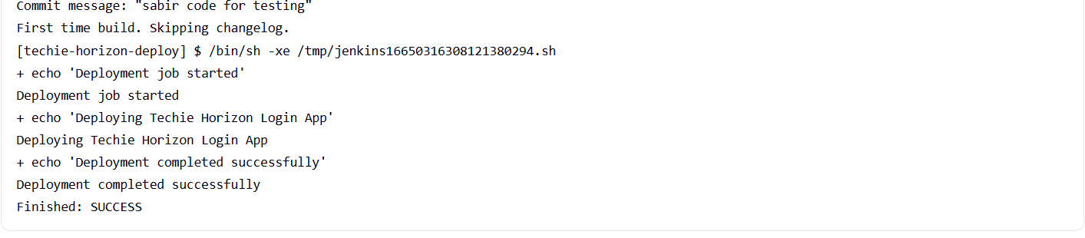
Build → Test → Deploy flow
GitHub
│
▼
Jenkins
│
├── techie-horizon-build ✅
│
├── techie-horizon-test ✅
│
└── techie-horizon-deploy ✅

6: Create one Jenkins job using GitHub Private repository.
1. Objective
The objective of this task is to configure a Jenkins job to access a private GitHub repository using a GitHub Personal Access Token (PAT), clone the repository, and execute a simple build successfully.
2. Architecture
GitHub
Private Repository
│
│ HTTPS + PAT
▼
Jenkins
┌─────────────────┐
│ Credentials │
│ github-private- │
│ creds │
└────────┬────────┘
│
▼
Clone Repository
│
▼
Execute Build
│
▼
SUCCESS

3. Create a Private GitHub Repository
- Log in to GitHub.
- Click New repository.
- Enter the repository name:
techie-horizon-private
- Select Private visibility.
- Add a README file.
- Click Create repository.
Repository created
Repository: majeedkhan91/techie-horizon-private
Visibility: Private
Branch: main
Screenshot: Take a screenshot showing the private repository and its main branch.

4. Create a GitHub Personal Access Token
A GitHub PAT is used by Jenkins to authenticate with the private repository.
- Open GitHub.
- Go to Settings.
- Open Developer settings.
- Select Personal access tokens.
- Select Fine-grained tokens.
- Click Generate new token.
Configure the token:
Token name: jenkins-private-repo
Expiration: October 29, 2026
Repository access: Only select repositories
Repository: techie-horizon-private
Under repository permissions, provide:
Contents: Read-only
Metadata: Read-only / Required
- Generate the token.
- Copy and securely save the token.
Note: The PAT acts as the password when Jenkins connects to GitHub. Never share the token in documentation or screenshots.
Screenshot: Take a screenshot of the PAT configuration, but do not show the actual token.

5. Add GitHub Credentials in Jenkins
- Open Jenkins.
- Go to:
Manage Jenkins → Credentials
- Select the appropriate credential store/domain.
- Click Add Credentials.
Configure:
Kind: Username with password
Username: majeedkhan91
Password: GitHub Personal Access Token
ID: github-private-creds
Description: GitHub Private Repository Credentials
Scope: Global
- Click Create/Save.
The credential ID is:
github-private-creds
Screenshot: Take a screenshot showing the credential configuration. Do not expose the PAT.

6. Create the Jenkins Job
- From the Jenkins dashboard, click New Item.
- Enter:
techie-horizon-private
- Select Freestyle project.
- Click OK.

7. Configure GitHub Repository
Inside the job configuration:
Source Code Management
Select:
Git
Repository URL:
https://github.com/majeedkhan91/techie-horizon-private.git
Credentials:
github-private-creds
Branch
Under Branches to build, enter:
*/main
Important: The repository uses the main branch. If */master is configured, Jenkins will fail with Couldn't find any revision to build.

8. Configure Build Step
Scroll to Build Steps.
Select:
Execute shell
Enter:
echo "Private GitHub repository cloned successfully"
echo "Jenkins private repository job executed successfully"
ls -la
These commands confirm that Jenkins successfully cloned the private repository and can access its files.

9. Save the Jenkins Job
Click:
Save
The Jenkins job is now configured.

10. Run the Jenkins Job
- Open the techie-horizon-private job.
- Click Build Now.
- Open the latest build.
- Click Console Output.
The successful build should show information similar to:
using credential github-private-creds
Fetching upstream changes from https://github.com/majeedkhan91/techie-horizon-private.git

git rev-parse refs/remotes/origin/main^{commit}

Checking out Revision ...
Commit message: "Initial commit"

Private GitHub repository cloned successfully
Jenkins private repository job executed successfully

README.md

Finished: SUCCESS

11. Observations
- Jenkins successfully connected to the private GitHub repository.
- Jenkins used the configured GitHub credential for authentication.
- The GitHub PAT allowed Jenkins to read the private repository.
- Jenkins successfully fetched the main branch.
- The repository was successfully cloned into the Jenkins workspace.
- The build shell commands executed successfully.
- The final build status was SUCCESS.

12. Result
Task 6 was successfully completed.
Jenkins was successfully configured to authenticate with a private GitHub repository using a GitHub Personal Access Token, clone the repository, and execute a build.

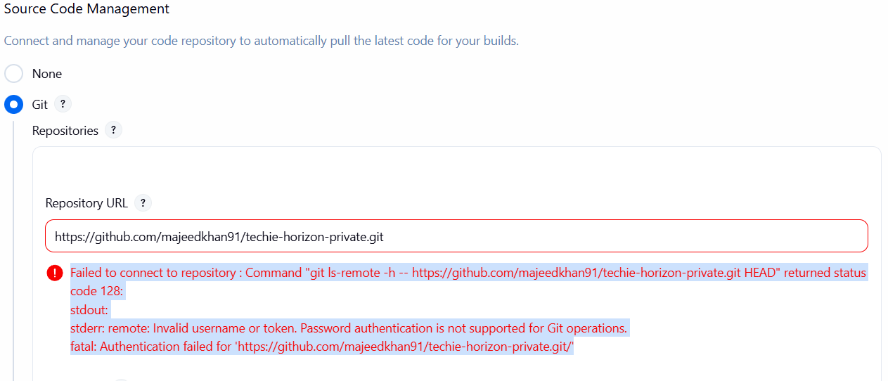
This error is clear: Jenkins is reaching GitHub, but GitHub is rejecting the credential.
The most likely issue is that the PAT stored in Jenkins is incorrect or was pasted incorrectly.
ERROR :
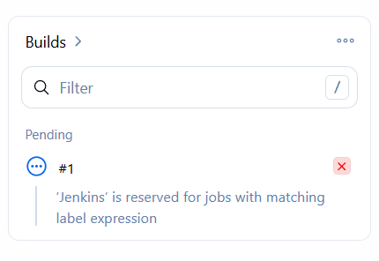
now we found the important detail. ✅
Your Built-In Node has the label linux-node, not Jenkins.
That explains the pending message:
‘Jenkins’ is reserved for jobs with matching label expression

Error:
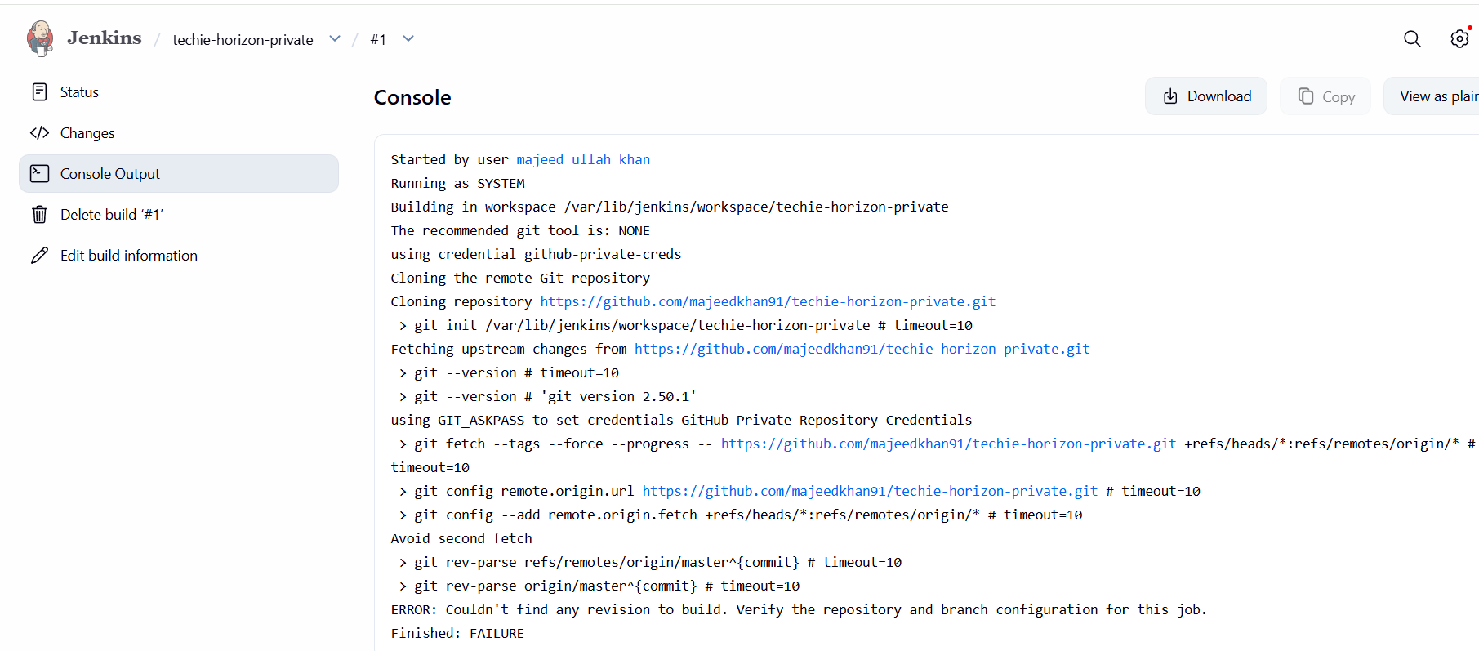
Fix it
Go to:
techie-horizon-private → Configure
Find:
Source Code Management → Git → Branches to build
In Branch Specifier, enter exactly:
*/main
Make sure it is not:
*/master
Then click Save.

