

INTERNSHIP REPORT ON

(Itech Solution)

**Name: Fahad Khan**

**Sid: 10968**

**Program: BE - Software Engineering**

Internship started from_02-Oct-2022____ to _02-Dec-2022 __

**SUBMITTED TO:**

**Farjad Alam (Site Supervisor)**

**Ahsan Ullah (Faculty Supervisor)**

**Date: 10-June-2022**

**KARACHI INSTITUTE OF ECONOMICS & TECHNOLOGY**

Faculty Supervisor Evaluation Form

Instructions:

This section is to be completed by the faculty supervisor, who will score the intern’s report using the following criteria:

1= Does not meet expectations

2= Inconsistently meets expectations

3= Consistently meets expectations

4= Above expectations

5= Far above expectations

|  |  |  |  |  |  |  |
| --- | --- | --- | --- | --- | --- | --- |
| Score | | | | | | |
| 1 | Tasks Performed | 1 | 2 | 3 | 4 | 5 |
| 2 | Learning Experience | 1 | 2 | 3 | 4 | 5 |
| 3 | Overcome Challenges | 1 | 2 | 3 | 4 | 5 |



Faculty Supervisor Signature: _____________________________

Date: 10-June-2023____

APPRECIATION OF THE ORGANIZATION

I am very grateful to the Itech Solution for having offered me a chance to do my internship here. The management and staff have been very kind and helpful in guiding me meet the internship objectives of learning.

From the very beginning, it was evident that Software House prioritizes the growth and development of its interns. The guidance and support provided by the entire team were truly commendable. Each team member went above and beyond to ensure that I had a fulfilling experience and gained practical knowledge in the field of software development.

Throughout my internship, I had the privilege of working on challenging projects that allowed me to apply the theoretical concepts I had learned in my studies. The hands-on experience, coupled with the opportunity to collaborate with experienced professionals, enabled me to enhance my technical skills and broaden my understanding of the industry.

Copy of internship certificate

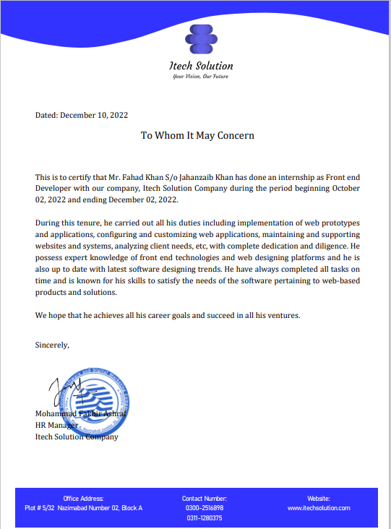

Table of Contents

1 Introduction and Overview of Internship Organization 6

1.1 Introduction of the organization 6

1.2 Details of organization’s Products / Services 6

2 Tasks Performed By Intern (Activity log) 7

2.1 Name and a brief introduction of the branch/ area office and department of the organization where you did your internship 7

2.2 Weekly task performed by the intern. Includes major duties designated to you and assignments you have completed. Same to be shown to Faculty Supervisor during internship. 8

3 Learning Experience (Communicate skills and knowledge that you gained or refined through the internship). 10

4 Challenges (Detail major challenges in your role and how you tackled them) 11

5 Internee’s humble Suggestions 12

# Introduction and Overview of Internship Organization

## Introduction of the organization

Itech Solution is a leading software company dedicated to providing innovative and cutting-edge solutions to meet the evolving needs of businesses in today's digital world. With a strong focus on technology and a team of highly skilled professionals, Itech Solution offers a wide range of software services and solutions tailored to enhance operational efficiency, drive growth, and optimize business processes.

At Itech Solution, we leverage our expertise in software development, application integration, and data analytics to deliver scalable and robust solutions across various industries. Our team is committed to understanding our clients' unique requirements and delivering customized software solutions that align with their business goals.

As a forward-thinking software company, Itech Solution remains at the forefront of innovation, constantly exploring emerging technologies and industry trends. We are dedicated to driving digital transformation and enabling businesses to thrive in the rapidly evolving digital landscape.

## Details of organization’s Products / Services

Itech Solution offers a comprehensive range of products and services to cater to the diverse needs of businesses. Our offerings include custom software development, web and mobile application development, enterprise software solutions, cloud computing services, and software testing and quality assurance.

We specialize in building scalable and intuitive software solutions that streamline business processes, enhance productivity, and drive digital transformation. Our team of experienced professionals utilizes the latest technologies and methodologies to deliver high-quality software products that meet industry standards.

In addition to software development, we provide consultancy services to help businesses identify their technology needs, develop effective strategies, and optimize their IT infrastructure. Our goal is to empower our clients with innovative software solutions that enable them to stay competitive in the digital age.

# Tasks Performed by Intern (Activity log)

## Name and a brief introduction of the branch/ area office and department of the organization where you did your internship

During my internship at Itech Solution, I had the opportunity to work in the Software Development Department at the Nazimabad area office. The Nazimabad office is one of the company's branch locations and serves as a hub for software development activities.

The Software Development Department is responsible for creating and maintaining cutting-edge software solutions for clients across various industries. As an intern, I was part of a talented team of developers, designers, and quality assurance professionals who collaborated to deliver high-quality software products.

Working in the Software Development Department provided me with hands-on experience in various aspects of the software development life cycle. I had the chance to contribute to the development of web and mobile applications, participate in code reviews, perform debugging and testing, and gain exposure to industry-standard software development practices.

The Nazimabad office fostered a dynamic and collaborative work environment, where knowledge sharing and innovation were encouraged. My time in the Software Development Department at the Nazimabad area office allowed me to enhance my technical skills, gain practical experience, and work alongside industry professionals, making it a valuable and enriching internship experience.

## Weekly task performed by the intern. Includes major duties designated to you and assignments you have completed. Same to be shown to Faculty Supervisor during internship.

|  |  |  |
| --- | --- | --- |
| **Weeks** | **Tasks Performed** | **No of Hours** |
| Week 1 | * Assisted in setting up development environment * Conducted research on industry best practices * Participated in team meetings and brainstorming sessions * Attended orientation sessions and familiarized with company systems | 30 hours |
| Week 2 | * Continued working on user stories. * Resolved bugs and defects. * Participated in code reviews. | 30 hours |
| Week 3 | * Developed a new feature for the company's website * Collaborated with team members on project planning * Attended a workshop on agile development methodologies * Conducted performance testing on a web application | 30 hours |
| Week 4 | * Fixed bugs and issues reported by users * Assisted in database design and optimization * Participated in a brainstorming session for a new project * Implemented a new API endpoint for data retrieval | 30 hours |
| Week 5 | * Worked on code refactoring to improve code quality * Assisted in writing technical documentation * Attended a team meeting to discuss project progress * Researched and experimented with new programming languages | 30 hours |
| Week 6 | * Implemented security updates and vulnerability fixes * Assisted in performance testing and optimization * Collaborated with QA team for software testing * Prepared a presentation on a relevant software topic | 30 hours |
| Week 7 | * Prepared for the release of the software * Collaborated with team members on project planning * Conducted performance testing on software | 30 hours |
| Week 8 | * Resolved any last-minute issues * Supported the software after it was released * Answered customer questions | 30 hours |
| Week 9 | * Completed all of my assigned tasks * Reviewed the code of my fellow teammates * Helped QA team to prepare for a presentation to the client | 30 hours |
| Week 10 | * The project was successfully deployed to production * Received positive feedback from my manager | 20 hours |
| Week 11 | * Started working on a new project * Learned about the new project's requirements * Started working on some of the initial tasks | 20 hours |
| Week 12 | * Continued working on the new project * Attended a few meetings to discuss the project * Helped fellow teammates to debug some of the code | 20 hours |
| Week 13 | * Continued working on additional tasks * Helped dev ops team to deploy the previous project to production * Fixed bugs and issues reported by users | 20 hours |
| Week 14 | * Continued working on additional tasks * Completed all of my assigned tasks * Reviewed the code of my teammates | 20 hours |
| Week 15 | * Participated in project feedback * Assisted in preparing project release notes * Concluded internship with a presentation to the team | 20 hours |



Site Supervisor signature: ________________________



Faculty Supervisor signature: ________________________

Student-Intern signature: ________________



# Learning Experience (Communicate skills and knowledge that you gained or refined through the internship).

During my internship at Itech Solution in the Software Development department, I had an enriching learning experience that significantly enhanced my skills and knowledge. I gained practical exposure to various aspects of software development, including debugging and issue resolution, code reviews, prototyping, and collaborating with a team.

I refined my skills in conducting unit testing, optimizing databases, and implementing security updates. I also acquired valuable knowledge in front-end design, UI improvements, and performance testing. The internship provided me with the opportunity to work with cutting-edge technologies and explore new software development trends.

Moreover, I learned the importance of effective communication and teamwork through participating in team meetings, brainstorming sessions, and collaborating with QA teams. The experience at Itech Solution helped me develop a holistic understanding of the software development lifecycle and improved my ability to document code changes and project documentation.

Overall, the internship at Itech Solution's Software Development department equipped me with practical skills, expanded my technical knowledge, and fostered a collaborative work ethic essential for success in the software industry.

# Challenges (Detail major challenges in your role and how you tackled them)

During my internship in the Software Development department at Itech Solution, I encountered several significant challenges that tested my problem-solving skills and adaptability. One major challenge was debugging complex software issues. To tackle this, I adopted a systematic approach, analyzing the code, utilizing debugging tools, and seeking guidance from senior developers when necessary.

I also faced challenges in managing tight deadlines and multiple tasks simultaneously. To overcome this, I prioritized tasks, created a detailed schedule, and effectively communicated with team members to ensure efficient collaboration. Additionally, I encountered the challenge of learning new technologies and frameworks within limited timeframes.

To address this, I dedicated extra time to self-study, sought guidance from experienced colleagues, and actively participated in training sessions provided by the company. These strategies enabled me to navigate and overcome challenges, further developing my problem-solving abilities and resilience in a professional software development environment.

# Internee’s humble Suggestions

During my internship at Itech solution, i have some humble suggestions for improvement that i believe could contribute to the growth and success of the organization. Firstly, implementing a mentorship program for interns and junior employees would greatly benefit their professional development. Pairing them with experienced mentors who can provide guidance, support, and constructive feedback would help accelerate their learning and integration into the company.

Secondly, organizing regular knowledge-sharing sessions or tech talks among team members could foster a culture of continuous learning and innovation. This would provide an opportunity for employees to share their expertise, exchange ideas, and stay updated with the latest industry trends.

On the other hand, i have observed several strong areas within the organization during my internship. The company's commitment to teamwork and collaboration stands out. The team members are highly supportive and willing to help each other, creating a positive work environment. Additionally, the company's focus on quality assurance and code reviews ensures the delivery of robust and reliable software solutions. Moreover, i appreciate the emphasis on professional development through training sessions and exposure to cutting-edge technologies, which enhances the skill set of employees.

Overall, by implementing mentorship programs and fostering a culture of knowledge-sharing, Itech solution can further enhance its strengths and continue to excel in the software development industry.