CSS Grid Layout Module

The CSS Grid Layout Module offers a grid-based layout system, with rows and columns, making it easier to design web pages without having to use floats and positioning

A Grid Layout must have a parent element with the **display** property set to **grid** or **inline-grid**. Direct child element(s) of the grid container automatically becomes grid items.

The vertical lines of grid items are called columns.

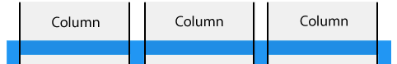

The horizontal lines of grid items are called rows.

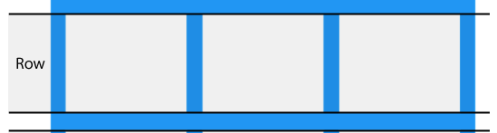

The spaces between each column/row are called gaps. You can adjust the gap size by using one of the following properties:

grid-column-gap 🡪 grid-column-gap: 50px;

grid-row-gap

grid-gap 🡪 grid-gap: 20px 50px; 50 is row gap and 50 is column gap if there is only 20px value then it will be 20 for row as well column

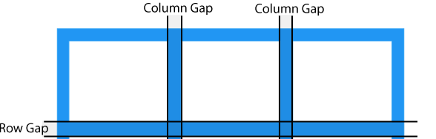

The lines between columns are called column lines.   
The lines between rows are called row lines

