Collective excitations in competing phases in two and three dimensions

Joshua Althüser∗ and Götz S. Uhrig†

*Condensed Matter Theory, TU Dortmund University,*

*Otto-Hahn Straße 4, 44227 Dortmund, Germany*

∗joshua.althueser@tu-dortmund.de

† goetz.uhrig@tu-dortmund.de

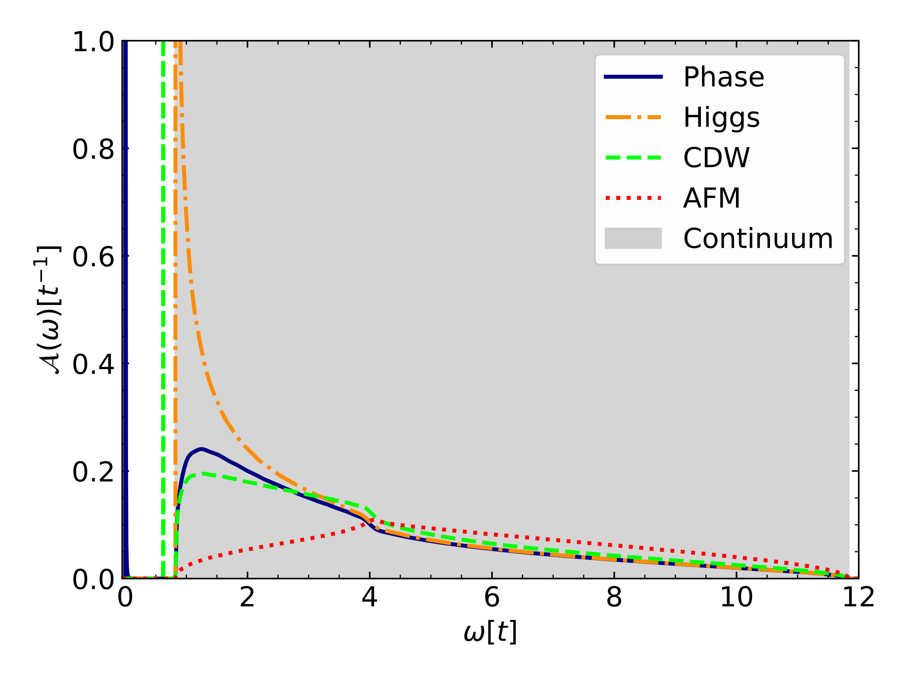

We investigate the superconducting (SC), charge-density wave (CDW), and antiferromagnetic (AFM) phases in the extended Hubbard model at zero temperature and half-filling. We employ the iterated equations of motion approach [1,2] to compute the two-particle Green’s functions and by extension, the corresponding spectral densities. The equations are formulated in energy space so that the 2D and the 3D case can be treated with comparable effort. This renders a comprehensive analysis of collective excitations and the concomitant continuous spectra possible as the model’s parameters are changed across phase transitions. We identify the well-known amplitude (Higgs) and phase (Anderson-Bogoliubov) modes within the superconducting phase and observe a Cooper mode (“cooperon”) in the CDW phase shifting towards zero energy upon approaching the SC phase. In the CDW phase, close to the phase transition to the AFM phase, we find a collective mode that does not shift significantly in energy and another mode that becomes soft as the phase boundary is approached.

Fig. 1 Spectral functions of various operators generating distinct collective excitations for a simple cubic lattice in the superconducting phase.

[1] M. Kalthoff, F. Keim, H. Krull, and G. S. Uhrig, Comparison of the iterated equation of motion approach and the density matrix formalism for the quantum Rabi model, The European Physical Journal B **90**, 97 (2017).

[2] P. Bleicker and G. S. Uhrig, Strong quenches in the one-dimensional Fermi-Hubbard model, Phys. Rev. A **98**, 033602 (2018).