

Faculty of Engineering and Technology

Electrical and Computer Engineering Department
  - Computer architecture

  - project #2

Instructor Name: Ahmad Afaneh
Student Name: Amjad Shomali
Student ID: 1161957

Abstract:
Using the Logisim simulator to design and implement a functional 16-bit RISC pipelined processor that supports the following instruction set:
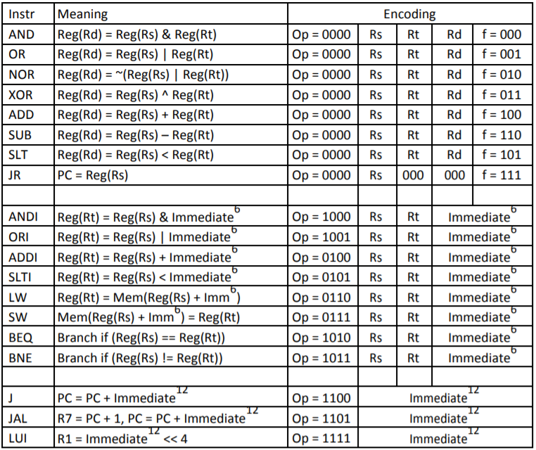
Figure 1: ISA
The processor supports the basic instruction formats being: R-Type, I-Type, J-Type. divided respectively as blocks in Fig. 1

*Note: I did not make it pipelined as it generated an insane amount of errors prior to the original design, I did not have enough time to fix them as I did the project alone and had to attend Christmas traditions with my family.

Design & Implementation:

Components:
- Memory:

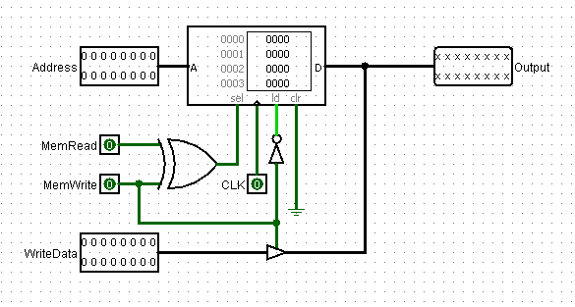
Figure 2: 16-bit Memory
Effectively using the RAM block in Logisim by adding the MemRead and MemWrite inputs and other proper inputs, While also syncing the write data with the read function using a tri-state buffer.

- Register File:
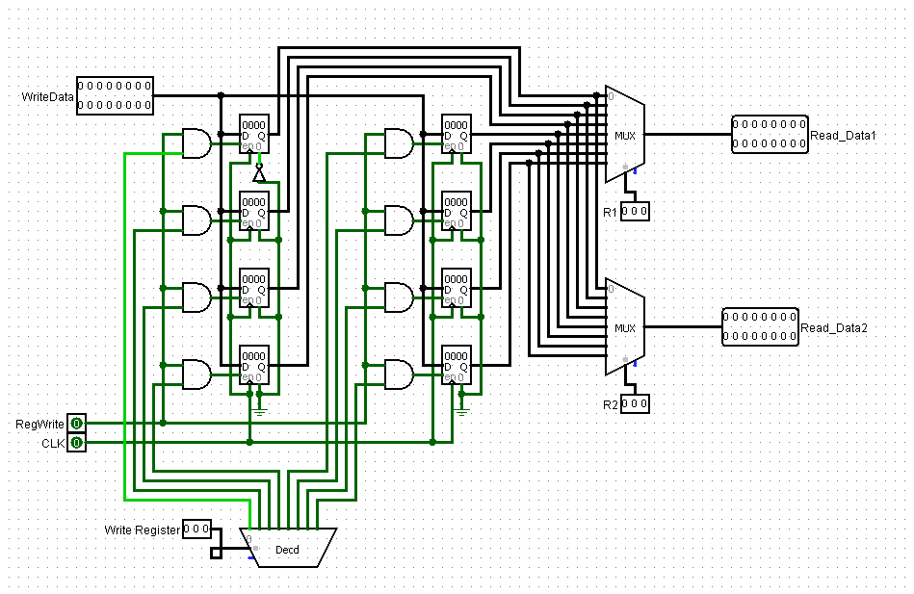
Figure 3: 16-Bit Register File
8 registers were used, the reading mode was activated by constantly projecting the register data into multiplexers that have register number input as it’s selection, While the write function was implemented using a decoder that synchronize with a Write Register input – being #ofTheRegister to be written and a RegWrite input to activate writing.

- Control Unit
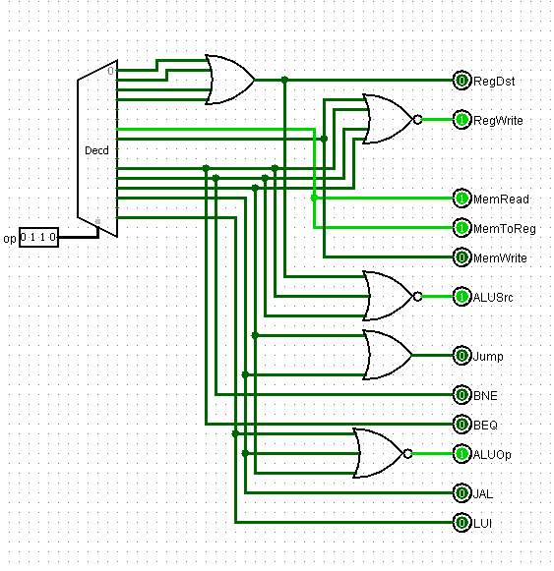
Figure 4: Control Unit
 | RegDst | RegWrite | MemRead | MemToReg | MemWrite | AluSRC | Jump | BNE | BEQ | ALUOp | JAL | LUI
R | 1 | 1 | 0 | 0 | 0 | 0 | 0 | 0 | 0 | 1 | 0 | 0
I | 0 | 1 | 0 | 0 | 0 | 1 | 0 | 0 | 0 | 1 | 0 | 0
LW | 0 | 1 | 1 | 1 | 0 | 1 | 0 | 0 | 0 | 1 | 0 | 0
SW | 0 | 0 | 0 | 0 | 1 | 1 | 0 | 0 | 0 | 1 | 0 | 0
BEQ | 0 | 0 | 0 | 0 | 0 | 0 | 0 | 0 | 1 | 1 | 0 | 0
BNE | 0 | 0 | 0 | 0 | 0 | 0 | 0 | 1 | 0 | 1 | 0 | 0
J | 0 | 0 | 0 | 0 | 0 | 1 | 1 | 0 | 0 | 0 | 0 | 0
JAL | 0 | 1 | 0 | 0 | 0 | 1 | 1 | 0 | 0 | 0 | 1 | 0
LUI | 0 | 1 | 0 | 0 | 0 | 1 | 0 | 0 | 0 | 0 | 0 | 1
RegDst: Determines if another register input is taken in RegisterFile, as in R-Type instructions
RegWrite: Enables writing into Register File
MemRead/MemWrite: enables reading or writing from/to DataMemory
MemToReg: Enabled when we want to write back data to a register such in LW
AluSRC: used to determine if the second ALU input is from the RegisterFile or an Immediate
Jump,BNE,BEQ,JAL,LUI: External outputs to enable unique functions. The names are very self-explainatory.
ALUOp: Pass the ALU’s Output

- ALU
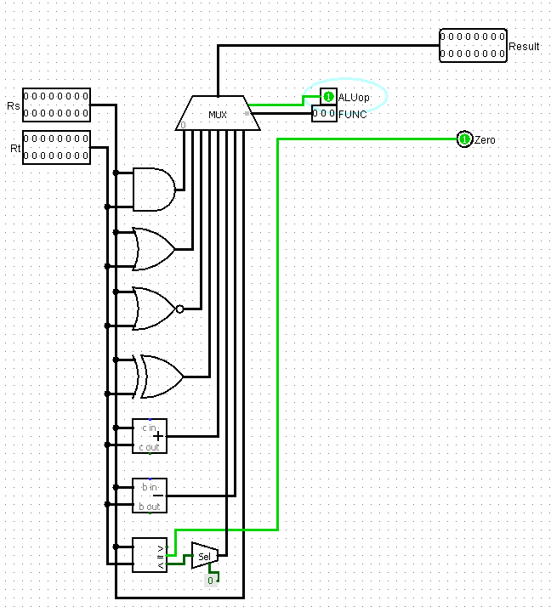
Figure 5: ALU
Result is passed depending on the ALUop input, the FUNC input determines the type of operation done on the inputs, in which are made according to (Fig. 1), There’s also a Zero output which is the same as the ZeroFlag used in BNE,BEQ operations.

the cpu a whole:

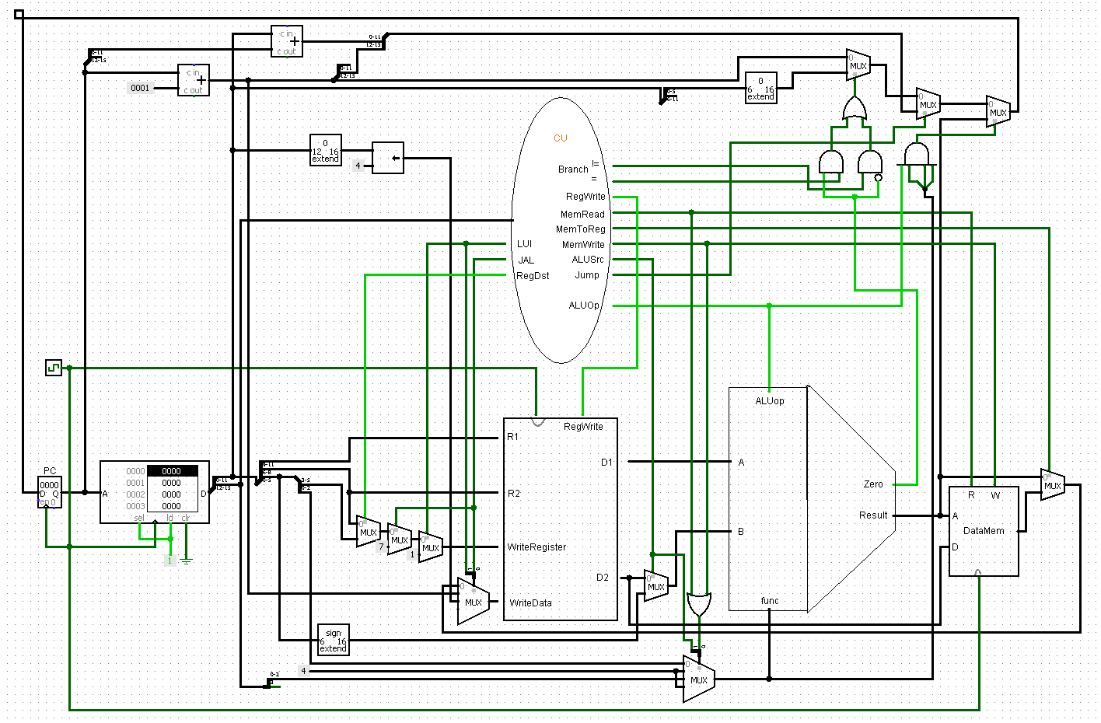
Figure 6: The full CPU
Most of the components are as explained in the lecture but there are some extra components added to insure the functionality of certain instructions whom include:

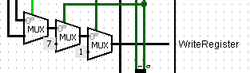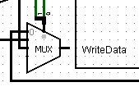
The 3 series multiplexers pick between which register to write depending on the function,
- R-Type: Decoded from OP-CODE
- JAL: R7
- LUI: R1
While the WriteData 2bit mux selects what data to write depending on the aforementioned input.

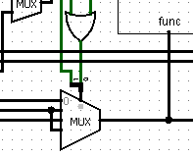
The Func Mux selects where do we take the function input from,
- 0: Selects the R-Type Decoded FUNC
- 1: Basically a don’t care, connected to 3 for safety
- 2: Is picked when ALUSrc = 1 meaning the function is I-Type and we have to decode the func from the OPCODE
- 3: Selects Function 4 which is an adder and is used in immediate address calculations in load and store functions

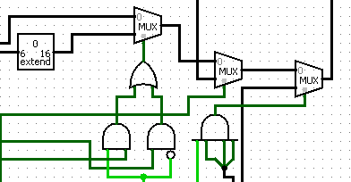
This is the PC Manipulation area,
- First Mux is enabled when there is a BEQ,BNE enables and takes the immediate value of the branch
- Second Mux is enabled when the J control is enabled so it passes the immediate of the J-Type
- Third mux is enabled when JR is inputed as it’s the only func equal to 111

Testing:
The following code was loaded into the CodeSegment
//Fill First array @ addr 0000  9242 | 1001 001 001 000010 | ori r1, 2  7040 | 0111 000 001 000000 | sw r1, 0  4241 | 0100 001 001 000001 | addi r1,r1,1  7041 | 0111 000 001 000001 | sw r1, 1  4241 | 0100 001 001 000001 | addi r1,r1,1  7042 | 0111 000 001 000010 | sw r1, 2  //Fill Second Array @ addr 0004  9484 | 1001 010 010 000100 | ori r2, 0004 //load arr addr  60c0 | 0110 000 011 000000 | lw r3,x0000  02c9 | 0000 001 011 001 001| or r1,r1,r3 //2 or 4 = 6  7440 | 0111 010 001 000000 | sw r1, 0(r2) //r3 = 0004  4241 | 0100 001 001 000001 | addi r1,r1,1  4481 | 0100 010 010 000001 | addi r2,r2,1  7440 | 0111 010 001 000000 | sw r1, 0(r2)  4241 | 0100 001 001 000001 | addi r1,r1,1  4481 | 0100 010 010 000001 | addi r2,r2,1  7440 | 0111 010 001 000000 | sw r1, 0(r2)  d020 | 1101 0000 0001 0000 | JAL by 20 hex to procedure | //Procedure  024b | 0000 001 001 001 011 | xor r1,r1,r1  9240 | 1001 001 001 000000 | ori r1, 0 //addr 1  0493 | 0000 010 010 010 011 | xor r2,r2,r2  9484 | 1001 010 010 000100 | ori r2, 4 //addr 2  06db | 0000 011 011 011 011 | xor r3,r3,r3  96c3 | 1001 011 011 000011 | ori r3, 3 //size  9D88 | 1001 110 110 001000 | ori r6, 8 //store index  loop:  6300 | 0110 001 100 000000 | lw r4, [r1]  6540 | 0110 010 101 000000 | lw r5, [r2]  0964 | 0000 100 101 100 100| add r4,r4,r5  7D00 | 0111 110 100 000000 | store in 8 from r4  4241 | 0100 001 001 000001 | addi r1,r1,1  4481 | 0100 010 010 000001 | addi r2,r2,1  4D81 | 0100 110 110 000001 | addi r6,r6,1  46FF | 0100 011 011 111111 | addi r3,r3,-1  B0F7 | 1011 000 011 110110 | beq r0,r3 loop(0037)  0e07 | 0000 111 000 000111 | JR
It does the following:
Initiates two arrays in the DataMem segment using ORI and a variable R1 which is incremented by one starting from 2, meaning we have 2,3,4 on address 0 in the data mem
Second array is filled starting form addr 4, then R-type OR function is used to determine the first array index which is or r1,r3 = 6 and is then incremented in the same manner leading us to 6,7,8
Those two arrays are then added together in a loop procedure using JR and JAL which are highlighted in the text.
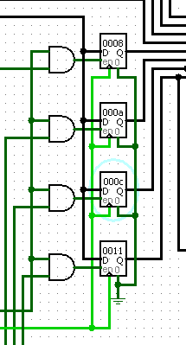
The expected output is: 8, A, C
We can see the array on the right-hand side with the 4th register being the JR return address.

