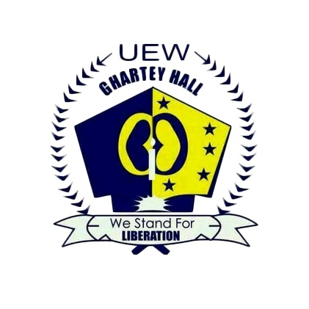**GHARTEY HALL**

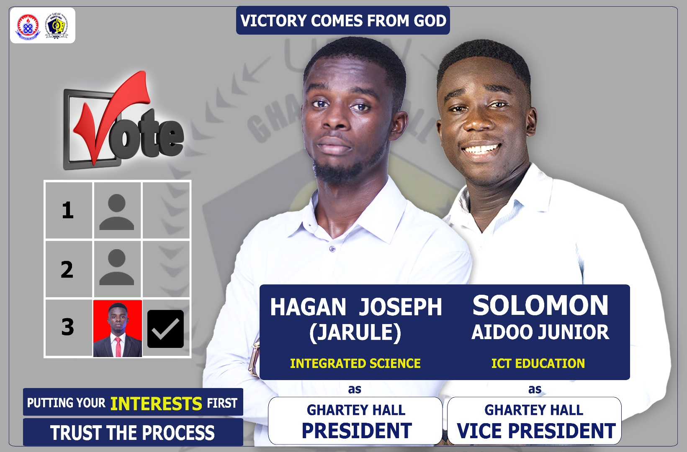**A MANIFESTO READ BY HAGAN JOSEPH ON 10TH MAY, 2019 AT BOADI PAVILION AS GHARTEY HALL PRESIDENTIAL CANDIDATE**

Mr. Chairman, Hall Manageress, Hall Executives, Co-Aspirants, fellow affiliates, ladies and gentlemen, we would like to say good evening to you all. We take it as a great delight to read our manifesto to you all today.  
  
It is a fact however, that not many people see the significance of a manifesto.  
Some see it as a list of promises to attract votes, therefore not much thought is given to their fulfillment. To others, it is a complete wastage of time.

For our part, we fully understand the consequence of putting your signature to a contract.

This manifesto, to us, is s social contract between myself, together with my Vice and all Ghartey Hall affiliates.

The manifesto should also help the affiliates to distinguish between the various aspirants because, the plans and programmes they set out would be influenced by the ideologies and beliefs.

We offering our manifesto to you today means, we sign our part of the contract. Your Vote would also constitute your signature on the contract and the mandate you have given us to implement the ideas in our manifesto.

Ladies and gentleman, exactly 6 days from today, all affiliates of Ghartey Hall will embark on an extremely important exercise of electing new executives.

The choice we make on that day, will not only determine where Ghartey Hall will be led to for the next academic year, but also have an impact after the next academic year has ended.

Despite all the efforts being made by some aspirants to make the affiliates focus lesson us, we understand this upcoming election to be nothing but a competition of innovative ideas to propel our beloved hall forward. And these ideas can only be successfully executed with the right mix of competence, determination and integrity.

Ladies and gentlemen, our vision statement for Ghartey is as follows, and I quote “To shape the academic and social will of all affiliates of Ghartey Hall, creating a well restored and serene environment to enable each affiliate experience an educational journey that is intellectually, socially and personally transformative”.

We came up with feasible and realistic vision because of the following innovative set of tasks that constitutes our mission statement.

**CREATION OF A GHARTEY HALL WEBSITE**

Ghartey Hall, first of all cannot be as strong and firm as we would like it to be if we leave a very important developmental tool known as communication out. As part of our policies to improve upon the communication system of Ghartey Hall, we will develop a website for Ghartey hall, where all forms of information will be published for every affiliate to view including applicants who will be potential Ghartey Hall Affiliates.

We will therefore, liaise with the school administration, to add the website address to the admission letters of affiliates of Ghartey Hall so that they can log on and view information about their affiliation to the hall in order not to leave them stranded when they gain admission.

The creation of the website will not be awarded to any firm outside UEW, but rather be given to the best student web development firm. By so doing, students will be given the chance to bid for contracts which will even prepare them for the job market.

Affiliates will also be given a comments section on the website in order to know their views concerning issues of the hall. Issues like hall meetings, hall week celebrations, general meetings, seminars and many more.

We will always update the website with scholarship opportunities from our nation and beyond so that students will be able to access them as well apply for it.

Ghartey Hall will even make some money out of the website that will be created.

**HEALTH CONCERN**

The core aim of every affiliate for coming to University of Education Winneba, cannot be met if they constantly experience health challenges. As part of our policies for the development of Ghartey Hall and shaping the academic and social will of every affiliate of Ghartey Hall, in collaboration with the Ghana Health Service, every affiliate on provision of a receipt for the payment of JCRC dues will be provided with a treated mosquito net in order to reduce the rate at which they fall ill just for the betterment of their academics.

**IMPROVEMENT OF SANITATION**

We will cooperate with the hall management in order to improve upon the sanitation of our beloved hall. By doing so, all faulty WC’s and sinks will be repaired and if possible, replaced alongside other key factors that can be improved upon to create a severe environment for Ghartey Hall.

The hall in collaboration with Aggrey Hall, will liaise with the school management to provide bins at vantage point on campus.

**IMPROVEMENT OF ENETERTAINMENT FACILITIES**

Entertainment, as we all know cannot be left out if we really want to achieve our vision for Ghartey Hall. We will therefore cooperate with the management to provide our various JCR’s with projectors, Ghartey C for instance in order to ease the pressure at the JCR’s during live matches. We will also provide our various JCR’s with gaming systems like PS4 as an extra source of entertainment to all affiliates of Ghartey. By doing so, we will be indirectly reducing the rates at which some students drown at the sea. This is because since there’s no other form of entertainment other than the hall week celebration and live matches, affiliates tend to go to the beach in large numbers just to entertain themselves, but eventually, some fail to return back due to drowning. My team therefore came up with the idea that, if a constant form of entertainment is being provided at our various JCR’s, students will not be going to the beach in large numbers and by so doing, we would be protecting the lives of our affiliates and eventually shaping their social will as well.

**PROVISION OF SUGGESTION BOX**

Mr. chairman, we definitely will definitely not be good leaders if don’t take the opinions and wishes of the affiliates into consideration. Just as our team’s slogan goes, we are here to put the interest of the affiliates first. For this to be more realistic we wouldn’t rely on meetings only for opinions of our affiliates but also provide them with suggestions boxes in which they can place all their suggestions opinions and challenges they are facing at the halls in them for us to cooperate with the management to find the best solutions to their problems.

**SAFETY**

The safety of affiliates at the hall is our concern as well. Therefore, we will cooperate with the management to provide the halls with at least one fire extinguisher at each floor and then refill the old ones as well.

**EQUIPING OUR HALLS WITH PUMPING MACHINE**

We will equip our various blocks with water pumping machines for the machines to pump water to the top floors when the pressure of the water ascending to the top floors is low. This is to aid our affiliates by reducing the rate at which they descend the blocks for water from the polytanks.

**OTHER MATTERS**

Other pressing issues may rise up during our tenure of office but then we would work tirelessly to resolve them.

We will also cooperate with management to seek sponsorships from organizations and media houses for programs like the Hall week celebrations and other activities that we will be organizing as well.  
Such activities include monthly sports activities among we the affiliates, educational seminars and many more other activities.

We will also provide our royal garvians with bibs and musical instruments as well.

Royals, I wish to assure you that in my tenure of office, you will have a competent, incorruptible, selfless, honest and a compassionate leader who will work with his team to deliver on the solutions to our hall’s problems.

Royals, the voting is in your hands and it is your own decision to make this vision of ours come through. I am appealing to you all to vote for **Hagan Joseph** as your next Ghartey Hall President in order to enable us to implement our policies for the betterment of Ghartey Hall. Once again Royals, listen to the cry of your humble servant, **Hagan Joseph**, vying for the post of the President of Ghartey Hall who happens to be the third on the ballot screen.

**Hagan Joseph** is here to serve Ghartey Hall,

**Hagan Joseph** is here to serve you all,

**Hagan Joseph** is here to put your interests first.

Royals! Yes, we can! We can develop our hall by voting for **Hagan Joseph** as the next Ghartey Hall President.

**I trust the process, you trust the process, we trust the process**.

Long live Royals!

Long live Royal Garvians!

Long live Ghartey Hall!

Long live UEW!

I thank you all.

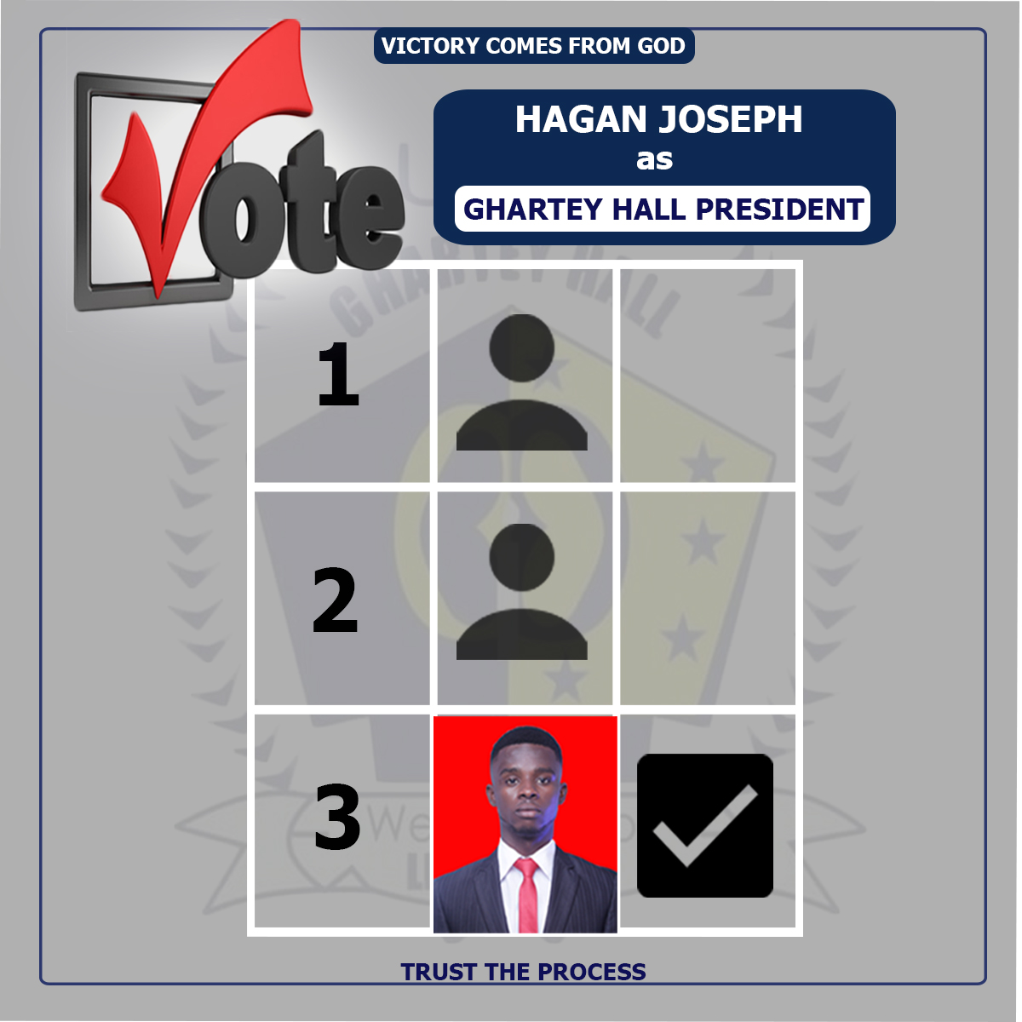Vote for **Hagan Joseph** as the next **Ghartey Hall President** for this vision to be a reality.