# MySql

## MySql基础

登录

mysql –uspa –p spa P3306 –h192.168.1.100 –Dspa

mysql>

退出

\q exit quit

提示符

Prompt \u@\h\d

spa@192.168.1.100 spa>

定界符

Delimiter @

SELECT VERSION() @

SELECT USER() @

数据库操作：

CREATE DATABASE test1;

ALTER DATABASE test1 CHARACTER SET gbk;

## 数据类型与操作数据表

CREATE TABLE `spa_user` (

`id` varchar(24) NOT NULL,

`login_name` varchar(64) DEFAULT NULL,

`name` varchar(45) CHARACTER SET utf8mb4 DEFAULT NULL COMMENT '呢称',

`password` varchar(45) DEFAULT NULL COMMENT '密码',

`salt` varchar(45) DEFAULT NULL COMMENT '盐',

`gender` varchar(10) DEFAULT NULL COMMENT '性别',

`avatar_status` varchar(10) DEFAULT NULL,

`avatar` varchar(10) DEFAULT NULL COMMENT '头像',

`phone_num` varchar(16) DEFAULT '' COMMENT '手机号码',

`serial_no` varchar(16) DEFAULT NULL COMMENT '技师编号',

`club_id` varchar(24) DEFAULT NULL COMMENT '会所id',

`birth_year` int(11) NOT NULL DEFAULT '0' COMMENT '出生年份',

`birth_mon` int(11) NOT NULL DEFAULT '0' COMMENT '出生月份',

`birth_day` int(11) NOT NULL DEFAULT '0' COMMENT '出生日期',

`description` varchar(1000) CHARACTER SET utf8mb4 DEFAULT NULL COMMENT '描述',

`status` varchar(10) DEFAULT NULL COMMENT '状态',

`end_time` varchar(64) DEFAULT NULL,

`register_date` datetime DEFAULT NULL COMMENT '创建时间',

`updated_at` datetime DEFAULT NULL COMMENT '修改时间',

`user_type` varchar(10) DEFAULT NULL COMMENT '用户类型:tech,Manager,newtech(新技师)',

`roles` varchar(1000) DEFAULT NULL COMMENT '权限',

`province` varchar(45) DEFAULT NULL COMMENT '省',

`city` varchar(45) DEFAULT NULL COMMENT '市',

`province_code` varchar(10) DEFAULT NULL COMMENT '省编号',

`city_code` varchar(10) DEFAULT NULL COMMENT '市编号',

`star` int(11) NOT NULL DEFAULT '0' COMMENT '评分',

`comment_count` int(11) NOT NULL DEFAULT '0' COMMENT '评论数',

`login_date` datetime DEFAULT NULL COMMENT '登录时间',

`bad_comment_count` int(11) DEFAULT '0' COMMENT '差评数',

`top_orders` int(11) NOT NULL DEFAULT '0' COMMENT '首页排序',

`recommend` varchar(2) DEFAULT 'N',

`top_order` int(11) NOT NULL DEFAULT '0' COMMENT '首页排序',

`scene_id` int(10) NOT NULL DEFAULT '0' COMMENT '带参数二维码值',

`headimgurl` varchar(200) DEFAULT NULL COMMENT '微信头像Url',

`open_id` varchar(30) DEFAULT NULL COMMENT '微信用户openId',

`alipay_user_id` varchar(256) DEFAULT NULL COMMENT '支付宝用户userId',

`invite_code` varchar(10) DEFAULT NULL COMMENT '邀请码',

`created_date` date DEFAULT NULL COMMENT '创建时间',

`view_club_type` varchar(20) DEFAULT 'all_club' COMMENT '用户查看会所类型',

`view_album_type` int(11) NOT NULL DEFAULT '1' COMMENT '查看相册类型, 1 全部看见,2 vip用户可见',

`temporary` varchar(10) DEFAULT '' COMMENT '临时账号：Y是，null,N不是',

`tech_open_id` varchar(30) DEFAULT NULL,

`create_user_id` bigint(20) DEFAULT NULL COMMENT '创建人ID',

`update_user_id` bigint(20) DEFAULT NULL COMMENT '最后修改人ID',

`service_status` varchar(1) DEFAULT 'N' COMMENT '客服状态: Y-客服接收消息;;N-非客服',

`associated_id` varchar(256) DEFAULT NULL COMMENT '关联用户ID',

PRIMARY KEY (`id`),

UNIQUE KEY `invite_code` (`invite_code`),

UNIQUE KEY `LOGINNAME_UNIQUE` (`login_name`,`user_type`) USING BTREE,

KEY `IDX_CLUB` (`club_id`),

KEY `IDX_PHONE_NUM` (`phone_num`),

KEY `index_phone_num` (`phone_num`),

KEY `idx_user_associated_id` (`associated_id`),

KEY `idx_open_id` (`open_id`)

) ENGINE=InnoDB DEFAULT CHARSET=utf8

ALTER TABLE `spa_user` ADD `recommend` varchar(2) DEFAULT 'N'

## 约束

## 操作数据表中的记录

插入一条记录

INSERT INTO spa_user (`id`, `login_name`, `name`, `password`, `salt`, `gender`, `avatar_status`, `avatar`, `phone_num`, `serial_no`, `club_id`, `birth_year`, `birth_mon`, `birth_day`, `description`, `status`, `end_time`, `register_date`, `updated_at`, `user_type`, `roles`, `province`, `city`, `province_code`, `city_code`, `star`, `comment_count`, `login_date`, `bad_comment_count`, `top_orders`, `recommend`, `top_order`, `scene_id`, `headimgurl`, `open_id`, `alipay_user_id`, `invite_code`, `created_date`, `view_club_type`, `view_album_type`, `temporary`, `tech_open_id`, `create_user_id`, `update_user_id`, `service_status`, `associated_id`)

VALUES ('939073515913482240', 'shuye', '树叶子账号', '0c48c367628bedbd61e4bec8e839c7b2e5dd8cb9', '6700a2ac5e9612a2', NULL, NULL, NULL, '13823549945', NULL, '918401766939172864', '0', '0', '0', NULL, 'valid', NULL, '2017-12-08 18:05:48', NULL, 'manager', 'club_manager,subuser', NULL, NULL, NULL, NULL, '0', '0', NULL, '0', '0', NULL, '0', '0', NULL, NULL, NULL, '9910970', '2017-12-08', NULL, '1', NULL, NULL, '930354460658503680', '930354460658503680', 'N', '939073515913482240');

插入两条记录

INSERT INTO spa_user (`id`, `login_name`, `name`, `password`, `salt`, `gender`, `avatar_status`, `avatar`, `phone_num`, `serial_no`, `club_id`, `birth_year`, `birth_mon`, `birth_day`, `description`, `status`, `end_time`, `register_date`, `updated_at`, `user_type`, `roles`, `province`, `city`, `province_code`, `city_code`, `star`, `comment_count`, `login_date`, `bad_comment_count`, `top_orders`, `recommend`, `top_order`, `scene_id`, `headimgurl`, `open_id`, `alipay_user_id`, `invite_code`, `created_date`, `view_club_type`, `view_album_type`, `temporary`, `tech_open_id`, `create_user_id`, `update_user_id`, `service_status`, `associated_id`)

VALUES

('618294715984384000', '17727979917', '哈哈', '11107ae6b10b458295d5ef57eb994cfc4b265261', 'de9876a6e90b5ee5', 'female', NULL, '144284', '17727979917', '1717', '918401766939172864', '0', '0', '0', '', 'free', NULL, '2015-07-07 13:45:22', NULL, 'tech', 'tech', '广西壮族自治区', '防城港市', '450000', '450600', '0', '0', '2015-07-07 13:45:22', '0', '0', 'N', '0', '1000949', NULL, NULL, NULL, 'f9wo3b', '2015-07-07', 'my_club', '1', NULL, NULL, NULL, NULL, 'N', '618294715984384000')

,('752718097458139136', '13823549915', '王五', 'e443ba7b8cdd837e815b50a846bb2937b8d2f3a6', '0efac136ca81ea35', 'female', NULL, '152754', '13823549915', '9915', '918401766939172864', '0', '0', '0', '我对你的感觉，其实你懂得；心里小小的甜蜜，其实你懂得；心里所有的想法，其实你懂得', 'busy', NULL, '2016-07-12 12:15:53', NULL, 'tech', 'tech', '', '', '', '', '0', '0', '2016-11-07 10:29:40', '0', '1', 'Y', '0', '1001039', NULL, 'oROVLw-ZCAaZGcECHQCX8CDJPzwI', NULL, '0dyqlr', '2016-07-12', 'my_club', '1', NULL, NULL, NULL, NULL, 'N', '752718097458139136');

## 子查询与连接

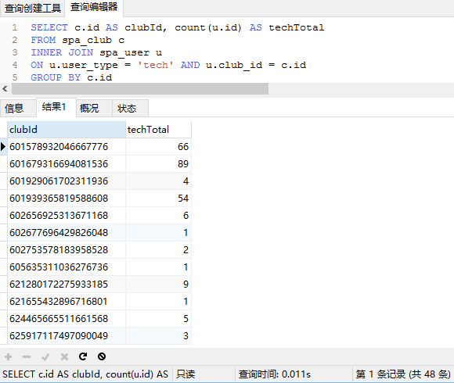

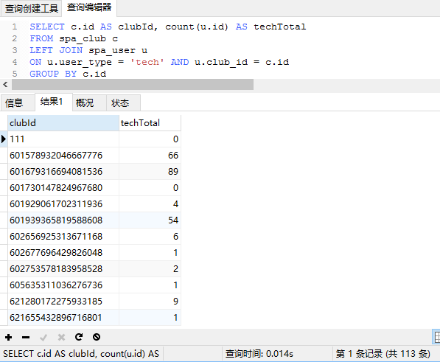

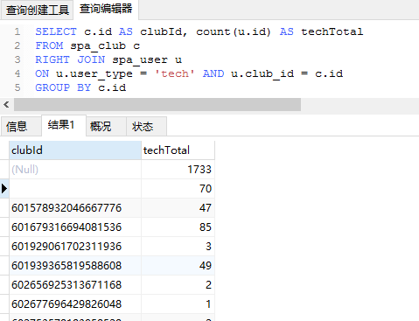

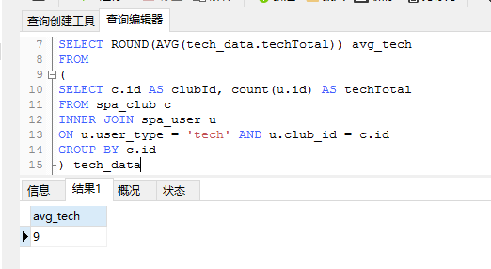

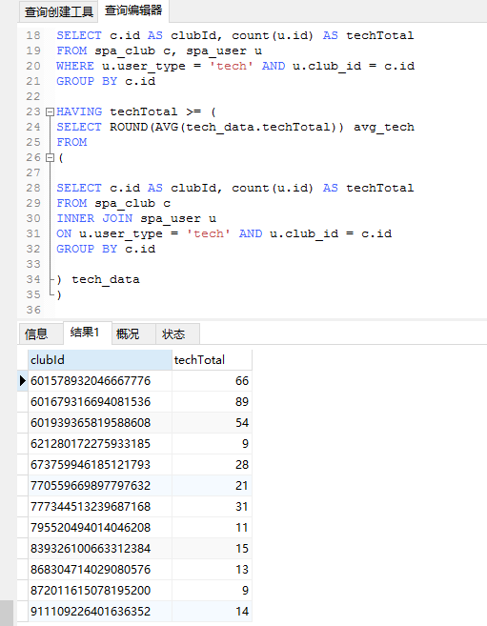

## 内置函数

SELECT

`spa_deal`.`biz_id` AS `biz_id`,

`spa_deal`.`club_id` AS `club_id`,

`spa_deal`.`business_category` AS `consume_type`,

round(

(

`spa_deal`.`trade_amount` / 100

),

2

) AS `amount`,

0 AS `formalities_fee`,

round(

(

`spa_deal`.`trade_amount` / 100

),

2

) AS `tech_amount`,

0 AS `club_amount`,

`spa_deal`.`deal_datetime` AS `deal_date`

FROM

`spa_deal`

WHERE

(

(

`spa_deal`.`business_category` = 'user_reward'

)

AND (

`spa_deal`.`business_type` = 'user_reward'

)

)

UNION ALL

SELECT

`spa_deal`.`biz_id` AS `biz_id`,

`spa_deal`.`club_id` AS `club_id`,

`spa_deal`.`business_category` AS `consume_type`,

sum(

(

CASE

WHEN (

(

`spa_deal`.`dst_type` IN ('system', 'tech', 'manager')

)

AND (

`spa_deal`.`trade_type` = 'income'

)

) THEN

round(

(

`spa_deal`.`trade_amount` / 100

),

2

)

ELSE

0

END

)

) AS `amount`,

sum(

(

CASE

WHEN (

(

`spa_deal`.`dst_type` = 'system'

)

AND (

`spa_deal`.`trade_type` = 'income'

)

) THEN

round(

(

`spa_deal`.`trade_amount` / 100

),

2

)

ELSE

0

END

)

) AS `formalities_fee`,

sum(

(

CASE

WHEN (

(

`spa_deal`.`dst_type` = 'tech'

)

AND (

`spa_deal`.`trade_type` = 'income'

)

) THEN

round(

(

`spa_deal`.`trade_amount` / 100

),

2

)

ELSE

0

END

)

) AS `tech_amount`,

sum(

(

CASE

WHEN (

(

`spa_deal`.`dst_type` = 'manager'

)

AND (

`spa_deal`.`trade_type` = 'income'

)

) THEN

round(

(

`spa_deal`.`trade_amount` / 100

),

2

)

ELSE

0

END

)

) AS `tech_amount`,

`spa_deal`.`deal_datetime` AS `deal_date`

FROM

`spa_deal`

WHERE

(

(

`spa_deal`.`business_category` IN ('paid_coupon', 'paid_order')

)

AND (

`spa_deal`.`business_type` IN (

'commission',

'platform_fee',

'club_fee'

)

)

)

GROUP BY

`spa_deal`.`biz_id`

UNION ALL

SELECT

`spa_deal`.`biz_id` AS `biz_id`,

`spa_deal`.`club_id` AS `club_id`,

`spa_deal`.`business_category` AS `consume_type`,

round(

(

`spa_deal`.`trade_amount` / 100

),

2

) AS `amount`,

0 AS `formalities_fee`,

0 AS `tech_amount`,

round(

(

`spa_deal`.`trade_amount` / 100

),

2

) AS `club_amount`,

`spa_deal`.`deal_datetime` AS `deal_date`

FROM

`spa_deal`

WHERE

(

`spa_deal`.`business_category` = 'user_recharge'

)

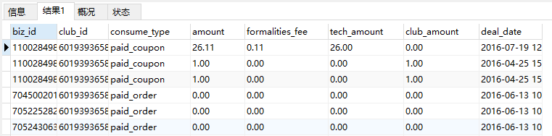

## 自定义函数

## MySQL存储过程

CREATE PROCEDURE procedure_test()

BEGIN

UPDATE spa_user SET login_date = now() WHERE login_name = '17727979917';

END;

CREATE EVENT IF NOT EXISTS e_test

on SCHEDULE EVERY 1 HOUR

ON COMPLETION PRESERVE

DO CALL procedure_test();

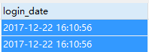

CREATE DEFINER=`spa`@`%` PROCEDURE `item_update2`()

BEGIN

declare a varchar(24);

DECLARE p varchar(20);

DECLARE d varchar(20);

DECLARE s int default 0;

DECLARE item CURSOR FOR select id from spa_service_item;

DECLARE CONTINUE HANDLER FOR SQLSTATE '02000' SET s=1;

OPEN item;

fetch item into a;

while s <> 1 do

select @p:=price, @d:=duration from spa_service_item_price where item_id=a order by id limit 0,1;

if @p is not null then

update spa_service_item set price=@p, duration=@d where id=a;

end if;

fetch item into a;

end while;

close item;

END

## MySQL存储引擎

锁

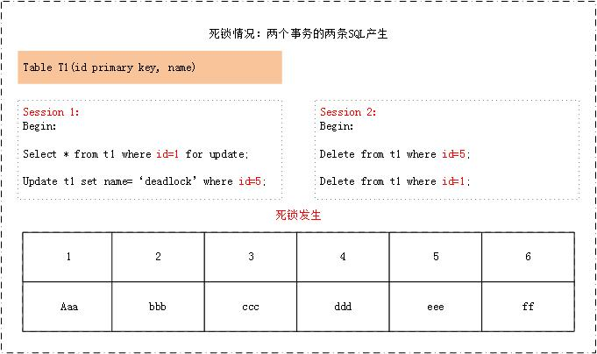

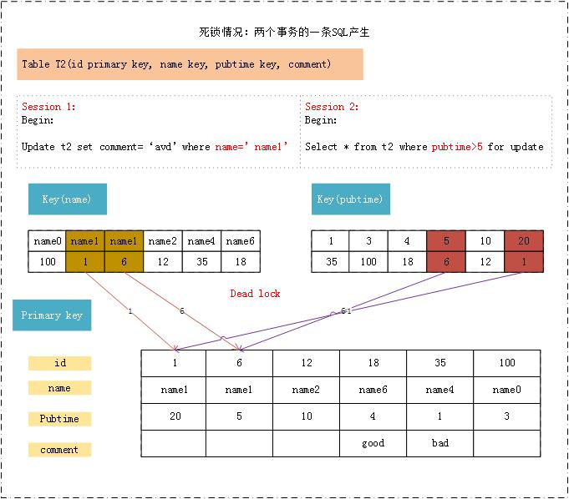

事务

## MySQL图形化管理工具

