Create or Insert Operation:

Database intro:

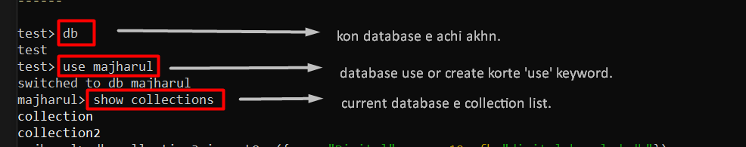

For creating collections(table) with One document(row):

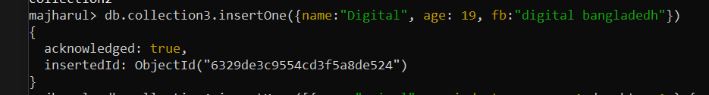

For creating collections(table) with Many document(row):

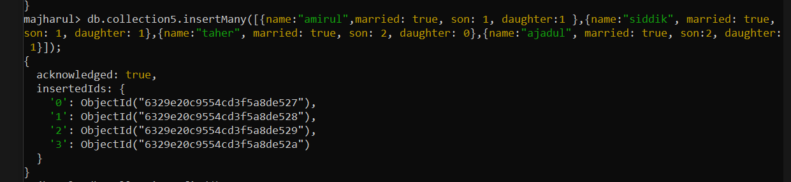

To show document(row) in collection(table) :

🡪 [db.collection name.find()]

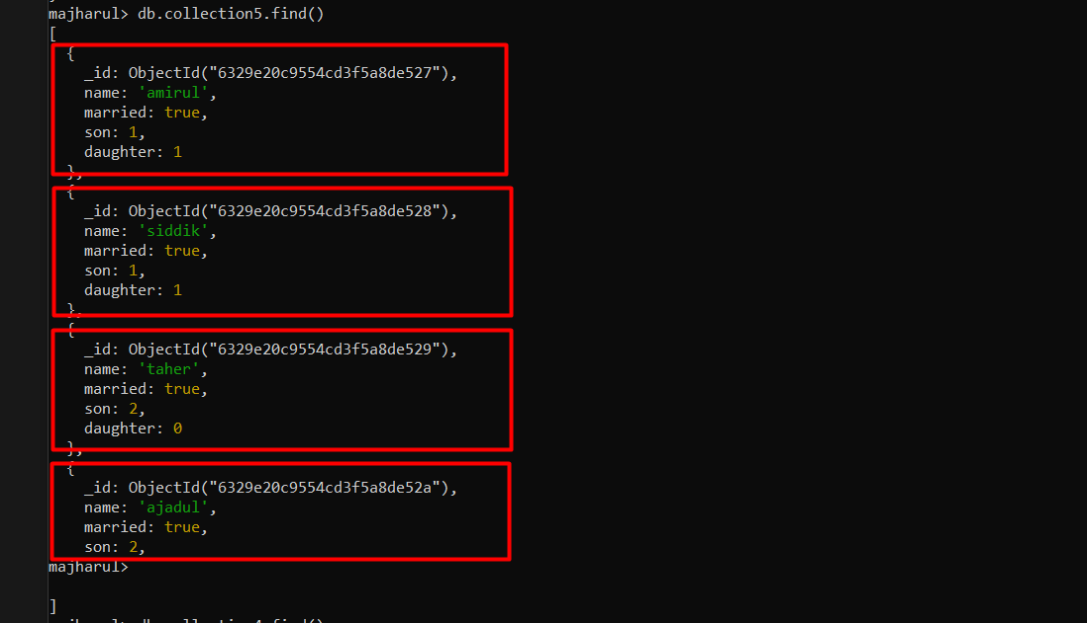

Read or Queries the Documents :

Find by ‘name’: it will give total documents.

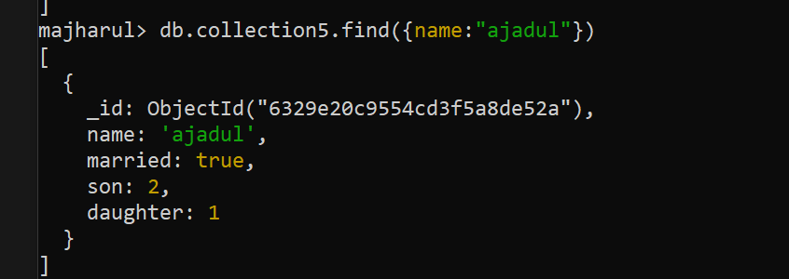

↓

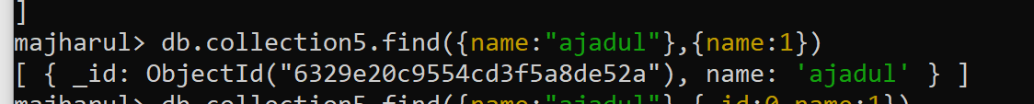

↓



**Another Example:**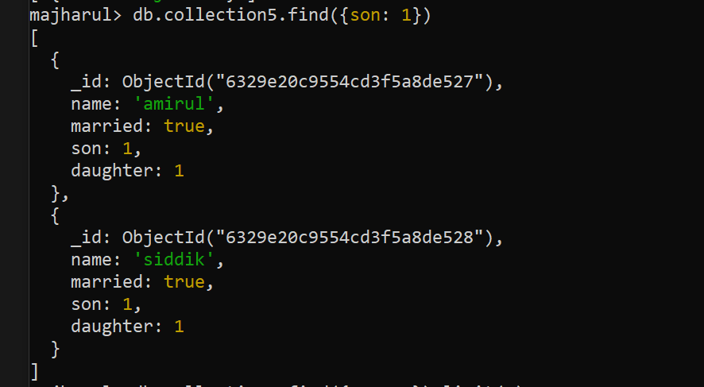

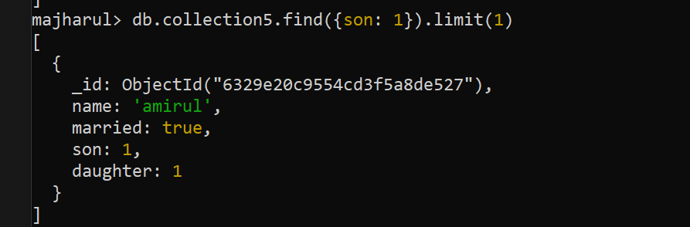

**Two way -> using ‘limit’/’findOne’**

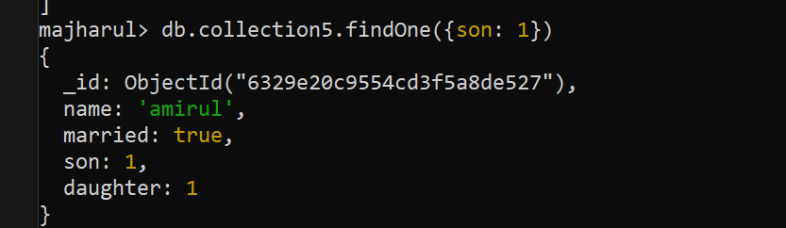

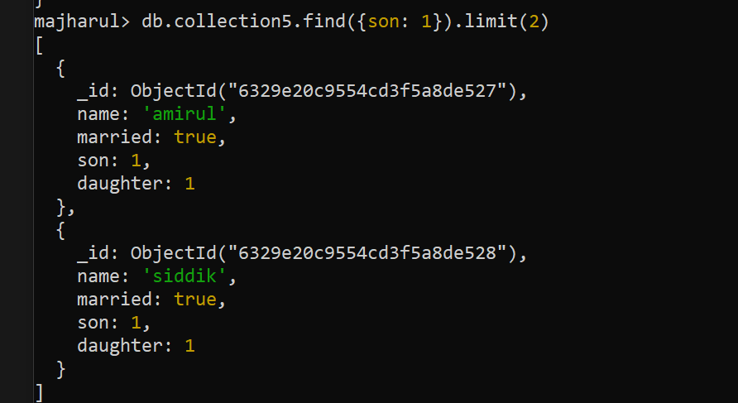

//It means find and limit er first output ta skip korbe, porer ta show korbe.

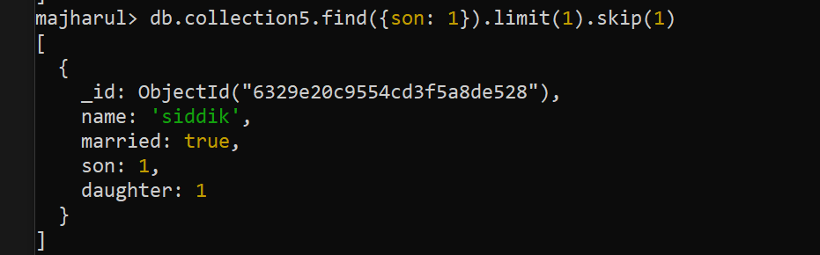

Update the Documents:

updateOne:

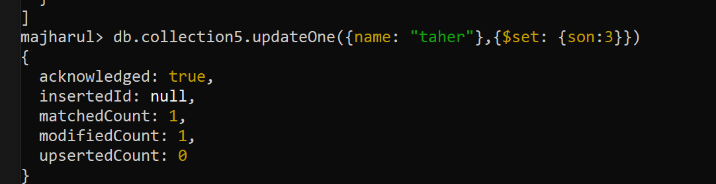

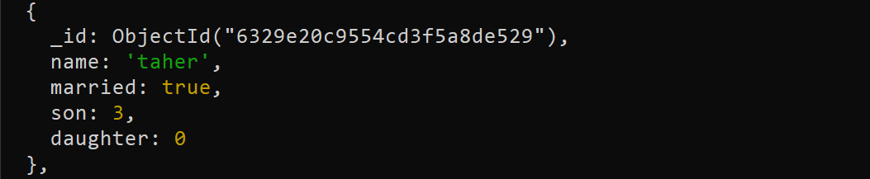

updateMany:

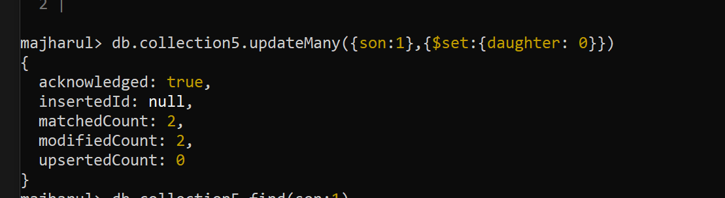

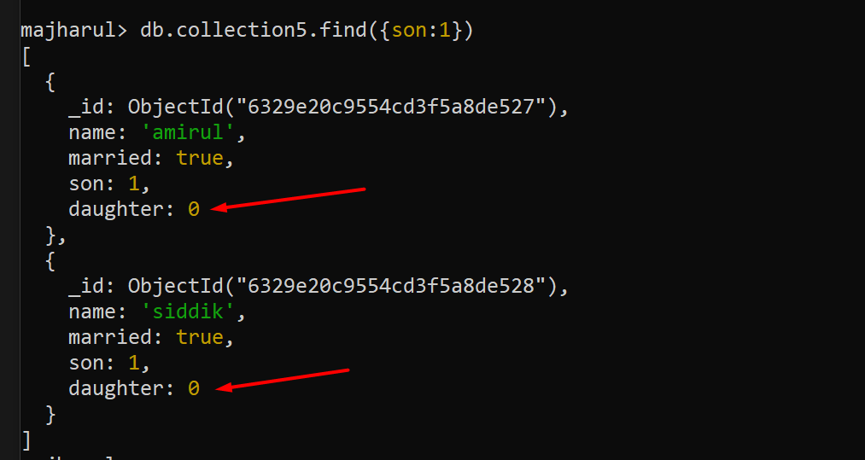

Delete the Documents: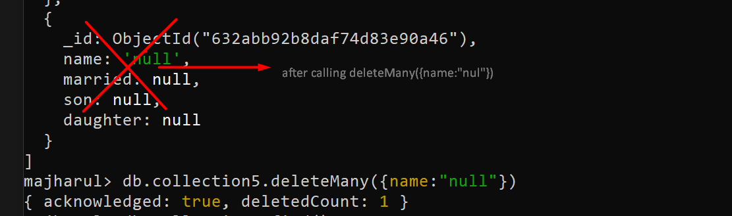

//crate collection manually

db.createCollection(‘collection_name’);

//delete collection from command

db.collection_name.drop()

//delete database from command

Db.dropDatabase();

More Info:

[Documents — MongoDB Manual](https://www.mongodb.com/docs/manual/core/document/) : <https://www.mongodb.com/docs/manual/core/document/>

Delete the Documents (mongodb/doc):

[findOneAndDelete()](https://www.mongodb.com/docs/manual/reference/method/db.collection.findAndModify/#std-label-findAndModify-wrapper-sorted-remove) provides a sort option. The option allows for the deletion of the first document sorted by the specified order.

[db.collection.findAndModify()](https://www.mongodb.com/docs/manual/reference/method/db.collection.findAndModify/#mongodb-method-db.collection.findAndModify) provides a sort option. The option allows for the deletion of the first document sorted by the specified order.

[db.collection.bulkWrite()](https://www.mongodb.com/docs/manual/reference/method/db.collection.bulkWrite/#mongodb-method-db.collection.bulkWrite) method provides the ability to perform bulk insert, update, and delete operations.

[bulkWrite()](https://www.mongodb.com/docs/manual/reference/method/db.collection.bulkWrite/#mongodb-method-db.collection.bulkWrite) supports the following write operations:

* [insertOne](https://www.mongodb.com/docs/manual/reference/method/db.collection.bulkWrite/#std-label-bulkwrite-write-operations-insertOne)
* [updateOne](https://www.mongodb.com/docs/manual/reference/method/db.collection.bulkWrite/#std-label-bulkwrite-write-operations-updateOneMany)
* [updateMany](https://www.mongodb.com/docs/manual/reference/method/db.collection.bulkWrite/#std-label-bulkwrite-write-operations-updateOneMany)
* [replaceOne](https://www.mongodb.com/docs/manual/reference/method/db.collection.bulkWrite/#std-label-bulkwrite-write-operations-replaceOne)
* [deleteOne](https://www.mongodb.com/docs/manual/reference/method/db.collection.bulkWrite/#std-label-bulkwrite-write-operations-deleteOneMany)
* [deleteMany](https://www.mongodb.com/docs/manual/reference/method/db.collection.bulkWrite/#std-label-bulkwrite-write-operations-deleteOneMany)

try {

db.pizzas.bulkWrite( [

{ insertOne: { document: { _id: 3, type: "beef", size: "medium", price: 6 } } },

{ insertOne: { document: { _id: 4, type: "sausage", size: "large", price: 10 } } },

{ updateOne: {

filter: { type: "cheese" },

update: { $set: { price: 8 } }

} },

{ deleteOne: { filter: { type: "pepperoni"} } },

{ replaceOne: {

filter: { type: "vegan" },

replacement: { type: "tofu", size: "small", price: 4 }

} }

] )

} catch( error ) {

print( error )

}