Surface-Potential-Based Modeling of MOS Capacitors Including Non-Ideal Effects for SiC CMOS Processes
Md Majharul Islam, Abu Shahir Md Khalid Hasan, Kevin Chen Aireen Amir Jalal , Priyam Saha, H. Alan Mantooth …
ª Department of Electrical Engineering and Computer Science, University of Arkansas, Fayetteville, AR, USA, mi031@uark.edu

Summary
In this study, A surface potential based analytical model has been developed to accommodate different non-ideal effects. This study illustrates how interface trap density, fixed oxide charge, terminal impedance, and minority carrier generation lifetime influence capacitance-voltage (C-V) characteristics and overall device behavior. An interactive visualization tool has been developed to simulate the model. The visualization tool provides valuable insights into the impact of these non-ideal effects and can aid in the analysis, design, and optimization of SiC-based MOS devices.
.

Motivation
The metal-oxide-semiconductor capacitor (MOSCAP) is one of the most extensively studied and well-understood devices in semiconductor physics, especially for silicon (Si). However, practical MOSCAPs, especially non-silicon ones often exhibit non-ideal behaviors due to fabrication processes, oxide interfaces, material properties, measurement-related anomalies, interface trapping, and material defects etc is still not explored thoroughly. Efforts have been made to model MOSCAP for both Silicon and SiC based devices which generally ignore non-ideal scenarios. Silicon Carbide (SiC) based CMOS processes have recently emerged to enable operation at high temperatures and high power. Unlike Si, SiC exhibits numerous defects, as well as interface and measurement-related anomalies due to interface trap density, fixed oxide charge, terminal impedance, and minority carrier generation lifetime, low intrinsic career concentration in wide bandgap materials which result is frequency dispersion, interface trap-related deviations in C-V characterization. Recently Model for low voltage MOSFET including C-V behavior for CMOS process has been introduced however only account the interface trap density while ignoring others.[1] While this serve an excellent for IC design but due to the BSIM4 based model architecture it calculated C-V empirically. To accurately analyze these errors, there is a critical need for physics-based models that accurately capture SiC-specific physics—to advance circuit simulation and progress of SiC CMOS process development in this study, we developed a surface potential-based model for a SiC MOSCAP including the non-ideal behaviors and validated it against measured results
Results
The results show that the initial measured and analytical characteristics deviate due to the presence of fixed oxide charge, terminal impedance, and interface trap density. However, when these non-ideal effects are incorporated into the analytical model, the discrepancy is significantly reduced, and the simulated results closely match the measured data. This strong agreement validates both the proposed model and the fabricated SiC MOSCAP. These findings demonstrated with interactive visualizing tool that accounting for non-ideal effects is essential for accurate modeling and inclusion in the process design kit (PDK) to be considered in the circuit design and simulation of SiC-based MOSCAPs and CMOS process that is being developed for high temperature and harsh environment.
Figures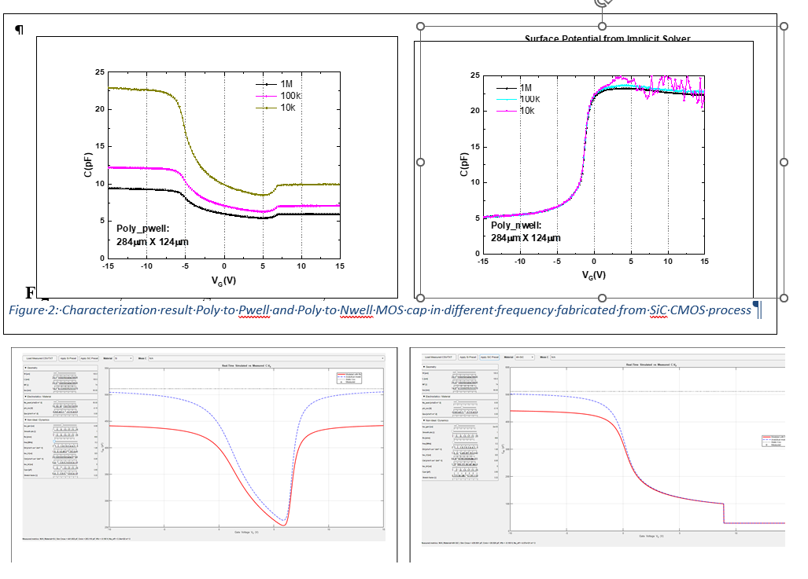
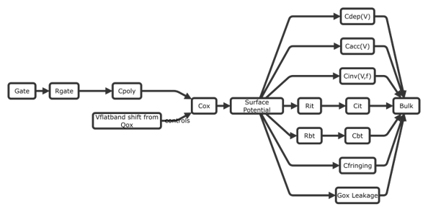
Fig. 2: SPICE equivalent model with non-ideal effects
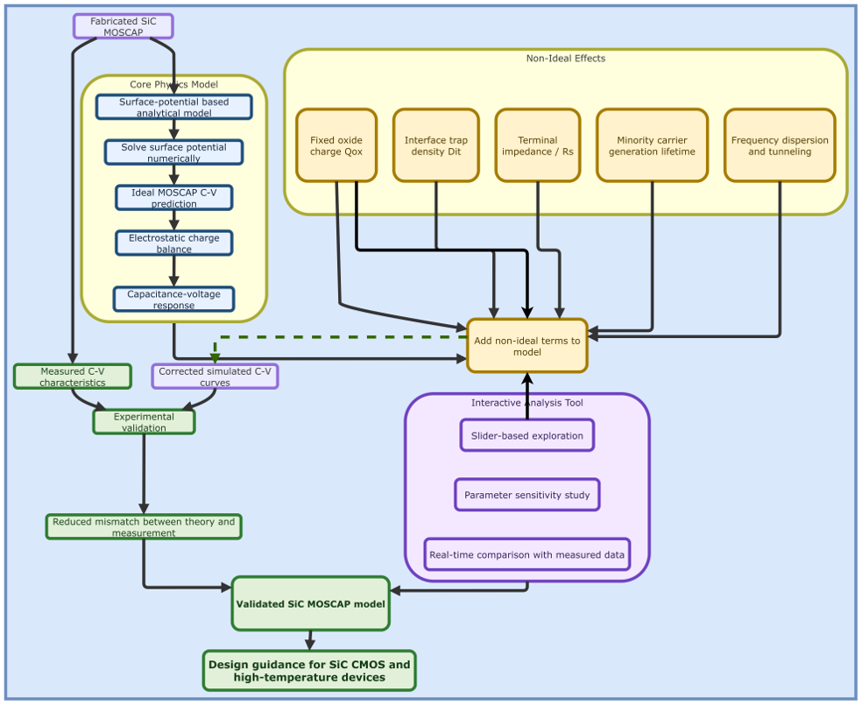
Fig. 3: Summary of the proposed Surface potential based MOSCAP model with Non-Ideal Behavior of SiC Device.

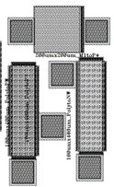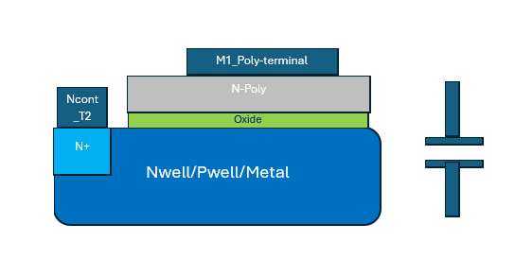
Fig. 1: Layout and Device Structures.
Figure 1: Measured result at different frequencies and Interactive tool for visualization
Conclusion:
This study bridges the gap between theoretical models and practical device behavior in SiC MOSCAPs. By developing an analytical surface potential model validated by experimental data, we demonstrated that incorporating non-ideal effects—such as fixed oxide charge, terminal impedance, and interface traps—is critical for accurate device characterization. Supported by a newly developed visualization tool, these findings provide a vital foundation for advancing the design and optimization of high-performance SiC CMOS processes.
Reference:
A. S. M. K. Hasan, M. M. Hossain, M. Z. Islam, M. Majharul Islam, S. Ahmed and H. Alan Mantooth, "Temperature Scaling and C–V Modeling of SiC Low-Voltage MOSFETs for IC Design," in IEEE Journal of Emerging and Selected Topics in Power Electronics, vol. 13, no. 1, pp. 335-347, Feb. 2025, doi: 10.1109/JESTPE.2024.3482971

