Working with Newman

# What is Newman:

Newman is an API collection runner which works from command-line. It allows you to run and test a Postman Collection directly from the command line. It is built with extensibility in mind so that you can easily integrate it with your continuous integration servers and build systems.

# Why use Newman:

Newman maintains feature parity with Postman and allows you to run collections the way they are executed inside the collection runner in Postman.

Newman resides in the [NPM registry](https://www.npmjs.org/package/newman) and on [GitHub.](https://github.com/postmanlabs/newman)

We can show the report in proper way using Newman and using command line operation is becoming popular day by day.

# Installing process of Newman:

Newman is built on Node.js. To run Newman, make sure you have Node.js installed. You can [download](http://nodejs.org/download/) [and install](http://nodejs.org/download/) Node.js on Linux, Windows, and Mac OSX.

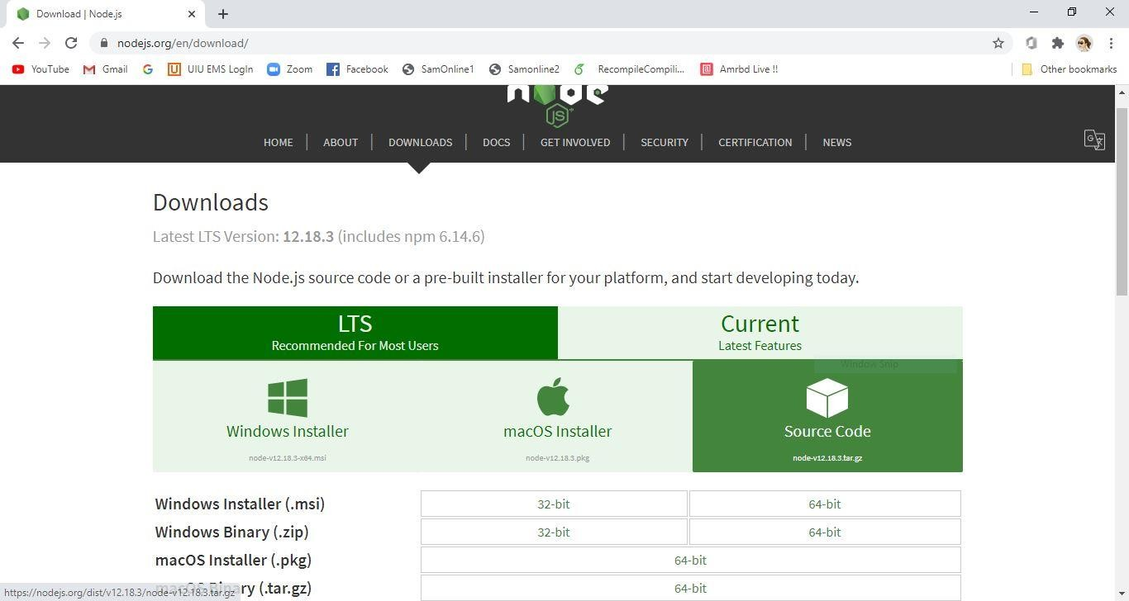

Picture 1: Newman Install (1)

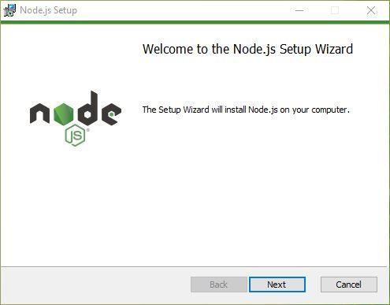

Picture 2: Newman Install (2)

Now we need to go to command prompt of our windows operating system. Then write **‘node -v’** and

**‘npm -v’** to see weather is it successfully install or not.

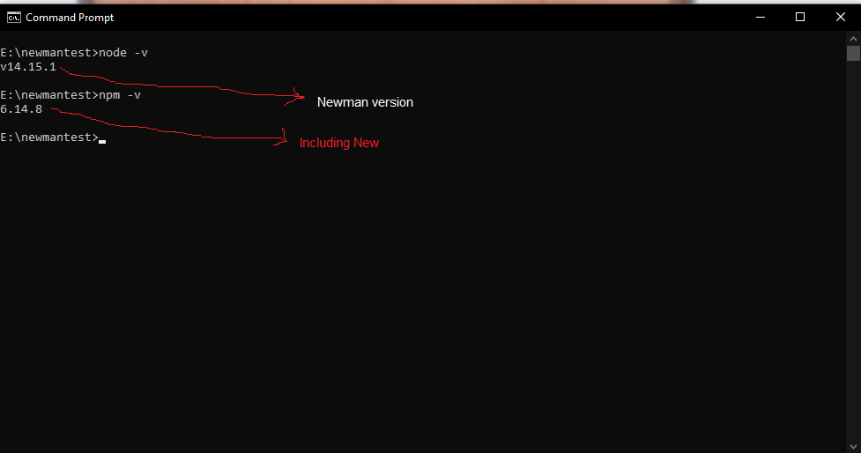

Picture 3: Check Node.js version

These sure that Node.js is successfully installed.

Now install the Newman with command **‘npm i -g newman’**

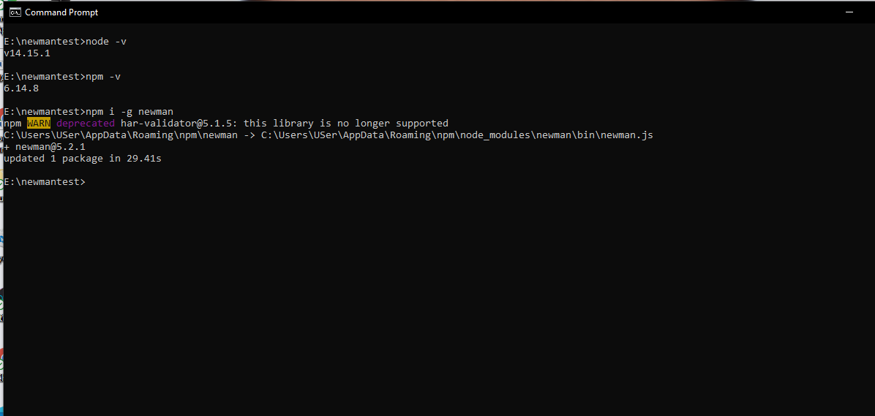

Picture 4: Install Newman

Now we will run the collection of APIs from Newman. We need an exported json file of API collection from postman.

Our file name: **Collection1.postman_collection.json**

Directory: **E:\open**

In this location my exported collection file with json format is located.

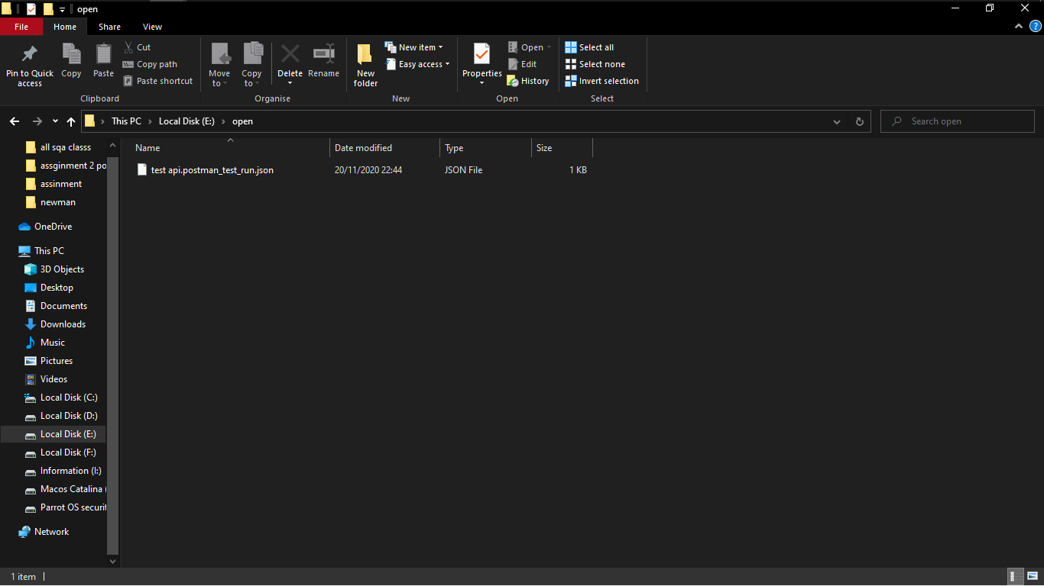

Picture 5: Collection file location

Now again go to the command prompt. Go to this location with command.

Our current directory is C\user\User> (Here User is username). But our file is in E:\open.

So, we need to go there. If I save file on C drive suppose in desktop then I can easily move with command ‘cd (that file location)’.

In my case I have to go E directory.

## Write command:

1. **C:\Users\User>cd/**
2. **C:\>E**
3. **E:**
4. **E:\>dir**
5. **E:\>cd open**
6. **E:\open>**

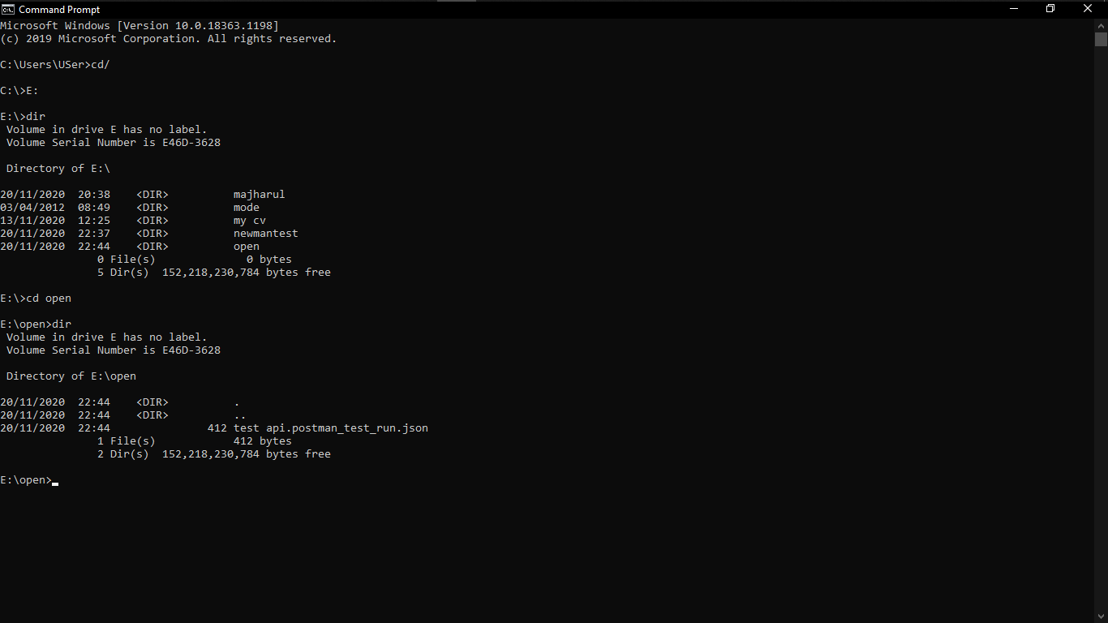

Picture 6: Directory change Then the directory will change. Now we are in **E:\open**

We can easily save the file in C drive just because run in Newman will become easy. But this is not good practice. We should always try to free our C drive as possible.

Now run the collection file.

Write command **‘newman run Collection1.postman_collection.json’**

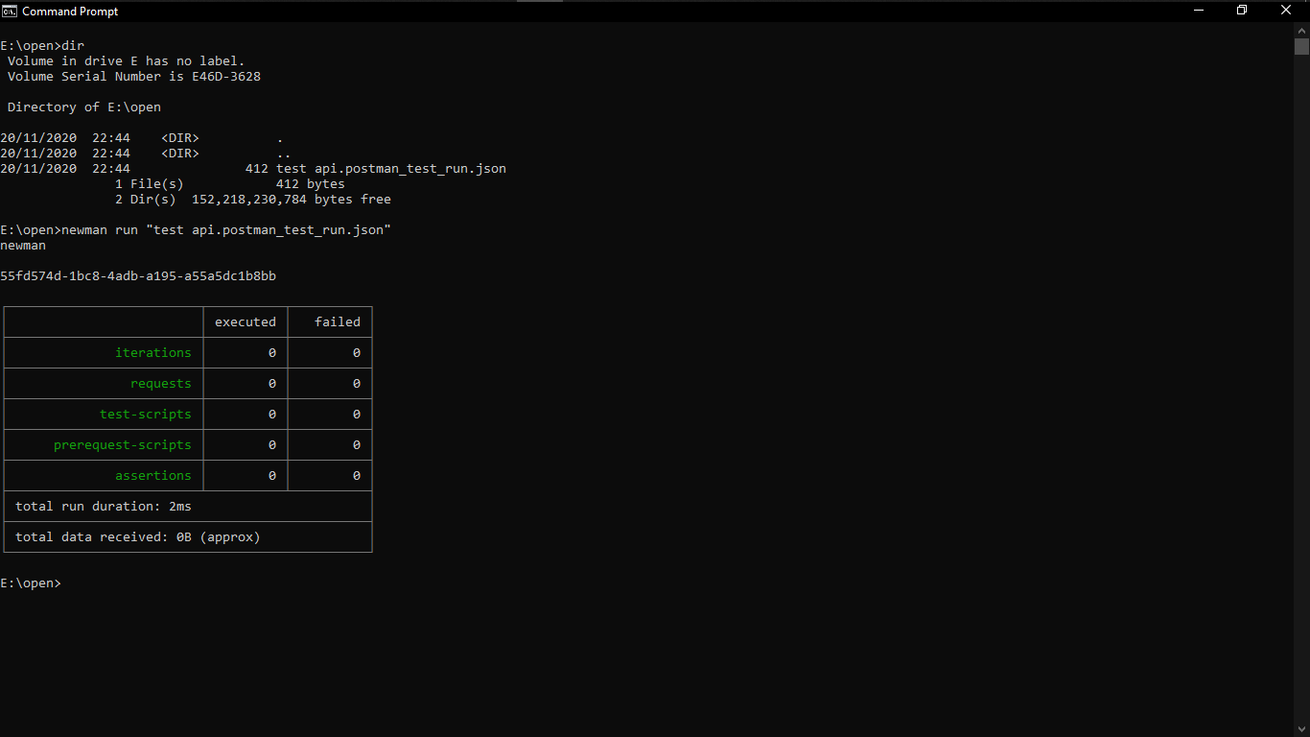

Picture 7: Run collection and get report