## 下载源码

git clone --branch v5.2.8.RELEASE <https://gitee.com/Z201/spring-framework.git>

## 修改settings.gradle文件

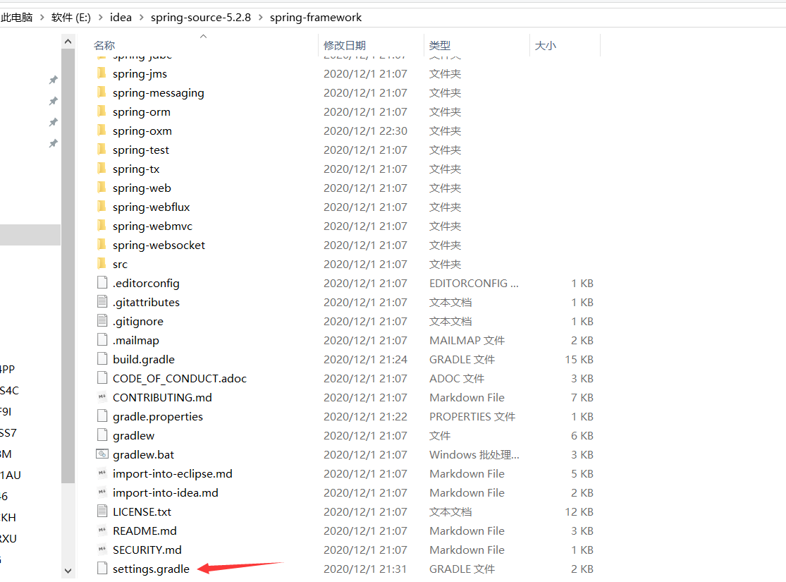

repositories {  
 gradlePluginPortal()  
 maven { url 'https://maven.aliyun.com/repository/public' }  
 maven { url 'https://repo.spring.io/plugins-release' }  
}

## 修改gradle.properties文件

version=5.2.8.RELEASE  
org.gradle.jvmargs=-Xmx2048M  
org.gradle.caching=true  
org.gradle.parallel=true  
org.gradle.configureondemand=true  
org.gradle.daemon=true

## 修改build.gradle文件

maven { url 'https://maven.aliyun.com/nexus/content/groups/public/' }  
maven { url 'https://maven.aliyun.com/nexus/content/repositories/jcenter'}

## gradlew :spring-oxm:compileTestJava

编译spring-oxm模块

编译成功后的截图

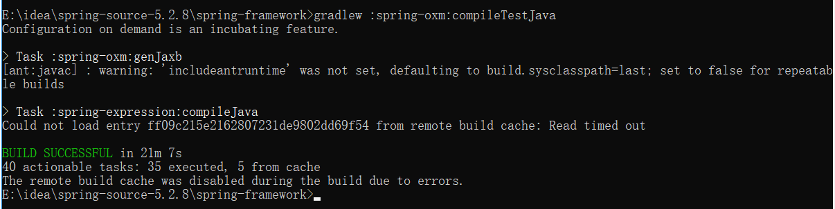

## 6、IDEA导入Spring源码

File -> New -> Project from Existing Souces...

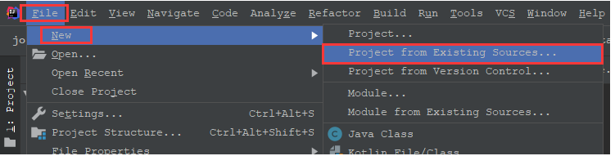

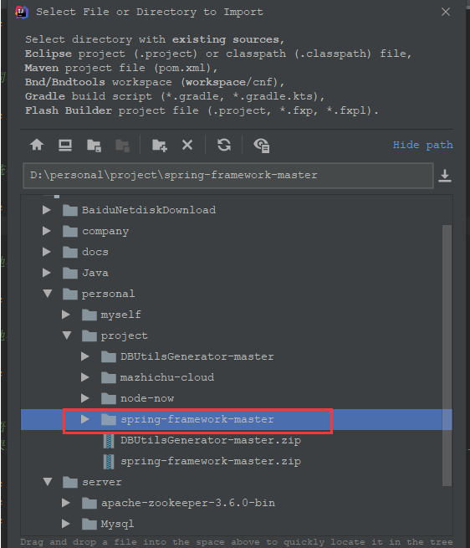

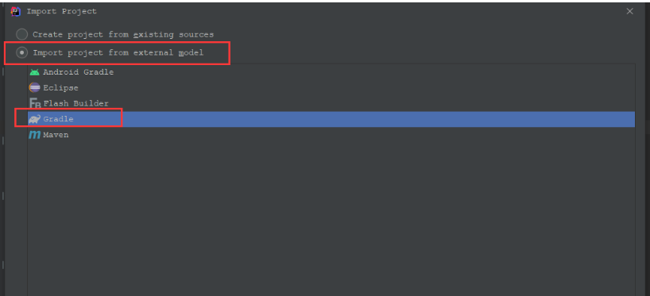

成功后的截图

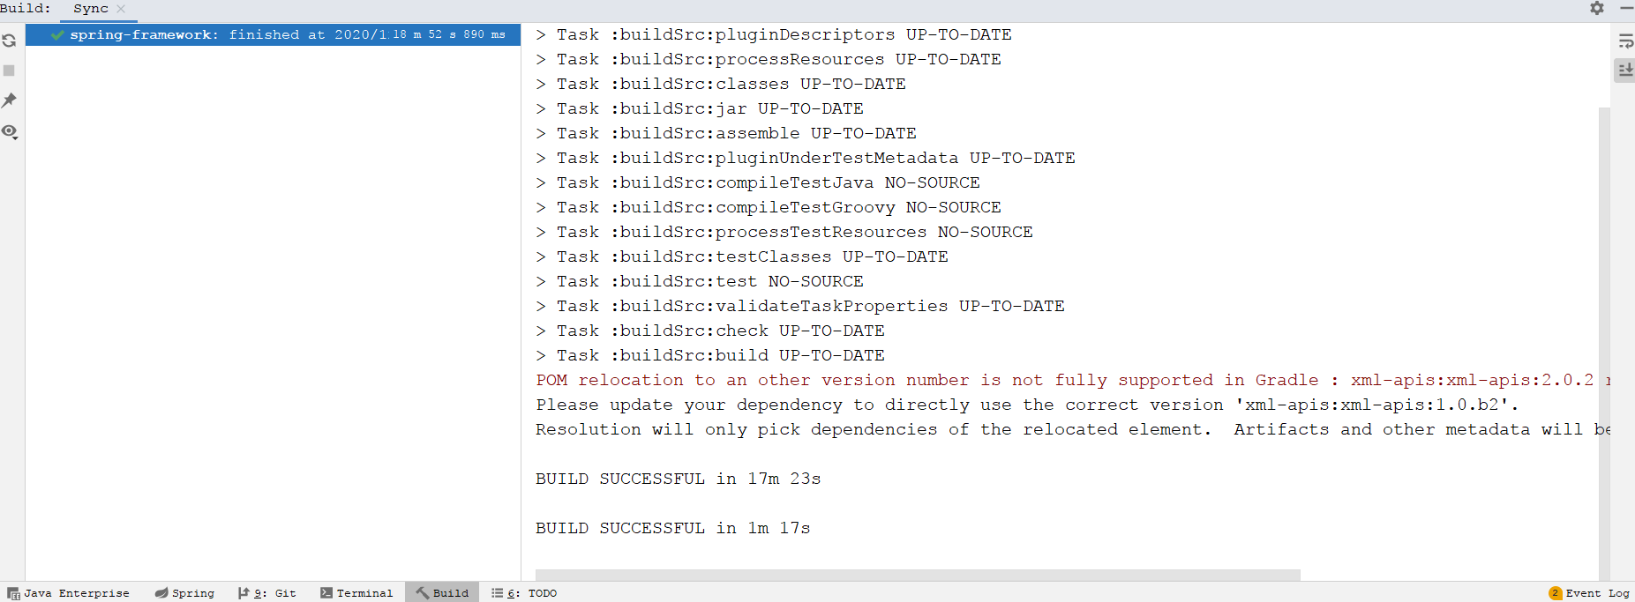

## 7、Idea kotlin插件安装

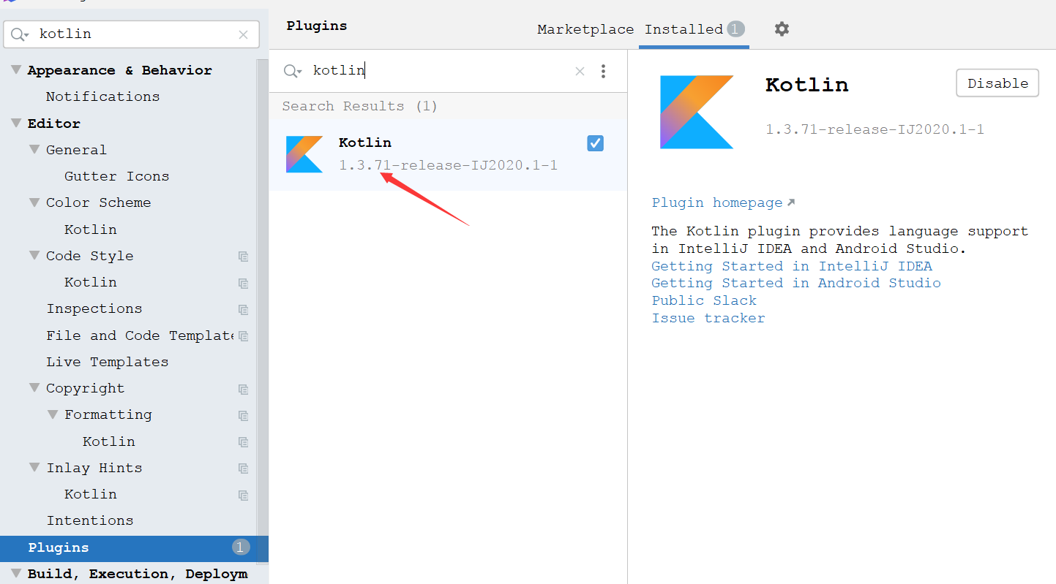

## gradle安装

配置gradle环境变量

新增GRADLE_HOME

