**Steps Taken**

1. Loaded the data set as a data frame (118,987 observations).
2. Identified 715 data points where both weekend and weeknights equal zero.
   1. Since these are both variable in our model, we will remove these data points.
3. 4 data points have children as NA (model should ignore)
4. 403 data points where adult variable equals zero (removed these data points)
   * 645 data points remained with weekend and weeknights both are zero.
   * **UNABLE TO REMOVE THESE 645 DATA POINTS (help appreciated)**
5. Replaced 1169 Undefined with SC
6. Ran Linear Regression using numerical variables (just for perspective)
7. Initial Exploratory Logistic Model
8. **Renamed Dataset and converted categorical values to factors.**
   1. Date Year, Date Month, Meal, Country, Market Segment, Distribution Channel, Customer Type
9. Added Season Variable (Dec, Jan, Feb = Winter etc…)
10. NEW **Exploratory Model**

1. **Lead time should be scaled in further regression analysis.**

1. Split data in to Canceled/Not-Canceled as well as Hotel/City datasets
2. Visual of Cancelation ratios by Meal Plan type. *Plenty more visuals can be made.*

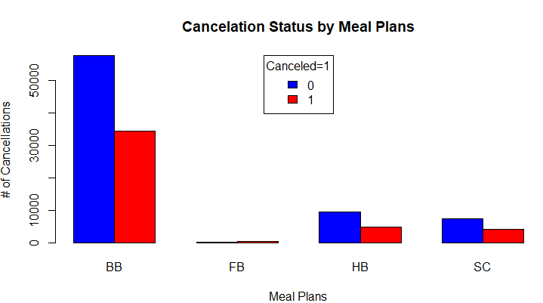

1. **Correlation Matrix with significance above 0.5**

