1. Several variables had long tails, confirming the need for scaling.

1. Cancelation ratios by Meal Plan type: ratios are similar for all except FB type, but there are fewer observations.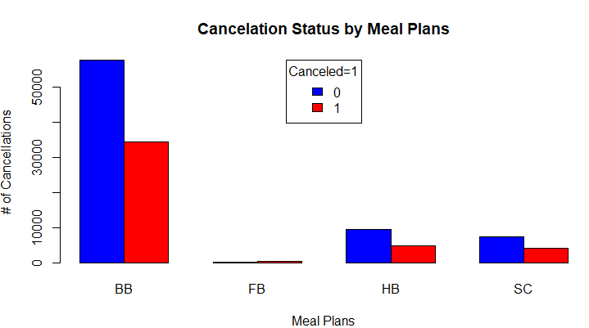
2. Cancelation ratios by Season for the two hotels in the primary dataset.Chart, bar chart

   Description automatically generated
3. Overall correlation matrix

1. Correlation funnel of primary dataset Table

   Description automatically generated