高考英语读后续写专题（五）
一：典题技法指导
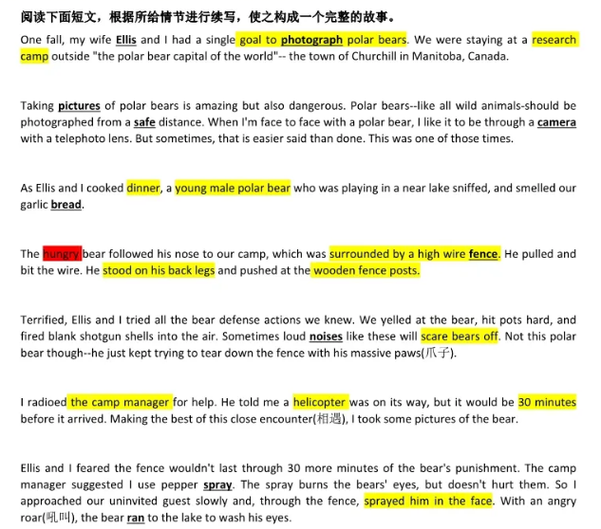
1. 所续写短文的词数应为150左右；
2. 应使5个以上短文中标有下划线的关键词语；
3. 续写部分分为两段，每段的开头语已为你写好；
4. 续写完成后, 请用下划线标出你所使用的关键词语。
Paragraph 1: A few minutes later, the bear headed back to our camp.

Paragraph 2: At that very moment, the helicopter arrived.

写作思路
1. 确定主题：大主题是人与自然。故事主要内容是夫妻偶遇北极熊自救，最后感悟人与动物的关系，体谅动物的生存环境。hungry是关键词，可以思考什么原因导致饥饿？人类的活动是否是主要原因？人类应该做些什么？
2. 时空变化：没有大的时空转换，making dinner时，短时间内发生在营地篱笆附近的险情。危急时，正好直升飞机赶到。
3. 续写难点：情节比较简单，但想象的空间很大。一般的处理方法是侧重细节描写，心理活动与情感描写，平时需要积累一定量的能表现人物情绪与心理的具体动作词汇。
提纲
Paragraph 1: A few minutes later, the bear headed back to our camp.
1. He exposed his sharp teeth, snarling at us, as he ran forward.
2. And again the furious creature stood on his back legs and began to snap at the fence like a demon.
3. It seemed that his mouth was dripping with blood and his eyes were red with rage.
4. At the sight of it, I could feel a flicker of fear flooding over me, and Ellis was stunned, her mouth hanging open.
5. It was only then that my mind began to race.
6. Once again, I plucked my courage to blast him with pepper spray, but without success.
7. Then all of a sudden, came a crash of the fence falling down.
Paragraph 2: At that very moment, the helicopter arrived.
1. It landed in a clearing, not far from our camp, and the loud noises from the rescue helicopter scared the bear.
2. For an instant, he froze, but after a while, he started to charge at us again.
3. "Ellis!" I shrieked, "Look out!"
4. We immediately stepped aside, spun round and galloped towards the helicopter.
5. The moment we were into the helicopter, we collapsed, gasping with relief.
6. As it took off, we could see the bear was hungrily eating the bread we had made.
7. What a hungry bear! After we returned home safe and sound, we realized that something should be done for bears.
参考范文
Paragraph 1: A few minutes later, the bear headed back to our camp. He exposed his sharp teeth, snarling at us, as he ran forward. And again the furious creature stood on his back legs and began to snap at the fence like a demon. It seemed that his mouth was dripping with blood and his eyes were red with rage. At the sight of it, I could feel a flicker of fear flooding over me, and Ellis was stunned, her mouth hanging open. It was only then that my mind began to race. Once again, I plucked my courage to blast him with pepper spray, but without success. Then all of a sudden, came a crash of the fence falling down.
Paragraph 2: At that very moment, the helicopter arrived. It landed in a clearing, not far from our camp, and the loud noises from the rescue helicopter scared the bear. For an instant, he froze, but after a while, he started to charge at us again. "Ellis!" I shrieked, "Look out!" We immediately stepped aside, spun round and galloped towards the helicopter. The moment we were into the helicopter, we collapsed, gasping with relief. As it took off, we could see the bear was hungrily eating the bread we had made. What a hungry bear! After we returned home safe and sound, we realized that something should be done for bears.
二：课后练习
A man came home from work late, tired and irritated(不耐烦的), to find his 5-year-old son waiting for him at the door.
“Daddy, may I ask you a question?”
“Yeah sure, what is it?” replied the man.
“Daddy, how much do you make an hour?”
“That’s none of your business. Why do you ask such a thing?” the man said angrily.
“I just want to know. Please tell me. How much do you make an hour?” pleaded the little boy.
“If you must know, I make $20 an hour.”
“Oh,” the little boy replied, with his head down. Looking up, he said, “Daddy, may I please borrow $10?”
The father was angry, “If the only reason you asked that is that you can borrow some money to buy a silly toy or some other nonsense, then you march yourself straight to your room and go to bed. Think about why you are being so selfish. I work hard every day for such childish behavior.” The little boy quietly went to his room and shut the door. The man sat down and started to get even angrier about the little boy’s questions. “How dare he ask such questions only to get some money?” he thought to himself. After about an hour or so, the man calmed down, and started to think: Maybe there was something he really needed to buy with that $10 and he really didn’t ask for money very often. The man went to the door of the little boy’s room and opened the door. “Are you asleep, son?” he asked.
“No, daddy, I’m awake,” replied the boy.
“I’ve been thinking, maybe I was too hard on you earlier,” said the man. “It has been a long day and I took out my anger on you. Here’s the $10 you asked for.”
The little boy sat straight up, smiling. “Oh. Thank you, daddy!” he yelled. Then, reaching under his pillow he pulled out some crumpled(皱巴巴的) bills.
注意:
1.所续写短文的词数应为150左右;
2.至少使用5个短文中标有下划线的关键词语;
3.续写部分分为两段,每段的开头语已为你写好;
4.续写完成后,请用下划线标出你所使用的关键词语。
Paragraph 1: The man, seeing that the boy already had money started to get angry again.
___________________________________________________________________________
Paragraph 2: Not knowing what his son meant, the father just stood there, waiting for his boy’s explanation.
___________________________________________________________________________
参考答案:
Paragraph 1: The man, seeing that the boy already had money started to get angry again. “How can you be so selfish? Why do you want more money since you already have these bills?” the father could hardly hold his anger back and inquired with two eyebrows knitted into one. With holding back tears in his eyes, the little boy slowly and carefully counted out his money, and then looked up at his father, replying, “Because I didn’t have enough before, but now I do.” with big blue eyes shining with tears.
Paragraph 2: Not knowing what his son meant, the father just stood there, waiting for his boy’s explanation. Wiping away his tears and an innocent smile appearing on his face, the boy requested in a relieved voice, “Daddy, I have $20 now. Can I buy an hour from you? Please come home early tomorrow. I want to have dinner with you.” Hearing the boy’s small but sincere request, the father couldn’t hold back his tears. Realizing he was too busy with his business to spare some time with his beloved ones, he gathered his son into his arms and apologized again and again, “Sorry..., and I promise I’ll be back early tomorrow.”

