高考英语读后续写专题（六）
一：典题技法指导
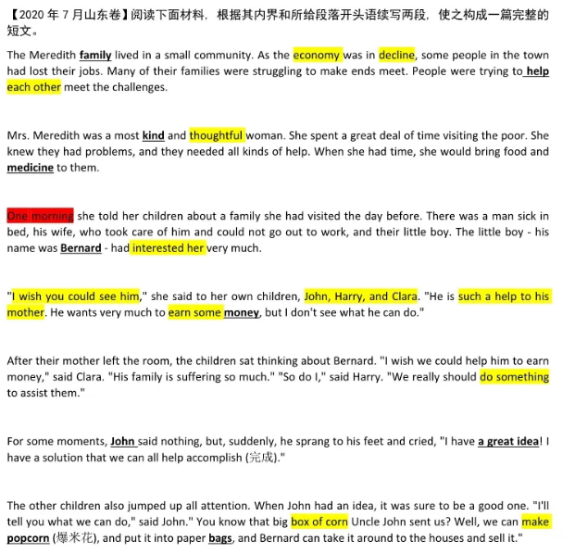
1. 所续写短文的词数应为150左右；
2. 应使5个以上短文中标有下划线的关键词语；
3. 续写部分分为两段，每段的开头语已为你写好；
4. 续写完成后, 请用下划线标出你所使用的关键词语。
Paragraph 1: When Mrs. Meredith heard of John's idea, she thought it was a good one, too.

Paragraph 2: With everything ready. Bernard started out on his new business..

写作思路
1. 确定主题：大主题是人与社会。故事主要内容是Mrs. Meredith希望孩子们帮助一个困难家庭，儿子John想出好方法。孩子们一起准备做爆米花送给Bernard，让他卖爆米花挣钱。
2. 时空变化：有一些时空转换的设定。第一段可以设定在上午发生在家里做爆米花。第二段可以将时间设定在午饭后至晚上这一段时间。
3. 续写难点：情节比较简单，但想象的空间很大，须设定波折。一般的处理方法是侧重细节描写，心理活动与情感描写，平时需要积累一定量的能表现人物情绪与心理的具体动作词汇。
提纲
Paragraph 1: When Mrs. Meredith heard of John's idea, she thought it was a good one, too.
1. With her support, the children made a plan to put the idea into action.
2. "Harry, go next door to borrow a popcorn machine! Clara, fetch some corn for popcorn!" John said excitedly before he went to the store to buy some seasonings and some paper bags.
3. Shortly after, they returned and gathered in the kitchen.
4. Cautiously, John put some corn in the machine and switched it on.
5. For a moment, none of them spoke and they waited and waited, it seemed, for several hours.
6. Then suddenly came the amazing sounds of corn popping, and all of them clapped and jumped with great joy.
7. The whole morning, the children made 30 bags of popcorn in all, and then after lunch, they carried them to Bernard's.
Paragraph 2: With everything ready. Bernard started out on his new business.
1. They went to a busy street and started to cry for sale, "Popcorn, popcorn..."
2. But to their disappointment, it turned out that no one came to buy their popcorn.
3. When evening fell, their spirits sank.
4. Exhausted and hungry, they decided to go back home, not knowing what to do with 30 bags of popcorn.
5. Just then, a good idea popped into John's head and he exclaimed, "Aha! We can sell popcorn outside the gate of the cinema."
6. Sure enough, 30 bags of popcorn sold out almost immediately as they called out, "Buy two and get one free..."
7. With the money in his hand, Bernard thanked them for their generous help, tears of gratitude welling up in his eyes.
参考范文
Paragraph 1: When Mrs. Meredith heard of John's idea, she thought it was a good one, too. With her support, the children made a plan to put the idea into action. "Harry, go next door to borrow a popcorn machine! Clara, fetch some corn for popcorn!" John said excitedly before he went to the store to buy some seasonings and some paper bags. Shortly after, they returned and gathered in the kitchen. Cautiously, John put some corn in the machine and switched it on. For a moment, none of them spoke and they waited and waited, it seemed, for several hours. Then suddenly came the amazing sounds of corn popping, and all of them clapped and jumped with great joy. The whole morning, they made 30 bags of popcorn in all, and then after lunch, they carried them to Bernard's.
Paragraph 2: With everything ready. Bernard started out on his new business. They went to a busy street and started to cry for sale, "Popcorn, popcorn..." But to their disappointment, it turned out that no one came to buy their popcorn. When evening fell, their spirits sank. Exhausted and hungry, they decided to go back home, not knowing what to do with 30 bags of popcorn. Just then, a good idea popped into John's head and he exclaimed, "Aha! We can sell popcorn outside the gate of the cinema." Sure enough, 30 bags of popcorn sold out almost immediately as they called out, "Buy two and get one free..." With the money in his hand, Bernard thanked them for their generous help, tears of gratitude welling up in his eyes.
二：课后练习
To celebrate his girlfriend’s birthday, Luke Fortune drove from a small town in Central Oregon to Portland, where he parked his car in a paid garage overnight. The next morning, he discovered that the car’s window had been smashed, along with his dreams for the future: His backpack and computer were gone.
“Everything important to me was on that computer,” said Fortune, 21, who is studying to become a paramedic(护理人员). “My classwork, every paper I’d written, and all the programs I needed for my paramedic tests. Every letter I was working on for job applications. I felt sick.”
Two days after the theft, another young man was standing outside his apartment, also in Portland. Masoud Almazrouei, 29, is an exchange student from the United Arab Emirates. He had been approached by a man who said he had a computer for sale. Only $200. Almazrouei, who had been in the United States for only a year, admits now that he was naive(天真). But he needed a computer, so he bought it, took it home, and turned it on. Within seconds, he saw files and photographs.
“I wondered who would sell a computer with all of this on it,” he said. “I realized it could be stolen.” Almazrouei found what appeared to be the owner’s cellphone number and called it.
“This guy with a thick accent told me he had my computer,” Fortune said. “He told me the story and said it was his fault. I thought it was a scam(骗局). I told him if he really had the computer, he should take it to the police.”
Soon after, a police officer called Fortune to say that a man had dropped the computer off and had said he was sorry. He passed along the man’s number.
注意:
1.所续写短文的词数应为150左右;
2续写部分分为两段,每段的开头语已为你写好;
Paragraph 1:Fortune called and thanked Almazrouei and insisted on paying him a reward of $200, the money he was out.
__________________________________________________________________________
Paragraph 2: A story about the two young men’s encounter made it to the local papers.
___________________________________________________________________________
参考答案
Paragraph 1: Fortune called and thanked Almazrouei and insisted on paying him a reward of $200, the money he was out. Almazrouei refused. He said it was his mistake to buy the computer from someone he didn’t know and he was the one to shoulder the responsibility. More importantly, he said, it was his honor to return the property to the rightful owner. “I saw a photo of this man in his paramedic uniform,” Almazrouei said. “They help people. He is a good man. I don’t want my money back.”
Paragraph 2: A story about the two young men’s encounter made it to the local papers. Overnight, Almazrouei became a household name and received numerous compliments for his honesty and kindness. One day he got a call from the president of Portland State University, where Almazrouei is studying economics. Impressed with his student’s integrity, the president gave Almazrouei a new MacBook Pro. “We thought since you gave back the laptop, we should give you a laptop so that you’ll have one,” He told Almazrouei. “We’re very proud of you. It was a great story, and you did the right thing.”

