**应用文15 图画类**

**真题回顾**

假设你是红星中学高三学生李华。你们班上周组织了一次以“劳动最光荣”为主题的社会实践活动。请根据以下四幅图的先后顺序，写一篇英文周记，记述整个过程。

注意：词数不少于60。

提示词：西瓜watermelon

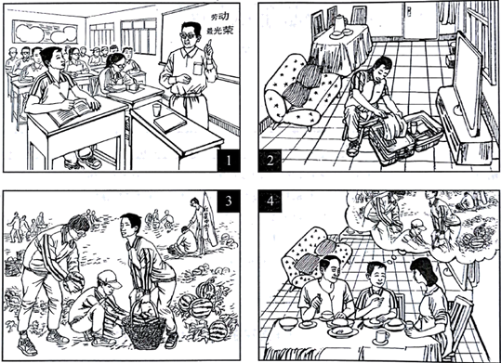

________________________________________________________________________________________________________________________________________________________________________________________

【写作指导】

本写作主要以“劳动最光荣”为主题，贴合实际生活，四幅图的要点分别是“老师在黑板上写下活动主题‘劳动最光荣'”，“打包行李出发去乡 下”，“在乡下摘西瓜”“和家长吃饭，回忆劳动历程”;考生切忌在文章开篇犯低级语法错误，在保证要点齐全的前提下，适当添加细节，并且要注意句式的多样性及用词的准确性和丰富性，适当增加长难句的使用，如对非谓语动词、三大从句及特殊句式进行灵活运用，同时注意逻辑的流畅性。

【参考范文】

Last week I took part in a farmwork programme in the suburbs.

At the class meeting, our teacher told us about the programme with the theme “Working is most beautiful”. And he stressed the importance of working with our own hands.

When I got home, I packed up my luggage for the trip.

On the farm, we helped pick watermelons. While working, I realised how hard it was to work in the fields under a hot sun.

When I came back home, I shared my experiences with my parents. And they were very proud of me.



**1. 用于描述图画或引入话题的句式：**

(1)As is described/illustrated/shown in the picture...

(2)In the picture we/I can see…

**2. 用于记叙事件经过或分析现象的语句：**

(1)At first...Then...Five minutes later...Finally/In the end...

(2)Some...; some...; others...

(3)More and more people have come to realize the importance of...

**3. 用于发表议论或进行总结的语句：**

(1)If such measures were not taken, the problem would be more serious.

(2)We can conclude from the picture that...

(3)As has been stated, we must...

必背模板

模板

It seems to me that the cartoon / drawing is sending a message about ____________(图画内容)，which reveals ____________(稍作评价)

There　are　at　least　two　good　reasons accounting for ______. For one thing, ____________(从社会角度论证). For another thing, ____________(从个人角度说明). For example, ____________(自己、朋友或他人，只要自己知道或听过的例子).Last but not least, ____________(从反面角度谈论).

As a result, the drawer of the illustration is urging us to _____________(建议或措施).Only in this way can we ____________(展望结果).In conclusion / To my understanding, ____________(再次表明观点或态度). We should ____________(进一步说明个人的观点).

思路点金

**1.描述漫画：**  
As is vividly depicted in the cartoon given above, we can observe that…  
或As is vividly shown in the picture, we can see that……  
或As we can see from the picture,…  
**2. 描述漫画本质/内涵**Apparently, the picture reflects/reveals that ……  
或The cartoon informs us of the phenomenon that……

**3. 出现的问题或现象的原因(或者导致的影响)：**

**原因**(1)We believe that three reasons can account for this phenomenon. First,____. Second, ____. Third, _____.

(2)Reasons for …… are in abundance.或The reasons for this phenomenon are as follows. Firstly,____. Secondly, ____. Thirdly, _____.

(3)There　are　at　least　two　good　reasons accounting for ______. On　the　one　hand, ________. On　the　other　hand,　_______ is　due　to　the　fact　that ________.

**影响：**

(1)What contributed to these changes? I think the reasons are as follows. To start with, ④______. Secondly, ⑤______ . What’s more, ⑥ _______. Last but not least, ⑦________.

(2)So far as I’m concerned, I believe that such phenomenon will give rise to a series of consequences. First and foremost, it will exert a far-reaching / negative impact on...... ; Besides, it may bring about a considerable change/damage to...... . One more point that can’t be ignored is that ...... .

**4. 个人观点(提出措施/建议)**：

Therefore, immediate measures should be taken to …. To begin with,…….. What’s more,……. Last but not least,……

或It is high time that strict measures were taken to stop ...

或It is necessary that steps should be taken to ...

或To solve the above-mentioned problem, we must ...

From what has been discussed above, we can draw the conclusion that ...

或In conclusion, it is imperative that ...

或In summary, if we continue to ignore the above-mentioned issue, more problems will crop up.

或With the efforts of all parts concerned, the problem will be solved thoroughly.

或We might do more than identify the cause ;it is important to take actions to ...

或Taking all these into account, we ...

或Whether it is good or not /positive or negative, one thing is certain/clear...

或Given all the above factors, it is safe to reach the conclusion that …

或Taking into account all the above factors, it is reasonable to reach the conclusion **that …**

**必背范文**

(2020届北京朝阳区高三上学期期中) 假设你是红星中学高三学生李华。请根据以下四幅图的先后顺序，介绍上周末你陪同交换生游览长城的完整过程，并以“Our Trip to the Great Wall”为题，给校刊“英语角”写一篇英文稿件。词数不少于60。

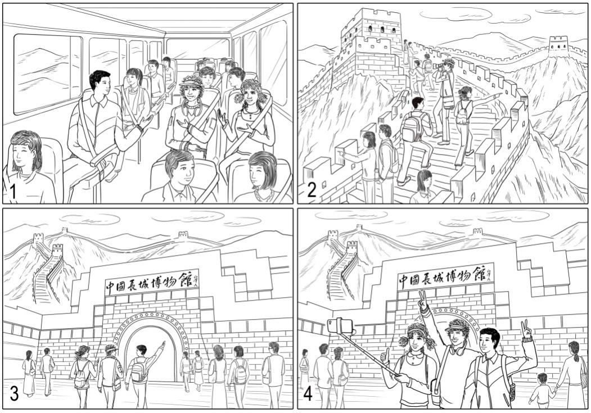

**Our Trip to the Great Wall**

____________________________________________________________________________________________________________________________________________________________________________________________________________________________________________________________________________________________________________________________________________________________________________________________________________________________________________________________________________

【参考范文】

Our Trip to the Great Wall

Last weekend, I accompanied two exchange students to the Great Wall, which proved to be a very pleasant trip.

Early on Saturday morning, we got on the bus happily. Everyone was excited, discussing what we had known about the Great Wall, including anecdotes and legends. Two hours later we got to our destination, and everyone couldn’t wait to start climbing. We spent the next few hours on the Great Wall, stopping from time to time to take photos and appreciate its magnificence as well as the breathtaking scenery around it. Then we went to the Great Wall Museum nearby. It contains exhibitions showing the history of the Great Wall and the social landscape along it, from which we got a better understanding of the Great Wall. Time passed quickly! It was noon before we knew it. Before leaving, we took a group selfie to record this unforgettable moment. Excitement was written on everyone’s face.

It was really an impressive trip and I really felt proud of this world wonder.