#### CSci 5715, Fall 18: Homework 1

#### Due on 9/20 before class.

In-class students: hard copy; UNITE students: Email.

#### Table of Participation

|  |  |  |
| --- | --- | --- |
| Question ID | Answer drafted by | Answer reviewed by |
| 1 |  |  |
| 2 |  |  |
| 3 |  |  |
| 4 |  |  |
| 5 |  |  |

#### Chapter 1: Introduction to Spatial Databases

Answer **one** of the following choices for question 1 (limit 200 words):

**Q1 (Choice A):** The internet creates a virtual world where people can meet friends (e.g., Hangouts), watch movies (e.g., Netflix), take courses (e.g., Coursera), share and edit notes together (e.g., google docs), go shopping (e.g., Amazon.com), and visually explore places (e.g., hololens) irrespective of locations. Does geography still matter? Justify your answer.

Two hundred thousand years of human evolution, and indeed hundreds of millions of years of animal evolution before that, have ingrained spatial processing into our brains. Our sense of sight, hearing, touch, and smell are processed through a spatial lens, telling us the appearance, location, and dimensions of people and objects. While many problems have been solved through virtualization, I believe that we are very reliant on geography and that we still have much to learn about how we subconsciously process it.

In the case of making friends, I find that many social cues developed under a 3 dimensional representation get lost even over video or audio, let alone text. Geographic presence is necessary here. While shopping, I often hold back from purchasing items that I decide I would like to try on first, or try them on in the store before ordering them online. Movies may be one area where virtual worlds have overtaken physical, but keep in mind that these were already “virtual” constructs designed for two dimensions. For these and many other examples, I do believe that geography still has an important role to play.

#### Chapter 2: Spatial Concepts and Data Models

**Q2:** Given the map of county level mortality rate (in quantiles) of breast cancer in Florida, answer the following questions.

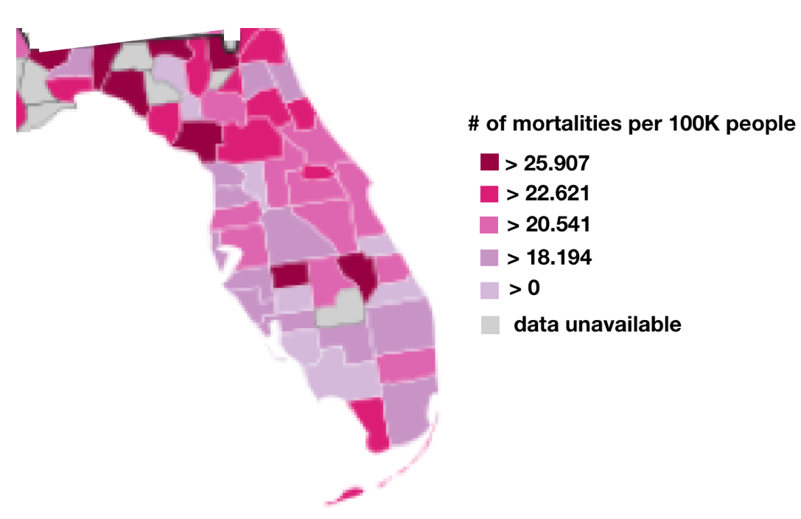

What type of operations (local, focal, or zonal, global) should be used to answer the following queries?

|  |  |
| --- | --- |
| **Query** | **Type of Operation** |
| * 1. How many cells have mortality rate higher than 20.541 per 100K people? | global |
| 1. What is the mortality rate of the county “Nassau”? | local |
| 1. If a county has a rate higher than 22.621, but all its neighbors have rates lower than 22.621, we consider it as a spatial outlier. Which counties are spatial outliers? | focal |

**Q3:** Fill out the following form with Boolean nine-intersection matrices each with two spatial objects namely A and B. In the upper row, A is a polygon, B is a line. In the lower row, both A(Red) and B(Blue) are lines. The boundary of a line is its end points

|  |  |  |  |  |
| --- | --- | --- | --- | --- |
| Map | A  B | A  B | B  A | B  A |
| Nine-intersection matrix ($Γ_{9}(A,B)$) | $$\left(\begin{matrix}1 & 1 & 1 \\ 1 & 0 & 1 \\ 1 & 1 & 1\end{matrix}\right)$$ | $$\left(\begin{matrix}0 & 0 & 1 \\ 1 & 0 & 1 \\ 1 & 1 & 1\end{matrix}\right)$$ | $$\left(\begin{matrix}0 & 0 & 1 \\ 0 & 1 & 1 \\ 1 & 1 & 1\end{matrix}\right)$$ | $$\left(\begin{matrix}1 & 0 & 1 \\ 1 & 0 & 1 \\ 1 & 1 & 1\end{matrix}\right)$$ |
| Map | B  A | A  B | A  B | A  B |
| Nine-intersection matrix () |  |  |  |  |

Contains

Intersection

n

n

1

1

Has

1

n

Traffic Light

Chapter 3: Spatial Query Languages

**Q4:** The dimension-extended nine-intersection model: DE-9IM extends Egenhofer’s nine-intersection model introduced in Chapter 2. The template matrix of DE-9IM is shown below.

$$Γ_{9}\left(A,B\right)=\left(\begin{matrix}dim⁡(A^{°}∩B^{°}) & dim⁡(A^{°}∩∂B) & dim⁡(A^{°}∩B^{-}) \\ dim⁡(∂A∩B^{°}) & dim⁡(∂A∩∂B) & dim⁡(∂A∩B^{-}) \\ dim⁡(A^{-}∩B^{°}) & dim⁡(A^{-}∩∂B) & dim⁡(A^{-}∩B^{-})\end{matrix}\right)$$

The key difference between 9IM and DE-9IM is that instead of testing whether each entry in the matrix is empty or nonempty; in the DE-9IM only the dimension of the geometric object is required. The dimension of planar two-dimensional objects can take four values: -1 for empty-set, 0 for points, 1 for lines, and 2 for nonzero area objects.

**4a.** Fill out the following form with **dimensional** nine-intersection matrices each with two spatial objects namely A and B (same objects as in Q3). In the upper row, A is a polygon, B is a line. In the lower row, both A(Red) and B(Blue) are lines. The boundary of a line is its end points:

|  |  |  |  |  |
| --- | --- | --- | --- | --- |
| Map | A  B | B  A | A  B | A  B |
| **Dimensional**  Nine-intersection matrix ($Γ_{9}(A,B)$) | $$\left(\begin{matrix}1 & 0 & 2 \\ 0 & -1 & 1 \\ 1 & 0 & 2\end{matrix}\right)$$ | $$\left(\begin{matrix}-1 & -1 & 2 \\ 1 & -1 & 1 \\ 1 & 0 & 2\end{matrix}\right)$$ | $$\left(\begin{matrix}-1 & -1 & 2 \\ -1 & 0 & 1 \\ 1 & 0 & 2\end{matrix}\right)$$ | $$\left(\begin{matrix}1 & -1 & 2 \\ 0 & -1 & 1 \\ 1 & 0 & 2\end{matrix}\right)$$ |
| Map | B  A | A  B | A  B | A  B |
| **Dimensional**  Nine-intersection matrix ($Γ_{9}(A,B)$) | $$\left(\begin{matrix}-1 & -1 & 1 \\ -1 & -1 & 0 \\ 1 & 0 & 2\end{matrix}\right)$$ | $$\left(\begin{matrix}1 & -1 & -1 \\ 0 & -1 & -1 \\ 1 & 0 & 2\end{matrix}\right)$$ | $$\left(\begin{matrix}-1 & -1 & 1 \\ 0 & -1 & 0 \\ 1 & 0 & 2\end{matrix}\right)$$ | $$\left(\begin{matrix}0 & -1 & 1 \\ -1 & -1 & 0 \\ 1 & 0 & 2\end{matrix}\right)$$ |

**4b.** Find the **Boolean** 9-intersection matrix and **dimensional** 9-intersection matrix of the following relationships (a) and (b):

(a) Object A: Hennepin County; Object B: Minnesota

Boolean 9-intersection matrix: $\left(\begin{matrix}1 & 0 & 0 \\ 1 & 0 & 0 \\ 1 & 1 & 1\end{matrix}\right)$

Dimensional 9-intersection matrix: $\left(\begin{matrix}2 & -1 & -1 \\ 1 & -1 & -1 \\ 2 & 1 & 2\end{matrix}\right)$

(b) Object A: Italy; Object B: San Marino

Boolean 9-intersection matrix: $\left(\begin{matrix}0 & 0 & 1 \\ 0 & 1 & 1 \\ 1 & 0 & 1\end{matrix}\right)$

Dimensional 9-intersection matrix: $\left(\begin{matrix}-1 & -1 & 2 \\ -1 & 1 & 1 \\ 2 & -1 & 2\end{matrix}\right)$

Search online for the information of these places. (Hint: Hennepin County is part of Minnesota. San Marino is not part of Italy)

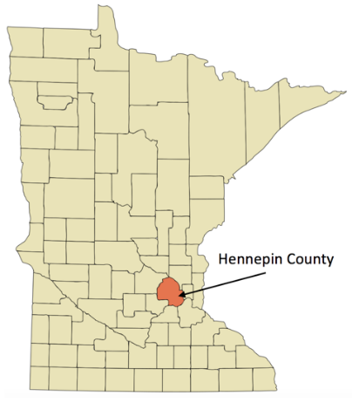

A map of Hennepin County and Minnesota

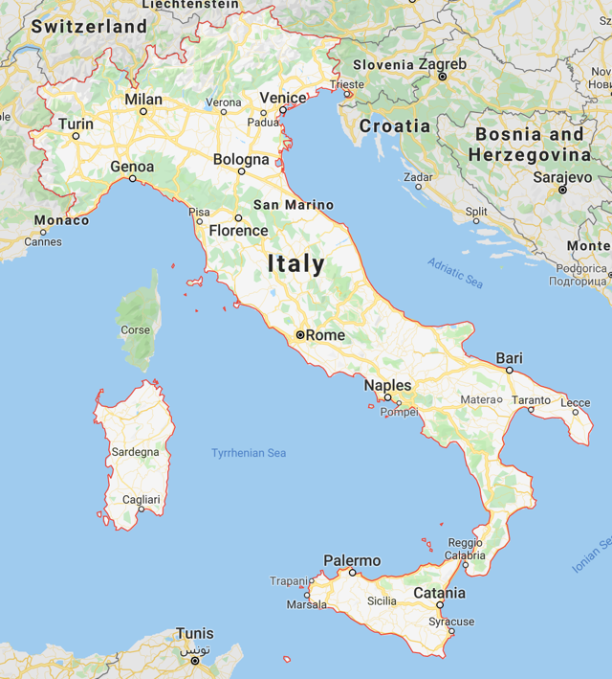

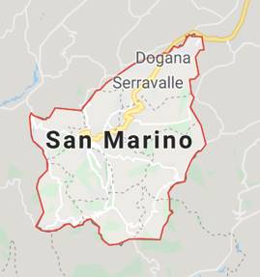

A map of Italy and San Marino

**Q5:** Given the schema:

**US_State** (StateName: varchar, StatePop: integer, StateGDP: float, Shape: Polygon)

**Highway** (HighwayName: varchar, HighwayLength: float, HighwayShape: LineString)

**Gas_Station**(StationID: integer, StationName: varchar, StationShape: Point)

**Restraunts** (RestrauntNo: varchar, RestrauntName: Restrauntchar, CityName: varhchar, HouseShape: Point**)**

where table names are bold (e.g., **City**), and the primary keys are underlined (e.g., CityName), answer the following questions.

**5a.** For the City table, match the corresponding SQL queries and RA queries.

|  |  |
| --- | --- |
| **SQL Query** | **RA query** |
| 1. SELECT St.StateName   FROM US_State St  WHERE St.StateTax > 36.0  AND St.StatePop > 400,000  AND St.StatePop < 600,000; |  |
| 1. SELECT St1.StateName   FROM US_State St1, US_State St2  WHERE St2.StatePop < 600,000  AND St1.StateName LIKE ‘F%’  AND St1.StateTax > St2.StateTax; |  |
| 1. SELECT St1.StateName   FROM US_State St1  WHERE St1.StateName NOT LIKE ALL (  SELECT St2.StateName  FROM US_State St2  WHERE St2.StateTax < 36.0  AND St2.StatePop > 400,000); |  |
| 1. SELECT St1.StateName   FROM US_State St1, US_State St2  WHERE St2.StatePop > 600,000  AND St1.StateName LIKE ‘F%’  AND St1.StateName = St2.SteName | $St1= π_{StateName}\left(US_State\right)$ $$St2=π_{Name}\left(σ_{\begin{aligned}StateTax < 36.0 \\ ^ StatePop > 400,000\end{aligned}}US_State\right)$$ $$St1-St2$$ |

**Note that the RA query for (1) is incorrect , it should select a StatePop < 600,000**

**5b.** Write SQL3/OGIS simple feature type expression for the following English questions.

1. List the names of US_State that Highway named “NH8” passes through.

SELECT US_State.Name

FROM US_State, Highway

WHERE Highway.Name = “NH8”

AND CROSS(Highway.Shape, US_State.Shape)

1. List the names of restraunts that are within the State of Minnesota.

SELECT Restaurant.Name

FROM Restaurant, US_State

WHERE US_State.Name = “Minnesota”

AND WITHIN(Restaurant.Shape, US_State.Shape)

1. For each restraunts list the nearest Gas Station, its distance and store the result of Query-3 in the temporary table:

**Restraunt2** (RestrauntNo: varchar, RestrauntName: varchar, StateName: varhchar, DistToGasStation: float).

INSERT INTO Restaurant2

VALUES (

SELECT Restaurant.Number, Restaurant.Name, US_State.Name, Dist

FROM Restaurant, US_State, Gas_Station

WHERE WITHIN(Restaurant.Shape, US_State.Shape)

AND DISTANCE(Restaurant.Shape, Gas_Station.Shape)

<= ALL (

SELECT DISTANCE(Restaurant.Shape, G2.Shape)

FROM Gas_Station G2

WHERE G2.Name <> Gas_Station.Name

)

)