**Spatial hotspot detection:**

Please follow the instruction given in the user guide to firstly run the analysis on the sample dataset random.csv. Are the results statistically significant?

No as all of locations that are detected as hotspot have a p-value greater than 0.01.

CLUSTERS DETECTED

1.Location IDs included.: 593, 77

Coordinates / radius..: (890.476,800.921) / 0.46

Number of cases.......: 2

Expected cases........: 0.00053

Observed / expected...: 3793.52

Log likelihood ratio..: 14.485128

P-value...............: 0.202

2.Location IDs included.: 153, 752

Coordinates / radius..: (666.339,324.855) / 0.57

Number of cases.......: 2

Expected cases........: 0.00081

Observed / expected...: 2483.79

Log likelihood ratio..: 13.638386

P-value...............: 0.279

3.Location IDs included.: 520, 65

Coordinates / radius..: (100.222,476.08) / 1.59

Number of cases.......: 2

Expected cases........: 0.0064

Observed / expected...: 313.95

Log likelihood ratio..: 9.507338

P-value...............: 0.992

4.Location IDs included.: 132, 362

Coordinates / radius..: (431.651,716.67) / 1.74

Number of cases.......: 2

Expected cases........: 0.0076

Observed / expected...: 263.35

Log likelihood ratio..: 9.157010

P-value...............: 0.996

5.Location IDs included.: 114, 312

Coordinates / radius..: (648.991,784.423) / 1.80

Number of cases.......: 2

Expected cases........: 0.0081

Observed / expected...: 245.53

Log likelihood ratio..: 9.017473

P-value...............: 0.996

6.Location IDs included.: 735, 773, 292, 606, 111, 574

Coordinates / radius..: (653.69,401.791) / 15.25

Number of cases.......: 6

Expected cases........: 0.58

Observed / expected...: 10.26

Log likelihood ratio..: 8.573780

P-value...............: 0.996

7.Location IDs included.: 365, 740, 431

Coordinates / radius..: (769.114,187.713) / 5.33

Number of cases.......: 3

Expected cases........: 0.071

Observed / expected...: 42.06

Log likelihood ratio..: 8.293696

P-value...............: 0.996

8.Location IDs included.: 176, 731, 436

Coordinates / radius..: (120.612,146.515) / 5.44

Number of cases.......: 3

Expected cases........: 0.074

Observed / expected...: 40.37

Log likelihood ratio..: 8.173684

P-value...............: 0.996

NOTE: The sequential Monte Carlo procedure was used to terminate the calculations after 247

replications.

CLUSTERS DETECTED

1.Location IDs included.: 396, 899, 960, 878, 979, 958, 936, 809, 831, 868, 903, 993, 844, 823,

309, 906, 969, 827, 968, 971, 801, 920, 967, 821, 944, 981, 843, 924,

857, 852, 931, 837, 923, 900, 930, 975, 876, 859, 869, 992, 105, 980,

912, 945, 816, 964, 204, 966, 846, 828, 849, 856, 848, 255, 836, 917,

530, 949, 810, 946, 970, 940, 842, 456, 972, 911, 974, 817, 934, 937,

850, 854, 855, 948, 925, 877, 847, 840, 908, 929, 927, 907, 995, 880,

826, 962, 941, 804, 874, 959, 918, 896, 885, 963, 939, 834, 879, 888,

978, 884, 965, 991, 875, 933, 802, 858, 928, 853, 112, 866, 904, 986,

845, 835, 985, 819, 829, 447, 766, 897, 902, 983, 987, 901, 872, 976,

951, 998, 812, 860, 832, 865, 841, 1000, 913, 815, 943, 950, 882,

891, 862, 989, 938, 830, 576, 883, 806, 808, 984, 839, 996, 919, 916,

990, 932, 818, 873, 994, 895, 982, 947, 52, 910, 811, 922, 997, 820,

861, 886, 898, 814, 952, 813, 833, 889, 805, 863, 926, 871, 851, 955,

999, 838, 867, 915, 956, 890, 893, 957, 954, 894, 864, 988, 935, 201,

914, 807, 517, 803, 824, 905, 84, 977, 336, 961, 825, 942, 921, 174,

973, 822, 417, 47, 887, 870, 477, 953, 881

Coordinates / radius..: (495.177,504.398) / 79.21

Number of cases.......: 218

Expected cases........: 19.71

Observed / expected...: 11.06

Log likelihood ratio..: 347.215154

**P-value...............: 0.001**

**This location id is statistically significant as it has p-value less 0.01.**

2.Location IDs included.: 593, 77

Coordinates / radius..: (890.476,800.921) / 0.46

Number of cases.......: 2

Expected cases........: 0.00066

Observed / expected...: 3034.82

Log likelihood ratio..: 14.038472

**P-value...............: 0.309**

3.Location IDs included.: 520, 65

Coordinates / radius..: (100.222,476.08) / 1.59

Number of cases.......: 2

Expected cases........: 0.0080

Observed / expected...: 251.16

Log likelihood ratio..: 9.062142

**P-value...............: 0.997**

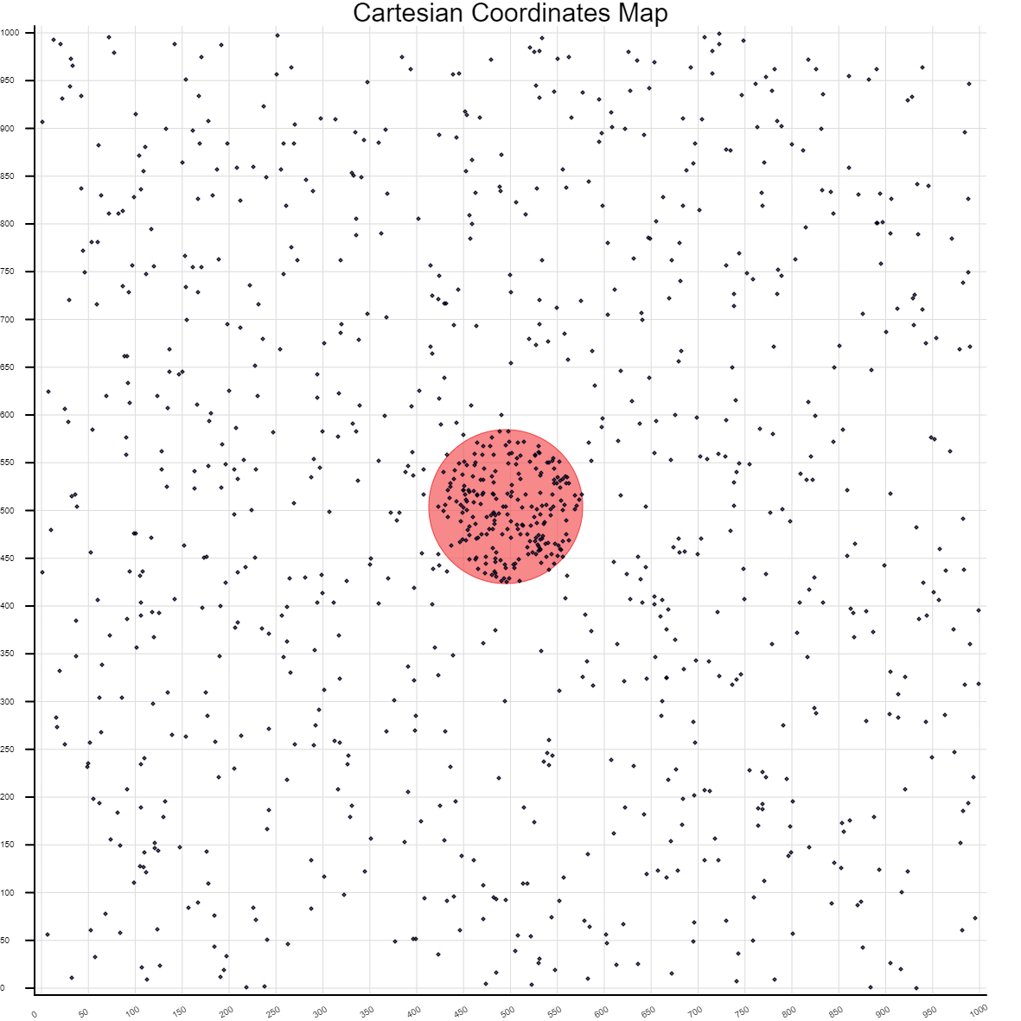

Figure 1.

Based on above image the cluster that is identified as hotspot, it is a valid hotspot.

CLUSTERS DETECTED

**1.Location IDs included.: 226, 227, 228, 74, 229, 139, 73, 225, 230, 138, 72, 75, 137, 71, 232,**

**233, 224, 231, 70, 223, 209, 76, 234, 136, 217, 222, 235, 130, 216,**

**77, 238, 69, 207, 131, 78, 111, 210, 236, 79, 215, 83, 132, 221, 68,**

**80, 6, 208, 110, 109, 67, 220, 211, 214, 81, 133, 108, 212, 66, 84,**

**218, 128, 134, 86, 5, 82, 4, 3, 213, 65, 205, 206, 2, 85, 107, 125,**

**59, 1, 198, 60, 62, 87, 20, 19, 239, 127, 18, 106, 135, 63, 197, 219,**

**58, 64, 8, 196, 61, 129, 194, 57, 117, 88, 240, 105, 195, 7, 10, 192,**

**193, 157, 89, 104, 90, 241, 204, 126, 190, 112, 156, 9, 242, 199,**

**246, 203, 11, 91, 243, 113, 191, 200, 124, 94, 202, 201, 15, 237, 92,**

**14, 185, 123, 52, 155, 13, 154, 158**

**Coordinates / radius..: (529402,181041) / 132.56**

**Number of cases.......: 144**

**Expected cases........: 62.13**

**Observed / expected...: 2.32**

**Log likelihood ratio..: 60.376872**

**P-value...............: 0.001**

2.Location IDs included.: 170, 172, 174, 173, 171

Coordinates / radius..: (529591,181161) / 7.50

Number of cases.......: 5

Expected cases........: 0.20

Observed / expected...: 25.16

Log likelihood ratio..: 11.371095

P-value...............: 0.352

3.Location IDs included.: 27, 29, 28, 26

Coordinates / radius..: (529247,181060) / 6.95

Number of cases.......: 4

Expected cases........: 0.17

Observed / expected...: 23.40

Log likelihood ratio..: 8.810967

P-value...............: 0.775

4.Location IDs included.: 167, 166, 168, 169

Coordinates / radius..: (529568,181142) / 7.16

Number of cases.......: 4

Expected cases........: 0.18

Observed / expected...: 22.06

Log likelihood ratio..: 8.584994

P-value...............: 0.816

5.Location IDs included.: 46, 47, 48, 45

Coordinates / radius..: (529304,180925) / 8.03

Number of cases.......: 4

Expected cases........: 0.23

Observed / expected...: 17.56

Log likelihood ratio..: 7.719316

P-value...............: 0.927

6.Location IDs included.: 142, 141, 143, 140

Coordinates / radius..: (529522,180941) / 8.34

Number of cases.......: 4

Expected cases........: 0.25

Observed / expected...: 16.26

Log likelihood ratio..: 7.428179

P-value...............: 0.950

7.Location IDs included.: 150, 149, 153, 151, 160, 148

Coordinates / radius..: (529570,181062) / 15.08

Number of cases.......: 6

Expected cases........: 0.80

Observed / expected...: 7.46

Log likelihood ratio..: 6.918324

P-value...............: 0.982

8.Location IDs included.: 40, 42, 38, 39, 41

Coordinates / radius..: (529223,180979) / 12.46

Number of cases.......: 5

Expected cases........: 0.55

Observed / expected...: 9.11

Log likelihood ratio..: 6.635646

P-value...............: 0.989

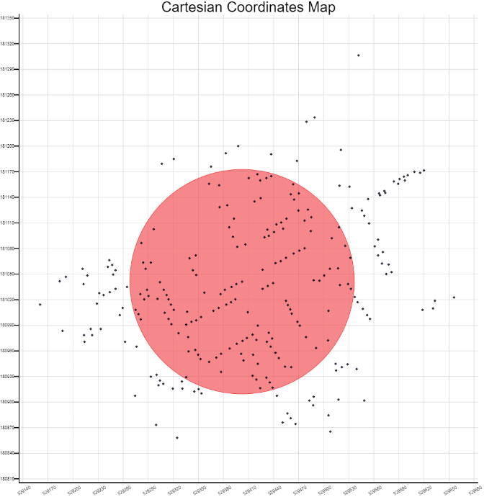

Figure 2.

The highlighted cluster above is statistically significant, as we can see its p-value is less than the define threshold.

CLUSTERS DETECTED

1.Location IDs included.: 225, 224, 138, 137, 139, 223, 226, 222, 227, 233, 217, 216, 232, 221,

228, 136, 215, 210, 74, 220, 130, 229, 209, 75, 73, 214, 211, 218,

131, 230, 72, 212, 132, 128, 207, 76, 213, 125, 208, 71, 219, 133,

127, 111, 231, 70, 196, 77, 134, 234, 129, 198, 110, 238, 194, 78,

83, 235, 197, 109, 195, 206, 79, 236, 193, 205, 157, 108, 192, 156,

80, 117, 69, 126, 135, 190, 107, 68, 191, 86, 81, 84, 155, 6, 124,

158, 199, 67, 106, 154, 185, 123, 200, 85, 203, 201, 87, 82, 112, 66,

204, 202, 113, 122, 5, 59, 105, 4, 3, 2, 104, 65, 121, 246, 1, 62,

239, 88, 60, 58, 63, 20, 90, 19, 18, 64, 119, 164, 89, 57, 61, 8, 91,

240, 186, 187, 120, 182, 247, 162, 152, 163, 161, 92, 94, 243, 153,

7, 118, 241, 140, 10, 188, 159, 150, 242, 183, 160, 9, 143, 151, 184,

142, 93, 237, 11, 141, 149, 165, 148, 52, 15, 14, 13, 55, 101, 114,

56, 51, 103, 12, 54, 167, 166, 245, 189, 53, 102, 96, 168, 169, 16,

244, 43, 50, 26, 45, 116, 97, 21, 46, 17, 47, 22, 27, 95, 181, 49,

28, 48, 98, 25, 44, 29, 171, 100, 180, 172, 24, 170, 115, 144, 23,

173, 174, 36, 41, 99, 175, 146, 145, 30, 248, 176, 32, 31, 42, 40,

177, 250, 249, 178, 38, 39, 147

Coordinates / radius..: (529427,181055) / 231.10

Number of cases.......: 245

Expected cases........: 6.87

Observed / expected...: 35.69

Log likelihood ratio..: 856.396950

P-value...............: 0.001

Figure 3.

Changing the boundary results in having a circle that has identified more cases to be inside the circle which means they are core point or boundary, and we end up having less outliers. (Figure 3.) But as we were previously in figure 2, those defined boundaries were better defied although, as we had different clusters for other points out of the bigger circle. So, it is really important how we defined the bounding box, as by changing then we have different number clusters, and different value for log likelihood ratio and p-value.

**Google Earth engine:**

