Nome de tabela : exampl

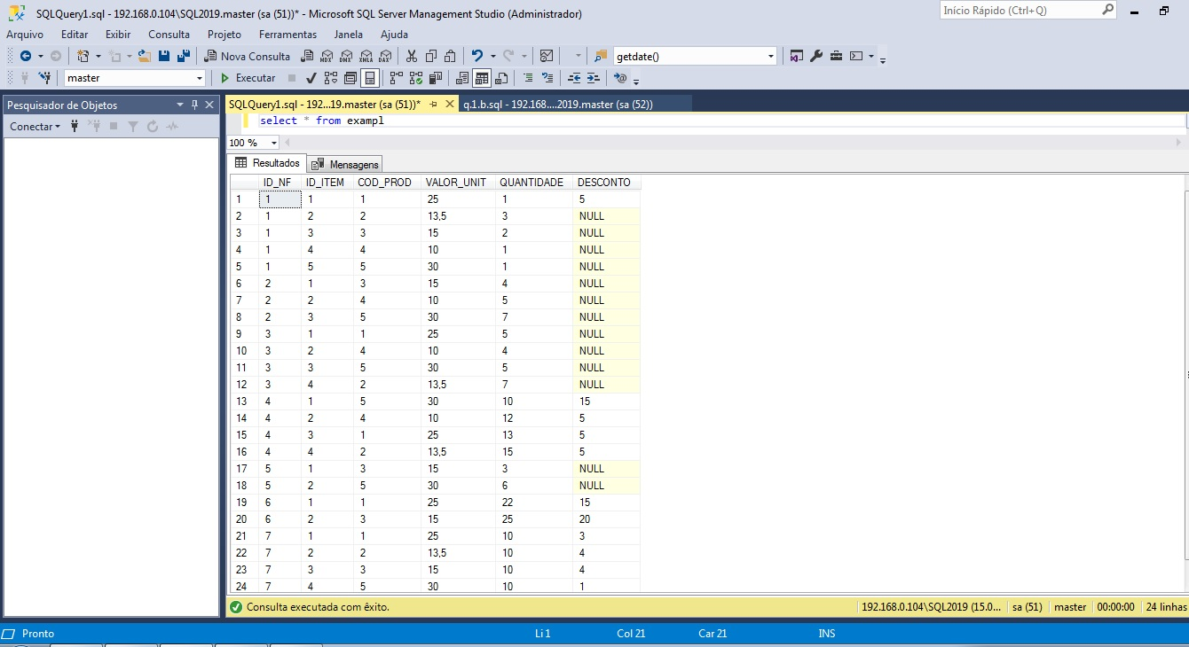

Q_1_a

……………………………………………………………………………………………………………………………………………………………………………………………………….

select ID_NF,ID_ITEM, COD_PROD, VALOR_UNIT

from exampl

where DESCONTO is null

Q_1_b

……………………………………………………………………………………………………………………………………………………………………………………………………….

select ID_NF,ID_ITEM, COD_PROD, VALOR_UNIT ,DESCONTO,

VALOR_UNIT - (VALOR_UNIT*(DESCONTO/100))as VALOR_VENDIDOS

from exampl

where DESCONTO is not null

Q_1_c

……………………………………………………………………………………………………………………………………………………………………………………………………….

select ID_NF,ID_ITEM, COD_PROD, VALOR_UNIT ,DESCONTO

from exampl

UPDATE [examp] SET [DESCONTO] = 0 WHERE [DESCONTO] IS NULL

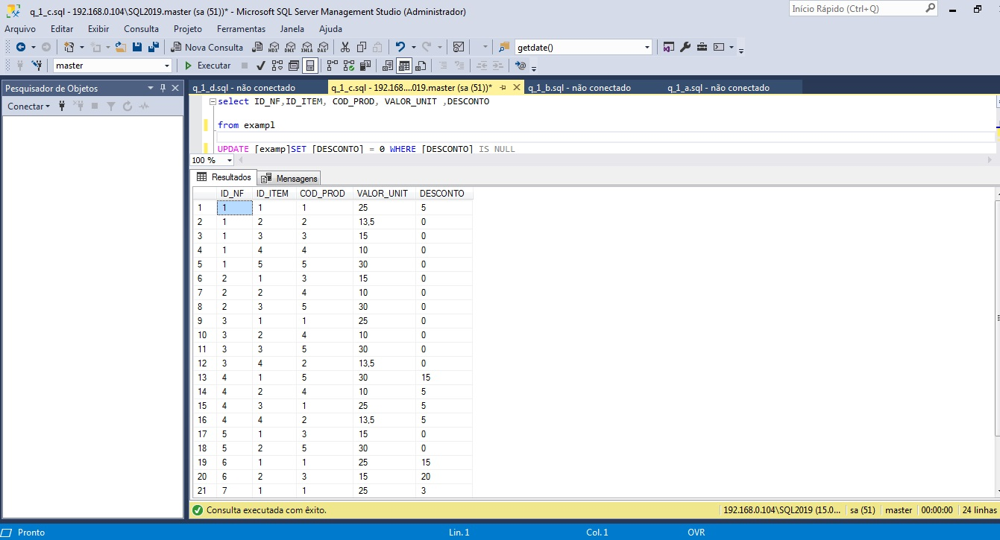

Q_1_d

……………………………………………………………………………………………………………………………………………………………………………………………………….

select ID_ITEM, COD_PROD, VALOR_UNIT ,DESCONTO,

VALOR_UNIT - (VALOR_UNIT*(DESCONTO/100)) as VALOR_VENDIDOS,

QUANTIDADE * VALOR_UNIT as VALOR_TOTAL

from examp

Q_1_e

……………………………………………………………………………………………………………………………………………………………………………………………………….

select ID_NF,

sum( QUANTIDADE * VALOR_UNIT) as valor

from examp

group by ID_NF

order by ID_NF

Q_1_f

……………………………………………………………………………………………………………………………………………………………………………………………………….

select ID_NF,

sum( QUANTIDADE * VALOR_UNIT) as VALOR_TOTAL,

sum( VALOR_UNIT - (VALOR_UNIT*(DESCONTO/100))) as VALOR_VENDIDO

from examp

group by ID_NF

order by ID_NF

Q_1_g

……………………………………………………………………………………………………………………………………………………………………………………………………….

select COD_PROD,

sum(QUANTIDADE) as QUANTIDADE

from examp

group by COD_PROD

order by QUANTIDADE desc

Q_1_h

……………………………………………………………………………………………………………………………………………………………………………………………………….

select ID_NF, COD_PROD,

sum(QUANTIDADE) as QUANTIDADE

from examp

where QUANTIDADE > 10

group by ID_NF ,COD_PROD

Q_1_i

……………………………………………………………………………………………………………………………………………………………………………………………………….

select ID_NF, sum(QUANTIDADE * VALOR_UNIT) as VALOR_TOT

from examp

group by ID_NF

having sum(QUANTIDADE * VALOR_UNIT) >500

order by sum(QUANTIDADE * VALOR_UNIT) desc

Q_1_j

……………………………………………………………………………………………………………………………………………………………………………………………………….

Select COD_PROD,

avg(DESCONTO)as MEDIA

from examp

group by COD_PROD

Q_1_k

……………………………………………………………………………………………………………………………………………………………………………………………………….

Select COD_PROD,

min(DESCONTO) as MENOR,

max(DESCONTO) as MAIOR,

avg(DESCONTO) as MEDIA

from examp

group by COD_PROD

Q_1_l

……………………………………………………………………………………………………………………………………………………………………………………………………….

select ID_NF,

sum (QUANTIDADE) as QTD_ITENS

from examp

group by ID_NF

order by sum (QUANTIDADE) desc

Q_2 database_Alunos

……………………………………………………………………………………………………………………………………………………………………………………………………….

CREATE TABLE Aluns (

MAT int,

nome varchar(255),

endereço varchar(255),

cidade varchar(255)

);

INSERT INTO Aluns(MAT, nome, endereço, cidade)

VALUES (2015010101, 'JOSE DE ALENCAR', 'RUA DAS ALMAS', 'NATAL'),

(2015010102, 'JOÃO JOSÉ', 'AVENIDA RUY CARNEIRO', 'JOÃO PESSOA'),

(2015010103, 'MARIA JOAQUINA', 'RUA CARROSSEL', 'RECIFE'),

(2015010104, 'MARIA DAS DORES', 'RUA DAS LADEIRAS', 'FORTALEZA'),

(2015010105, 'JOSUÉ CLAUDINO DOS SANTOS', 'CENTRO', 'NATAL'),

(2015010106, 'JOSUÉLISSON CLAUDINO DOS SANTOS', 'CENTRO', 'NATAL')

select * from Aluns

Q_2 database_ Turma

……………………………………………………………………………………………………………………………………………………………………………………………………….

CREATE TABLE Turma(

COD_DISC varchar(255),

COD_TURMA int,

COD_PROF int,

ANO int,

horário varchar(255)

);

INSERT INTO Turma (COD_DISC, COD_TURMA, COD_PROF, ANO, horário)

VALUES ('BD', 1, 212131, 2015, '11H-12H'),

('BD', 2, 212131, 2015, '13H-14H'),

('POO', 1, 192011, 2015, '08H-09H'),

('WEB', 1, 192011, 2015, '07H-08H'),

('ENG', 1, 122135, 2015, '10H-11H')

select *from Turma

Q_2 database_ Disciplinas

……………………………………………………………………………………………………………………………………………………………………………………………………….

CREATE TABLE Disciplinas (COD_DISC varchar(255),

nome_disc varchar(255),

carga_hor int

);

INSERT INTO Disciplinas (COD_DISC, nome_disc, carga_hor)

VALUES

('BD', 'BANCO DE DADOS', 100),

('POO', 'PROGRAMAÇÃO COM ACESSO A BANCO DE DADOS', 100),

('WEB', 'AUTORIA WEB', 50),

('ENG', 'ENGENHARIA DE SOFTWARE', 80)

select * from Disciplinas

Q_2 database_ Professores

……………………………………………………………………………………………………………………………………………………………………………………………………….

CREATE TABLE Professores(COD_PROF int,

nome varchar(255),

endereço varchar(255),

cidade varchar(255)

);

INSERT INTO Professores (COD_PROF, nome, endereço, cidade)

VALUES (212131, 'NICKERSON FERREIRA', 'RUA MANAÍRA', 'JOÃO PESSOA'),

(122135, 'ADORILSON BEZERRA', 'AVENIDA SALGADO FILHO', 'NATAL'),

(192011, 'DIEGO OLIVEIRA', 'AVENIDA ROBERTO FREIRE', 'NATAL')

select *from Professores

Q_2 database_ Histórico

……………………………………………………………………………………………………………………………………………………………………………………………………….

CREATE TABLE Histórico (

MAT int,

COD_DISC varchar(255),

COD_TURMA varchar(255),

COD_PROF int,

ANO int,

horário varchar(255)

);

INSERT INTO Histórico (MAT, COD_DISC, COD_TURMA, COD_PROF,ANO,horário)

VALUES

(2015010101, 'BD', 1, 212131, 2015, '11H-12H'),

(2015010102, 'BD', 1, 212131, 2015, '11H-12H'),

(2015010103, 'BD', 1, 212131, 2015, '11H-12H'),

(2015010104, 'BD', 1, 212131, 2015, '11H-12H'),

(2015010105, 'BD', 1, 212131, 2015, '11H-12H'),

(2015010106, 'BD', 1, 212131, 2015, '11H-12H'),

(2015010101, 'BD', 2, 212131, 2015, '13H-14H'),

(2015010102, 'BD', 2, 212131, 2015, '13H-14H'),

(2015010103, 'BD', 2, 212131, 2015, '13H-14H'),

(2015010104, 'BD', 2, 212131, 2015, '13H-14H'),

(2015010105, 'BD', 2, 212131, 2015, '13H-14H'),

(2015010106, 'BD', 2, 212131, 2015, '13H-14H'),

(2015010101, 'POO', 1, 192011, 2015, '08H-09H'),

(2015010102, 'POO', 1, 192011, 2015, '08H-09H'),

(2015010103, 'POO', 1, 192011, 2015, '08H-09H'),

(2015010104, 'POO', 1, 192011, 2015, '08H-09H'),

(2015010105, 'POO', 1, 192011, 2015, '08H-09H'),

(2015010106, 'POO', 1, 192011, 2015, '08H-09H'),

(2015010101, 'WEB', 1, 192011, 2015, '07H-08H'),

(2015010102, 'WEB', 1, 192011, 2015, '07H-08H'),

(2015010103, 'WEB', 1, 192011, 2015, '07H-08H'),

(2015010104, 'WEB', 1, 192011, 2015, '07H-08H'),

(2015010105, 'WEB', 1, 192011, 2015, '07H-08H'),

(2015010106,'WEB', 1, 192011, 2015, '07H-08H'),

(2015010101, 'ENG', 1, 122135, 2015, '10H-11H'),

(2015010102, 'ENG', 1, 122135, 2015, '10H-11H'),

(2015010103, 'ENG', 1, 122135, 2015, '10H-11H'),

(2015010104, 'ENG', 1, 122135, 2015, '10H-11H'),

(2015010105, 'ENG', 1, 122135, 2015, '10H-11H'),

(2015010106, 'ENG', 1, 122135, 2015, '10H-11H')

select * from Histórico