**Calculations**

1. Voltage measurement

We have, Data-

Max Voltage from solar panel- 7 Volts

Arduino Nano has 10 bit ADC with reference voltage of 5 Volts

So we have to Drop down the Max voltage to 5 Volts.

So we will use Voltage Divider Network

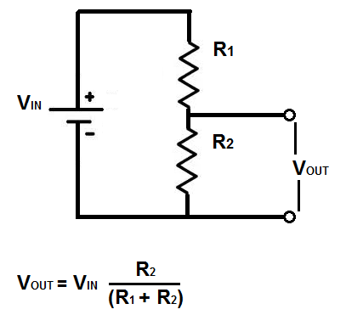

We know that Vout= 5 Volts, Vin= 7 Volts, lets Assume R1=15K

So

**5V=7V*(R2/15K+R2)**

**R2=37.7K**

**Calculations for Voltage Measurement using Arduino**

Arduino has 10 bit ADC So 2^10=1024 counts

And has reference voltage of 5 Volts so

Voltage per Count = 5/1024 = 0.004883 Volts

So to measure the actual Voltage of solar panel we will multiply the adc counts with 0.004883 Volts

So we get the value of actual voltage but this is not actual voltage from solar panel as we have drop down it to match the Arduino reference level so we will calculate actual volateg by following formula

**Vs=(Vout*(R1+R2))/R2**

Here Vout is the voltage measured by Arduino ADC and Vs is the actual voltage from the Solar Panel

**Calculations for Current Measurement using Arduino**

As we know current is measured in series with the load so we will measure the remaining voltage after drop across the load and then divide it by known Value Resistor known as sense resistor

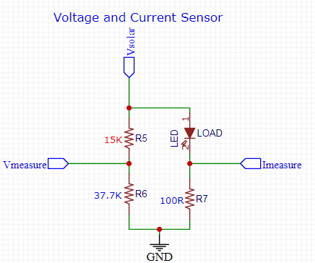

**We are using the Sense Resistor of 100 ohms**

So in order to measure current we calculate the Voltage after the load Led by previous method used to calculate the Voltage and then Divide that value by 100 to get the Current in Amps

**I= Vsense/Rsense**

But this value is in Amps and our load draws very less current so to represent it more neatly we will display it in Milliamps by dividing it by 1000

**Calculations for Power Measurement using Arduino**

As we know power is nothing but the product of Volatge and current, so

So we will calculate the power by multiplying previously measured Voltage and Current

**Power=Voltage*Current**