**XGboost Model Evaluation**

XGBoost Accuracy: **0.8**

XGBoost Confusion Matrix:

**[[ 33 26]**

**[ 14 127]]**

XGBoost Classification Report:

precision recall f1-score support

0 0.70 0.56 0.62 59

1 0.83 0.90 0.86 141

accuracy 0.80 200

macro avg 0.77 0.73 0.74 200

weighted avg 0.79 0.80 0.79 200

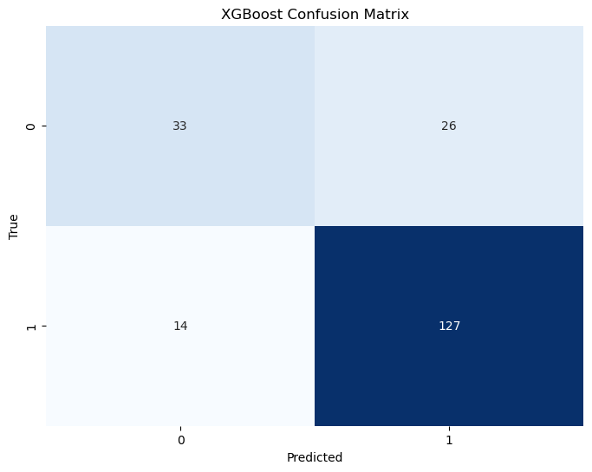

**STRUCTURE OF THE MODEL**