**REBASE:**  
For rebase followed some steps given below:

1. First will create Empty repository inside of the folder gitproject directory.
2. On master branch we created 2 files A.txt and B.txt.
3. With Command **GIT add A.txt B.txt** and **GIT commit A.txt B.txt** we added and committed these files on staging and local repository area.
4. 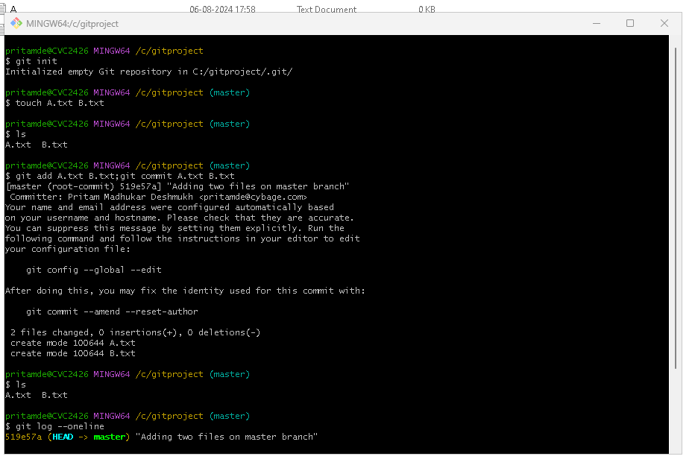
5. With command **GIT LOG –Oneline** we can see the actual commits with commit id’s.
6. After that we created 2 files X.txt and Y.txt on feature branch
7. and likewise we added and committed these 2 files on staging and local respository area.
8. Now we can see total 4 files on feature branch.
9. Let’s switch back to master branch with **GIT CHECKOUT MASTER.** and add C.txt and commit on master branch so totally we have 2 commits on master branch.  
   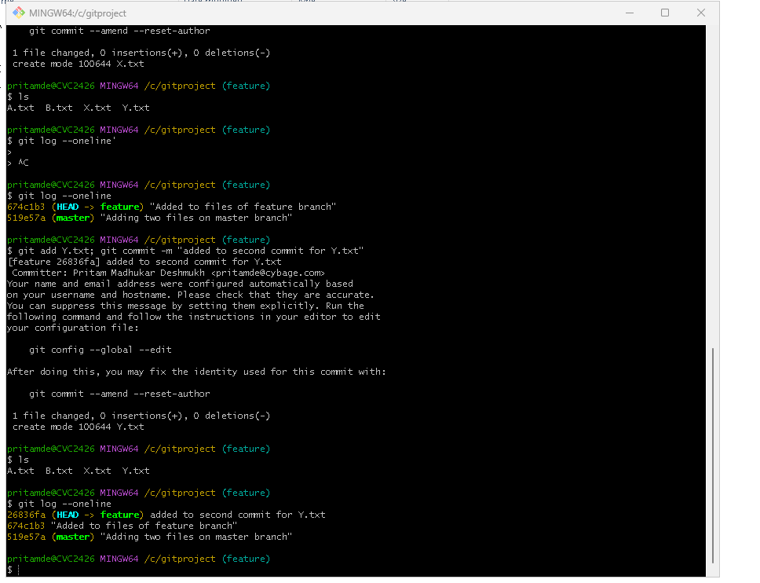
10. So, currently on master branch we have 2 commits and feature branch we have 3 commits and we have to rebase the feature branch on top of Master Branch So,   
    **GIT CHECKOUT FEATURE  
    GIT REBASE MASTER**with this commands we rebase our feature branch on top of master branch it will create an objects for that feature branch 2 commits and rebased it with master commits
11. So, we can see the commit Id’s are same from the master branch after rebasing previous commit id’s of feature branch.
12. So, now the step is to Merge it for that  
     **GIT CHECKOUT MASTER  
     GIT MERGE FEATURE**

