**RESET:**Reset: Moving the head pointer from one position to previous commit position.

1. There are three types of reset:   
   **1)Mixed Reset:**   
   - It’s default reset  
   - in this reset the commit get removed and data from staging is also removed.  
   Here, on master branch we created three files Code.txt, S.txt and W.txt and we commited all the files to local respository area.  
     
   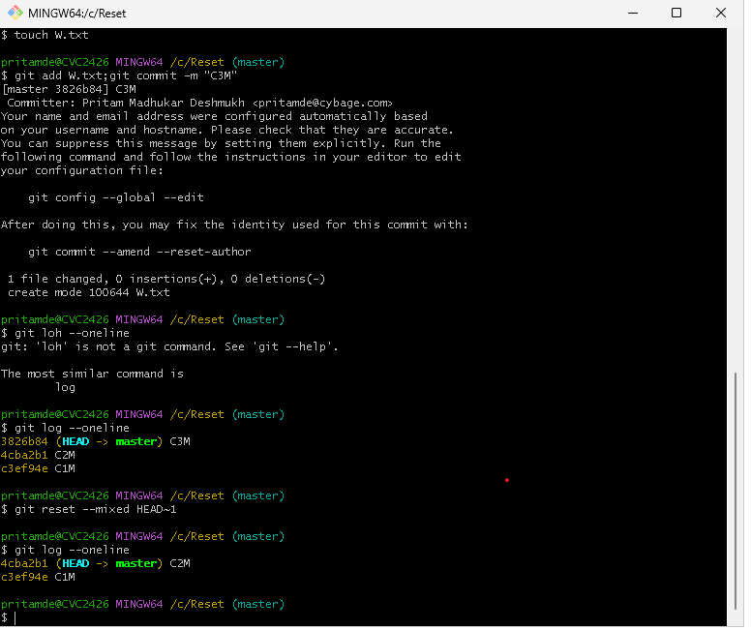From the above way with help of   
   **GIT RESET –MIXED HEAD~1** this command we perform mixed reset.
2. **SOFT RESET:**

* In this reset commit get removed but data till present in staging area and workspace . 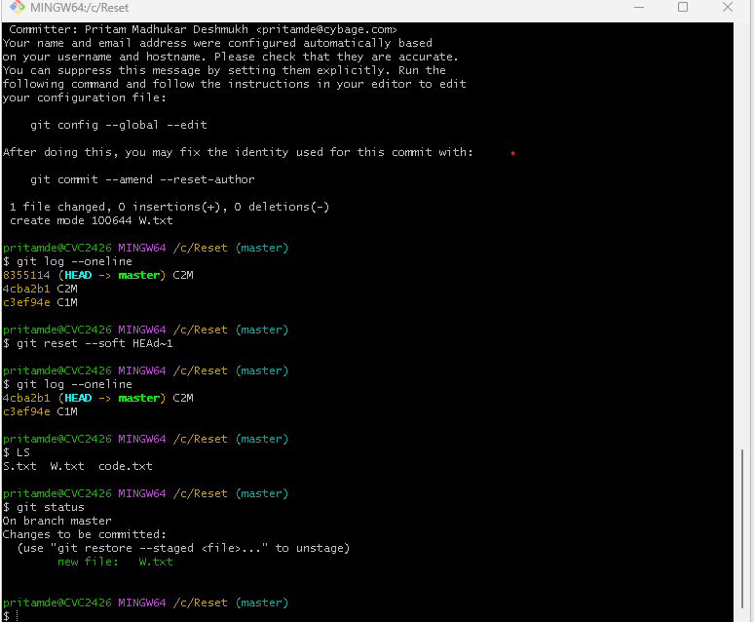
* In soft reset we can perform action using **GIT RESET –SOFT HEAD~1** this command.

1. **RESET HARD:**

* In this reset commit gets removed also data is also removed from staging as well as workspace.
* File is also get deleted in this case.
* 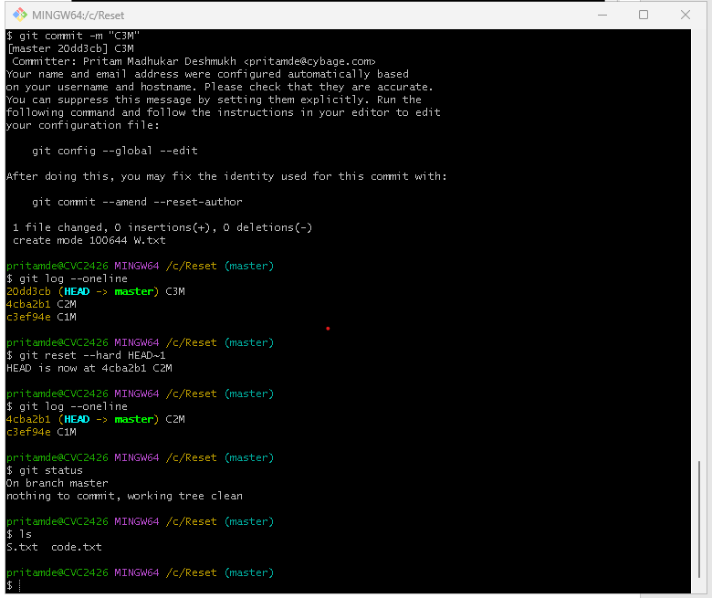
* In this case with **GIT RESET –HARD HEAD~1** commit all commits were deleted also from staging as well as file is deleted. By performing **LS** you can se e file is also deleted W.txt

**REVERT:**

* First we create m1.txt, m2.txt and m3.txt and commited these files respectively, after

**GIT LOG**  we can see the commits then with   
**GIT REVERT <COMMIT ID>** with this command we can delete file as well as the commit from working directory area and staging as well.

* After this operations we can actually see Extra REVERT commit.
* 

