Session 2 - Assignment

1. Write a program which accepts a sequence of comma-separated numbers from console and

generate a list.

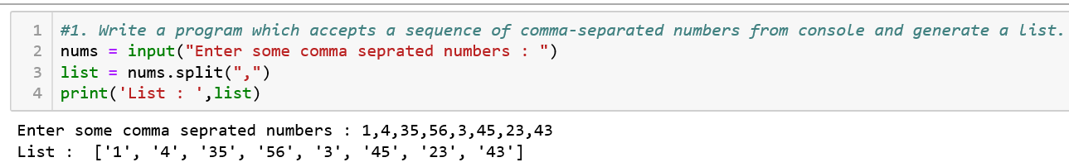

2. Create the below pattern using nested for loop in Python.

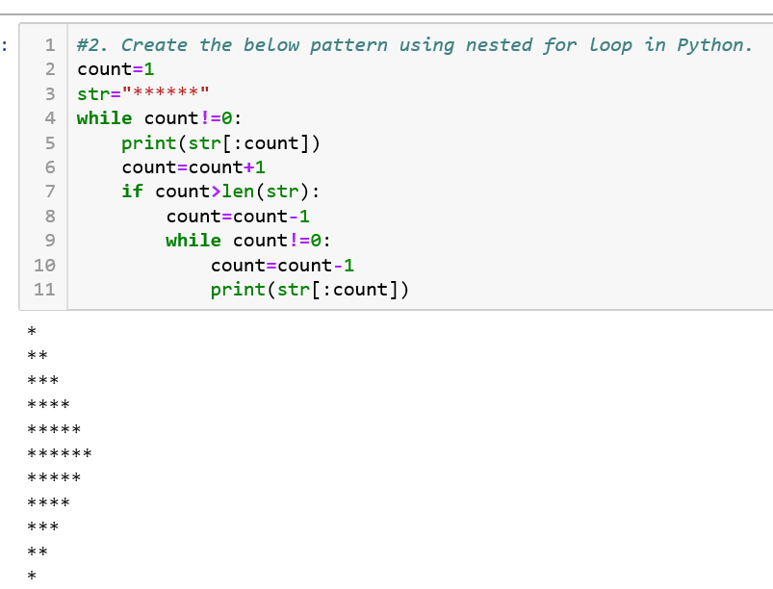

3. Write a Python program to reverse a word after accepting the input from the user.

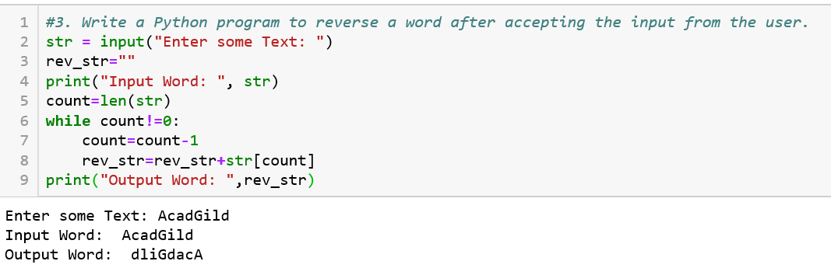

4. Write a Python Program to print the given string in the format specified in the **sample**

**output.**

WE, THE PEOPLE OF INDIA, having solemnly resolved to constitute India into a SOVEREIGN,

SOCIALIST, SECULAR, DEMOCRATIC REPUBLIC and to secure to all its citizens

**Sample Output:**

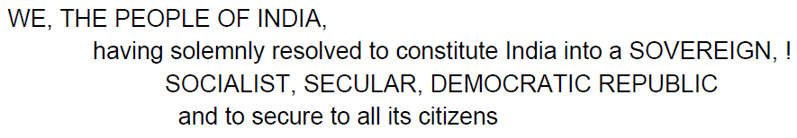

**Answer:** 