**Economy of Europe 2022**

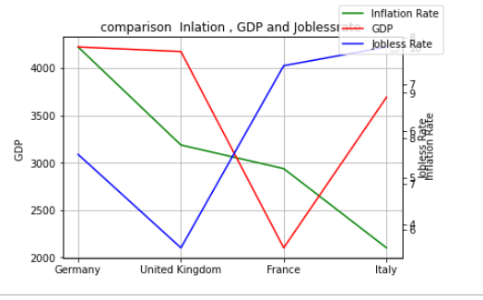

This line plot shows three main economic indicators of the most flourishing countries in Europe. These all countries which are Germany, the United Kingdom, France, and Italy, are listed on the x-axis of the line plot, and these indicators which are GDP, Inflation, and jobless Rate are mentioned on the y-axis of the plot. This line plot gives us a quick visualization of all countries’ economic indicators.

Firstly, in the case of Germany, the GDP is going well but on the other side inflation is too high and the third indicator which is jobless is not so good but also not fully acceptable, need to work on this indicator.

Secondly, in the case of the United Kingdom, all indicators are showing outstanding results. A good GDP leads to normal inflation and a good job rate.

Thirdly, in the case of France, all indicators are totally opposite to the United Kingdom. When any country's GDP is so low, the jobless rate automatically goes up and inflation remains.

Finally, in the case of Italy inflation is too low which is also not good for any country’s GDP just like high inflation. If any country is suffering in GDP so it will directly affect the job rates.

<https://www.kaggle.com/datasets/hanzlanawaz/economy-of-europe-2022>

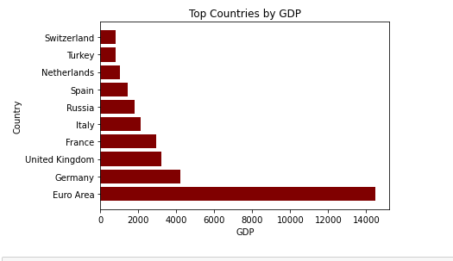

In this graph we are comparing GDP of top 10 countries of the world. Among top 10 countries Euro area shows highest GDP, that is, above 14000, then there is Germany on number 2, with GDP of 4000. We can observe in the graph that Switzerland has lowest GDP, that is around 500.

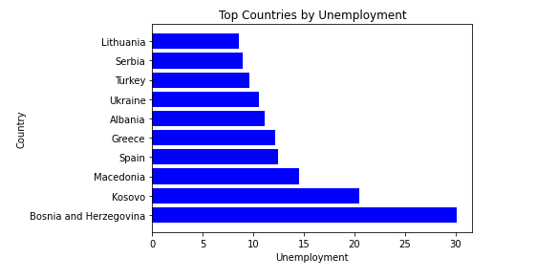

This bar plot demonstrates the unemployment rate of different countries. We can see that Bosnia and Herzegovina have highest unemployment rate of 30. Then we can see a decrease in unemployment rate in other countries, like Greece has an unemployment rate of around 12. Country with lowest unemployment rate is Lithuania with unemployment rate of about 9.

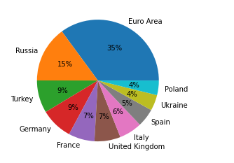

In this pie chart population of different countries is visualized. Pie chart shows that Poland and Ukraine have smallest population which is 4%, for each country. Turkey has a population of 9%. But countries with the highest population is Euro area as it comprises 35% of the population.

**Choice of graph**

Line graph

A line graph, which consists of a succession of data points connected by straight line segments on two axes, is frequently used to show change over time. Because one group of numbers is constantly dependent on the other, the line graph aids in establishing the link between two sets of values. A line chart will be used to emphasize differences in values for one variable (plotted on the vertical axis) for continuous values of a second variable (plotted on the horizontal).

Bar chat

Bar plot makes it simple to compare various data sets among various groupings. Using two axes, with the categories on one and the various values on the other, it quickly illustrates this relationship. A bar graph can be used to show significant changes in data over time.

Pie chart

Pie charts can be used to show percentages of a whole group and show percentages at a particular moment. In contrast to bar graphs and line graphs, pie charts do not show changes over time.