
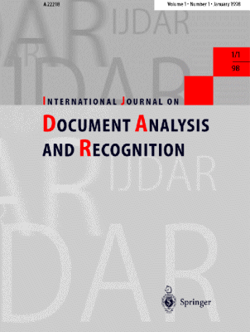

Special Issue on Camera-based
Text and Document Recognition

Submission Deadline: November 2003
Review by: March 2004
Revision by: May 2004
Editor’s Decisions: June 2004
Final publication: Sept/Oct 2004

