Class 7th
SA I
Session 2026-27
Subject – Math
Note – All the questions are compulsory.
- Solve the following equations:
- 5x – 3 = 3x + 5
- – 3 + n = – 8
- $\frac{x}{3}$ – 4 = – 2
- – 3 + 5x = 7
- Find:-
  - The complement of 76°.
  - The supplement of 39°.
- Find the value of x and y in the following figures:
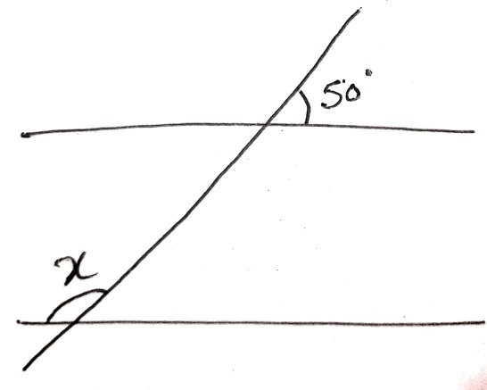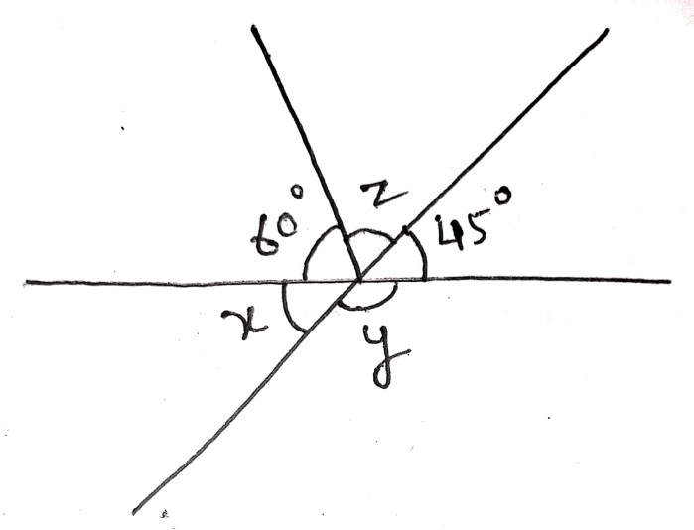
- Solve the following:
(a) 28.4 ÷ 4 (b) 7.59 × 5.4 (c) 12.6 × 2.8
(d) $\frac{- 3}{8}+\frac{5}{6}$ (e) $\frac{1}{3}+\left(\frac{- 1}{4}\right)$ (f) $\frac{- 4}{9}×\frac{- 12}{10}$ (g) $\frac{6}{8} ÷\frac{4}{3}$
- Convert 2.35 into a fraction and reduce it to the lowest form.
- Convert $\frac{25}{10}$ into decimal.
- Solve the following:
- $-5+(-2)$
- $–(-8)+(-7)$
- $\left(-2\right)×\left(-3\right)×\left(-4\right)$
- $(-50)÷5$
- Add the following:
- 2x + 7y and – 4x + 8y
- 2x – y + z and 3z – 3x + 7y
- Subtract
- 11xy + 12ab – 2z from 4xy + 10ab – 5z.
- 2x – 3y + 4z – 5 from 9x + 12y + 8z + 6b.

