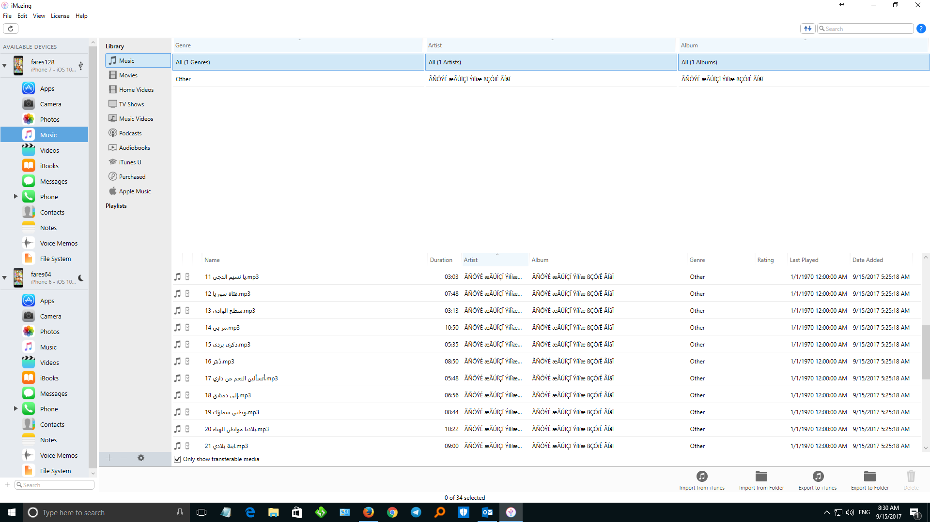

Arabic not supported , here in imazing2

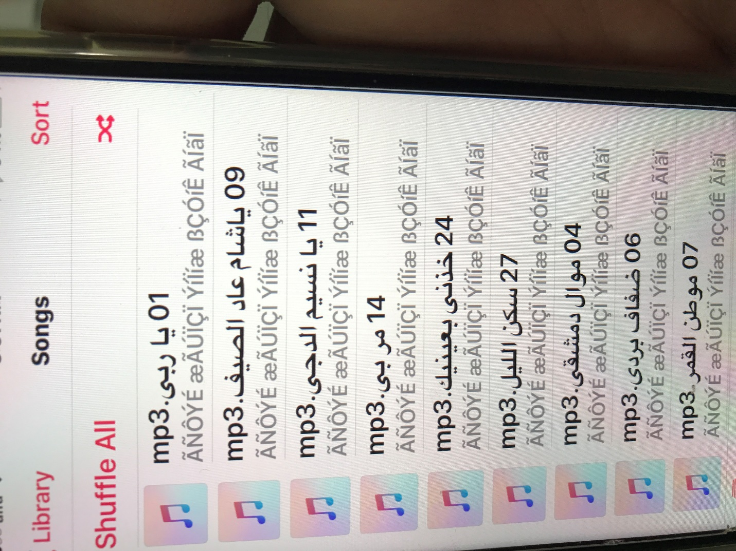

The Arabic In iphone7 (music) show like this