ELITE FORENSIC INTELLIGENCE & INVESTIGATION FRAMEWORK
  - PASS 4: GLOBAL COMPLIANCE & AI-DRIVEN DISCOVERY
Forensic Technology & Investigative Services
Table of Contents

1. THE INTELLIGENCE DASHBOARD (C-SUITE VIEW)
High-velocity summary of findings and regulatory exposure.
Expert Guidance (Pass 4 - Elite Grade): * Regulatory Exposure: In Pass 4, we don’t just find fraud; we map it to legal risk (e.g., Nazaha Law, FCPA). * Confidence Score: Professional investigators now include a “Confidence Level” based on the quality of evidence collected.
Elite Investigative Dashboard
Dimension | Details | Impact
Substantiated Loss | SAR 6,420,000 | Critical
Regulatory Risk Map | KSA Anti-Corruption Law / Nazaha | High
AI Confidence Score | 94% (High) | Valid
Investigation Velocity | 32 Days to Conclusion | Efficient
Key Suspect(s) | Subject A + 2 External Co-Conspirators | Identified
Evidence Admissibility | Court-Ready (Chain of Custody Verified) | Verified

2. GLOBAL REGULATORY MAPPING
Aligning investigative findings with statutory requirements.
Expert Guidance: * Global Standards: If the entity is listed or has international operations, you MUST map findings to the UK Bribery Act or US FCPA. * Local Compliance: For KSA-based entities, reference the National Strategy for Maintaining Integrity and Combating Corruption.

2.1 Statutory Violations
[e.g., “The evidence suggests potential violations of the KSA Anti-Bribery Law, specifically Article 2 regarding public/private sector kickbacks.”]

3. AI & ADVANCED LINK ANALYSIS
Uncovering hidden relationships through data science.
Expert Guidance: * Link Analysis: The chart below represents “Social Network Analysis.” In a real audit, this identifies “Common Addresses,” “Shared Phone Numbers,” or “Shared IP Addresses” between employees and vendors. * NLP: Mention if Natural Language Processing was used to analyze sentiment or “pressure keywords” in corporate emails.
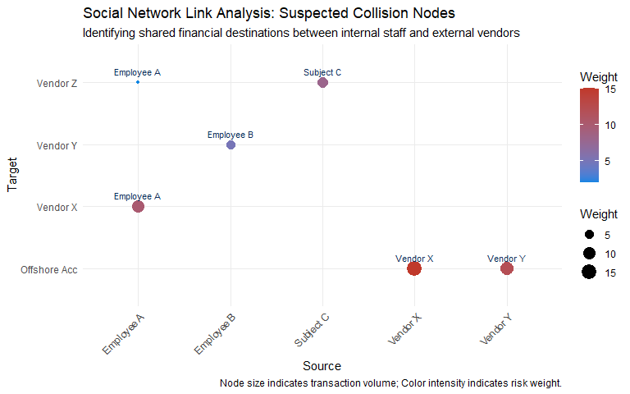

4. FORENSIC INTERVIEWING & PSYCHOLOGY
The human element of the investigation.
Expert Guidance: * The PEACE Model: Reference the use of the PEACE framework (Planning, Engage, Account, Closure, Evaluation). * Deception Indicators: Note physical or verbal “Leakage” observed during admission-seeking interviews. * Miranda-style Warnings: Ensure documentation that the subject participated voluntarily and was aware of company policy.

4.1 Interview Summaries
[Detailed breakdown of the strategy used for each key subject.]

5. DIGITAL FOOTPRINT & METADATA FORENSICS
The data that cannot be deleted.
Expert Guidance: * Exif Data: Mention analysis of metadata on submitted PDF invoices to check for original “Creation Dates.” * IP Geolocation: Correlating the time an invoice was “Authorized” in the ERP with the Subject’s known travel logs.

6. STRATEGIC REMEDIATION & “FUTURE-PROOFING”
Moving from “Cure” to “Immunity.”
Strategic AI-Driven Remediation Matrix
Risk_Area | AI_Fix | Impact_ROI | Status
Procurement | Unsupervised Clustering for Vendor Spend | Saves SAR 1.2M/yr | Implementing
Payroll | Biometric Authentication | Prevents Ghost Employees | Proposed
IT Admin | Behavioral Identity Analytics | Stops Data Exfiltration | Critical Priority

7. APPENDICES (THE COURT VAULT)
- Appendix A: Digital Evidence Hashing Log (SHA-256)
- Appendix B: Network Traffic Logs (VPN/IP Corroboration)
- Appendix C: Behavioral Analysis Report
- Appendix D: External Intelligence (Open Source Intelligence - OSINT)
- Appendix E: Expert Witness Statement

