Clustering Datasets
K-Means Clustering Analysis
Quantitative Research Methods

1. Introduction
For this task, I used K-Means clustering to analyze different datasets. The main purpose of clustering is to find groups of observations that have similar characteristics.
I used four datasets in the analysis: Mall Customers, Wholesale Customers, Wine Clustering, and Credit Card data. Feature scaling was used before K-Means because the variables have different ranges and units.
The number of clusters was selected as 5 for the Mall Customers dataset, 4 for the Wholesale Customers dataset, 3 for the Wine dataset, and 4 for the Credit Card dataset.

2. Mall Customers Dataset
The first analysis uses the Mall Customers dataset. The clustering uses Annual Income and Spending Score. Before applying K-Means, the two features were scaled so that both variables had a similar effect on the distance calculation.
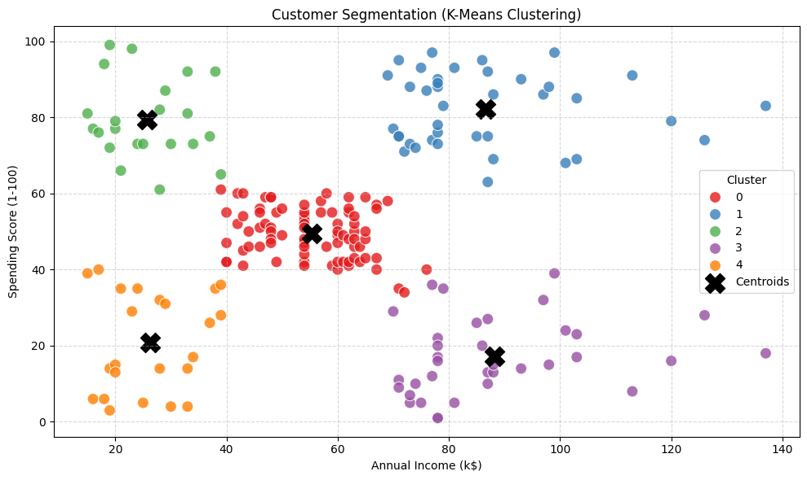
Figure 1. Customer segmentation using K-Means.
The K-Means algorithm created five customer groups. The first group contains customers with high income and high spending. The second group has high income but low spending. The third group is around the average income and average spending level. The fourth group has low income and high spending. The last group has both low income and low spending.
The clusters show that customers with similar income do not always have the same spending behavior. The Annual Income and Spending Score therefore give a useful way to separate the customers into different groups.

3. Wholesale Customers Dataset
The second analysis uses the Wholesale Customers dataset. It contains spending data for six product categories: Fresh, Milk, Grocery, Frozen, Detergents_Paper, and Delicassen.
The spending values have very different sizes, so I used StandardScaler before K-Means. Four clusters were used in this analysis. The cluster centers were shown in a normalized heatmap.
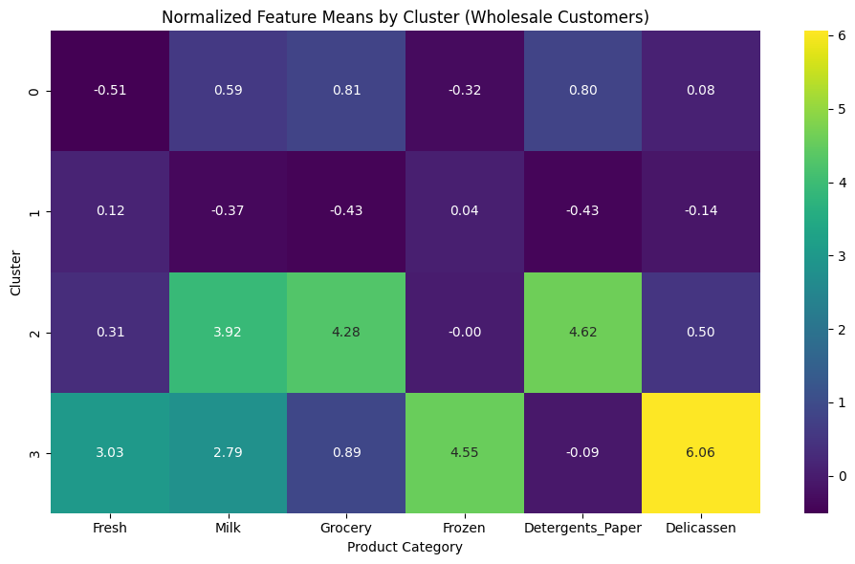
Figure 2. Normalized feature means by cluster for Wholesale Customers.
Cluster 0 represents small-scale buyers. Their spending is below the average in most product categories.
Cluster 1 represents general grocery retailers or supermarkets. This group has especially high spending in Grocery, Milk, and Detergents_Paper.
Cluster 2 is a smaller group of large wholesale buyers. They have high spending across all product categories.
Cluster 3 has higher spending mainly in Fresh and Frozen products. This group can represent fresh food markets or customers with a similar buying pattern.

4. Wine Clustering Dataset
The third analysis uses the Wine Clustering dataset. It contains 13 chemical features. Because the features use different numerical scales, StandardScaler was applied before clustering.
K-Means was used with three clusters. The cluster centers were visualized with a normalized heatmap.
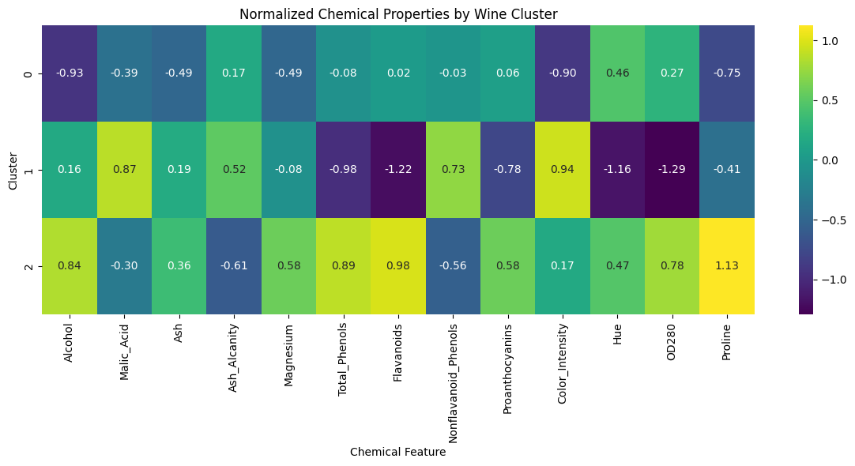
Figure 3. Normalized chemical properties by wine cluster.
Cluster 0 represents lighter wines. This group has lower average alcohol, color intensity, and proline levels.
Cluster 1 is chemically different from the other groups. It has low flavanoids and total phenols, together with higher malic acid and color intensity.
Cluster 2 represents wines with high levels of alcohol, proline, flavanoids, and total phenols.
The results show that the wines can be separated into groups using their chemical properties, even without using a predefined class label.

5. Credit Card Dataset
The fourth analysis uses the Credit Card dataset. This dataset is more complex because it has many variables and also contains missing values.
The customer ID was removed because it is not useful for clustering. Missing values were replaced with the median value. After this step, the features were scaled and K-Means was applied with four clusters.
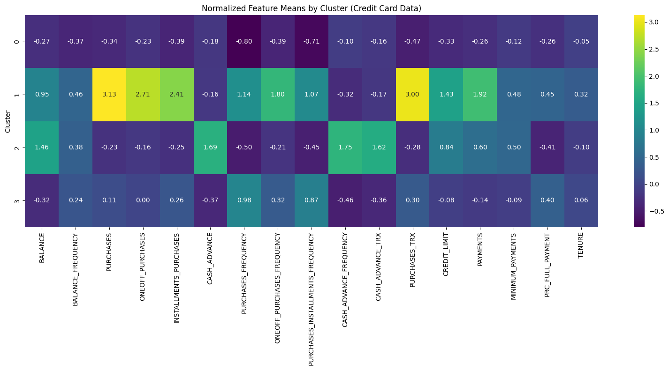
Figure 4. Normalized feature means by cluster for Credit Card data.
Cluster 0 represents conservative users. They have low balances and make purchases less often.
Cluster 1 represents active users who use their cards frequently for normal purchases but keep a manageable balance.
Cluster 2 represents big spenders. This group has high credit limits and high purchase volumes, especially for expensive or one-off transactions.
Cluster 3 represents users who depend more on cash advances. They have high balances and frequently withdraw cash instead of making direct purchases. This pattern may indicate higher credit risk.

6. Overall Interpretation
The four examples show how K-Means can be used with different types of data. In each case, scaling the features was useful because the variables did not have the same numerical range.
The Mall Customers dataset gives a simple visual example of customer groups using two variables. The Wholesale Customers and Credit Card datasets show how clustering can also be used when there are many variables. The Wine dataset shows how chemical measurements can be used to find different groups.
The cluster centers are useful for interpretation because they show the typical feature values for each group. Looking at these values makes it possible to give a practical description to each cluster.

7. Conclusion
K-Means clustering was applied successfully to four different datasets. The results produced meaningful groups based on customer behavior, product spending, wine chemistry, and credit card behavior.
The main lesson from these examples is that clustering can find patterns in data without using predefined labels. The interpretation of the clusters depends on the features used and on the meaning of those features.

8. Self-Organizing Maps (SOM)
SOM was not used in this analysis. The work was completed with K-Means, as suggested in the task. Therefore, there is no SOM visualization or comparison to report.

