Correlation and Regression Analysis
Combined Cycle Power Plant (CCPP) Dataset

1. Dataset
For this task, I used the Combined Cycle Power Plant (CCPP) dataset. The dataset has four input variables and one output variable.
Variable | Description | Role
AT | Ambient Temperature | Input
V | Exhaust Vacuum | Input
AP | Ambient Pressure | Input
RH | Relative Humidity | Input
PE | Electrical Energy Output | Output
The main purpose of the analysis is to see how the four input variables are related to PE and how well they can be used together to predict PE.

2. Analysis Method
I used Python to perform the analysis. The main libraries used in the Colab notebook were pandas, seaborn, matplotlib, and scikit-learn.
First, I created a correlation heatmap for all variables. Then, I created a scatter plot for AT and PE. After that, I fitted a multiple linear regression model using AT, V, AP, and RH as input variables and PE as the output.
Finally, I plotted the regression coefficients to see the direction and size of the coefficients in the model.

3. Correlation Analysis
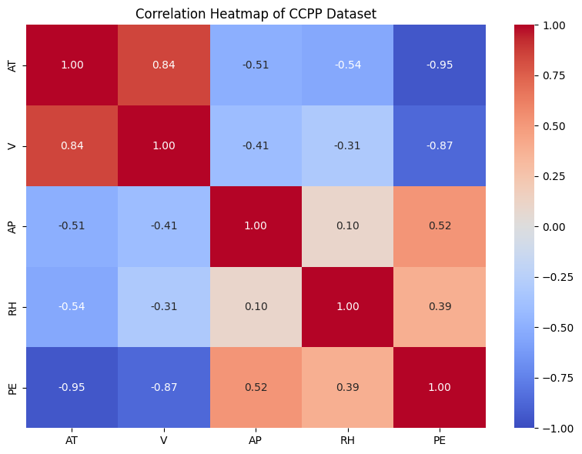
Figure 1. Correlation heatmap of the CCPP dataset.
The heatmap shows that AT has the strongest correlation with PE. The correlation is about -0.95, which means there is a strong negative relationship between ambient temperature and electrical energy output. In simple terms, higher AT is generally related to lower PE.
V also has a strong negative correlation with PE, about -0.87. AP has a moderate positive correlation with PE, about 0.52. RH has a weaker positive correlation with PE, about 0.39.
I also noticed a strong positive correlation between AT and V, about 0.84. This means that some of the input variables are also related to each other. This is useful to keep in mind when interpreting the regression model.

4. Ambient Temperature and Energy Output
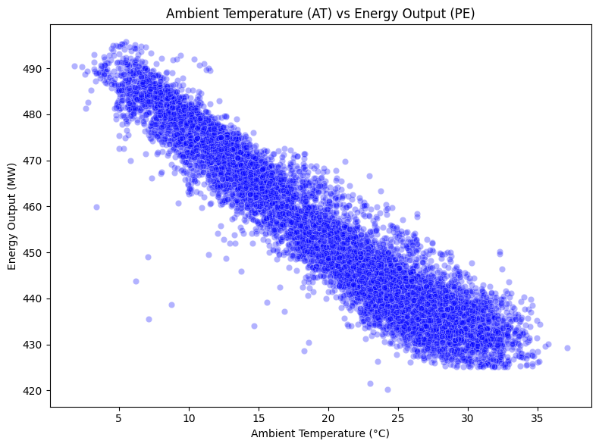
Figure 2. Scatter plot of Ambient Temperature (AT) and Energy Output (PE).
The scatter plot shows a clear downward pattern. When the ambient temperature increases, the energy output generally decreases. The points are close to the same downward trend, which is consistent with the correlation value of -0.95.
For me, this is the clearest relationship in the dataset. However, this result shows an association between AT and PE. It does not by itself prove that AT causes the change in PE.

5. Multiple Linear Regression
I used multiple linear regression to study the four input variables together. The model uses AT, V, AP, and RH to predict PE.
R² = 0.9287
The R² value from the model is 0.9287. This means that the model explains about 92.87% of the variation in PE in the data used for fitting the model.
This is a high R² value, so the model fits the available data well. However, in the Colab code I used the same data for fitting the model and for calculating R². Therefore, this value is an in-sample result. It does not tell us directly how the model will perform on new data.

6. Feature Coefficients
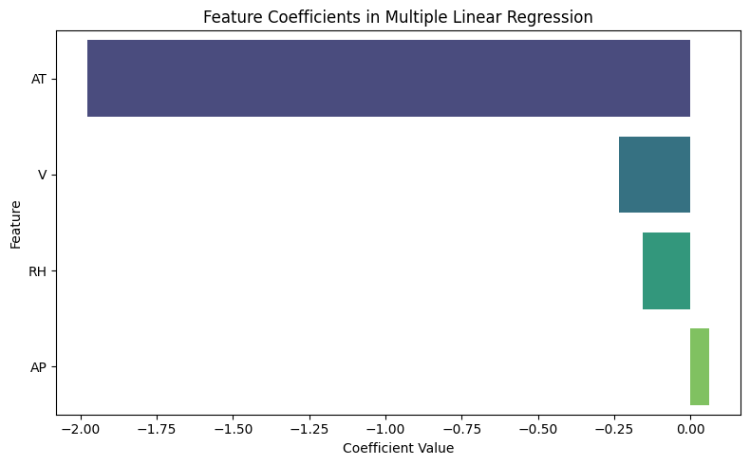
Figure 3. Feature coefficients from the multiple linear regression model.
The coefficient plot shows that AT has a clearly negative coefficient and the largest absolute coefficient in the model. This means that, when the other variables are included in the regression model, higher AT is associated with lower predicted PE.
V and RH also have negative coefficients. AP has a small positive coefficient. The direction of these coefficients is generally consistent with the correlation results.
The coefficient values should not be used alone to say which variable is the most important because the variables have different units and scales. In this analysis, I mainly use the coefficient plot to understand the direction of the relationship in the fitted model.

7. My Interpretation of the Results
The main result from this analysis is the strong negative relationship between ambient temperature and electrical energy output. Both the heatmap and the scatter plot show the same pattern. The correlation is -0.95, and the scatter plot has a clear downward trend.
The regression model also gives a high R² value of 0.9287. This suggests that AT, V, AP, and RH together can explain a large part of the variation in PE for the data used in this analysis.
The coefficient plot gives a similar picture. AT has the largest negative coefficient, while V and RH are also negative and AP is positive. Therefore, the different parts of the analysis give a generally consistent result.
One limitation is that the regression model was not tested on a separate test dataset in this Colab. Also, correlation does not mean causation. A future analysis could use a train/test split or cross-validation to check the model on unseen data.

8. Gemini Prompt Used for the Analysis
A simple prompt for Gemini can be used to perform and explain the analysis:
Analyze the Combined Cycle Power Plant dataset. Create a correlation heatmap for all numerical variables. Create a scatter plot of Ambient Temperature (AT) and Electrical Energy Output (PE). Then build a multiple linear regression model using AT, V, AP, and RH to predict PE. Show the R² value and create a feature coefficient plot. Explain the main results in simple English. Also mention that correlation does not prove causation.

9. Conclusion
In this analysis, AT shows the strongest negative relationship with PE. The multiple linear regression model has an R² of 0.9287 for the available data. The coefficient plot also shows a large negative coefficient for AT. Overall, the heatmap, scatter plot, and regression model show a similar pattern in the data.

