Exploratory Data Analytics (EDA) Report
Exploratory data analysis of five Kaggle datasets: Titanic, Red Wine Quality, Palmer Archipelago Penguins, Avocado Prices, and 80 Cereals Nutrition.

1. Titanic - Survival Data
This dataset has information about Titanic passengers, like age, passenger class, ticket fare, and if they survived.
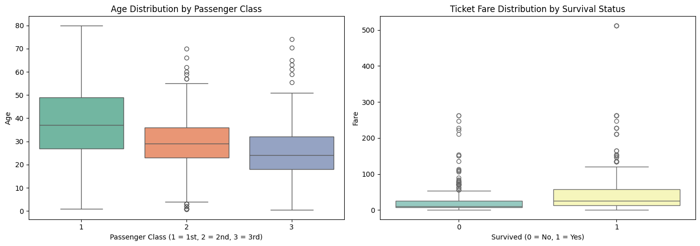
Age by passenger class, and fare by survival status
- Passengers in 1st class were older on average than passengers in 2nd and 3rd class.
- People who survived paid a higher fare on average than people who did not survive.
- There are some very high fares (outliers), especially among survivors.

2. Red Wine Quality
This dataset has chemical measurements of red wine samples, together with a quality score from 3 to 8.
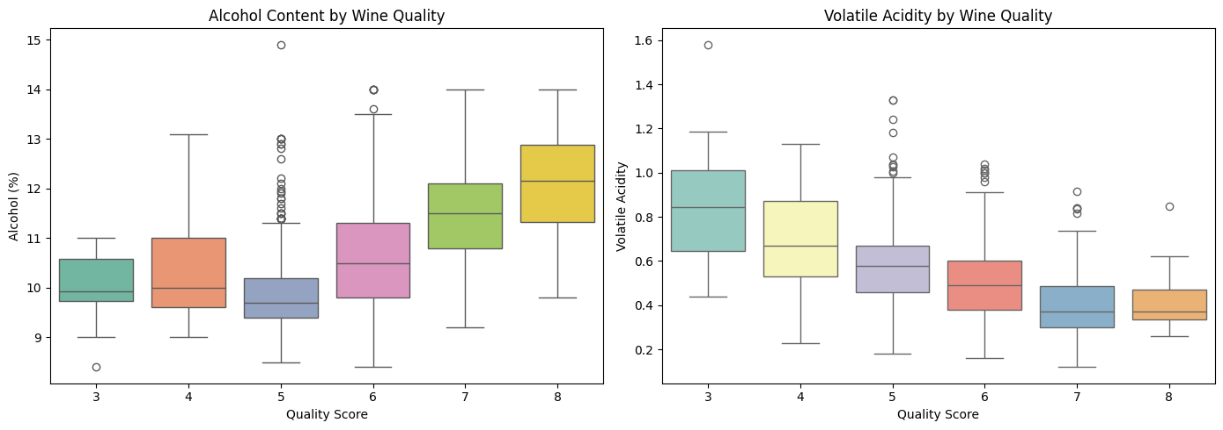
Alcohol content and volatile acidity by wine quality
- Wines with a higher quality score tend to have more alcohol.
- Wines with a higher quality score tend to have lower volatile acidity.
- This suggests alcohol and volatile acidity are both linked to wine quality.

3. Palmer Archipelago Penguins
This dataset has body measurements for three penguin species: Adelie, Chinstrap, and Gentoo.
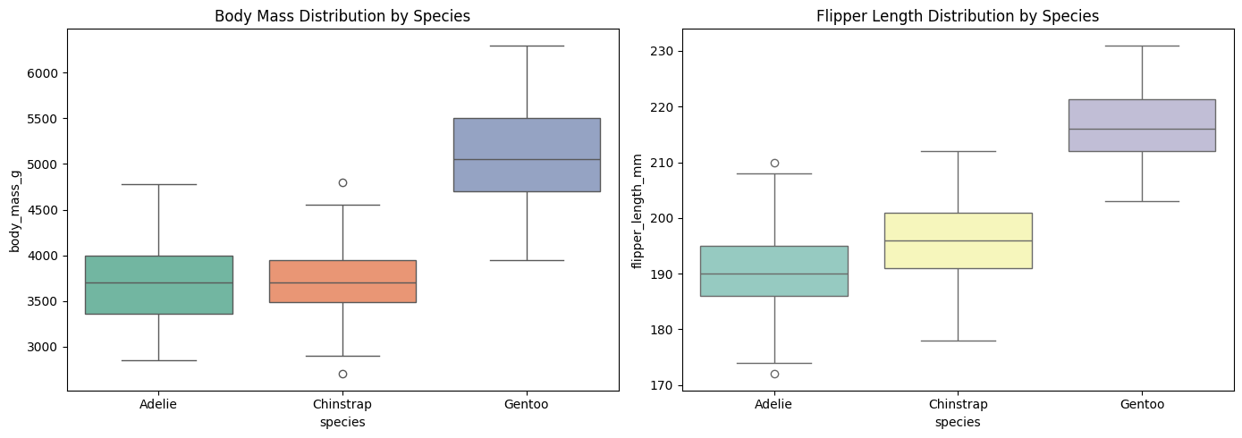
Body mass and flipper length by species
- Gentoo penguins are clearly bigger than the other two species, in both body mass and flipper length.
- Adelie and Chinstrap penguins are similar in size to each other.
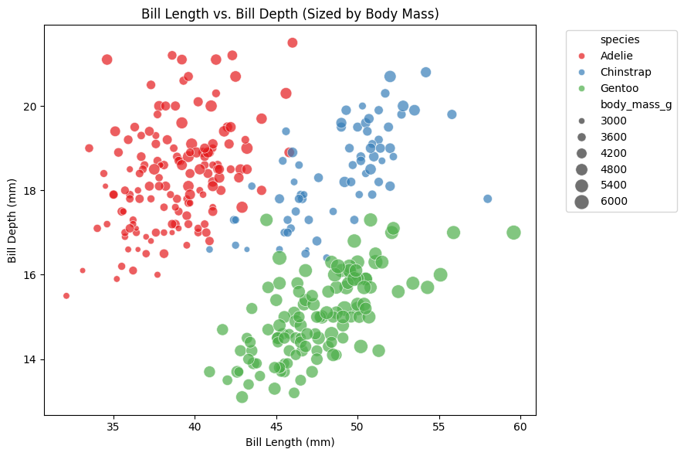
Bill length vs. bill depth, colored by species
- Bill shape separates the species well: Adelie penguins have short, deep bills, while Chinstrap and Gentoo penguins have longer bills.
- Gentoo penguins have the shallowest bills of the three species.

4. Avocado Prices
This dataset has weekly avocado prices and sales volume across different US regions, from 2015 to 2018.
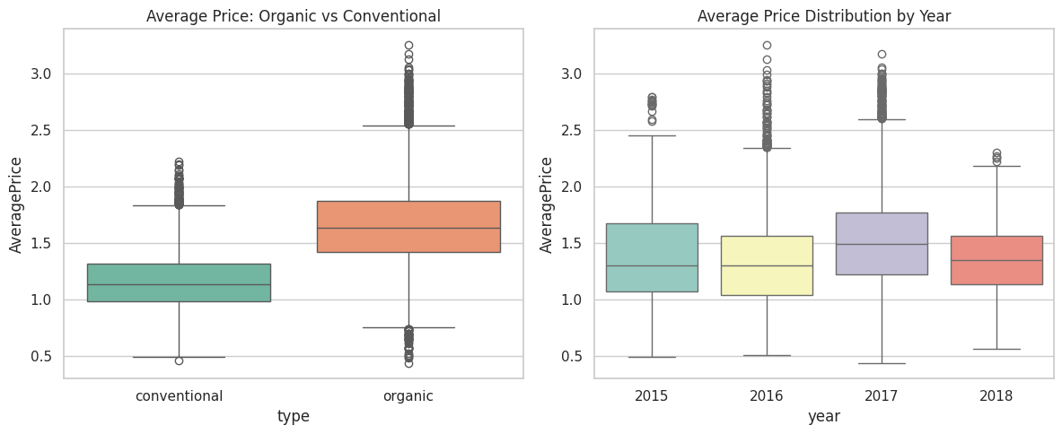
Average price by type (organic vs. conventional) and by year
- Organic avocados cost more than conventional avocados, on average about 50 cents more per avocado.
- Average prices were fairly stable across 2015-2018, with 2017 slightly higher than other years.
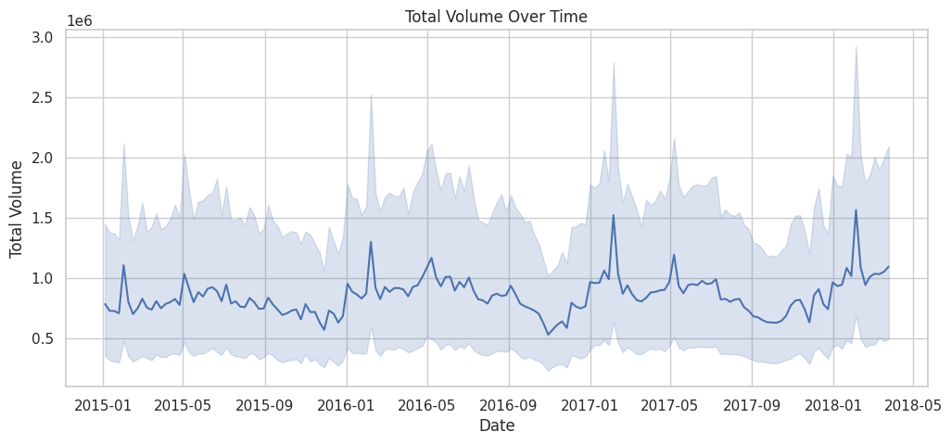
Total sales volume over time
- Sales volume goes up and down through the year, with sharp spikes around the start of each year (likely Super Bowl season, when avocado demand is high).

5. 80 Cereals Nutrition
This dataset has nutrition facts for 80 breakfast cereals, including the manufacturer, sugar content, and a nutrition rating.
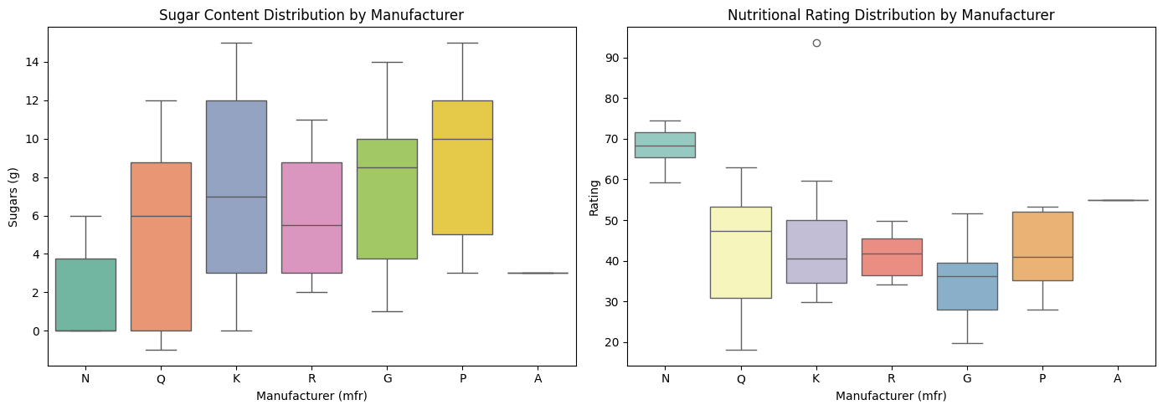
Sugar content and nutrition rating by manufacturer
- Manufacturer 'N' (Nabisco) has the lowest sugar content and the highest nutrition rating.
- Manufacturer 'K' (Kellogg's) has some of the highest sugar levels.
- In general, cereals with less sugar tend to have a higher nutrition rating.

Summary
All five datasets are good for practicing box plots and simple comparisons between groups. In each case, splitting the data into groups (species, quality score, passenger class, manufacturer, etc.) shows clear differences that are easy to see in a chart.

