This plug-in extends the uGUI Text rich Text format, support uGUI rich Text format, on the basis of a uniquely also adds the following format:

#R-Said the back of the font in red(red)  
#G-Said the back of the font in green(green)  
#B-Said the back of the font in blue(blue)  
#K-Said the back of the font in blank(blank)  
#Y-Said the back of the font in yellow(yellow)  
#W-Said the back of the font in white(white)  
#b-Said the back of the font to blink(blink)  
#c + Six or eight number or A - F - custom color.For example,For example,c008000=Dark green  
#u + text + #u-Words are underlined。  
#n-All text back to normal status。

#r-Wrap text。  
##-Is equal to a #。

#hThe text displayed{Hyperlinks parameters}#h The format for hyperlinks, click on the hyperlink, can obtain the parameters of the link.

**Note** that to receive the control parameters of events, please add the component SymbolTextEventComponents, and register the callback.

Class the following syntax format HTML tag syntax, supports the following tags:

**一：<sprite n=A w=B h=C b=D c=E t=F>**This format can display an elf in the current position,

A For the name of the elves, available elves can be commissioned by the custom.Tools.s_get_sprite In order to get.The default add here

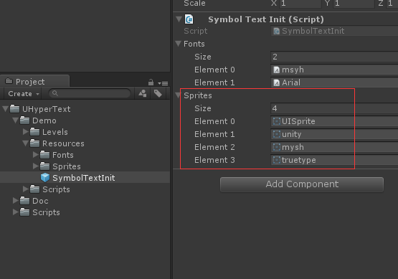

B As the width of the current elves, optional, the default value is the actual width of the elves

C For the current the height of the elves, the default value is the actual height of the elves

D Indicates whether or not the flashing, and value of 0 or 1

ESaid the color of the current elves, can pick up an RGB color value or defined color name, format for:

c=#RGB and c=ColorName,The color can be in ColorConst.Set。

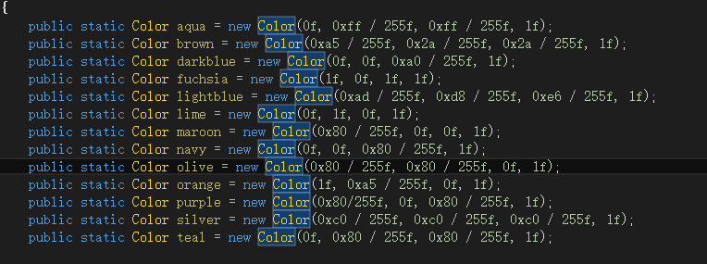

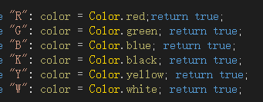

This to a better color names have been added.  
  
**F** original size with the size of the currently displayed to geometric scaling, 1 value according to the width of the scale 2 value according to the high scale, 0 means no mandatory geometric scaling.

1. **<pos v=A t=B>**

This format can be set up to draw the starting position of the elements, below A value for A specific value type, B value of 0 means the absolute coordinate location information format 1 2 said automatic matching relative coordinates, i.e. the node useless.  
For example,  
< pos v = 0.5 t = 1 > in the location of the 50% began to draw the next element.  
< pos v = 100 t = 0 > in the position of the x = 100 began to draw the next element.

1. **<RectSprite xxx> xxx**Content is consistent with the Sprite nodes**，**This node with Sprite difference is that RectSprite must specify the location of the map, other elements can be displayed around the region, similar to the following effect**:**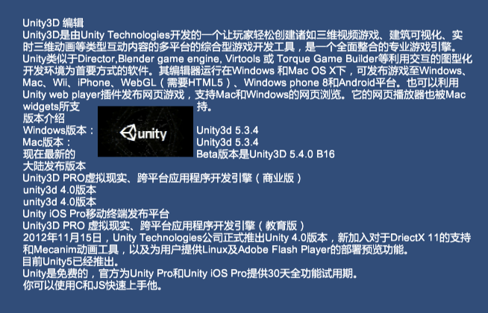
2. **<hy t=A l=B fs=C ft=D fn=E fc=F fhc=G ul=H so=I>**Second, the format for the format of the hyperlink, the following is a detailed description:

T = A - > A for the hyperlink to display content  
L = B - > B said the parameters of the hyperlinks, when click on this link, the content will be passed to the delegate.  
Fs = C - > C said the type size of hyperlinks, C represent Numbers  
Ft = D - > D said the font format, optional is normal, bold, italics, coarse + inclined  
Fn = E - > E said this the name of the font, font name can be set in the middle of the delegate, view s_get_font, the default binding here: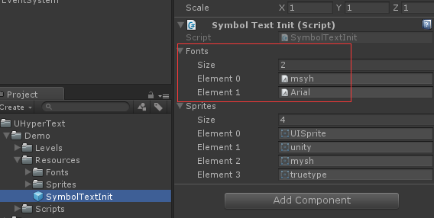

fc = F - > F said the color of the font, color format consistent with Sprite label  
fhc = G - > G the mouse-over hyperlinks on this, the color of the font, color format consistent with Sprite label

ul = H - > H the hyperlinks have underlined 1 0  
so = I - > I will indicate whether the hyperlinks have deleted line 1 is 0

1. **<color=XXX>** format, this is a node set colors, color format is consistent with the above
2. **</color>** Restore the color for the initial value.
3. **<b>**Start as bold
4. **</b>End** as bold
5. **<i>**Began to tilt display
6. **</i>**Tilt the ending of
7. **<size=A>**Set the current font size
8. **</size>**Restore the initial size

**The word connection details:**  
Most of the time, if appear this kind of situation, very affect beautiful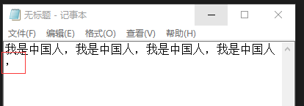

Symbol alone at first.This control to support the element we want in the same line as far as possible try to piece together on the same line, can choose: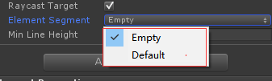

Use the Empty way, similar to the following: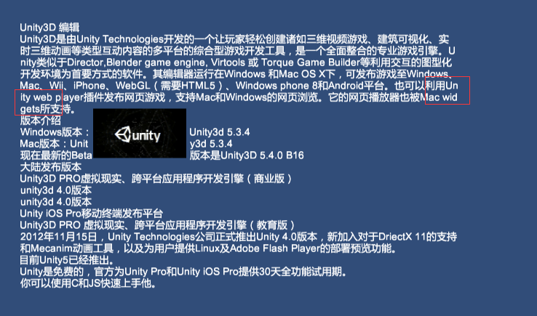

Word is split into multiple lines shows, use the Default is true: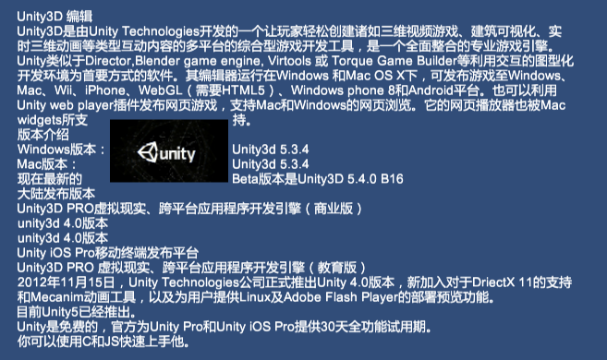

Can be customised to add combination rules of the elements,

ESFactory.Add(string name, ElementSegment es);