## Module 2 Assignment 2

#install.packages("MASS")  
#install.packages("leaps")

library(tidyverse)

## -- Attaching packages ------------------------------------ tidyverse 1.2.1 --

## v ggplot2 3.1.0 v purrr 0.3.0  
## v tibble 2.0.1 v dplyr 0.7.8  
## v tidyr 0.8.2 v stringr 1.3.1  
## v readr 1.3.1 v forcats 0.3.0

## -- Conflicts --------------------------------------- tidyverse_conflicts() --  
## x dplyr::filter() masks stats::filter()  
## x dplyr::lag() masks stats::lag()

library(GGally)

##   
## Attaching package: 'GGally'

## The following object is masked from 'package:dplyr':  
##   
## nasa

library(MASS)

##   
## Attaching package: 'MASS'

## The following object is masked from 'package:dplyr':  
##   
## select

library(leaps)

bike <- read_csv("hour.csv")

## Parsed with column specification:  
## cols(  
## instant = col_double(),  
## dteday = col_date(format = ""),  
## season = col_double(),  
## yr = col_double(),  
## mnth = col_double(),  
## hr = col_double(),  
## holiday = col_double(),  
## weekday = col_double(),  
## workingday = col_double(),  
## weathersit = col_double(),  
## temp = col_double(),  
## atemp = col_double(),  
## hum = col_double(),  
## windspeed = col_double(),  
## casual = col_double(),  
## registered = col_double(),  
## count = col_double()  
## )

View(bike)

bike = bike %>% mutate(season = as_factor(as.character(season))) %>%  
mutate(season = fct_recode(season,  
"Spring" = "1",  
"Summer" = "2",  
"Fall" = "3",  
"Winter" = "4"))%>% mutate(yr = as_factor(as.character(yr)))%>% mutate(mnth = as_factor(as.character(mnth)))%>% mutate(hr = as_factor(as.character(hr)))%>% mutate(holiday = as_factor(as.character(holiday))) %>%  
mutate(holiday = fct_recode(holiday,  
"NotHoliday" = "0",  
"Holiday" = "1"))%>% mutate(workingday = as_factor(as.character(workingday))) %>%  
mutate(workingday = fct_recode(workingday,  
"NotWorkingDay" = "0",  
"WorkingDay" = "1"))%>% mutate(weathersit = as_factor(as.character(weathersit))) %>%  
mutate(weathersit = fct_recode(weathersit,  
"NoPrecip" = "1",  
"Misty" = "2",  
"LightPrecip" = "3",  
"HeavyPrecip" = "4"))%>% mutate(weekday = as_factor(as.character(weekday))) %>%  
mutate(weekday = fct_recode(weekday,  
"Sunday" = "0",  
"Monday" = "1",  
"Tuesday" = "2",  
"Wednesday" = "3",  
"Thursday" = "4",  
"Friday" = "5",  
"saturday" = "6"))

str(bike)

## Classes 'tbl_df', 'tbl' and 'data.frame': 17379 obs. of 17 variables:  
## $ instant : num 1 2 3 4 5 6 7 8 9 10 ...  
## $ dteday : Date, format: "2011-01-01" "2011-01-01" ...  
## $ season : Factor w/ 4 levels "Spring","Summer",..: 1 1 1 1 1 1 1 1 1 1 ...  
## $ yr : Factor w/ 2 levels "0","1": 1 1 1 1 1 1 1 1 1 1 ...  
## $ mnth : Factor w/ 12 levels "1","2","3","4",..: 1 1 1 1 1 1 1 1 1 1 ...  
## $ hr : Factor w/ 24 levels "0","1","2","3",..: 1 2 3 4 5 6 7 8 9 10 ...  
## $ holiday : Factor w/ 2 levels "NotHoliday","Holiday": 1 1 1 1 1 1 1 1 1 1 ...  
## $ weekday : Factor w/ 7 levels "saturday","Sunday",..: 1 1 1 1 1 1 1 1 1 1 ...  
## $ workingday: Factor w/ 2 levels "NotWorkingDay",..: 1 1 1 1 1 1 1 1 1 1 ...  
## $ weathersit: Factor w/ 4 levels "NoPrecip","Misty",..: 1 1 1 1 1 2 1 1 1 1 ...  
## $ temp : num 0.24 0.22 0.22 0.24 0.24 0.24 0.22 0.2 0.24 0.32 ...  
## $ atemp : num 0.288 0.273 0.273 0.288 0.288 ...  
## $ hum : num 0.81 0.8 0.8 0.75 0.75 0.75 0.8 0.86 0.75 0.76 ...  
## $ windspeed : num 0 0 0 0 0 0.0896 0 0 0 0 ...  
## $ casual : num 3 8 5 3 0 0 2 1 1 8 ...  
## $ registered: num 13 32 27 10 1 1 0 2 7 6 ...  
## $ count : num 16 40 32 13 1 1 2 3 8 14 ...

We make “yr”, “mnth”, and “hr” into factors because then we can use them as categories or “containers” for our data analysis.  
This may mean that we just look at the observations with the mnth = 9. In this category we would look at all of the observations relevant to September (i.e. 9).

ggpairs(bike, cardinality_threshold = 24)

## `stat_bin()` using `bins = 30`. Pick better value with `binwidth`.  
## `stat_bin()` using `bins = 30`. Pick better value with `binwidth`.  
## `stat_bin()` using `bins = 30`. Pick better value with `binwidth`.  
## `stat_bin()` using `bins = 30`. Pick better value with `binwidth`.  
## `stat_bin()` using `bins = 30`. Pick better value with `binwidth`.  
## `stat_bin()` using `bins = 30`. Pick better value with `binwidth`.  
## `stat_bin()` using `bins = 30`. Pick better value with `binwidth`.  
## `stat_bin()` using `bins = 30`. Pick better value with `binwidth`.  
## `stat_bin()` using `bins = 30`. Pick better value with `binwidth`.  
## `stat_bin()` using `bins = 30`. Pick better value with `binwidth`.  
## `stat_bin()` using `bins = 30`. Pick better value with `binwidth`.  
## `stat_bin()` using `bins = 30`. Pick better value with `binwidth`.  
## `stat_bin()` using `bins = 30`. Pick better value with `binwidth`.  
## `stat_bin()` using `bins = 30`. Pick better value with `binwidth`.  
## `stat_bin()` using `bins = 30`. Pick better value with `binwidth`.  
## `stat_bin()` using `bins = 30`. Pick better value with `binwidth`.  
## `stat_bin()` using `bins = 30`. Pick better value with `binwidth`.  
## `stat_bin()` using `bins = 30`. Pick better value with `binwidth`.  
## `stat_bin()` using `bins = 30`. Pick better value with `binwidth`.  
## `stat_bin()` using `bins = 30`. Pick better value with `binwidth`.  
## `stat_bin()` using `bins = 30`. Pick better value with `binwidth`.  
## `stat_bin()` using `bins = 30`. Pick better value with `binwidth`.  
## `stat_bin()` using `bins = 30`. Pick better value with `binwidth`.  
## `stat_bin()` using `bins = 30`. Pick better value with `binwidth`.  
## `stat_bin()` using `bins = 30`. Pick better value with `binwidth`.  
## `stat_bin()` using `bins = 30`. Pick better value with `binwidth`.  
## `stat_bin()` using `bins = 30`. Pick better value with `binwidth`.  
## `stat_bin()` using `bins = 30`. Pick better value with `binwidth`.  
## `stat_bin()` using `bins = 30`. Pick better value with `binwidth`.  
## `stat_bin()` using `bins = 30`. Pick better value with `binwidth`.  
## `stat_bin()` using `bins = 30`. Pick better value with `binwidth`.  
## `stat_bin()` using `bins = 30`. Pick better value with `binwidth`.  
## `stat_bin()` using `bins = 30`. Pick better value with `binwidth`.  
## `stat_bin()` using `bins = 30`. Pick better value with `binwidth`.  
## `stat_bin()` using `bins = 30`. Pick better value with `binwidth`.  
## `stat_bin()` using `bins = 30`. Pick better value with `binwidth`.  
## `stat_bin()` using `bins = 30`. Pick better value with `binwidth`.  
## `stat_bin()` using `bins = 30`. Pick better value with `binwidth`.  
## `stat_bin()` using `bins = 30`. Pick better value with `binwidth`.  
## `stat_bin()` using `bins = 30`. Pick better value with `binwidth`.  
## `stat_bin()` using `bins = 30`. Pick better value with `binwidth`.  
## `stat_bin()` using `bins = 30`. Pick better value with `binwidth`.  
## `stat_bin()` using `bins = 30`. Pick better value with `binwidth`.  
## `stat_bin()` using `bins = 30`. Pick better value with `binwidth`.  
## `stat_bin()` using `bins = 30`. Pick better value with `binwidth`.  
## `stat_bin()` using `bins = 30`. Pick better value with `binwidth`.  
## `stat_bin()` using `bins = 30`. Pick better value with `binwidth`.  
## `stat_bin()` using `bins = 30`. Pick better value with `binwidth`.  
## `stat_bin()` using `bins = 30`. Pick better value with `binwidth`.  
## `stat_bin()` using `bins = 30`. Pick better value with `binwidth`.  
## `stat_bin()` using `bins = 30`. Pick better value with `binwidth`.  
## `stat_bin()` using `bins = 30`. Pick better value with `binwidth`.  
## `stat_bin()` using `bins = 30`. Pick better value with `binwidth`.  
## `stat_bin()` using `bins = 30`. Pick better value with `binwidth`.  
## `stat_bin()` using `bins = 30`. Pick better value with `binwidth`.  
## `stat_bin()` using `bins = 30`. Pick better value with `binwidth`.  
## `stat_bin()` using `bins = 30`. Pick better value with `binwidth`.  
## `stat_bin()` using `bins = 30`. Pick better value with `binwidth`.  
## `stat_bin()` using `bins = 30`. Pick better value with `binwidth`.  
## `stat_bin()` using `bins = 30`. Pick better value with `binwidth`.  
## `stat_bin()` using `bins = 30`. Pick better value with `binwidth`.  
## `stat_bin()` using `bins = 30`. Pick better value with `binwidth`.  
## `stat_bin()` using `bins = 30`. Pick better value with `binwidth`.  
## `stat_bin()` using `bins = 30`. Pick better value with `binwidth`.  
## `stat_bin()` using `bins = 30`. Pick better value with `binwidth`.  
## `stat_bin()` using `bins = 30`. Pick better value with `binwidth`.  
## `stat_bin()` using `bins = 30`. Pick better value with `binwidth`.  
## `stat_bin()` using `bins = 30`. Pick better value with `binwidth`.  
## `stat_bin()` using `bins = 30`. Pick better value with `binwidth`.  
## `stat_bin()` using `bins = 30`. Pick better value with `binwidth`.  
## `stat_bin()` using `bins = 30`. Pick better value with `binwidth`.  
## `stat_bin()` using `bins = 30`. Pick better value with `binwidth`.

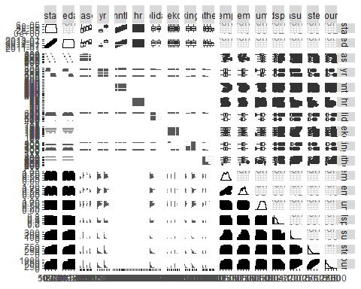

ggcorr(bike, label = TRUE)

## Warning in ggcorr(bike, label = TRUE): data in column(s) 'dteday',  
## 'season', 'yr', 'mnth', 'hr', 'holiday', 'weekday', 'workingday',  
## 'weathersit' are not numeric and were ignored

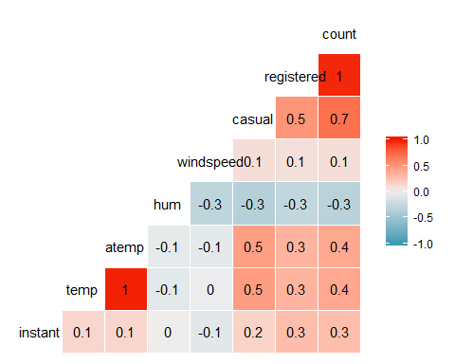

The quantitative variable that is best orrelated with count is casual.

ggplot(bike,aes(x=season,y=count)) + geom_boxplot()

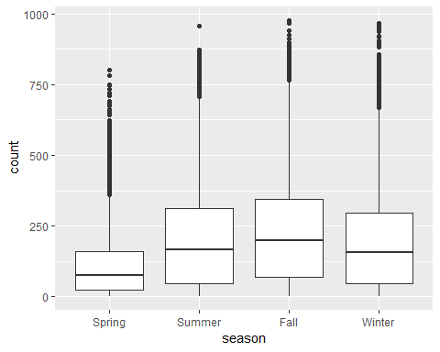

It seems that the count increases as we get to nicer weather in Summer and Fall.

ggplot(bike,aes(x=yr,y=count)) + geom_boxplot()

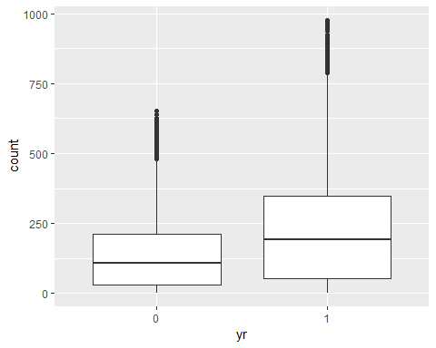

It appears as if there was a higher count in the second year than the first. I am not sure that there is any correlation though.

ggplot(bike,aes(x=mnth,y=count)) + geom_boxplot()

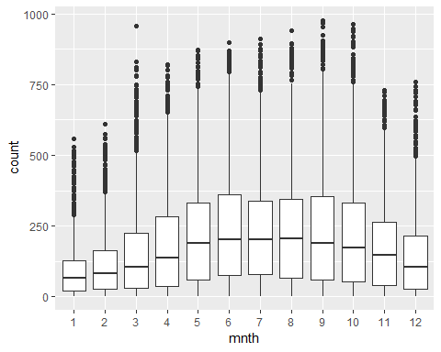

This coincides with the season data. As the weather gets nicer in the summer and fall months (6-9) be see an increased count.

ggplot(bike,aes(x=hr,y=count)) + geom_boxplot()

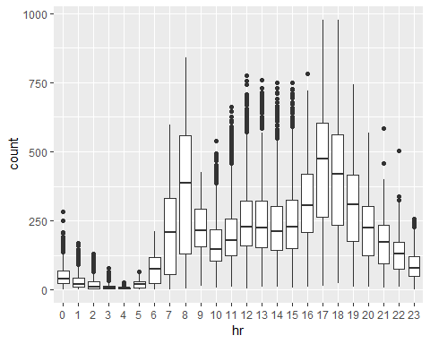

The time of day effects the count. What seems to be the trend here is that people do the activity before and after work. In the 8 hr we also may count the people that do the activity on the way to work.

ggplot(bike,aes(x=holiday,y=count)) + geom_boxplot()

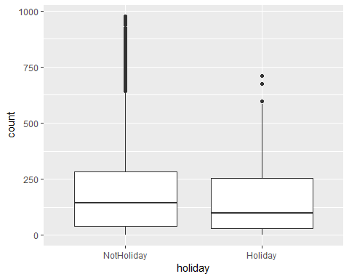

Based on the above data it seems like the activity is performed because of or in relation to work versus when people are off work.

ggplot(bike,aes(x=workingday,y=count)) + geom_boxplot()

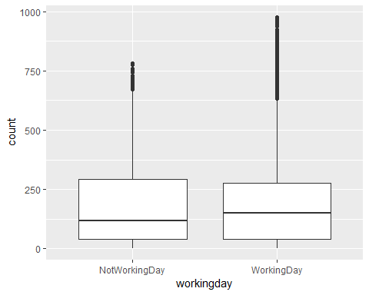

Again, as stated above, it seems like the activity is performed because of or in relation to work versus when people are off work.

ggplot(bike,aes(x=weathersit,y=count)) + geom_boxplot()

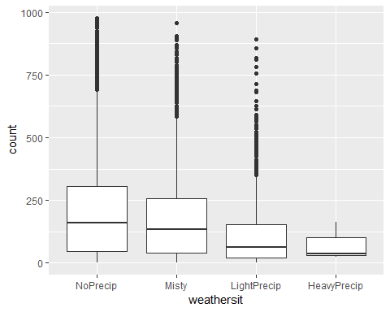

We see a gradual lowering in count based on the amount of precpitation in the weather.

ggplot(bike,aes(x=weekday,y=count)) + geom_boxplot()

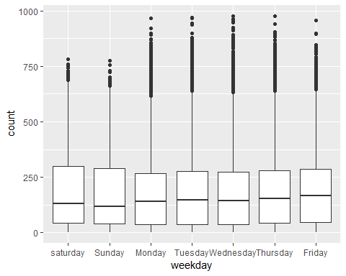

The weekdays what people most commonly have work have the highest count. This directly ties back to the various graphs showing higher counts around working days.

The variables that seem to affect count are weekday, weathersit, workingday, holiday, hr, mnth, & season.

bike2 = bike %>% dplyr::select(-c(instant, dteday, registered, casual))

allmod = lm(count ~., bike2)  
summary(allmod)

##   
## Call:  
## lm(formula = count ~ ., data = bike2)  
##   
## Residuals:  
## Min 1Q Median 3Q Max   
## -393.87 -60.66 -7.96 51.31 439.18   
##   
## Coefficients: (1 not defined because of singularities)  
## Estimate Std. Error t value Pr(>|t|)   
## (Intercept) -67.542 6.612 -10.216 < 2e-16 ***  
## seasonSummer 38.178 4.856 7.862 4.00e-15 ***  
## seasonFall 32.055 5.749 5.575 2.51e-08 ***  
## seasonWinter 67.994 4.882 13.928 < 2e-16 ***  
## yr1 85.431 1.563 54.658 < 2e-16 ***  
## mnth2 3.426 3.920 0.874 0.38219   
## mnth3 14.299 4.407 3.244 0.00118 **   
## mnth4 6.230 6.548 0.951 0.34144   
## mnth5 20.657 7.007 2.948 0.00320 **   
## mnth6 6.238 7.205 0.866 0.38662   
## mnth7 -13.269 8.082 -1.642 0.10065   
## mnth8 7.897 7.879 1.002 0.31622   
## mnth9 32.269 7.001 4.609 4.07e-06 ***  
## mnth10 15.843 6.483 2.444 0.01455 *   
## mnth11 -9.840 6.238 -1.577 0.11474   
## mnth12 -6.256 4.954 -1.263 0.20672   
## hr1 -17.294 5.345 -3.236 0.00122 **   
## hr2 -26.369 5.364 -4.916 8.91e-07 ***  
## hr3 -37.112 5.403 -6.869 6.67e-12 ***  
## hr4 -40.263 5.408 -7.445 1.01e-13 ***  
## hr5 -23.501 5.373 -4.374 1.23e-05 ***  
## hr6 35.393 5.359 6.605 4.10e-11 ***  
## hr7 170.418 5.348 31.864 < 2e-16 ***  
## hr8 310.801 5.342 58.183 < 2e-16 ***  
## hr9 163.101 5.347 30.501 < 2e-16 ***  
## hr10 108.444 5.370 20.196 < 2e-16 ***  
## hr11 133.843 5.409 24.742 < 2e-16 ***  
## hr12 173.142 5.456 31.735 < 2e-16 ***  
## hr13 168.102 5.494 30.600 < 2e-16 ***  
## hr14 152.249 5.525 27.558 < 2e-16 ***  
## hr15 161.707 5.535 29.213 < 2e-16 ***  
## hr16 223.834 5.524 40.522 < 2e-16 ***  
## hr17 377.535 5.491 68.750 < 2e-16 ***  
## hr18 345.587 5.455 63.350 < 2e-16 ***  
## hr19 236.919 5.404 43.841 < 2e-16 ***  
## hr20 157.293 5.375 29.266 < 2e-16 ***  
## hr21 107.840 5.353 20.147 < 2e-16 ***  
## hr22 70.907 5.343 13.272 < 2e-16 ***  
## hr23 32.112 5.338 6.015 1.83e-09 ***  
## holidayHoliday -26.228 4.881 -5.374 7.81e-08 ***  
## weekdaySunday -16.089 2.878 -5.591 2.30e-08 ***  
## weekdayMonday -6.814 2.970 -2.294 0.02180 *   
## weekdayTuesday -5.240 2.899 -1.807 0.07071 .   
## weekdayWednesday -2.464 2.894 -0.851 0.39469   
## weekdayThursday -2.940 2.892 -1.016 0.30947   
## weekdayFriday 1.356 2.885 0.470 0.63823   
## workingdayWorkingDay NA NA NA NA   
## weathersitMisty -10.409 1.920 -5.421 6.00e-08 ***  
## weathersitLightPrecip -65.189 3.236 -20.145 < 2e-16 ***  
## weathersitHeavyPrecip -62.580 58.893 -1.063 0.28797   
## temp 116.384 29.513 3.943 8.06e-05 ***  
## atemp 127.975 30.624 4.179 2.94e-05 ***  
## hum -82.802 5.554 -14.909 < 2e-16 ***  
## windspeed -29.167 7.052 -4.136 3.55e-05 ***  
## ---  
## Signif. codes: 0 '***' 0.001 '**' 0.01 '*' 0.05 '.' 0.1 ' ' 1  
##   
## Residual standard error: 101.7 on 17326 degrees of freedom  
## Multiple R-squared: 0.6864, Adjusted R-squared: 0.6854   
## F-statistic: 729.1 on 52 and 17326 DF, p-value: < 2.2e-16

emptymod = lm(count ~1, bike2)  
summary(emptymod)

##   
## Call:  
## lm(formula = count ~ 1, data = bike2)  
##   
## Residuals:  
## Min 1Q Median 3Q Max   
## -188.46 -149.46 -47.46 91.54 787.54   
##   
## Coefficients:  
## Estimate Std. Error t value Pr(>|t|)   
## (Intercept) 189.463 1.376 137.7 <2e-16 ***  
## ---  
## Signif. codes: 0 '***' 0.001 '**' 0.01 '*' 0.05 '.' 0.1 ' ' 1  
##   
## Residual standard error: 181.4 on 17378 degrees of freedom

forwardmod = stepAIC(emptymod, direction = "forward",  
scope=list(upper=allmod,lower=emptymod),  
 trace = TRUE)

## Start: AIC=180764.7  
## count ~ 1  
##   
## Df Sum of Sq RSS AIC  
## + hr 23 286734681 285026910 168713  
## + temp 1 93677759 478083832 177657  
## + atemp 1 91907421 479854170 177721  
## + hum 1 59618351 512143240 178853  
## + mnth 11 42909976 528851615 179431  
## + season 3 37729358 534032233 179584  
## + yr 1 35876722 535884870 179641  
## + weathersit 3 12285030 559476561 180393  
## + windspeed 1 4970060 566791531 180615  
## + holiday 1 546889 571214702 180750  
## + workingday 1 524387 571237204 180751  
## + weekday 6 687929 571073662 180756  
## <none> 571761591 180765  
##   
## Step: AIC=168712.5  
## count ~ hr  
##   
## Df Sum of Sq RSS AIC  
## + atemp 1 50518941 234507969 165324  
## + temp 1 50101685 234925225 165355  
## + mnth 11 44822160 240204750 165761  
## + season 3 39619754 245407156 166117  
## + yr 1 36875130 248151780 166307  
## + weathersit 3 13766672 271260238 167858  
## + hum 1 4924310 280102600 168412  
## + windspeed 1 1476211 283550699 168624  
## + holiday 1 561784 284465126 168680  
## + weekday 6 719530 284307380 168681  
## + workingday 1 485366 284541544 168685  
## <none> 285026910 168713  
##   
## Step: AIC=165324  
## count ~ hr + atemp  
##   
## Df Sum of Sq RSS AIC  
## + yr 1 33463769 201044200 162650  
## + weathersit 3 9227265 225280704 164632  
## + hum 1 7008684 227499285 164799  
## + season 3 6580442 227927527 164835  
## + mnth 11 5854560 228653409 164907  
## + weekday 6 607638 233900331 165291  
## + holiday 1 274006 234233963 165306  
## + temp 1 152153 234355816 165315  
## + windspeed 1 120557 234387412 165317  
## + workingday 1 90170 234417799 165319  
## <none> 234507969 165324  
##   
## Step: AIC=162650.2  
## count ~ hr + atemp + yr  
##   
## Df Sum of Sq RSS AIC  
## + weathersit 3 8408358 192635842 161914  
## + season 3 7190305 193853896 162023  
## + mnth 11 6486062 194558138 162102  
## + hum 1 4341837 196702363 162273  
## + weekday 6 641648 200402552 162607  
## + holiday 1 324763 200719438 162624  
## + windspeed 1 109311 200934889 162643  
## + workingday 1 106404 200937797 162643  
## + temp 1 91735 200952465 162644  
## <none> 201044200 162650  
##   
## Step: AIC=161913.7  
## count ~ hr + atemp + yr + weathersit  
##   
## Df Sum of Sq RSS AIC  
## + season 3 7771024 184864818 161204  
## + mnth 11 7464989 185170852 161249  
## + hum 1 805099 191830743 161843  
## + weekday 6 686172 191949670 161864  
## + holiday 1 413536 192222305 161878  
## + workingday 1 212428 192423414 161897  
## + temp 1 134482 192501360 161904  
## + windspeed 1 44407 192591435 161912  
## <none> 192635842 161914  
##   
## Step: AIC=161204.1  
## count ~ hr + atemp + yr + weathersit + season  
##   
## Df Sum of Sq RSS AIC  
## + mnth 11 2051323 182813495 161032  
## + hum 1 1810161 183054657 161035  
## + weekday 6 704303 184160515 161150  
## + holiday 1 392702 184472116 161169  
## + temp 1 352584 184512234 161173  
## + workingday 1 214973 184649845 161186  
## <none> 184864818 161204  
## + windspeed 1 158 184864660 161206  
##   
## Step: AIC=161032.2  
## count ~ hr + atemp + yr + weathersit + season + mnth  
##   
## Df Sum of Sq RSS AIC  
## + hum 1 2356411 180457084 160809  
## + weekday 6 692672 182120823 160978  
## + holiday 1 312321 182501174 161004  
## + temp 1 233052 182580443 161012  
## + workingday 1 203953 182609542 161015  
## <none> 182813495 161032  
## + windspeed 1 68 182813428 161034  
##   
## Step: AIC=160808.7  
## count ~ hr + atemp + yr + weathersit + season + mnth + hum  
##   
## Df Sum of Sq RSS AIC  
## + weekday 6 581105 179875980 160765  
## + holiday 1 322997 180134087 160780  
## + workingday 1 194139 180262945 160792  
## + windspeed 1 114287 180342797 160800  
## + temp 1 100025 180357059 160801  
## <none> 180457084 160809  
##   
## Step: AIC=160764.7  
## count ~ hr + atemp + yr + weathersit + season + mnth + hum +   
## weekday  
##   
## Df Sum of Sq RSS AIC  
## + holiday 1 274717 179601263 160740  
## + workingday 1 274717 179601263 160740  
## + windspeed 1 112085 179763895 160756  
## + temp 1 77171 179798809 160759  
## <none> 179875980 160765  
##   
## Step: AIC=160740.1  
## count ~ hr + atemp + yr + weathersit + season + mnth + hum +   
## weekday + holiday  
##   
## Df Sum of Sq RSS AIC  
## + windspeed 1 111562 179489701 160731  
## + temp 1 95460 179505803 160733  
## <none> 179601263 160740  
##   
## Step: AIC=160731.3  
## count ~ hr + atemp + yr + weathersit + season + mnth + hum +   
## weekday + holiday + windspeed  
##   
## Df Sum of Sq RSS AIC  
## + temp 1 160954 179328746 160718  
## <none> 179489701 160731  
##   
## Step: AIC=160717.7  
## count ~ hr + atemp + yr + weathersit + season + mnth + hum +   
## weekday + holiday + windspeed + temp  
##   
## Df Sum of Sq RSS AIC  
## <none> 179328746 160718

summary(forwardmod)

##   
## Call:  
## lm(formula = count ~ hr + atemp + yr + weathersit + season +   
## mnth + hum + weekday + holiday + windspeed + temp, data = bike2)  
##   
## Residuals:  
## Min 1Q Median 3Q Max   
## -393.87 -60.66 -7.96 51.31 439.18   
##   
## Coefficients:  
## Estimate Std. Error t value Pr(>|t|)   
## (Intercept) -67.542 6.612 -10.216 < 2e-16 ***  
## hr1 -17.294 5.345 -3.236 0.00122 **   
## hr2 -26.369 5.364 -4.916 8.91e-07 ***  
## hr3 -37.112 5.403 -6.869 6.67e-12 ***  
## hr4 -40.263 5.408 -7.445 1.01e-13 ***  
## hr5 -23.501 5.373 -4.374 1.23e-05 ***  
## hr6 35.393 5.359 6.605 4.10e-11 ***  
## hr7 170.418 5.348 31.864 < 2e-16 ***  
## hr8 310.801 5.342 58.183 < 2e-16 ***  
## hr9 163.101 5.347 30.501 < 2e-16 ***  
## hr10 108.444 5.370 20.196 < 2e-16 ***  
## hr11 133.843 5.409 24.742 < 2e-16 ***  
## hr12 173.142 5.456 31.735 < 2e-16 ***  
## hr13 168.102 5.494 30.600 < 2e-16 ***  
## hr14 152.249 5.525 27.558 < 2e-16 ***  
## hr15 161.707 5.535 29.213 < 2e-16 ***  
## hr16 223.834 5.524 40.522 < 2e-16 ***  
## hr17 377.535 5.491 68.750 < 2e-16 ***  
## hr18 345.587 5.455 63.350 < 2e-16 ***  
## hr19 236.919 5.404 43.841 < 2e-16 ***  
## hr20 157.293 5.375 29.266 < 2e-16 ***  
## hr21 107.840 5.353 20.147 < 2e-16 ***  
## hr22 70.907 5.343 13.272 < 2e-16 ***  
## hr23 32.112 5.338 6.015 1.83e-09 ***  
## atemp 127.975 30.624 4.179 2.94e-05 ***  
## yr1 85.431 1.563 54.658 < 2e-16 ***  
## weathersitMisty -10.409 1.920 -5.421 6.00e-08 ***  
## weathersitLightPrecip -65.189 3.236 -20.145 < 2e-16 ***  
## weathersitHeavyPrecip -62.580 58.893 -1.063 0.28797   
## seasonSummer 38.178 4.856 7.862 4.00e-15 ***  
## seasonFall 32.055 5.749 5.575 2.51e-08 ***  
## seasonWinter 67.994 4.882 13.928 < 2e-16 ***  
## mnth2 3.426 3.920 0.874 0.38219   
## mnth3 14.299 4.407 3.244 0.00118 **   
## mnth4 6.230 6.548 0.951 0.34144   
## mnth5 20.657 7.007 2.948 0.00320 **   
## mnth6 6.238 7.205 0.866 0.38662   
## mnth7 -13.269 8.082 -1.642 0.10065   
## mnth8 7.897 7.879 1.002 0.31622   
## mnth9 32.269 7.001 4.609 4.07e-06 ***  
## mnth10 15.843 6.483 2.444 0.01455 *   
## mnth11 -9.840 6.238 -1.577 0.11474   
## mnth12 -6.256 4.954 -1.263 0.20672   
## hum -82.802 5.554 -14.909 < 2e-16 ***  
## weekdaySunday -16.089 2.878 -5.591 2.30e-08 ***  
## weekdayMonday -6.814 2.970 -2.294 0.02180 *   
## weekdayTuesday -5.240 2.899 -1.807 0.07071 .   
## weekdayWednesday -2.464 2.894 -0.851 0.39469   
## weekdayThursday -2.940 2.892 -1.016 0.30947   
## weekdayFriday 1.356 2.885 0.470 0.63823   
## holidayHoliday -26.228 4.881 -5.374 7.81e-08 ***  
## windspeed -29.167 7.052 -4.136 3.55e-05 ***  
## temp 116.384 29.513 3.943 8.06e-05 ***  
## ---  
## Signif. codes: 0 '***' 0.001 '**' 0.01 '*' 0.05 '.' 0.1 ' ' 1  
##   
## Residual standard error: 101.7 on 17326 degrees of freedom  
## Multiple R-squared: 0.6864, Adjusted R-squared: 0.6854   
## F-statistic: 729.1 on 52 and 17326 DF, p-value: < 2.2e-16

The variables that are included in the forward model are hr, atemp, yr, weathersit, season, mnth, hum, weekday, holiday, windspeed, and temp.

This is a good model. You can see that the R square value is .69 which is pretty high. High enough to have a decent amount of confidence in the model. We also see that the predictor value is much lower than .05 at 2.2e-16. I would say that the model does indeed pass the common sense test. We see that many of the variables that we looked earlier have low p-values that are great predictors of count. Some of these include the season, the hour of the activity, and the weather. That said, earlier we thought the day of the week was correlated with count but based on the model we see that there isn’t strong evidence that they are related.

backmod = stepAIC(allmod, direction = "backward", trace = TRUE)

## Start: AIC=160717.7  
## count ~ season + yr + mnth + hr + holiday + weekday + workingday +   
## weathersit + temp + atemp + hum + windspeed  
##   
##   
## Step: AIC=160717.7  
## count ~ season + yr + mnth + hr + holiday + weekday + weathersit +   
## temp + atemp + hum + windspeed  
##   
## Df Sum of Sq RSS AIC  
## <none> 179328746 160718  
## - temp 1 160954 179489701 160731  
## - windspeed 1 177057 179505803 160733  
## - atemp 1 180751 179509498 160733  
## - holiday 1 298893 179627639 160745  
## - weekday 6 498795 179827541 160754  
## - mnth 11 2426171 181754917 160929  
## - hum 1 2300667 181629413 160937  
## - season 3 2398467 181727213 160943  
## - weathersit 3 4208731 183537478 161115  
## - yr 1 30920851 210249597 163480  
## - hr 23 196741474 376070220 173542

summary(backmod)

##   
## Call:  
## lm(formula = count ~ season + yr + mnth + hr + holiday + weekday +   
## weathersit + temp + atemp + hum + windspeed, data = bike2)  
##   
## Residuals:  
## Min 1Q Median 3Q Max   
## -393.87 -60.66 -7.96 51.31 439.18   
##   
## Coefficients:  
## Estimate Std. Error t value Pr(>|t|)   
## (Intercept) -67.542 6.612 -10.216 < 2e-16 ***  
## seasonSummer 38.178 4.856 7.862 4.00e-15 ***  
## seasonFall 32.055 5.749 5.575 2.51e-08 ***  
## seasonWinter 67.994 4.882 13.928 < 2e-16 ***  
## yr1 85.431 1.563 54.658 < 2e-16 ***  
## mnth2 3.426 3.920 0.874 0.38219   
## mnth3 14.299 4.407 3.244 0.00118 **   
## mnth4 6.230 6.548 0.951 0.34144   
## mnth5 20.657 7.007 2.948 0.00320 **   
## mnth6 6.238 7.205 0.866 0.38662   
## mnth7 -13.269 8.082 -1.642 0.10065   
## mnth8 7.897 7.879 1.002 0.31622   
## mnth9 32.269 7.001 4.609 4.07e-06 ***  
## mnth10 15.843 6.483 2.444 0.01455 *   
## mnth11 -9.840 6.238 -1.577 0.11474   
## mnth12 -6.256 4.954 -1.263 0.20672   
## hr1 -17.294 5.345 -3.236 0.00122 **   
## hr2 -26.369 5.364 -4.916 8.91e-07 ***  
## hr3 -37.112 5.403 -6.869 6.67e-12 ***  
## hr4 -40.263 5.408 -7.445 1.01e-13 ***  
## hr5 -23.501 5.373 -4.374 1.23e-05 ***  
## hr6 35.393 5.359 6.605 4.10e-11 ***  
## hr7 170.418 5.348 31.864 < 2e-16 ***  
## hr8 310.801 5.342 58.183 < 2e-16 ***  
## hr9 163.101 5.347 30.501 < 2e-16 ***  
## hr10 108.444 5.370 20.196 < 2e-16 ***  
## hr11 133.843 5.409 24.742 < 2e-16 ***  
## hr12 173.142 5.456 31.735 < 2e-16 ***  
## hr13 168.102 5.494 30.600 < 2e-16 ***  
## hr14 152.249 5.525 27.558 < 2e-16 ***  
## hr15 161.707 5.535 29.213 < 2e-16 ***  
## hr16 223.834 5.524 40.522 < 2e-16 ***  
## hr17 377.535 5.491 68.750 < 2e-16 ***  
## hr18 345.587 5.455 63.350 < 2e-16 ***  
## hr19 236.919 5.404 43.841 < 2e-16 ***  
## hr20 157.293 5.375 29.266 < 2e-16 ***  
## hr21 107.840 5.353 20.147 < 2e-16 ***  
## hr22 70.907 5.343 13.272 < 2e-16 ***  
## hr23 32.112 5.338 6.015 1.83e-09 ***  
## holidayHoliday -26.228 4.881 -5.374 7.81e-08 ***  
## weekdaySunday -16.089 2.878 -5.591 2.30e-08 ***  
## weekdayMonday -6.814 2.970 -2.294 0.02180 *   
## weekdayTuesday -5.240 2.899 -1.807 0.07071 .   
## weekdayWednesday -2.464 2.894 -0.851 0.39469   
## weekdayThursday -2.940 2.892 -1.016 0.30947   
## weekdayFriday 1.356 2.885 0.470 0.63823   
## weathersitMisty -10.409 1.920 -5.421 6.00e-08 ***  
## weathersitLightPrecip -65.189 3.236 -20.145 < 2e-16 ***  
## weathersitHeavyPrecip -62.580 58.893 -1.063 0.28797   
## temp 116.384 29.513 3.943 8.06e-05 ***  
## atemp 127.975 30.624 4.179 2.94e-05 ***  
## hum -82.802 5.554 -14.909 < 2e-16 ***  
## windspeed -29.167 7.052 -4.136 3.55e-05 ***  
## ---  
## Signif. codes: 0 '***' 0.001 '**' 0.01 '*' 0.05 '.' 0.1 ' ' 1  
##   
## Residual standard error: 101.7 on 17326 degrees of freedom  
## Multiple R-squared: 0.6864, Adjusted R-squared: 0.6854   
## F-statistic: 729.1 on 52 and 17326 DF, p-value: < 2.2e-16

In many cases the model has not changed. We still see that with this model we have a relatively high R-squared value at .69 and a very low predictor value at 2.2e-16. What I think is interesting though is how it flipped the order of the variables based on what would produce the best improvements.

As suggested the “workingday” variable has been kicked out of the model. The reason behind this is by combining the variables of holiday and weekday you can pretty well get the dfeined values that would be worrking days. Therefore, there is no need to for this redundant variable in the model. This shows that they are causing multicollinearity.

bike = bike %>% mutate(yr = as.integer(yr)-1)  
bike3 = bike %>% dplyr::select(-c(instant, dteday, registered, casual))

allmod = lm(count ~., bike3)  
summary(allmod)

##   
## Call:  
## lm(formula = count ~ ., data = bike3)  
##   
## Residuals:  
## Min 1Q Median 3Q Max   
## -393.87 -60.66 -7.96 51.31 439.18   
##   
## Coefficients: (1 not defined because of singularities)  
## Estimate Std. Error t value Pr(>|t|)   
## (Intercept) -67.542 6.612 -10.216 < 2e-16 ***  
## seasonSummer 38.178 4.856 7.862 4.00e-15 ***  
## seasonFall 32.055 5.749 5.575 2.51e-08 ***  
## seasonWinter 67.994 4.882 13.928 < 2e-16 ***  
## yr 85.431 1.563 54.658 < 2e-16 ***  
## mnth2 3.426 3.920 0.874 0.38219   
## mnth3 14.299 4.407 3.244 0.00118 **   
## mnth4 6.230 6.548 0.951 0.34144   
## mnth5 20.657 7.007 2.948 0.00320 **   
## mnth6 6.238 7.205 0.866 0.38662   
## mnth7 -13.269 8.082 -1.642 0.10065   
## mnth8 7.897 7.879 1.002 0.31622   
## mnth9 32.269 7.001 4.609 4.07e-06 ***  
## mnth10 15.843 6.483 2.444 0.01455 *   
## mnth11 -9.840 6.238 -1.577 0.11474   
## mnth12 -6.256 4.954 -1.263 0.20672   
## hr1 -17.294 5.345 -3.236 0.00122 **   
## hr2 -26.369 5.364 -4.916 8.91e-07 ***  
## hr3 -37.112 5.403 -6.869 6.67e-12 ***  
## hr4 -40.263 5.408 -7.445 1.01e-13 ***  
## hr5 -23.501 5.373 -4.374 1.23e-05 ***  
## hr6 35.393 5.359 6.605 4.10e-11 ***  
## hr7 170.418 5.348 31.864 < 2e-16 ***  
## hr8 310.801 5.342 58.183 < 2e-16 ***  
## hr9 163.101 5.347 30.501 < 2e-16 ***  
## hr10 108.444 5.370 20.196 < 2e-16 ***  
## hr11 133.843 5.409 24.742 < 2e-16 ***  
## hr12 173.142 5.456 31.735 < 2e-16 ***  
## hr13 168.102 5.494 30.600 < 2e-16 ***  
## hr14 152.249 5.525 27.558 < 2e-16 ***  
## hr15 161.707 5.535 29.213 < 2e-16 ***  
## hr16 223.834 5.524 40.522 < 2e-16 ***  
## hr17 377.535 5.491 68.750 < 2e-16 ***  
## hr18 345.587 5.455 63.350 < 2e-16 ***  
## hr19 236.919 5.404 43.841 < 2e-16 ***  
## hr20 157.293 5.375 29.266 < 2e-16 ***  
## hr21 107.840 5.353 20.147 < 2e-16 ***  
## hr22 70.907 5.343 13.272 < 2e-16 ***  
## hr23 32.112 5.338 6.015 1.83e-09 ***  
## holidayHoliday -26.228 4.881 -5.374 7.81e-08 ***  
## weekdaySunday -16.089 2.878 -5.591 2.30e-08 ***  
## weekdayMonday -6.814 2.970 -2.294 0.02180 *   
## weekdayTuesday -5.240 2.899 -1.807 0.07071 .   
## weekdayWednesday -2.464 2.894 -0.851 0.39469   
## weekdayThursday -2.940 2.892 -1.016 0.30947   
## weekdayFriday 1.356 2.885 0.470 0.63823   
## workingdayWorkingDay NA NA NA NA   
## weathersitMisty -10.409 1.920 -5.421 6.00e-08 ***  
## weathersitLightPrecip -65.189 3.236 -20.145 < 2e-16 ***  
## weathersitHeavyPrecip -62.580 58.893 -1.063 0.28797   
## temp 116.384 29.513 3.943 8.06e-05 ***  
## atemp 127.975 30.624 4.179 2.94e-05 ***  
## hum -82.802 5.554 -14.909 < 2e-16 ***  
## windspeed -29.167 7.052 -4.136 3.55e-05 ***  
## ---  
## Signif. codes: 0 '***' 0.001 '**' 0.01 '*' 0.05 '.' 0.1 ' ' 1  
##   
## Residual standard error: 101.7 on 17326 degrees of freedom  
## Multiple R-squared: 0.6864, Adjusted R-squared: 0.6854   
## F-statistic: 729.1 on 52 and 17326 DF, p-value: < 2.2e-16

emptymod = lm(count ~1, bike3)  
summary(emptymod)

##   
## Call:  
## lm(formula = count ~ 1, data = bike3)  
##   
## Residuals:  
## Min 1Q Median 3Q Max   
## -188.46 -149.46 -47.46 91.54 787.54   
##   
## Coefficients:  
## Estimate Std. Error t value Pr(>|t|)   
## (Intercept) 189.463 1.376 137.7 <2e-16 ***  
## ---  
## Signif. codes: 0 '***' 0.001 '**' 0.01 '*' 0.05 '.' 0.1 ' ' 1  
##   
## Residual standard error: 181.4 on 17378 degrees of freedom

forwardmod = stepAIC(emptymod, direction = "forward",  
scope=list(upper=allmod,lower=emptymod),  
 trace = TRUE)

## Start: AIC=180764.7  
## count ~ 1  
##   
## Df Sum of Sq RSS AIC  
## + hr 23 286734681 285026910 168713  
## + temp 1 93677759 478083832 177657  
## + atemp 1 91907421 479854170 177721  
## + hum 1 59618351 512143240 178853  
## + mnth 11 42909976 528851615 179431  
## + season 3 37729358 534032233 179584  
## + yr 1 35876722 535884870 179641  
## + weathersit 3 12285030 559476561 180393  
## + windspeed 1 4970060 566791531 180615  
## + holiday 1 546889 571214702 180750  
## + workingday 1 524387 571237204 180751  
## + weekday 6 687929 571073662 180756  
## <none> 571761591 180765  
##   
## Step: AIC=168712.5  
## count ~ hr  
##   
## Df Sum of Sq RSS AIC  
## + atemp 1 50518941 234507969 165324  
## + temp 1 50101685 234925225 165355  
## + mnth 11 44822160 240204750 165761  
## + season 3 39619754 245407156 166117  
## + yr 1 36875130 248151780 166307  
## + weathersit 3 13766672 271260238 167858  
## + hum 1 4924310 280102600 168412  
## + windspeed 1 1476211 283550699 168624  
## + holiday 1 561784 284465126 168680  
## + weekday 6 719530 284307380 168681  
## + workingday 1 485366 284541544 168685  
## <none> 285026910 168713  
##   
## Step: AIC=165324  
## count ~ hr + atemp  
##   
## Df Sum of Sq RSS AIC  
## + yr 1 33463769 201044200 162650  
## + weathersit 3 9227265 225280704 164632  
## + hum 1 7008684 227499285 164799  
## + season 3 6580442 227927527 164835  
## + mnth 11 5854560 228653409 164907  
## + weekday 6 607638 233900331 165291  
## + holiday 1 274006 234233963 165306  
## + temp 1 152153 234355816 165315  
## + windspeed 1 120557 234387412 165317  
## + workingday 1 90170 234417799 165319  
## <none> 234507969 165324  
##   
## Step: AIC=162650.2  
## count ~ hr + atemp + yr  
##   
## Df Sum of Sq RSS AIC  
## + weathersit 3 8408358 192635842 161914  
## + season 3 7190305 193853896 162023  
## + mnth 11 6486062 194558138 162102  
## + hum 1 4341837 196702363 162273  
## + weekday 6 641648 200402552 162607  
## + holiday 1 324763 200719438 162624  
## + windspeed 1 109311 200934889 162643  
## + workingday 1 106404 200937797 162643  
## + temp 1 91735 200952465 162644  
## <none> 201044200 162650  
##   
## Step: AIC=161913.7  
## count ~ hr + atemp + yr + weathersit  
##   
## Df Sum of Sq RSS AIC  
## + season 3 7771024 184864818 161204  
## + mnth 11 7464989 185170852 161249  
## + hum 1 805099 191830743 161843  
## + weekday 6 686172 191949670 161864  
## + holiday 1 413536 192222305 161878  
## + workingday 1 212428 192423414 161897  
## + temp 1 134482 192501360 161904  
## + windspeed 1 44407 192591435 161912  
## <none> 192635842 161914  
##   
## Step: AIC=161204.1  
## count ~ hr + atemp + yr + weathersit + season  
##   
## Df Sum of Sq RSS AIC  
## + mnth 11 2051323 182813495 161032  
## + hum 1 1810161 183054657 161035  
## + weekday 6 704303 184160515 161150  
## + holiday 1 392702 184472116 161169  
## + temp 1 352584 184512234 161173  
## + workingday 1 214973 184649845 161186  
## <none> 184864818 161204  
## + windspeed 1 158 184864660 161206  
##   
## Step: AIC=161032.2  
## count ~ hr + atemp + yr + weathersit + season + mnth  
##   
## Df Sum of Sq RSS AIC  
## + hum 1 2356411 180457084 160809  
## + weekday 6 692672 182120823 160978  
## + holiday 1 312321 182501174 161004  
## + temp 1 233052 182580443 161012  
## + workingday 1 203953 182609542 161015  
## <none> 182813495 161032  
## + windspeed 1 68 182813428 161034  
##   
## Step: AIC=160808.7  
## count ~ hr + atemp + yr + weathersit + season + mnth + hum  
##   
## Df Sum of Sq RSS AIC  
## + weekday 6 581105 179875980 160765  
## + holiday 1 322997 180134087 160780  
## + workingday 1 194139 180262945 160792  
## + windspeed 1 114287 180342797 160800  
## + temp 1 100025 180357059 160801  
## <none> 180457084 160809  
##   
## Step: AIC=160764.7  
## count ~ hr + atemp + yr + weathersit + season + mnth + hum +   
## weekday  
##   
## Df Sum of Sq RSS AIC  
## + holiday 1 274717 179601263 160740  
## + workingday 1 274717 179601263 160740  
## + windspeed 1 112085 179763895 160756  
## + temp 1 77171 179798809 160759  
## <none> 179875980 160765  
##   
## Step: AIC=160740.1  
## count ~ hr + atemp + yr + weathersit + season + mnth + hum +   
## weekday + holiday  
##   
## Df Sum of Sq RSS AIC  
## + windspeed 1 111562 179489701 160731  
## + temp 1 95460 179505803 160733  
## <none> 179601263 160740  
##   
## Step: AIC=160731.3  
## count ~ hr + atemp + yr + weathersit + season + mnth + hum +   
## weekday + holiday + windspeed  
##   
## Df Sum of Sq RSS AIC  
## + temp 1 160954 179328746 160718  
## <none> 179489701 160731  
##   
## Step: AIC=160717.7  
## count ~ hr + atemp + yr + weathersit + season + mnth + hum +   
## weekday + holiday + windspeed + temp  
##   
## Df Sum of Sq RSS AIC  
## <none> 179328746 160718

summary(forwardmod)

##   
## Call:  
## lm(formula = count ~ hr + atemp + yr + weathersit + season +   
## mnth + hum + weekday + holiday + windspeed + temp, data = bike3)  
##   
## Residuals:  
## Min 1Q Median 3Q Max   
## -393.87 -60.66 -7.96 51.31 439.18   
##   
## Coefficients:  
## Estimate Std. Error t value Pr(>|t|)   
## (Intercept) -67.542 6.612 -10.216 < 2e-16 ***  
## hr1 -17.294 5.345 -3.236 0.00122 **   
## hr2 -26.369 5.364 -4.916 8.91e-07 ***  
## hr3 -37.112 5.403 -6.869 6.67e-12 ***  
## hr4 -40.263 5.408 -7.445 1.01e-13 ***  
## hr5 -23.501 5.373 -4.374 1.23e-05 ***  
## hr6 35.393 5.359 6.605 4.10e-11 ***  
## hr7 170.418 5.348 31.864 < 2e-16 ***  
## hr8 310.801 5.342 58.183 < 2e-16 ***  
## hr9 163.101 5.347 30.501 < 2e-16 ***  
## hr10 108.444 5.370 20.196 < 2e-16 ***  
## hr11 133.843 5.409 24.742 < 2e-16 ***  
## hr12 173.142 5.456 31.735 < 2e-16 ***  
## hr13 168.102 5.494 30.600 < 2e-16 ***  
## hr14 152.249 5.525 27.558 < 2e-16 ***  
## hr15 161.707 5.535 29.213 < 2e-16 ***  
## hr16 223.834 5.524 40.522 < 2e-16 ***  
## hr17 377.535 5.491 68.750 < 2e-16 ***  
## hr18 345.587 5.455 63.350 < 2e-16 ***  
## hr19 236.919 5.404 43.841 < 2e-16 ***  
## hr20 157.293 5.375 29.266 < 2e-16 ***  
## hr21 107.840 5.353 20.147 < 2e-16 ***  
## hr22 70.907 5.343 13.272 < 2e-16 ***  
## hr23 32.112 5.338 6.015 1.83e-09 ***  
## atemp 127.975 30.624 4.179 2.94e-05 ***  
## yr 85.431 1.563 54.658 < 2e-16 ***  
## weathersitMisty -10.409 1.920 -5.421 6.00e-08 ***  
## weathersitLightPrecip -65.189 3.236 -20.145 < 2e-16 ***  
## weathersitHeavyPrecip -62.580 58.893 -1.063 0.28797   
## seasonSummer 38.178 4.856 7.862 4.00e-15 ***  
## seasonFall 32.055 5.749 5.575 2.51e-08 ***  
## seasonWinter 67.994 4.882 13.928 < 2e-16 ***  
## mnth2 3.426 3.920 0.874 0.38219   
## mnth3 14.299 4.407 3.244 0.00118 **   
## mnth4 6.230 6.548 0.951 0.34144   
## mnth5 20.657 7.007 2.948 0.00320 **   
## mnth6 6.238 7.205 0.866 0.38662   
## mnth7 -13.269 8.082 -1.642 0.10065   
## mnth8 7.897 7.879 1.002 0.31622   
## mnth9 32.269 7.001 4.609 4.07e-06 ***  
## mnth10 15.843 6.483 2.444 0.01455 *   
## mnth11 -9.840 6.238 -1.577 0.11474   
## mnth12 -6.256 4.954 -1.263 0.20672   
## hum -82.802 5.554 -14.909 < 2e-16 ***  
## weekdaySunday -16.089 2.878 -5.591 2.30e-08 ***  
## weekdayMonday -6.814 2.970 -2.294 0.02180 *   
## weekdayTuesday -5.240 2.899 -1.807 0.07071 .   
## weekdayWednesday -2.464 2.894 -0.851 0.39469   
## weekdayThursday -2.940 2.892 -1.016 0.30947   
## weekdayFriday 1.356 2.885 0.470 0.63823   
## holidayHoliday -26.228 4.881 -5.374 7.81e-08 ***  
## windspeed -29.167 7.052 -4.136 3.55e-05 ***  
## temp 116.384 29.513 3.943 8.06e-05 ***  
## ---  
## Signif. codes: 0 '***' 0.001 '**' 0.01 '*' 0.05 '.' 0.1 ' ' 1  
##   
## Residual standard error: 101.7 on 17326 degrees of freedom  
## Multiple R-squared: 0.6864, Adjusted R-squared: 0.6854   
## F-statistic: 729.1 on 52 and 17326 DF, p-value: < 2.2e-16

Based on my analysis there is no change between the forward stepwise regression models after you make the “yr” variable an integer.