2024
Joshua Flenley
Godalming College
03/06/2024
Computer Science NEA - Checkers

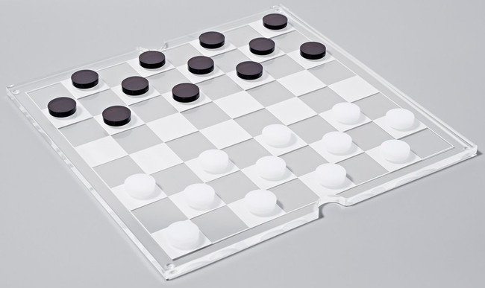
Contents
Research & Analysis 3
Why I chose this problem 3
Problem Overview 3
Types of pieces 4
Man pieces 4
King pieces 4
Capturing enemy pieces 5
Problem Solutions 5
Physical Solutions 5
Virtual Solutions 5
Variations of the Game 6
End-User and Their Problem 7
Interviewing End-Users 7
Research Summary 9
Data Flow Diagrams 9
Level 0 Data Flow Diagram 9
Level 1 Data Flow Diagram 10
Different AI systems 12
Monte Carlo Tree Search (MCTS) 12
Minimax algorithm with Alpha-Beta pruning 13
Login System 14
Dialogue 15
Objectives 16
Requirements 17
Design 19
UML Class Diagram 19
Game UI: 20
File Management/Data Storage 22
AI Opponent 25
Move Validation 25
Libraries and Dependencies 27
Testing 28
Testing Plan 28
Input and output testing 28
Navigation Table 38
Main Testing 39
Navigation Testing 49
Evaluation 50
Requirement Review 50
Potential for Further Development 55
Third Party Feedback 57
Conclusion 57
Technical Solution 58
main.py 58
play_menu.py 60
rules.py 61
checkers_game_screen.py 64
game.py 66
board.py 67
piece.py 73
minimax.py 74
end_menu.py 75
login_menu.py 76
accounts.py 81
db_functions.py 87
useful_classes.py 91
constants.py 92
Testing Images 94
References 108

Research & Analysis

Why I chose this problem
I chose this project because I have played checkers with my family many times and enjoyed it so creating this program would mean that I would still be able to play the game on my own, without needing a board also.

Problem Overview
The following references the American checkers version or the game.
Checkers is a 2-player game involving 12 identical pieces for each player, meaning that they can only play the same type of move, being forward diagonally.

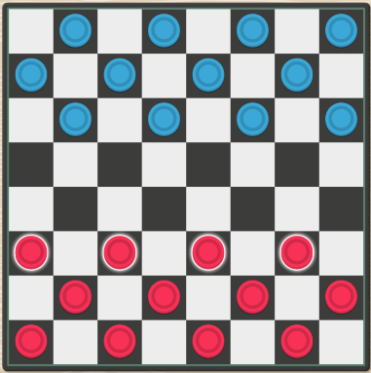
The game is played upon an 8x8 board where all the pieces start on a dark square, as shown in the image below, pulled from (gametable.org, 2024)

The problem to be solved is for one player to remove all enemy pieces from the board to win the game. This can be achieved by hopping over an enemy piece that is forwards diagonally aligned with one of the players’ pieces.

Types of pieces
In checkers, there are two types of pieces that can be on the board:

Man Pieces
These pieces are the 12 objects that each player begins the game with. All these pieces can only move forwards diagonally unless they are blocked by the edges of the board or other pieces. Their movements are shown below.

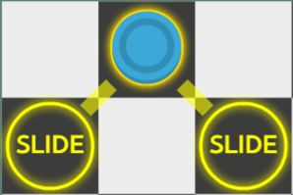
Man moves (gametable.org, 2024)

King Pieces
This piece can only come into play once a man reaches the end of the board without being taken. Kings have a more advanced move set compared to men because they are allowed to move in any diagonal direction, meaning that they are much more useful than standard men. The movements of a King are illustrated below.

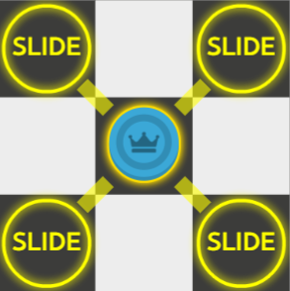
King moves (gametable.org, 2024)

Capturing Enemy Pieces
All pieces in the game can take other pieces from the board (see next page), acting towards the goal of the game, which is to be the player with the only pieces on the board.
However, men can only take other pieces in the forwards horizontal direction, whereas kings take a piece in any horizontal direction.
In some situations, it is possible for 1 piece to take multiple pieces in one turn, but only if they are aligned in a similar positioning to that on the next page
If a capture is possible, the player must play all the possible captures for that piece. Only one piece can capture any other pieces per turn.
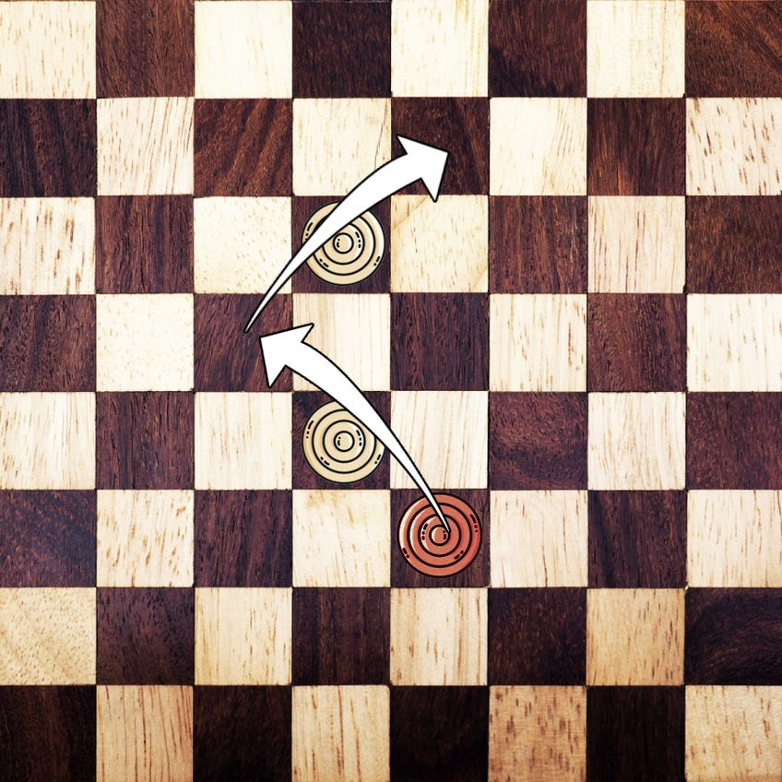
‘Double jump’ move in checkers (Dassanayake, 2024)
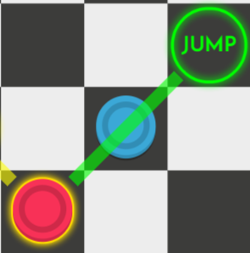
Taking a piece in checkers

Problem Solutions
Currently, there are many solutions to this problem, both online and offline.

Physical Solutions
Originally, checkers was entirely played on a physical board as its first iteration came about in roughly 3000 BCE, significantly before the invention of the first computer.

Virtual Solutions
However, nowadays, there are many programs and websites easily available to use to play the board game virtually. In 1951, Christopher Strachey attempted the first coded version of checkers, however, it did not function as intended due to errors in the program. It was not until a year later that he completed a working version. This is considered by some the first ever video game in existence (Wikipedia, 2024)

Variations of the Game
While there are more abstract variations of the game, the main ones in keeping with the game are:
- International draughts - (Wikipedia, 2024)
  - Played on a 10x10 board.
  - Each player has 20 men.
  - Captures can occur in any direction, not only forwards, as in American checkers.
  - Kings can ‘fly’ meaning that they can move as many spaces as they want in a single direction per turn.
  - If one or more capture is possible, the player must take it.
- Russian draughts - (Wikipedia, 2024)
  - Played on an 8x8 board.
  - 12 starting pieces
  - Capturing is mandatory.
  - If a man enters the final row in a capture sequence, it continues the sequence as a king.
Because checkers is such an old game, there are numerous deviations, separate to the main types of checkers, as listed below.
- Blue & Gray – (Wikipedia, 2024)
  - Played on a 9x9 board with 80 intersections.
  - 18 pieces
  - 17 ‘guards’, each that can move in any direction
  - 1 ‘captain’, that is escorted to the centre of the board to win
  - Captain can only move along a predetermined path and the guards can take other guards or attempt to stop the captain from advancing.
- Cheskers - (Wikipedia, 2024)
  - A mix between chess and checkers, where there are additional pieces.
  - These being:
    - Bishops, which function the same as in regular chess.
    - Camels (a.k.a. cooks), which moves one space diagonally and two straight, but can only take a piece by landing directly on it
- Each player starts with 2 kings, a knight, and a bishop and can gain more by moving a man to the end of the board.
- The game ends when one player loses all their kings or cannot play any more moves.
- Hexdame - (Wikipedia, 2024)
  - Literal translation of international checkers onto a hexagonal game board consisting of 61 tiles
  - Each player has 16 men that can move to an adjacent cell or take another man in an adjacent cell also.
  - All other rules are the same as international checkers.

End-User and Their Problem

The end user for this project is anyone that wants to play checkers in their free time without needing to find/buy a board and the pieces to play the game. Additionally, they will be able to play on their own against an AI opponent, meaning they can play easily when they are bored.
The problem that the End-User is attempting to solve is removing all the enemy pieces from the board before the enemy does by moving diagonally over them, employing various strategies to do so.

Interviewing End-Users
To interview end users for my project, I used a Microsoft Forms questionnaire to gather multiple results and to gain an idea of what players of an online checkers game would want to see.

The results of this show that only 33% of end users interviewed had ever played checkers before along with the same number having also played it online.
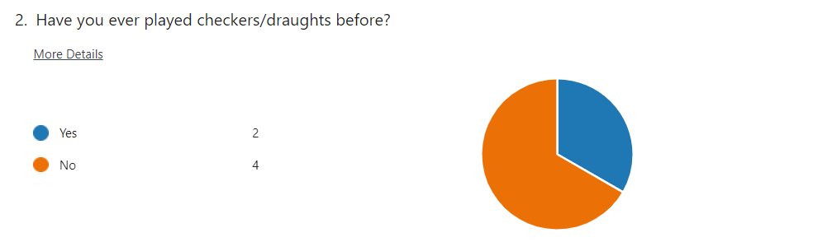
I also asked whether they would like a tutorial or set of instructions added to the game, to which 100% of interviewees responded yes to

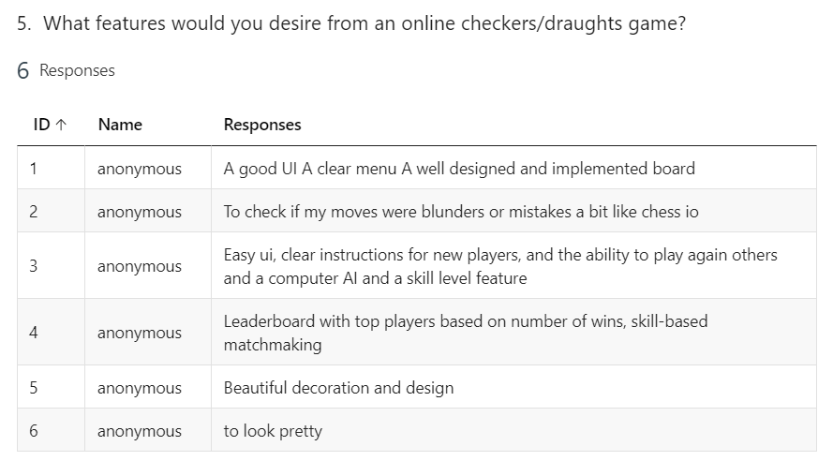
Additionally, I asked the interviewees what features that they would desire from an app such as mine, and many stated they wanted a ‘good’, ‘easy’ user interface, as well as ‘a well designed and implemented board’.
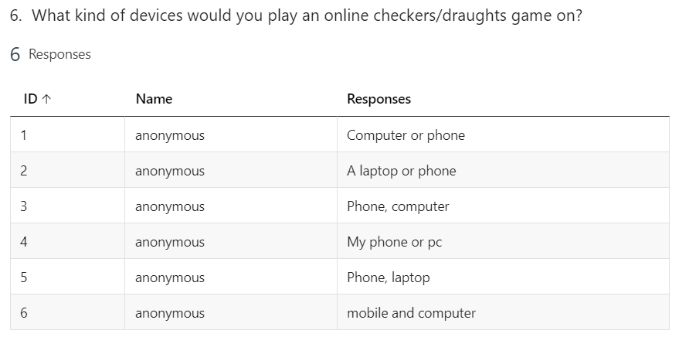
Furthermore, I inquired about the devices that people would be most likely to play my game on, with virtually all the responses mentioning a computer or mobile phone, meaning that I will not have to take into consideration different modes of input, such as using a games controller as that won't be a platform that people will use to play my game.

I asked my interviewees about whether they would prefer to have an AI opponent to play against in a game or have the game be online and against an opponent within a web front end. There was a 50/50 split in opinions, meaning that I will have to decide which route I want to take my project down and whether I feel that one of those options may be out of my scope.

When asked about how the game pieces should be operated, the majority of opinions where that the pieces should be ‘tap to move’, meaning that the user will select a piece then select where they want the piece to go. However, one person also had the idea to use a drag and drop feature for the pieces too, giving me a choice on how I would like my pieces to function.
Finally, I asked about the addition of other modes of checkers to the game, such as ‘Cheskers’ or ‘Blue and Gray’. The majority of responses where for the idea, implying that they would be open to playing iterations other than American checkers, meaning that I may include these modes as added functionality. (see next page for pie chart)

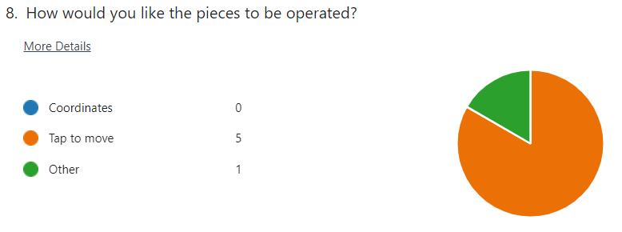

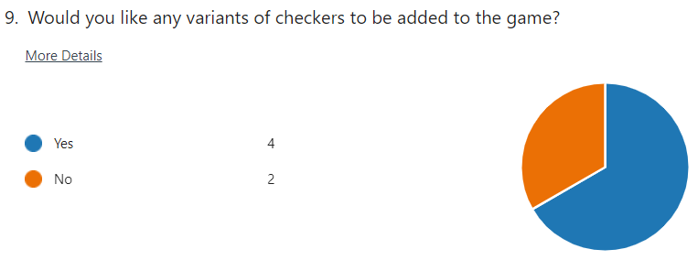
This questionnaire gives me an idea about the desires of the end-users of my game, showing me that I should add a set of instructions about how to play the game, a well thought out and easy to understand GUI, as well as other checkers variations to play to please the users.

Research Summary
Overall, checkers is a two-player game focussed on being the last colour left on the board. It was originally played in 3000 BCE, but in a different form and has had many online versions created since. There are many iterations of checkers, alongside branch off games, such as Cheskers and end-users of my product would be interested in seeing these sorts of games added alongside a concise GUI and either an AI or multiplayer element.

Data Flow Diagrams

Level 0 Data Flow Diagram
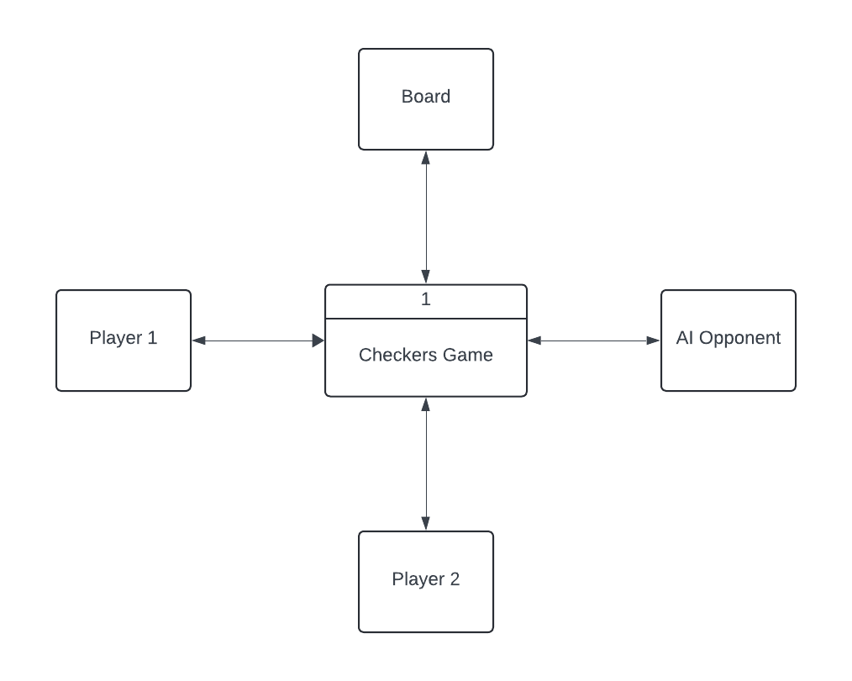

A level 0 data flow diagram shows the simplest form of transfers of data through the diagram. In the diagram on the previous page, the users (either physical or AI) send data to and from the game functions, such as to move pieces. Additionally, the game functions and the board communicate to represent the updating of piece positions.

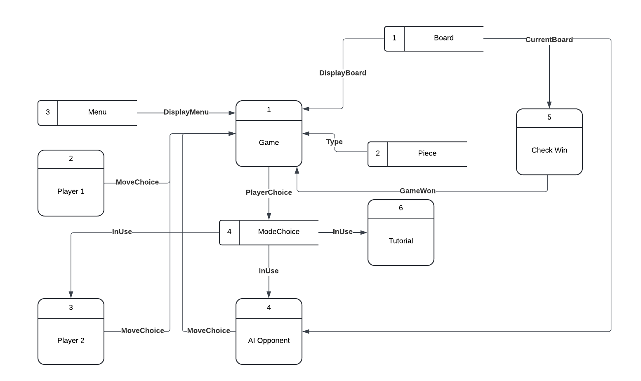
Level 1 Data Flow Diagram
Rules
This level 1 Data Flow diagram shows in greater depths the relationships between different methods and data stores within the program, showing how it all ties into the game function. This diagram shows that the Player1 method is always in use, but there can be either a second player or AI opponent in use. The program mainly uses the Board and Menu data stores because the board needs to constantly be displayed to the user and the user needs to be able to use the menus to select how they want to play the game. Additionally, the current board is repeatedly used by the CheckWin method to end the game once one side wins.

Data Dictionary

Data Dictionary
Reference | Name | Data Type | Occurrence | Description
1 | Board | 2D array | When a player makes a move | This is the data structure used to hold all the pieces in the game as well as blank spaces on the board
2 | Valid_move | List | When a player selects a piece | This is the data structure used to hold the end position of each move a piece can make along with the jumps made to get there
3 | Last_25_moves | Circular queue | When a turn is changed | This data structure to store information the last 25 moves played in the game. It will store whether a king moved and whether a jump was made
4 | Red_moves | Integer | When the red player plays a turn | This is used to store the number of moves the red player has made in the game. There is a similar variable for blue moves
5 | Logged_in | Boolean | When a user logs in to an account | This is used to determine what to display on menus, such as the main menu, and within the checkers game to display game history
6 | king | Boolean | When a piece reaches the end of the board | This is used to determine whether a piece is a king or a man, so that they can have different moves in a checkers game.
7 | uID | Int | When a new account is created | This is used to uniquely identify a user
8 | gameDate | DATE | When a game is completed | This is used to show the date and time that a game was played on

The table above describes some different variables and their respective data structures that I propose to use within the technical solution, as well as the cases where these data may be used.

Different AI systems

When focusing on the AI opponent within my checkers game, there are multiple different possibilities for me to choose from when I decide to implement an algorithm to serve as the second player. I have listed the options that I have researched for this project below:

Monte Carlo Tree Search (MCTS)

MCTS is a heuristic algorithm that works by implementing the following principles:
- Selecting child nodes from the root node (current board state) based on an evaluation of the exploration factor (trying new moves) vs the exploitation factor (looking towards moves that have already performed well). This is generally done by using the Upper Confidence Bound formula given below.
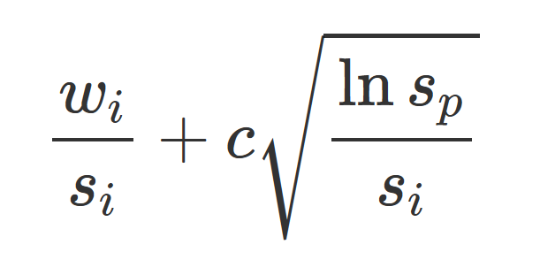
(Liu, 2017)

- The tree is expanded with another child node when an unexplored or partially explored node is reached
- A random or semi-random move is simulated on the board state until the game is won/drawn/lost, then the value of that position is estimated
- The result of each simulation is sent back up the tree, updating all nodes until the root has been updated.
This algorithm is beneficial for games with large branching factors as it focuses on the most promising branches of the tree, greatly reducing processing time. Additionally, this method would be beneficial as an evaluating function is not entirely necessary for my game, as the deterministic factor relies upon the outcome of each game.
However, the disadvantage of this method is that it can miss moves that don’t immediately lead to an advantageous position, resulting in some strategies being missed, decreasing its accuracy as the algorithm attempts to remove less relevant possibilities from the search. Furthermore, MCTS can be very expensive computationally as it still requires many different simulations to start becoming effective.

Minimax algorithm with Alpha-Beta pruning

A minimax algorithm is another heuristic approach to finding the most viable move to make for a computer opponent in my checkers game. It works by:
- Taking the current state of the board as the root node
- Creating child nodes for every single possible valid move that a piece can make.
- Simulating each possible valid move of each piece, switching between the maximising and minimising players
- Repeating this until the game is won or the predefined maximum search depth is reached
- Once this happens, the board will be evaluated based on the strength of the layout of pieces
- These evaluations are shifted back up the tree
  - The maximising team compares the two values from its child nodes and returns the highest
  - The minimising team compares the two values and returns the lowest
- This happens until the root is reach, which is the maximiser, then the highest of the 2 values is selected for the move to be made.
The diagram below outlines a simple scenario to decide the best value using the minimax algorithm.

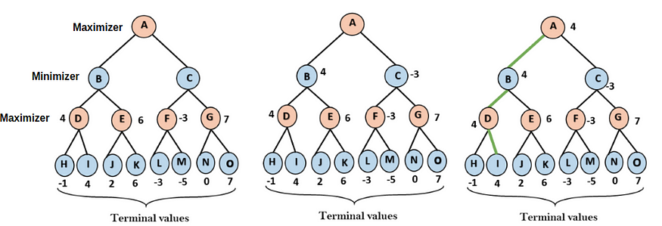
(Turk, 2022)

Additionally, alpha-beta pruning, the alpha value keeps the highest evaluated value, and beta keeps track of the lowest, so any branches with a value lower than alpha under the maximiser is pruned, as it cannot become larger than that value, and the same happens for the beta value under the minimiser. Implementing this reduces the processing time by roughly half.
The advantages of using this system for the AI are that it is not overly difficult to implement and that it can guarantee the best possible play depending on its heuristic function.
However, the disadvantage of using a minimax algorithm is that even with alpha-beta pruning, it is not feasible to use a large search depth, as it has a complexity of O(b^{d}), where b is the branching factor and d is the search depth. Additionally, a strong and in-depth evaluating function is required for the AI to perform well, otherwise it will miss important strategies from the game, making it easy to beat.

Login System
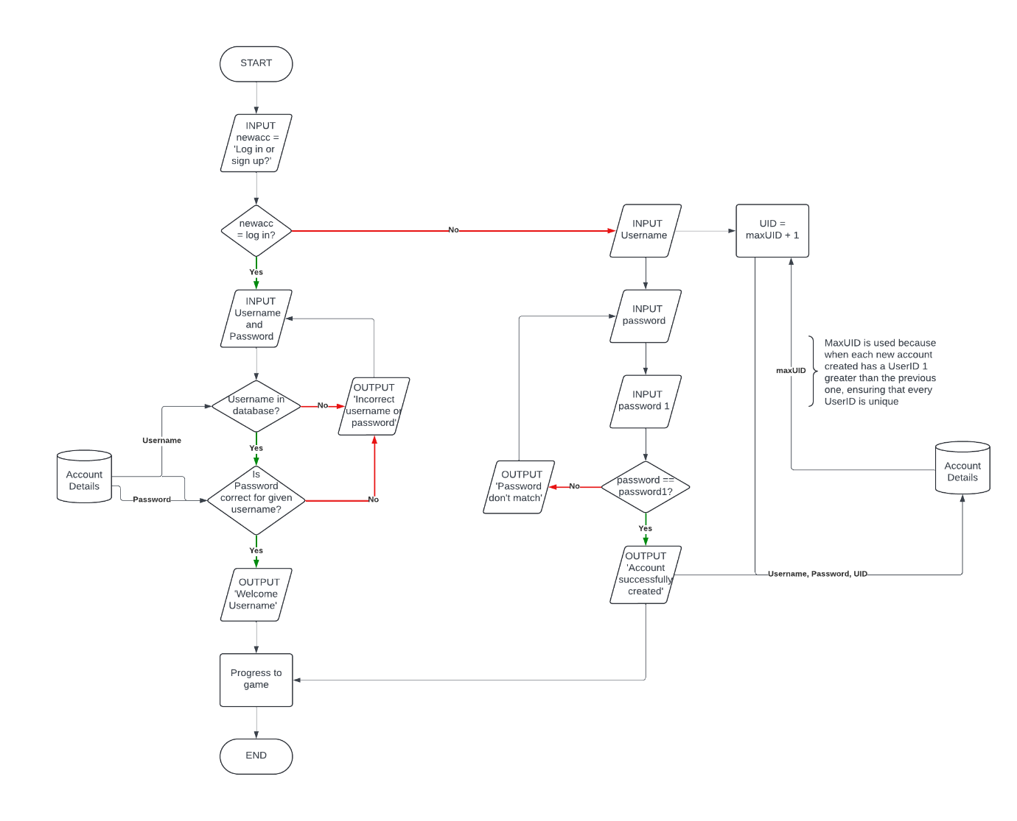
This flow chart describes the processes used to create an account for the program, which will be stored in an external, relational database to hold previous game records for the user, protected by a username and password that links to a User ID, see below for relating Entity Relationship Diagram.

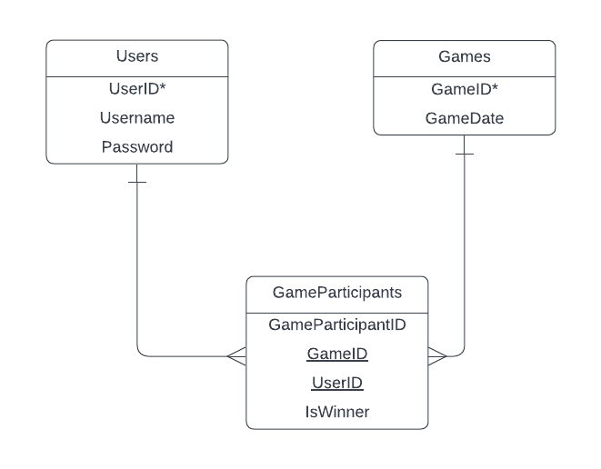

Dialogue

I have decided to implement my project as an application because I do not know how to code in languages such as HTML and JavaScript, meaning that there will be too much work for me to execute my project within the specified time frame. Therefore, I will solely base this game in python, using the pygame library to visualise my project to make the game more user-friendly.
For my AI opponent, I have decided that I will use an alpha-beta pruning algorithm. This algorithm is an extension to the ‘naïve’ minimax algorithm. Minimax works by checking the minimum score that the AI opponent (alpha) can get for a move and the maximum score that the human player can achieve (beta) from the move. The alpha-beta pruning extension to this algorithm discards any branches of moves where the beta score < the alpha score, meaning that the execution time of the algorithm is significantly reduced. Additionally, I will try and add multiple difficulties to the game because the fully functioning alpha-beta pruning algorithm will select the best possible move every single time, meaning that it will be too hard to beat it.
I have decided additionally to set the colour of the pieces to red and blue because the black colour of one set of pieces in the original versions of the game will be too difficult to see against the black tiles of the board.
During my thought process, I decided that I would also include an instruction/tutorial mode within the menus of my project because when I polled some possible end-users for my application, many had never played checkers before, meaning that they were unfamiliar with the rules. By adding an instruction/tutorial section, I can explain to new users the rules of the game, as well as possibly giving them visualisations of how the game is played, leading to greater enjoyment for the users.
Additionally, I have made the decision to protect the passwords by hashing them to protect them in case people where to attempt to steal people’s data. Furthermore, I will use protected SQL statements, so that my code will not be vulnerable to malicious SQL injections
When taking into consideration the design, I was planning on a simple design during the play session, where the checkerboard and pieces are shown centrally on the screen with a generic and simple image of a person or computer to depict which player is on which side and whether they are a robot or not. Additionally, I will display the number of wins and losses along with the account name for each player on either side of the screen, filling in blank space. I chose a simple design for the GUI because it means that the user(s) of my application wouldn’t become confused by too many options to choose from. Furthermore, I want the menu to keep the same colour scheme and air of simplicity as the main game, meaning that I will try and keep it as uncluttered as possible. I will show a visualisation of these two main screens in the design section of the NEA.

Objectives
Accounts
      - Develop a login system that allows users to create accounts, and log in to them using their username and password
      - Develop a menu option to manage the account of the user
        - Here, they can change their account name and password, as well as delete their entire account
Starting menu
      - Simple menu that shows different possible options the user can make
        - User can either play with an account or play as a guest
        - A facility for a game against a local, real-world player
        - A facility to play a game against an AI opponent at a certain skill level
        - Option for a rules mode
Main game
      - A well-structured GUI that displays a checkerboard with all of the pieces in their relevant position
      - Display results of all previous games for the user on the screen when they are playing
      - Clearly show when the game is won, who it is won by, and an option to play another game or go back to the main menu
      - Show the difference between a standard piece and a king piece
      - Show the possible moves for your selected piece (cannot select the enemy pieces)
Storing game results
      - Have a relational database that stores information about users, their passwords and their previous games
      - Protect the users’ passwords in the database using hashing

Requirements
All optional requirements will be in this colour
- Game Rules
  - Implement the standard rules of a checkers game
    - Each ‘man’ piece can only move diagonally forward 1 space
    - Each ‘king’ piece can move 1 space in any diagonal direction
    - Played on an 8x8 board
    - Pieces can capture 1 or more other pieces in 1 turn if correctly aligned (diagonally with one space afterwards)
    - All pieces are either blue or red, depending on their team
    - ‘Man’ pieces can be converted to ‘king’ pieces if they reach the end of the board
    - Pieces will be removed from the board if they are taken by other pieces
  - Handle illegal moves, draws, and wins
    - Illegal moves
      - All pieces are unable to move if 2 other pieces block that path
      - ‘Man’ pieces cannot move backwards
      - All pieces cannot move horizontally or vertically
      - Pieces are only allowed to move within the confines of the board
    - Draw conditions
      - Both players can declare a draw after 40 moves (not valid against an AI opponent)
      - If only 2 kings (one on each team) remain with no man pieces
      - If in the last 25 moves, only kings move and there are no jumps
      - If there are 3 kings, 2 kings and a piece, or a king and 2 pieces against a single king and both players have played at least 16 turns
    - Win conditions
      - One player has no valid moves remaining
      - One player has no more pieces remaining
- User Interface & pieces
  - Game Board
    - 8x8 board
    - Every other square is white, starting from the top left corner
  - Pieces
    - 24 total pieces at the start, 12 for each team (red and blue)
    - Man and king pieces will be visually discernible
  - Other features during game
    - Shows the win record of the player
      - One column for wins
      - One column for losses
      - One column for draws
    - Image for players/AI on their respective sides of the board
    - Pieces can be selected by clicking on them
    - Selecting a piece shows the valid moves that it can make
  - Menus
    - Start Menu
      - Title for the game
      - Play game option
        - Play menu
          - AI opponent option
          - Local, real player option
          - Rules Menu
            - Show the user different rules about the game of checkers then lets them play a game
      - Log in / Create account / account management option
        - Rejects non-valid usernames and passwords (in database)
        - Adds new accounts to database
        - Can change username, password, and delete account in account manager
    - Pause Menu
      - Restart game
      - Quit game
    - Endgame Menu
      - Shows winner
      - If not logged in, show option to log in / create account to log data
      - Rematch option
      - Return to main menu option
    - Leaderboard
      - Displays top 50 players on app based off total points
- Game modes
  - AI opponent
    - 3 different difficulties for the user to play against
      - Algorithm changes search depth based on difficulty selection
    - Alpha-beta pruning minimax algorithm
      - Algorithm removes branches that are discerned to be less viable than another
    - Shows the user the moves that it makes
    - Completes moves automatically on its turn
  - 2-player local
    - Switches between each player based on which turn it is
    - Each player can only select their pieces
- Database integration
  - Accounts
    - Unique user ID (UID) for every user
    - Hash protected passwords for all users
    - Stores username with password and UID in an entity
  - Score tracking
    - Entity that tracks all the wins, losses, and draws of each user
    - Linked to an output on GUI that displays these data
    - Points system
      - All users start on 1000 points
      - Add points for wins
        - If playing against AI, add more points for harder difficulties
      - Take away points for losses
      - Leave points unchanged for draws
      - Points added to score entity and is used for a leaderboard

Design

UML Class Diagram

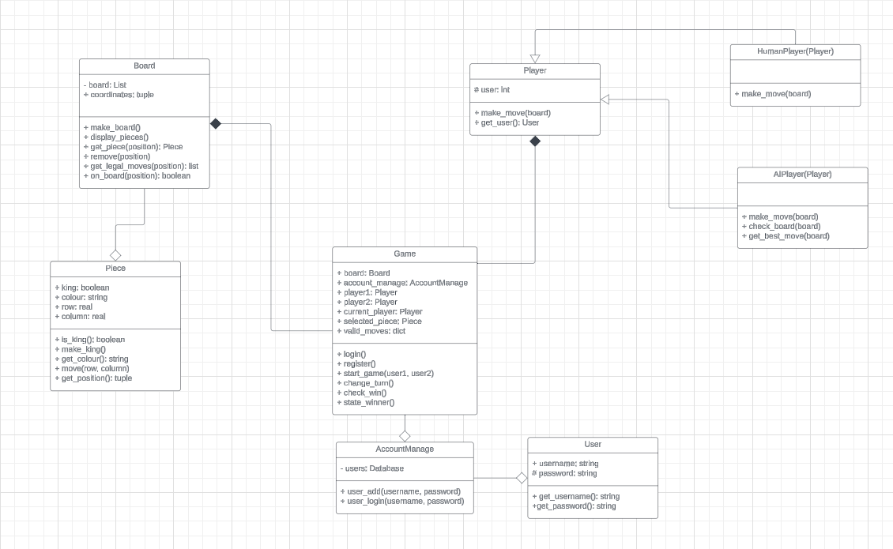
The above UML diagram shows some examples of the different methods and attributes that are being used in my project. For example, the attribute in the Game class, valid_moves is a dictionary that holds all the valid moves that a piece can make in a given turn and is updated by the get_legal_moves method within the Board class.

Game UI:
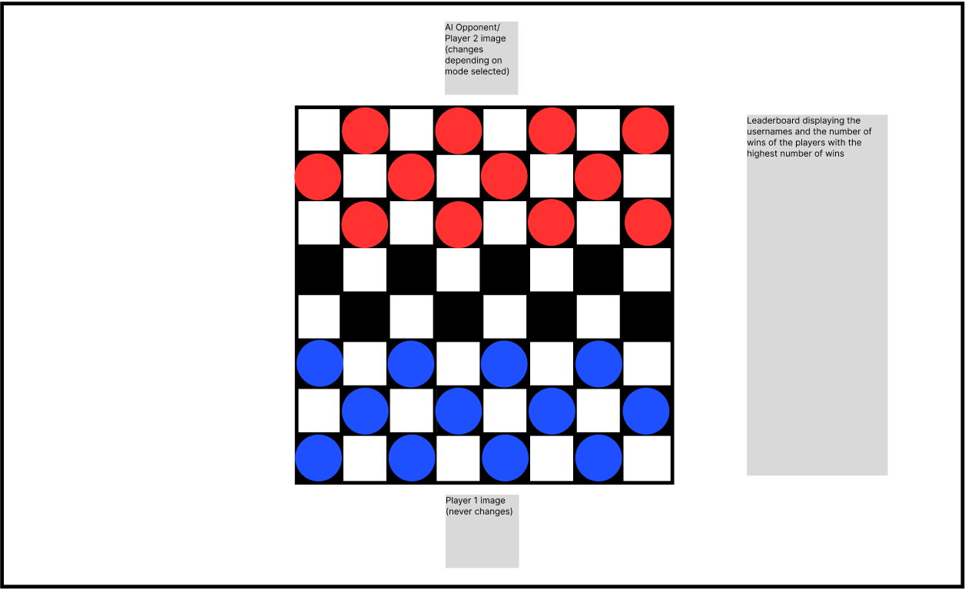
Background will be green, like in following screen grabs
Shows red pieces for player 2/AI opponent
Shows the blue pieces for player 1
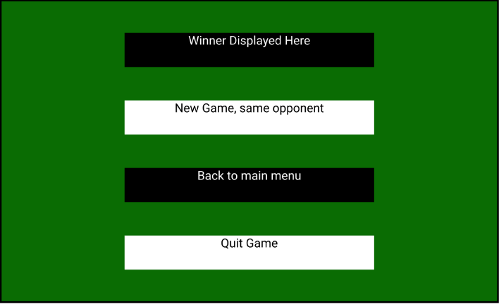

This is the final menu of the game, showing the winner of the game that has just been played, as well as giving the user the opportunity to play the ‘same’ game again as well as returning to menu, or quitting the application entirely.
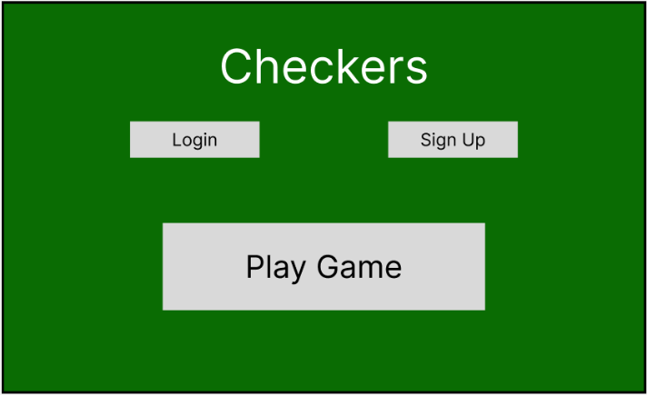

This is the first menu that you see when you open the application, prompting you to either play the game, or login/create an account.
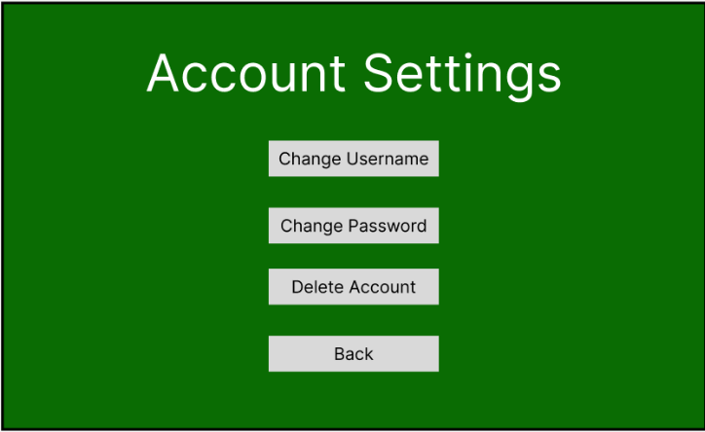
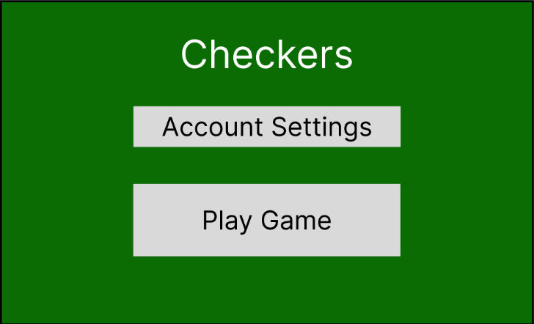

The display on the left shows the new menu when an account has been created or logged into, giving the user access to the account settings menu | The display on the right shows the contents of the ‘Account Settings’ menu. If the user clicks on the change username button, they’ll be prompted to enter a new username and confirm with their

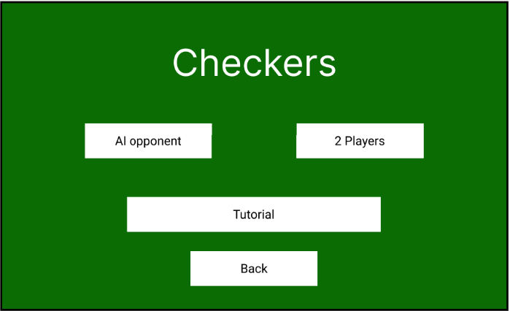

This menu appears when the user selects the play button on the main menu, prompting them the choose from either playing against the AI, a 2nd player, or playing through the tutorial section of the game. Additionally, all menus that branch from the main menu have a back button to be able to go back to said main menu, in case the user has a change of mind as to what they want to do.

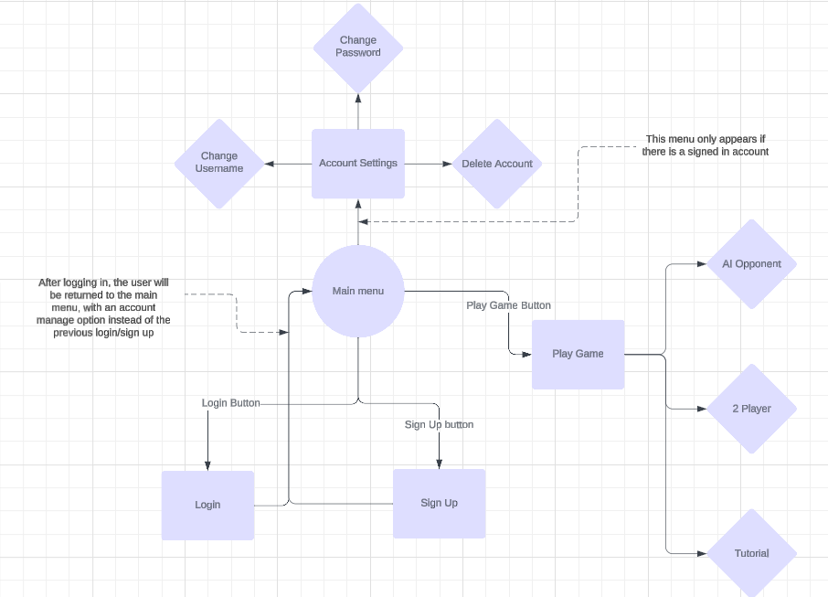

The diagram above shows the relationship between each of the menus displayed in the GUI, showing how the main menu is the central system for branching out into the different functionalities of the system.

File Management/Data Storage

To store the data for the board, I am using a 2-dimensional array that stores the information about each square on the board.
If the square is empty, a 0 will be stored in the array position, showing the program that it is empty.
If there is a piece in a square, the array will store the instantiated object within the entry, meaning that the array can be iterated through and the data and functions for each piece will be accessible. The pseudocode for the creation of information in this array is shown below:

1. FUNCTION create_pieces(w, h)
2. // Initialize board as empty 2D array
3. board ← empty_array
4.
5. FOR row ← 0 TO 7 DO
6. board[row] ← empty_array
7.
8. FOR col ← 0 TO 7 DO
9. IF (col MOD 2) = ((row + 1) MOD 2) THEN
10. IF row < 3 THEN
11. // Place red piece in upper section
12. board[row][col] ← create_red_piece(row, col, w, h)
13. ELSE IF row > 4 THEN
14. // Place blue piece in lower section
15. board[row][col] ← create_blue_piece(row, col, w, h)
16. ELSE
17. // Empty square in middle section
18. board[row][col] ← 0
19. END IF
20. ELSE
21. // Empty square on non-playable position
22. board[row][col] ← 0
23. END IF
24. END FOR
25. END FOR
26.
27. RETURN board
28. END FUNCTION

To store data for the accounts of different users, I am using a database, which is storing their username, password (protected using hashing), the game date, and whether they won the game. The ERD for this database can be seen in the analysis section of this NEA.
1. CREATE TABLE Users (
2. UserID INT PRIMARY KEY AUTO_INCREMENT,
3. Username VARCHAR(50) NOT NULL,
4. PasswordHash VARCHAR(255) NOT NULL
5. );
6.
7. CREATE TABLE Games (
8. GameID INT PRIMARY KEY AUTO_INCREMENT,
9. GameDate DATE
10. );
11.
12. CREATE GameParticipants (
13. GameID INT FOREIGN KEY REFERENCES Games (GameID),
14. UserID INT FOREIGN KEY REFERENCES Users (UserID),
15. IsWinner BOOL NOT NULL,
16. PRIMARY KEY (UserID, GameID)
17. );
18.

Additionally, I will need to query these entities within the database to be able to create the functionality for my account settings and for displaying the win record of players with accounts. Below show 2 examples that I have made for showing the win record, and for a section of the account delete function.
1. SELECT GameParticipants.IsWinner
2. FROM Users
3. INNER JOIN GameParticipants ON Users.UserID = GameParticipants.UserID
4. WHERE Users.Username = ?

This SQL query will retrieve all the outcomes of all the games played by a specific user, which will then be +able to be tallied up to display the win record
1. SELECT UserID from Users WHERE Username = ? AND Password = ?
2.
3. SELECT Games.GameID
4. FROM Users
5. INNER JOIN GameParticipants ON Users.UserID = GameParticipants.UserID
6. INNER JOIN Games ON GameParticipants.GameID = Games.GameID
7. WHERE Users.UserID = ?
8.
9. DELETE FROM Games WHERE GameID = ?
10. DELETE FROM Users WHERE UserID = ?
11. DELETE FROM GameParticipants WHERE UserID = ?

This SQL query finds the User ID for a given username and password, then uses an INNER JOIN SELECT statement to find all the games they played to delete all records of the user from the database.

To store the data relating to the last 25 moves played within a game for the draw condition where if there were only king movements without any jumps in the last 25 moves, I will implement a circular queue data structure, as this will be the easily and most effective way to manage a datatype of a fixed length. An example of the code that I will use to implement this circular queue has been inserted below.
1. CLASS Queue
2. // Constructor
3. FUNCTION init(maxSize)
4. contents ← array of size maxSize filled with null
5. maxSize ← maxSize
6. front ← 0
7. rear ← -1
8. size ← 0
9. END FUNCTION
10.
11. // Check if queue is at maximum capacity
12. FUNCTION isMax()
13. IF size = maxSize THEN
14. RETURN true
15. END IF
16. RETURN false
17. END FUNCTION
18.
19. // Check if queue is empty
20. FUNCTION isEmpty()
21. IF size = 0 THEN
22. RETURN true
23. END IF
24. RETURN false
25. END FUNCTION
26.
27. // Add item to queue
28. FUNCTION add(item)
29. IF NOT isMax() THEN
30. rear ← (rear + 1) MOD maxSize
31. contents[rear] ← item
32. size ← size + 1
33. RETURN true
34. END IF
35. RETURN false
36. END FUNCTION
37.
38. // Remove item from queue
39. FUNCTION remove()
40. IF NOT isEmpty() THEN
41. lead ← contents[front]
42. front ← (front + 1) MOD maxSize
43. size ← size - 1
44. RETURN lead
45. END IF
46. RETURN null
47. END FUNCTION
48.
49. // Display queue contents
50. FUNCTION showQueue()
51. RETURN contents
52. END FUNCTION
53. END CLASS

This works by receiving a length to set the queue, then filling the queue until it is full. Once its full, it will set the front pointer back to the start of the queue and write over the original item with the most recent.

AI Opponent
For my AI opponent to function correctly, including choosing the best possible move from all valid moves, I am using a minimax algorithm with alpha-beta pruning. See code below:
1. FUNCTION minimax(min_max, depth, turn, board)
2. // Base case: reached max depth or winner found
3. IF depth = 0 OR board.winner(turn) THEN
4. RETURN board.check_board(), board
5. END IF
6.
7. // Maximizing player's turn (RED)
8. IF min_max THEN
9. max_check ← -infinity
10. best_choice ← null
11. FOR EACH move IN possible_valid_moves(board, RED) DO
12. eval ← minimax(false, depth - 1, turn, move)
13. max_check ← maximum(max_check, eval[0])
14. IF max_check = eval[0] THEN
15. best_choice ← move
16. END IF
17. END FOR
18. RETURN max_check, best_choice
19.
20. // Minimizing player's turn (BLUE)
21. ELSE
22. min_check ← infinity
23. best_choice ← null
24. FOR EACH move IN possible_valid_moves(board, BLUE) DO
25. eval ← minimax(true, depth - 1, turn, board)
26. min_check ← minimum(min_check, eval[0])
27. IF min_check = eval[0] THEN
28. best_choice ← move
29. END IF
30. END FOR
31. RETURN min_check, best_choice
32. END IF
33. END FUNCTION

This algorithm works by giving a value to every move it can make, then doing the same for possible moves that the player can make. It does this multiple times to decide the best move to make for the current and possible future board layouts. The use of alpha-beta pruning takes the score from the path generated the best found move and compares it to what is currently on the current path. If the alpha score is greater than the beta score when it is the maximiser’s turn, the branch will be pruned as there is no way that the result of that path could get any better. This works in the opposite direction for the minimiser, as it won’t be able to make the board more negative. This ends up removing roughly half of the required processing for the minimax algorithm, greatly increasing the efficiency without a detriment to the AI’s efficacy.

Move Validation
To validate moves I will need to look at the spaces adjacent to the selected piece and evaluate whether those spaces are empty or not. If they aren’t then I will need to look at the spaces behind that. Once I have found the places that the piece will be able to jump to, I will use a list to store the end location of the jump, along with another list containing the pieces that the selected piece will jump over to get there. A mock up for this algorithm is shown below.

1. FUNCTION find_valid_moves(piece, row, col, direction, blank_spaces, step = 1)
2. moves ← empty_array
3. jump ← empty_array
4. middle_jump ← empty_array
5. new_row ← row + direction
6. new_col_l ← col - 1
7. new_col_r ← col + 1
8.
9. FOR new_col IN [new_col_l, new_col_r] DO
10. jump_move ← empty_array
11. temp ← null
12.
13. // Check if move is valid according to game rules
14. IF can_jump(new_col, new_row, row, col, piece) THEN
15. new_loc ← find_piece(new_row, new_col)
16.
17. // Handle simple moves (no jumps)
18. IF (new_row, new_col) IN blank_spaces AND step = 1 THEN
19. APPEND (new_row, new_col) TO moves
20. APPEND empty_array TO jump
21. END IF
22.
23. // Handle jumps over enemy pieces
24. IF new_loc ≠ 0 AND new_loc.colour ≠ piece.colour THEN
25. // Check left diagonal jump
26. IF (new_row + direction, new_col - 1) IN blank_spaces AND
27. (new_row, new_col) = (row + direction, col - 1) THEN
28.
29. // Recursively check for double jumps
30. double_jump ← find_valid_moves(piece, new_row + direction,
31. new_col - 1, direction,
32. blank_spaces, 2)
33.
34. IF double_jump[0] IS EMPTY THEN
35. APPEND (new_row + direction, new_col - 1) TO moves
36. ELSE
37. EXTEND moves WITH double_jump[0]
38. EXTEND middle_jump WITH double_jump[2]
39. temp ← double_jump[1]
40. FOR i IN temp DO
41. EXTEND jump_move WITH i
42. END FOR
43. END IF
44.
45. APPEND (new_row + direction, new_col - 1) TO middle_jump
46. APPEND (new_row, new_col) TO jump_move
47. END IF
48.
49. // Check right diagonal jump
50. IF (new_row + direction, new_col + 1) IN blank_spaces AND
51. (new_row, new_col) = (row + direction, col + 1) THEN
52.
53. // Recursively check for double jumps
54. double_jump ← find_valid_moves(piece, new_row + direction,
55. new_col + 1, direction,
56. blank_spaces, 2)
57.
58. IF double_jump[0] IS EMPTY THEN
59. APPEND (new_row + direction, new_col + 1) TO moves
60. ELSE
61. EXTEND moves WITH double_jump[0]
62. EXTEND middle_jump WITH double_jump[2]
63. temp ← double_jump[1]
64. FOR i IN temp DO
65. EXTEND jump_move WITH i
66. END FOR
67. END IF
68.
69. APPEND (new_row + direction, new_col + 1) TO middle_jump
70. APPEND (new_row, new_col) TO jump_move
71. END IF
72. END IF
73.
74. IF jump_move IS NOT EMPTY THEN
75. APPEND jump_move TO jump
76. END IF
77. END IF
78. END FOR
79.
80. RETURN moves, jump, middle_jump
81. END FUNCTION

This algorithm works by looking at adjacent spaces in the direction that the piece can move, and if it is empty, it will append it to the list. If it is full with a piece from the opposing team, it will look at the space behind it, and if that is empty, it will append that space to the list, and the intermediate space to the jump list too.

Libraries and Dependencies

While creating this game, I will include multiple different libraries to simplify parts of my code that would be unnecessarily complicated otherwise. Below, I have listed all the libraries that I plan to use within my project:
- pygame
  - I will use this module to display my game easily by creating a window that it operates in and putting images into it. This window will also be able to handle user inputs as events so that the user can interact with the game by using their mouse
- sqlite3
  - I will use this to manage my database extension for my login system with the use of SQL commands, such as the ones that were laid out above. This will allow me to seamlessly select, update, and delete any data stored about a user or a game.
- hashlib
  - I will use hashlib to implement a hashing algorithm on any passwords that the user inputs into the database effortlessly so that I can spend more time on other aspects of my code. This will improve the security of my system as, in the off chance that someone gains access to the database, they will not have access to any stored passwords.
- numpy
  - This will be used in only one instance, being used to get a value for infinity within my minimax algorithm. I will use this as it is not difficult to implement and helps optimise the AI for board evaluation.
- sys
  - I will include this module in my program as it is helpful for exiting the game when the user wants to quit as it completely terminates the program.
- copy
  - Once again, I will use this library in the minimax section to produce a complete copy of the board array. This is helpful because when you set one variable to the same as the board class, it doesn’t copy the entire array, it only copies the memory address, meaning that any changes made to the new array also appear in the old one. Deepcopy from the copy library, however, produces a complete copy of the contents of the array and stores it in a new memory location, meaning that this problem is circumvented.
- Re
  - This library will be used to validate user inputs in the login section of my project. This simplifies the process because it removes the need to validate each string with a variety of if statements and for loops. Instead, I can create a regular expression for the conventions that I require of each login detail, then use the command re.match to verify that a string fulfils the requirements to be accepted.

Testing

Testing Plan
To validate that my system works wholly as intended, I will perform a variety of TEX tests, making sure that all potential errors are dealt with.
For sections that include viewing a database file, I will be using https://inloop.github.io/sqlite-viewer/ which is an online SQL viewer to make outputs easily viewable.
All test tables with a B in the No. column are Blackbox tests, and all tests with W are Whitebox tests.
The following table describes the sections that each test will be split up into and roughly where to find them within the testing video.

Section | Description | Purpose
1 | Testing the game logic used during the game | To verify that the game works as intended and that the user can interact properly with it
2 | Testing AI functionality | To verify that the AI opponent works in a game environment
3 | Testing transition between all menus within the game | To verify that the user can navigate to all features of the program and interact with them through the GUI
4 | Validating inputs from user for account system | To verify whether users will be able to create an account, later log in to it, and change their account details
5 | Testing game inputs into database | To verify that information about each game played is added to the database and can be called to show to the user

Input and Output Testing

The following tables describe the tests that will be undergone, accompanied by the test data, the expected outcome, the actual outcome and where to find that test in the video. Every test will be accompanied by a standard, extreme, and erroneous datatypes to test where applicable.
- A standard data type is an expected input into the system that won’t produce any errors.
- An erroneous data type is outside of the expected scope, so a valid error should be returned in its place.
- An extreme data type is a lesser expected input, such as boundary data
No. | Description | Test Data  (Standard, Erroneous, Extreme) | Expected Outcome | Actual Outcome | Pass/Fail | Video Ref.
1.1  B | All pieces on current player’s team can be selected | Standard  Er: Keyboard button entered  * This will be the case for all test in this section unless stated otherwise  Ex: N/A | If a blue piece is selected on blue’s turn, it will show valid moves, otherwise nothing will happen
1.2  B | All pieces can only move within the confines of the board | Standard | If you try and move a piece off the board, nothing will happen, but if you move to a valid move given, the piece will move
1.3  B | ‘Man’ pieces can only move diagonally forward when no jumps are available | Standard  Ex: N/A | The selected piece will only have valid moves that will be diagonally forward and will only move to those valid moves
1.4  B | ‘Man’ pieces become King pieces when they reach the opposite end of the board | Standard | When a man piece reaches the end of the board in a turn, it will become a king piece that can move in any direction and be visibly different
1.5  B | ‘King’ pieces can move diagonally forwards or backwards when there are no jumps | Standard  Ex: N/A | The selected king piece will be able to move diagonally in any direction, as shown by the valid moves
1.6  B | All pieces will be able to jump over adjacent pieces of an opposite colour | Standard  Ex: N/A | The user’s piece will jump over and capture the adjacent piece and remove it from the board
1.7  B | All pieces can chain together multiple jumps in one turn | Standard  Ex: N/A | The user’s piece will jump over all the pieces in it path and remove them, with no other pieces being removed
1.8  B | King pieces can chain together multiple jumps in different directions in one turn | Standard  Ex: N/A | The king piece will remove all pieces in the jump path and will have taken them from different jump directions
1.9  B | A winner is declared when one team has no more valid moves (including having no more pieces) | Standard  Ex: N/A | The game is ended when one team has no more valid moves, declaring the winner.
1.10  B | A draw is declared if there have been no captures and only king moves in the last 25 moves | Standard | If the condition is met, a draw will be announced and the game ended
1.11  B | A draw is declared if there are 3 kings, 2 kings and a piece, or a king and 2 pieces against a single king and both players have played at least 16 turns | Standard | If one of these conditions are met, a draw will be announced and the game ended
1.12  B | A draw is declared if each team has only 1 king piece and no other pieces | Standard | If this condition is met, a draw will be announced and the game ended
1.13  B | A draw option is given if in 2 player mode and each player has played 40 moves or more | Standard  Ex: N/A | If both players in 2-Player mode have played 40 moves or more each, a ‘Declare Draw’ button will be shown that ends the game as a draw
1.14  B | The turn changes at the end of a player’s go | Standard | When a player’s turn ends, it switches to the turn of the opposing player

No. | Description | Test Data  (Standard, Erroneous, Extreme) | Expected Outcome | Actual Outcome | Pass/Fail | Video Ref.
2.1  B | When it is the AI’s turn, it makes a move | Standard | When the turn switches to the AI opponent, it makes a move without prompting from the user
2.2  B | AI player can take enemy pieces of the board | Standard | When the AI player has the chance to take one or more piece of the board, it can
2.3  B | The AI player uses system in place to determine value of each board state | Standard | For each turn for the AI, it will calculate a value for the state of the board at that point and find the best path

No. | Description | Test Data (Standard, Erroneous, Extreme) | Expected outcome | Actual outcome | Pass/Fail | Video Ref.
3.1  B | Showing landing page | Standard | When the program is run, the user is directed to a title page
3.2  B | Showing login page | Standard | When the ‘Login’ button is clicked, the user is directed to the login page
3.3  B | Showing sign up page | Standard | When the ‘Sign Up’ button is clicked, the user is directed to the sign-up page
3.4  B | Showing Account Settings button | Standard | When the user is logged in, an ‘Account Settings’ button is shown in place of the log in and sign up buttons
3.5  B | Showing change username, password, and delete account page | Standard | When the one of the three buttons are clicked, the user is directed to the relevant page
3.6  B | Showing the play game menu | Standard | When the user selects the ‘Play Game’ button, they are directed to a new page that displays different game options
3.7  B | Showing the rules section | Standard | When selecting the ‘Rules’ button, the user is taken to a screen that describes the rules of checkers
3.8  B | Using ‘NEXT’ and ‘PREV’ buttons on rules menu | Standard | On the rules menu, the user can move to the previous or next rule in the list if there is one
3.9  B | Entering the AI and Human game modes | Standard | When the user selects either the ‘One Player’ or ‘Two Player’ buttons, they enter the respective game mode
3.10  B | Showing end game screen | Standard | When the game being played is completed, the user will be directed to a new menu, showing the winner and giving them an option to return to main menu, restart, or quit
3.11  B | Showing wins, draws, and losses | Standard | During a game, the player that is logged in can see the number of wins, draws, and losses that they have had before.

No. | Description | Test Data (Standard, Erroneous, Extreme) | Expected outcome | Actual outcome | Pass/Fail | Video Ref.
4.1  B | Entering text where text is required | Standard | When the user attempts to enter text on any screens where text is required, they can
4.2  B | Password text length validation | Standard: ‘F!3n!3y’  Erroneous: Empty string  Extreme: ‘JoshuaFlen12’ | The user will only be able to enter strings no shorter than 8 chars and no longer than 12.  If the string is empty, they will be prompted to fill all boxes, but if the password is the wrong length, they will be told that have an invalid username or password
4.3  B | Username text length validation | Standard: ‘joshuaFlen’  Erroneous: Empty String  Extreme: ‘Joshua’ | The outcome of this test should be the same as the above, except the length of the string must be between 6 and 15 characters inclusive
4.4  B | Password characters validity check | Standard: ‘J0shuaF!en’  Erroneous: Empty String  Extreme: ‘J0shu@’ | If a password entered fulfils the criteria to be valid, it will be accepted, and the user can continue. Otherwise, the user will be told that they have an incorrect username or password
4.5  B | Username characters validity check | Standard: ‘JoshuaFlen’  Erroneous: ‘@!()I!$&*’  Extreme: ‘ThisIsA-Usernam’ | If the entered username is valid, the username will be accepted, otherwise, they will be told they have an incorrect username or password

No. | Description | Test Data (Standard, Erroneous, Extreme) | Expected outcome | Actual outcome | Pass/Fail | Video Ref.
5.1  B | Inputs into Users entity | Standard | When user creates account, their username, a hash of their password, and a unique user ID is entered into the ‘Users’ entity of the database
5.2  B | Input into Games entity | Standard | When a game is finished, a unique game ID, along with the game date and whether it is against an AI opponent is entered into the ‘Games’ entity
5.3  B | Input into GameParticipants entity | Standard | When the game is finished, the user ID of the player, the game ID of the game, and whether the user won, drew, or lost is entered into the ‘GameParticipants’ entity

No. | Overview | Description | Expected outcome | Actual outcome | Pass/Fail | Video Ref.
1.1  W | Test game.select() | Valid piece is selected, and the valid moves are displayed | Piece is selected
1.2  W | Test game._move() | Valid move updates the board and changes turns | Board is updated and turn is changed
1.3.1  W | Test sixteen_moves_draw() condition 1 | Checks that a draw is declared after there is 1 red king and 2 blue kings with 1 blue man | Draw is declared
1.3.2  W | Test sixteen_moves_draw() condition 2 | Checks that a draw is declared after there is 1 red king against 3 blue kings | Draw is declared
1.3.3  W | Test sixteen_moves_draw() condition 3 | Checks that a draw is declared after there is 1 red king against 1 blue king and 2 blue men | Draw is declared
1.3.4  W | Test sixteen_moves_draw() condition 4 | Checks that a draw is declared for the inverse of the previous 3 tests | Draw is declared
1.4  W | Test kings_draw() | Checks that a draw is declared when there is only 1 king on each team | Draw is declared
1.5  W | Test repeated_moves_draw() | Checks that a draw is declared when only king movements with no jumps have occurred in the last 25 moves | Draw is declared
1.6  W | Test turn_change() | Verify that the turn is changed after each player’s turn | Turn is changed, valid moves are reset, and last 25 moves are updated

No. | Overview | Description | Expected outcome | Actual outcome | Pass/Fail | Video Ref.
2.1  W | Test Minimax() | Test that the minimax function returns a new board state after working | A new board object is returned
2.2  W | Test possible_valid_moves() | Check that this function returns all the possible valid moves for every piece on the team currently being evaluated | All possible valid moves are returned
2.3  W | Test simulate_move() | Verify that simulate_move() changes a copy of the board to test the move | A move is simulated on a board copy
2.4  W | Test Minimax() again | Verify that the algorithm makes a choice based on the best move for each tree | A choice is made between 2 options, and the min/max is picked
2.5  W | Test alpha-beta pruning in Minimax() | Test that a branch is pruned if it is deemed that it cannot possibly result in a higher score than an already determined branch | Branch is pruned and the algorithm ignores any further
2.6  W | Test check_board() | Validate that this function determines a score based on the position of each piece, how close they are to ally and enemy pieces, how many kings are on the board, how many pieces are there, and how close a king is to being crowned | Calculated a value for the given board’s current state

No. | Overview | Description | Expected outcome | Actual outcome | Pass/Fail | Video Ref.
3.1  W | Test main.py for changing buttons | Verify that the buttons on the main screen are different depending on whether the user is logged in or not | Main menu is different if user is logged in
3.2  W | Test checkers() | Test that a new game is made when ‘restart’ is selected | Game can be restarted
3.3  W | Test that the main buttons transition the user to where they want to go | Validate that the Play button sends the user to the play menu, the quit button quits the program, and so on for the main menus | Buttons send user to correct functions

No. | Overview | Description | Expected outcome | Actual outcome | Pass/Fail | Video Ref.
4.1  W | Test login() for invalid inputs | A valid username and password returns ‘True’ | True is returned
4.2  W | Test if signup() makes a new account | Verify that a new account is created if a valid username and password is entered | New account is created and user is logged in

Navigation Table
This navigation table will show the relation between each menu within my project and where a user will be able to navigate to from each screen.
This table will be filled with ticks and crosses depending on whether see whether the navigation works as intended, and then a different colour box to show where navigation is not possible.

To  From ↓ | Main | Login | Sign Up | Account Settings | Username Change | Password Change | Delete Account | Play Game | Rules | 1-player | 2-player | Checkers Game | End
Main
Login
Sign Up
Account Settings
Username Change
Password Change
Delete Account
Play Game
Rules
1-player
2-player
Checkers Game
End

Main Testing

BlackBox testing video - https://youtu.be/E7Fqy4EtvC4?si=ZMmcyNwc9A7USn9B
WhiteBox testing video - https://youtu.be/mw3iRxfF4SU?si=NB-V6YZbvpdNKxvZ
No. | Description | Test Data  (Standard, Erroneous, Extreme) | Expected Outcome | Actual Outcome | Pass/Fail | Video Ref.
1.1  B | All pieces on current player’s team can be selected | Standard  Er: Keyboard button entered  * This will be the case for all test in this section unless stated otherwise  Ex: N/A | If a blue piece is selected on blue’s turn, it will show valid moves, otherwise nothing will happen | Piece is selected and possible valid moves are shown | Pass | 0:23
1.2  B | All pieces can only move within the confines of the board | Standard | If you try and move a piece off the board, nothing will happen, but if you move to a valid move given, the piece will move | Piece will not move if area off board is selected | Pass | 1:03
1.3  B | ‘Man’ pieces can only move diagonally forward when no jumps are available | Standard  Ex: N/A | The selected piece will only have valid moves that will be diagonally forward and will only move to those valid moves | Piece moves diagonally forward one space if available | Pass | 1:26
1.4  B | ‘Man’ pieces become King pieces when they reach the opposite end of the board | Standard | When a man piece reaches the end of the board in a turn, it will become a king piece that can move in any direction and be visibly different | When reaching end of board, piece is promoted to king, giving it a crown | Pass | 2:12
1.5  B | ‘King’ pieces can move diagonally forwards or backwards when there are no jumps | Standard  Ex: N/A | The selected king piece will be able to move diagonally in any direction, as shown by the valid moves | Piece moves diagonally in any direction where possible | Pass | 2:12
1.6  B | All pieces will be able to jump over adjacent pieces of an opposite colour | Standard  Ex: N/A | The user’s piece will jump over and capture the adjacent piece and remove it from the board | Piece jumps over adjacent piece and lands in empty space, taking other piece off the board | Pass | 3:07
1.7  B | All pieces can chain together multiple jumps in one turn | Standard  Ex: N/A | The user’s piece will jump over all the pieces in it path and remove them, with no other pieces being removed | Piece chains together multiple jumps in one go where possible | Pass | 3:52
1.8  B | King pieces can chain together multiple jumps in different directions in one turn | Standard  Ex: N/A | The king piece will remove all pieces in the jump path and will have taken them from different jump directions | King chains together multiple jumps in different directions | Pass | 4:37
1.9  B | A winner is declared when one team has no more valid moves (including having no more pieces) | Standard  Ex: N/A | The game is ended when one team has no more valid moves, declaring the winner. | Game is ended with winner being displayed | Pass | 5:37
1.10  B | A draw is declared if there have been no captures and only king moves in the last 25 moves | Standard | If the condition is met, a draw will be announced and the game ended | Draw is declared with user taken to end screen | Pass | 6:55
1.11  B | A draw is declared if there are 3 kings, 2 kings and a piece, or a king and 2 pieces against a single king and both players have played at least 16 turns | Standard | If one of these conditions are met, a draw will be announced and the game ended | Draw is declared with user taken to end screen | Pass | 9:31
1.12  B | A draw is declared if each team has only 1 king piece and no other pieces | Standard | If this condition is met, a draw will be announced and the game ended | Draw is declared with user taken to end screen | Pass | 13:43
1.13  B | A draw option is given if in 2 player mode and each player has played 40 moves or more | Standard  Ex: N/A | If both players in 2-Player mode have played 40 moves or more each, a ‘Declare Draw’ button will be shown that ends the game as a draw | A button offering a draw is shown and a draw can be declared with user taken to end screen | Pass | 14:32
1.14  B | The turn changes at the end of a player’s go | Standard | When a player’s turn ends, it switches to the turn of the opposing player | Turn is changed and only other team can select pieces and make moves | Pass | 15:41

No. | Description | Test Data  (Standard, Erroneous, Extreme) | Expected Outcome | Actual Outcome | Pass/Fail | Video Ref.
2.1  B | When it is the AI’s turn, it makes a move | Standard | When the turn switches to the AI opponent, it makes a move without prompting from the user | AI moves piece on its own | Pass | 16:44
2.2  B | AI player can take enemy pieces of the board | Standard | When the AI player has the chance to take one or more piece of the board, it can | AI removes enemy piece from board when possible | Pass | 17:50
2.3  B | The AI player uses system in place to determine value of each board state | Standard | For each turn for the AI, it will calculate a value for the state of the board at that point and find the best path | Algorithm enters evaluate function and finds a score for board state | Pass | 18:36

No. | Description | Test Data (Standard, Erroneous, Extreme) | Expected outcome | Actual outcome | Pass/Fail | Video Ref.
3.1  B | Showing landing page | Standard | When the program is run, the user is directed to a title page | Program opens to main menu | Pass | 19:38
3.2  B | Showing login page | Standard | When the ‘Login’ button is clicked, the user is directed to the login page | Login menu displayed when login button is clicked | Pass | 20:12
3.3  B | Showing sign up page | Standard | When the ‘Sign Up’ button is clicked, the user is directed to the sign-up page | Sign up menu is displayed when correct button is clicked | Pass | 20:24
3.4  B | Showing Account Settings button | Standard | When the user is logged in, an ‘Account Settings’ button is shown in place of the log in and sign-up buttons | Account settings button on main menu instead of login/sign up when logged in | Pass | 20:38
3.5  B | Showing change username, password, and delete account page | Standard | When the one of the three buttons are clicked, the user is directed to the relevant page | Shows desired page when clicking on each button, and user can use the page to do as the title implies | Pass | 21:12
3.6  B | Showing the play game menu | Standard | When the user selects the ‘Play Game’ button, they are directed to a new page that displays different game options | User is directed to page with rules and game options | Pass | 21:50
3.7  B | Showing the rules section | Standard | When selecting the ‘Rules’ button, the user is taken to a screen that describes the rules of checkers | Rules menu is shown with various rules of checkers | Pass | 21:50
3.8  B | Using ‘NEXT’ and ‘PREV’ buttons on rules menu | Standard | On the rules menu, the user can move to the previous or next rule in the list if there is one | Next button directs to the next page and previous to the previous  The buttons disappear when there are no more pages in that direction | Pass | 22:39
3.9  B | Entering the AI and Human game modes | Standard | When the user selects either the ‘One Player’ or ‘Two Player’ buttons, they enter the respective game mode | User can choose difficulty and enter a game when 1-player is selected, and they enter a 2-player game when 2-player is selected | Pass | 23:13
3.10  B | Showing end game screen | Standard | When the game being played is completed, the user will be directed to a new menu, showing the winner and giving them an option to return to main menu, restart, or quit | End game screen declaring winner is shown at end of game, with functioning main menu, quit and restart buttons | Pass | 23:56
3.11  B | Showing wins, draws, and losses | Standard | During a game, the player that is logged in can see the number of wins, draws, and losses that they have had before. | Wins, draws, and losses shown for accounts that are logged in. | Pass | 25:22

No. | Description | Test Data (Standard, Erroneous, Extreme) | Expected outcome | Actual outcome | Pass/Fail | Video Ref.
4.1  B | Entering text where text is required | Standard | When the user attempts to enter text on any screens where text is required, they can | Text can be entered into selected text boxes | Pass | 26:13
4.2  B | Password text length validation | Standard: ‘F!3n!3y:’  Erroneous: Empty string  Extreme: ‘Joshu@Flen12’ | The user will only be able to enter strings no shorter than 8 chars and no longer than 12.  If the string is empty, they will be prompted to fill all boxes, but if the password is the wrong length, they will be told that have an invalid username or password | Password only accepted if between 8 and 12 characters. The user is unable to enter strings longer than 12 characters | Pass | 26:57
4.3  B | Username text length validation | Standard: ‘joshuaFlen’  Erroneous: Empty String  Extreme: ‘JoshuA’ | The outcome of this test should be the same as the above, except the length of the string must be between 6 and 15 characters inclusive | Username only accepted if between 6 and 15 characters, and the user can only enter up to 15 characters | Pass | 29:27
4.4  B | Password characters validity check | Standard: ‘J0shuaF!en’  Erroneous: Empty String  Extreme: ‘J0shu@’  Extreme: ‘J0shu@fl’ | If a password entered fulfils the criteria to be valid, it will be accepted, and the user can continue. Otherwise, the user will be told that they have an incorrect username or password | Initially this test failed because the Extreme test was not valid, so it was replaced with the second one, otherwise, worked as expected | Fail  Pass | 31:05 – Fail  40:46 - Pass
4.5  B | Username characters validity check | Standard: ‘JoshuaFLen’  Erroneous: ‘@!()I!$&*’  Extreme: ‘ThisIsA-Usernam’ | If the entered username is valid, the username will be accepted, otherwise, they will be told they have an incorrect username or password | Username is rejected if it contains special characters outside of ‘._-‘ and is only accepted if it has at least 1 uppercase and 1 lowercase character | Pass | 33:28

No. | Description | Test Data (Standard, Erroneous, Extreme) | Expected outcome | Actual outcome | Pass/Fail | Video Ref.
5.1  B | Inputs into Users entity | Standard | When user creates account, their username, a hash of their password, and a unique user ID is entered into the ‘Users’ entity of the database | UserID, username, and hashed password entered into database when an account is created | Pass | 36:09
5.2  B | Input into Games entity | Standard | When a game is finished, a unique game ID, along with the game date and whether it is against an AI opponent is entered into the ‘Games’ entity | A gameID, along with the date played and whether played against AI is entered into database when game is completed | Pass | 38:25
5.3  B | Input into GameParticipants entity | Standard | When the game is finished, the user ID of the player, the game ID of the game, and whether the user won, drew, or lost is entered into the ‘GameParticipants’ entity | UserID, gameID, and whether player1 won is entered into database at the end of a game | Pass | 38:25

No. | Overview | Description | Expected outcome | Actual outcome | Pass/Fail | Video Ref.
1.1  W | Test game.select() | Valid piece is selected, and the valid moves are displayed | Piece is selected | A piece is selected when clicked upon | Pass | 00:36
1.2  W | Test find_valid_moves() | Selected piece coordinates are entered and valid moves with jumps are returned as a dictionary | Valid moves are returned | Valid move calculated with end location and intermediate jumps | Pass | 2:41
1.3  W | Test game._move() | Valid move updates the board and changes turns | Board is updated and turn is changed | Updates coordinates to target position | Pass | 4:54
1.4.1  W | Test sixteen_moves_draw() condition 1 | Checks that a draw is declared after there is 1 red king and 2 blue kings with 1 blue man | Draw is declared | Draws game with 1 red king vs 2 blue kings and a blue man | Pass | 6:41
1.4.2  W | Test sixteen_moves_draw() condition 2 | Checks that a draw is declared after there is 1 red king against 3 blue kings | Draw is declared | Draws game with 1 red king vs 3 blue kings | Pass | 8:27
1.4.3  W | Test sixteen_moves_draw() condition 3 | Checks that a draw is declared after there is 1 red king against 1 blue king and 2 blue men | Draw is declared | Draws game with 1 red king vs 1 blue kings and 2 blue men | Pass | 9:43
1.4.4  W | Test sixteen_moves_draw() condition 4 | Checks that a draw is declared for the inverse of the previous 3 tests | Draw is declared | Draws declared for all other tests inverted | Pass | 10:44
1.5  W | Test kings_draw() | Checks that a draw is declared when there is only 1 king on each team | Draw is declared | Game drawn when there is only 1 king vs. another | Pass | 13:50
1.6  W | Test repeated_moves_draw() | Checks that a draw is declared when only king movements with no jumps have occurred in the last 25 moves | Draw is declared | Draw is declared if only king movements and no jumps for last 25 turns | Pass | 15:15
1.7  W | Test turn_change() | Verify that the turn is changed after each player’s turn | Turn is changed, valid moves are reset, and last 25 moves are updated | Turn_change() called, turn is changed, and last_25_moves updated | Pass | 18:00
No. | Overview | Description | Expected outcome | Actual outcome | Pass/Fail | Video Ref.
2.1  W | Test Minimax() | Test that the minimax function returns a new board state after working | A new board object is returned | A new, different board object is returned | Pass | 19:21
2.2  W | Test possible_valid_moves() | Check that this function returns all the possible valid moves for every piece on the team currently being evaluated | All possible valid moves are returned | New board states for all possible valid moves are returned | Pass | 21:11
2.3  W | Test simulate_move() | Verify that simulate_move() changes a copy of the board to test the move | A move is simulated on a board copy | A valid move is simulated on a board copy | Pass | 22:37
2.4  W | Test Minimax() again | Verify that the algorithm makes a choice based on the best move for each tree | A choice is made between 2 options, and the min/max is picked | Depending on turn, higher or lower value is chosen | Pass | 24:54
2.5  W | Test alpha-beta pruning in Minimax() | Test that a branch is pruned if it is deemed that it cannot possibly result in a higher score than an already determined branch | Branch is pruned and the algorithm ignores any further | Unnecessary branches are pruned from the tree, decreasing evaluation time | Pass | 26:31
2.6  W | Test check_board() | Validate that this function determines a score based on the position of each piece, how close they are to ally and enemy pieces, how many kings are on the board, how many pieces are there, and how close a king is to being crowned | Calculated a value for the given board’s current state | A value for each board state is calculated based on surrounding pieces, no. of kings, no. of pieces, how close to promotion, and where pieces are on the board | Pass | 28:34

No. | Overview | Description | Expected outcome | Actual outcome | Pass/Fail | Video Ref.
3.1  W | Test main.py for changing buttons | Verify that the buttons on the main screen are different depending on whether the user is logged in or not | Main menu is different if user is logged in | Main menu changed after user enters an account | Pass | 32:27
3.2  W | Test checkers() | Test that a new game is made when ‘restart’ is selected | Game can be restarted | Game is restarted when chosen, and user returned to main menu when chosen | Pass | 34:59
3.3  W | Test that the main buttons transition the user to where they want to go | Validate that the Play button sends the user to the play menu, the quit button quits the program, and so on for the main menus | Buttons send user to correct functions | All buttons send user to expected functions, which work as expected | Pass | 36:37

No. | Overview | Description | Expected outcome | Actual outcome | Pass/Fail | Video Ref.
4.1  W | Test login() for invalid inputs | A valid username and password returns ‘True’ | True is returned | True is returned and user enters an account when valid login is entered | Pass | 47:34
4.2  W | Test if signup() makes a new account | Verify that a new account is created if a valid username and password is entered | New account is created, and user is logged in | New account is created with username, user ID, and password. Then the user is logged into the created account | Pass | 49:06

Navigation Testing

The table below is a one-way table that shows the navigation between all the different menus within the project. Orange cells show that the menu is not accessible from that position. Grey cells show that there is no need for navigation
Ticks imply that navigation from initial menu to the destination menu was successful
Crosses imply that navigation was unsuccessful.

To  From ↓ | Main | Login | Sign Up | Account Settings | Username Change | Password Change | Delete Account | Play Game | Rules | 1-player | Checkers Game | End
Main |  | ✔ | ✔ | ✔ |  |  |  | ✔
Login | ✔
Sign Up | ✔
Account Settings | ✔ |  |  |  | ✔ | ✔ | ✔
Username Change |  |  |  | ✔
Password Change |  |  |  | ✔
Delete Account | ✔ |  |  | ✔
Play Game | ✔ |  |  |  |  |  |  |  | ✔ | ✔ | ✔
Rules |  |  |  |  |  |  |  | ✔
1-player |  |  |  |  |  |  |  | ✔ |  |  | ✔
Checkers Game | ✔ |  |  |  |  |  |  |  |  |  |  | ✔
End | ✔ |  |  |  |  |  |  | ✔

I describe this section of the testing at 51:55 within the WhiteBox testing video

Evaluation

In this section, I will be evaluating how successfully I have met the requirements that I laid out before I began coding my project, as well as the feedback of end users after testing my completed project

Requirement Review
The following table reiterates the requirements laid out within the Research & Analysis section of the documentation and the extent to which I have fulfilled each section to deliver my end product to a user
Key:
Requirement not met | Requirement partially met | Requirement wholly met

Requirement No. | Description | Completed System | Evidence
1.1.1 | Man piece can only move diagonally forward | Men pieces can only move diagonally forward | E.1.1
1.1.2 | King piece can move diagonally in any direction | King pieces can only move 1 space diagonally in each direction when no jumps available | E.1.2
1.1.3 | Played on an 8x8 board | Game is played on an 8x8 board | E.1.3
1.1.4 | Pieces can capture 1 or more pieces when correctly aligned | Pieces can chain together valid jump combinations of length 1 or more | E.1.4
1.1.5 | All man pieces are blue or red, depending on their team | Only blue or red pieces are ever on the board | E.1.3
1.1.6 | Man pieces can be converted to king pieces when they reach the end of the board | Man pieces are changed to kings when at opposing edge of the board | E.1.5
1.1.7 | Pieces are removed from the board when taken by other pieces | If another piece hops over a piece, it is removed from the board | E.1.6
1.2.1.1 | All pieces are unable to move if 2 other pieces block that path | Pieces cannot be moved when blocked by 2 adjacent pieces in on direction | E.1.7
1.2.1.2 | Man pieces cannot move backwards | Man pieces can only move diagonally forward, not backwards | E.1.8
1.2.1.3 | All pieces cannot move horizontally or vertically | Pieces are only able to move diagonally, not in any other direction | E.1.8
1.2.1.4 | Pieces are only allowed to move within the confines of the board | If a piece tries to move outside of the board, it cannot, so it can only move within it | E.1.9
1.2.2.1 | Both players can declare a draw after 40 turns each (not against AI) | A button appears so that players can declare a draw after 40 turns each. This does not appear when playing against the AI | E.1.10
1.2.2.2 | If there remains only 1 king on each team with no other pieces, a draw is declared | A draw is declared when there is only 1 red king against 1 blue king | E.1.11
1.2.2.3 | If in the last 25 moves there were only king movements and no jumps, a draw is declared | A draw is declared if there were only king movements with no jumps in the last 25 moves | E.1.12
1.2.2.4 | If there are 3 kings, 2 kings and a piece, or a king and 2 pieces against a single king and both players have played at least 16 turns a draw is declared | A draw is declared if there are 3 kings, 2 kings and a man, or a king with 2 men against another king after 16 moves | E.1.13
1.2.3.1 | A win is declared if a team has no valid moves remaining | If one team has no more valid moves, a win is declared for the other team | E.1.14
1.2.3.2 | A win is declared if a team has no more pieces remaining | If one team no more pieces, the other team wins | E.1.14
2.1.1 | An 8x8 board is displayed on the screen for the user to interact with | The user can interact with an 8x8 board to play the game | E.1.3
2.1.2 | Every other square is white, starting from the top left corner | Checkerboard pattern is visible, starting with white square in top left corner | E.1.3
2.2.1 | 24 total pieces at the start, 12 for each team | Each team starts with 12 pieces, totalling to 24 | E.1.3
2.2.2 | Man pieces are visibly discernible from king pieces | King pieces have a crown on top, whereas men do not | E.1.2
2.3.1.1 | One column in game to show wins | One row in game to show wins | E.2.1
2.3.1.2 | One column in game to show losses | One row in game to show losses | E.2.1
2.3.1.3 | One column in game to show draws | One row in game to show draws | E.2.1
2.3.2 | Image for player/AI on respective sides of the board | When in 2-player, 2 human images in red/blue on each side of board. When against AI, red human becomes a computer | E.2.2
2.3.3 | Pieces can be selected by clicking on them | When piece is clicked on, it is selected | E.1.1
2.3.4 | When a piece is selected, the valid moves for the piece are shown | Valid moves for selected piece are shown on the board | E.1.1
2.4.1.1 | Title for the game is shown | Title is shown for game in main menu | E.2.3
2.4.1.2 | Quit option is shown | Quit button shown in main menu for the game | E.2.3
2.4.1.3.1.1 | AI opponent option shown in play menu | 1-player button shown in play menu | E.2.4
2.4.1.3.1.2 | Local, real player option is shown in play menu | 2-player button shown in play menu | E.2.4
2.4.1.3.1.3 | Back to main option shown in play menu | Back to main button in play menu | E.2.4
2.4.1.3.1.4 | Different rules of the game described to user within rules menu | Rules menu describes different rules of the game in a slideshow presentation | E.2.5
2.4.1.4.1 | When logging in/signing up, invalid usernames and passwords are rejected | Users are unable to enter invalid usernames or password to enter/create an account | E.2.6
2.4.1.4.2 | Adds new account to database | A new account is added to the database when a valid username and password are entered | E.2.7
2.4.1.4.3 | Username and Password can be changed, and accounts can be deleted | Usernames can be changed, as well as passwords. Accounts can be deleted | E.2.8
2.4.2.1 | Restart game option shown in pause menu | No pause menu implemented due to time constraints | N/A
2.4.2.2 | Quit game option shown in pause menu | No pause menu implemented due to time constraints | N/A
2.4.3.1 | Endgame menu shows game winner | Winner of game is shown on end menu | E.2.9
2.4.3.2 | If not logged in, show option to log in/sign up to log data | Not implemented due to time constraints | N/A
2.4.3.3 | Rematch option on end menu | Restart button shown on end menu, directing user back to the play menu | E.2.9
2.4.3.4 | Return to main menu on end menu | Back to main menu shown, directing user back to main | E.2.9
2.4.3.5 | Quit option displayed on end menu | Quit button on end menu, allowing user to exit the game | E.2.9
2.4.4.1 | Display top 50 players on app based on total points | Leaderboard not implemented due to lack of time | N/A
3.1.1.1 | Algorithm changes search depth based on difficulty selection | Search depth is changed depending on whether the user chooses easy, medium, or hard | N/A
3.1.2 | Shows the user the move the AI makes | The user can see the original position of the moved piece, and where it moves to | E.3.1
3.1.3 | Completes moves automatically on its turn | AI makes a move unprompted when it is the red team’s go | E.3.1
3.2.1 | Switched between each player based on which turn it is | The turn switches to the other player when a move is made | E.3.2
3.2.2 | Players can only select their pieces on their turn | Each player can only move on their turn | E.3.2
4.1.1 | Unique user ID for every user | Every user is identified by a unique number | E.3.3
4.1.2 | Hash protected passwords for all users | Users can enter a password, which is stored in a hashed form within the Users entity | E.3.3
4.1.3 | Stores UID, username, and password for all users within one entity | Users entity stores all relevant information for an account. | E.3.3
4.2.1 | Entity that tracks all wins, losses, and draws of each user | A win for the blue player is stored as a 1, a draw as a 2, and a loss as a 0 within the IsWinner attribute | E.3.4
4.2.2 | Win record linked to an output on GUI that displays these data | Within game, logged in player can view the number of wins, draws, and losses in their history | E.2.1
4.2.3 | Points system for players with leaderboard | Not implemented due to lack of time and the fact that this requirement was optional | N/A

Potential for Further Development

Over the course of completing my project, I have encountered multiple crossroads in development where I have had to decide on the direction that I wanted to take to see my game come to fruition adequately. I have listed below extensions to my project that I would take if I had more time, or had I had the knowledge that I have now when beginning my development.

- Neural Network integration
Firstly, had I had more time I might have incorporated a neural network within my AI algorithm. For this, I would use an Alpha-Zero-style training approach to reinforcement learning to improve the accuracy and strategic depth of my opponent. This would involve implementing the Monte Carlo Tree Search that I researched earlier in the project instead of using the minimax algorithm. The MCTS would evaluate moves based on their probability of being success. This method would be beneficial because the AI learns strategies from playing against itself, then determining the most effective moves with a reward-based scheme, allowing for more strategic and challenging play against users.

- Implementing a save game feature
If I were to spend more time on this project, I would implement a feature to load an unfinished game if a player is logged in, then they will be able to continue to play through that game from where they left off. To do this, I would create a new attribute within the game entity in my database, then, when a user leaves a game early, the board class, current turn, and number of turns will be saved to this new attribute. Then, when the user logs in and enters the play menu, they will be prompted to resume their last game. This would mean that games will be able to roll over throughout different runs of the program, and theoretically across different devices if I were to implement a centralised online server to host the database.

- Implementing my own hashing algorithm
Due to a lack of time, I used the hashlib library in python to run a hashing algorithm on passwords inputted into the database. However, given more time I would make my own custom hashing algorithm so that my project would be less dependent on external sources, improving maintainability and allowing for optimisation for my specific use case, ensuring that I would have strong security measures in place to protect the personal details of my users.

- Developing a 2-player online feature with a leaderboard and web interface
Given more time, I would like to implement an online mode to my game, allowing 2 users to enter a game and play against each other while being on different networks. To make this more accessible to users, I would integrate my application into a website, so that users would be able to play my game without having to download the software onto their computer. This could potentially increase the game’s popularity as end-users may be more likely to play my game if they don’t have to worry about installing the programs to their device. Furthermore, I would then add the leaderboard that I outlined within the optional requirements in my Analysis, permitting users to track their rank in comparison to other players and see the top players. Implementing this would add a more competitive aspect to my game too, encouraging player retention and engagement.

- Creating an undo move function
With my knowledge now, I would like to implement a button that would allow the user to undo the move they just made. This would provide more flexibility for the user to play the game as they will be able to undo mistakes that they make. To do this, I would save the game state at the beginning of each turn, then revert to the previous state if the undo button is clicked. To support the user wanting to revert back more than one move in the past, I would implement a stack data structure, which would use a Last In, First Out (LIFO) principle. This would be the most effective way to store these game states as each new move is pushed to the top of the stack, then popped when the undo button is pressed, giving players greater control over how they want to play the game

- Adding additional game variations
As an extension, I could implement using the basis of checkers that I have already determined in my project to branch out and add some of the different variations of checkers that I mentioned in the research. Games that I could include would be:
  - Cheskers
    - This is because I find the concept interesting and would be a good progression in the complexity of the game.
    - Additionally, this would set me up to be able to develop a chess game in the future as there is a greater overlap in the rules and functionality
  - International Draughts
    - This is because I like the idea of ‘flying’ kings that can move as many spaces as they want in one direction in a turn because it would make for an interesting solution to finding the valid moves
    - Furthermore, the rules are very similar to American Checkers, but played on a larger board with more pieces, meaning that it wouldn’t be overly complex to implement

- Implementing multi-platform support
For a final extension, I would implement cross-platform compatibility. Firstly, I would use platform specific methods to package my executable file, I have already used pyinstaller, meaning that it is downloadable on Windows and Linux. I would have to use py2app so that the game is able to be downloaded on macOS. Additionally, I would develop a mobile-compatible version of the game packaged as an .apk file with generalised coordinate calculations to allow seamless switching of resolutions and aspect ratios, providing an acceptable experience across many different devices.

Third Party Feedback

In this section I will gather feedback from an end user after they have used the project extensively. Their insights will help me evaluate the completeness and effectiveness of my project, while identifying additional areas that could be improved upon. This will further help me gain ideas for extensions that I could implement if I had more time
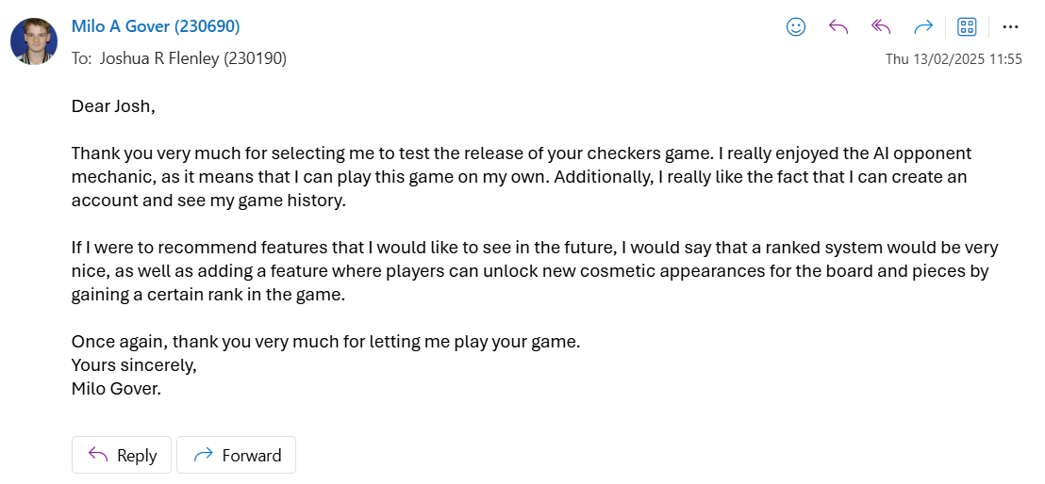
Overall, my end-user expressed satisfaction with the outcome of my project, stating that it would be fit to publish to a wider audience in this state. Accompanying the positive feedback, they also stated that I could improve my project by adding a ranked mode featuring different cosmetic items when players gain rank, which would further flesh out my project and make it more attractive to possible players.

Conclusion

Overall, I fulfilled all my mandatory requirements that I laid out before commencing the development of my technical solution, as well as completing some optional requirements, such as adding difficulties to my AI opponent. Throughout the course of my development, I encountered multiple hurdles when figuring out how to implement all the necessary features. An example of this was learning how to use pygame to create a GUI, as I had no experience with it previously. Furthermore, I ended up solving some steps of my program in different ways to what I planned originally, such as using a dictionary data structure to store the valid moves of the selected piece instead of an array. Changes such as these benefitted me in the end as it led to an easier implementation of features and more efficient code.

Technical Solution

main.py

1. # background size = 1344x832
2. import pygame
3. from pygame.locals import *
4. import sys
5. from constants import WHITE, SCREEN_WIDTH, SCREEN_HEIGHT, BUTTON_BG, RED, DARKER_RED, BLUE, SQUARE_WIDTH, SQUARE_HEIGHT, ARCADE_N, ARCADE_I, ARCADE
6. from play_menu import play_menu
7. from end_menu import end_menu
8. from login_menu import login_menu
9. from accounts import accounts_main
10. from useful_classes import button, show_text, rects_vertical
11.
12.
13. pygame.init()
14. pygame.display.set_caption('Main Menu')
15. clock = pygame.time.Clock()
16.
17. # fonts
18. button_font = ARCADE_N
19. text_font = ARCADE_I
20.
21. # screen setups
22. window_size = (SCREEN_WIDTH, SCREEN_HEIGHT)
23.
24. screen = pygame.display.set_mode(window_size)
25. surface = pygame.Surface(window_size, pygame.SRCALPHA)
26.
27. # images
28. main_play = pygame.transform.scale(BUTTON_BG.convert_alpha(), (689,210))
29. main_play_w, main_play_h = main_play.get_size()
30. main_play_x, main_play_y = (SCREEN_WIDTH // 2) - (main_play_w // 2), (SCREEN_HEIGHT // 13) * 8.5 - (main_play_h // 2)
31.
32. main_quit = pygame.transform.scale(BUTTON_BG.convert_alpha(), (689, 90))
33. main_quit_w, main_quit_h = main_quit.get_size()
34. main_quit_x, main_quit_y = (SCREEN_WIDTH // 2) - (main_quit_w // 2), (SCREEN_HEIGHT // 13) * 12 - (main_quit_h // 2)
35.
36. acc_x, acc_y = (SCREEN_WIDTH // 2) - (main_quit_w // 2), (SCREEN_HEIGHT // 13) * 5 - (main_quit_h // 2)
37.
38. main_login = pygame.transform.scale(BUTTON_BG.convert_alpha(), (360, 90))
39. main_login_w, main_login_h = main_login.get_size()
40. login_x, login_y = (SCREEN_WIDTH // 3) - (main_login_w // 2), (SCREEN_HEIGHT // 13) * 5 - (main_login_h // 2)
41. signup_x, signup_y = (SCREEN_WIDTH // 3) * 2 - (main_login_w // 2), (SCREEN_HEIGHT // 13) * 5 - (main_login_h // 2)
42.
43. #creating instances of buttons and text
44. play_button = button(main_play, "Play Game", button_font, 64, RED, DARKER_RED, screen, main_play_w, main_play_h, 2, 13, mult_y=8.5)
45. quit_button = button(main_quit, "Quit", button_font, 64, RED, DARKER_RED, screen, main_quit_w, main_quit_h, 2, 13, mult_y=12)
46. login_button = button(main_login, 'Login', button_font, 48, RED, DARKER_RED, screen, main_login_w, main_login_h, 3, 13, mult_y=5)
47. signup_button = button(main_login, 'Sign Up', button_font, 48, RED, DARKER_RED, screen, main_login_w, main_login_h, 3, 13, 2, 5)
48. account_button = button(main_quit, 'Account Settings', button_font, 38, RED, DARKER_RED, screen, main_quit_w, main_quit_h, 2, 13, mult_y=5)
49. start = show_text
50.
51. logged_in = False
52.
53. rects_vertical(surface, SQUARE_WIDTH, SQUARE_HEIGHT, 0, 0)
54.
55. def checkers(username):
56. winner, is_ai = play_menu(logged_in, username)
57. if winner != None:
58. restart = end_menu(winner, username, is_ai)
59. else:
60. restart = None
61.
62. return restart
63.
64. while True:
65. x,y = pygame.mouse.get_pos()
66. screen.fill((0,0,0))
67. screen.blit(surface, (0,0))
68. start.word(screen, text_font, 92, "Checkers", WHITE, 2, 5)
69. play_button.draw((x,y))
70. quit_button.draw((x,y))
71.
72. # shows different buttons for whether the user is logged in or not
73. if not logged_in:
74. login_button.draw((x,y))
75. signup_button.draw((x,y))
76. username = None
77. else:
78. start.word(screen, ARCADE, 48, username, BLUE, x=984, y=0)
79. account_button.draw((x,y))
80.
81. for event in pygame.event.get():
82. if event.type == MOUSEBUTTONDOWN:
83.
84. # if play button selected
85. if x in range(play_button.rect.left, play_button.rect.right) and y in range(play_button.rect.top, play_button.rect.bottom):
86. if checkers(username):
87. checkers(username)
88. else:
89. continue
90.
91. # if quit is selected
92. if x in range(quit_button.rect.left, quit_button.rect.right) and y in range(quit_button.rect.top, quit_button.rect.bottom):
93. pygame.quit()
94. sys.exit()
95. break
96.
97. # if login or sign up is selected and there is no account logged in
98. if x in range(login_button.rect.left, login_button.rect.right) and y in range(login_button.rect.top, login_button.rect.bottom) and not logged_in:
99. logged_in, username = login_menu(True, 'Login')[:2]
100. continue
101.
102. if x in range(signup_button.rect.left, signup_button.rect.right) and y in range(signup_button.rect.top, signup_button.rect.bottom) and not logged_in:
103. logged_in, username = login_menu(False, 'Sign Up')[:2]
104. continue
105.
106. # if account settings is selected and there is an account logged in
107. if x in range(account_button.rect.left, account_button.rect.right) and y in range(account_button.rect.top, account_button.rect.bottom) and logged_in:
108. logged_in, new_username = accounts_main(username)
109. if new_username is not None:
110. username = new_username
111. continue
112.
113. if event.type == pygame.QUIT:
114. pygame.quit()
115. sys.exit()
116. break
117.
118. pygame.display.flip()
119. clock.tick(60)

play_menu.py

1. import pygame
2. from pygame.locals import *
3. import sys
4. from checkers_game_screen import checkers_game
5. from rules import rules_screen
6. from constants import SCREEN_WIDTH, SCREEN_HEIGHT, BUTTON_BG, RED, DARKER_RED, GREEN, DARKER_GREEN, BLUE, DARKER_BLUE, SQUARE_WIDTH, SQUARE_HEIGHT, BLACK, ARCADE_N
7. from useful_classes import button, rects_vertical
8.
9. def play_menu(logged_in, username):
10.
11. pygame.init()
12.
13. pygame.display.set_caption('Play Menu')
14. clock = pygame.time.Clock()
15.
16. button_font = ARCADE_N
17.
18. window_size = (SCREEN_WIDTH, SCREEN_HEIGHT)
19. screen = pygame.display.set_mode(window_size)
20. surface = pygame.Surface(window_size, pygame.SRCALPHA)
21.
22. play_bg = pygame.transform.scale(BUTTON_BG.convert_alpha(), (360,122))
23. play_bg_w, play_bg_h = play_bg.get_size()
24.
25. play_back = pygame.transform.scale(BUTTON_BG.convert_alpha(), (400,122))
26. play_back_w, play_back_h = play_back.get_size()
27.
28. play_rules = pygame.transform.scale(BUTTON_BG, (657,122))
29. play_rules_w, play_rules_h = play_rules.get_size()
30.
31. human_button = button(play_bg, "Two Player", button_font, 32, RED, DARKER_RED, screen, play_bg_w, play_bg_h, 3, 2, 2)
32. ai_button = button(play_bg, "One Player", button_font, 32, RED, DARKER_RED, screen, play_bg_w, play_bg_h, 3, 2)
33. back_button_p = button(play_back, "Back to Main", button_font, 32, RED, DARKER_RED, screen, play_back_w, play_back_h, 2, 4, mult_y=3)
34. rules_button = button(play_rules, "Rules", button_font, 32, RED, DARKER_RED, screen, play_rules_w, play_rules_h, 2, 4)
35.
36. ai_easy_button = button(play_rules, 'Easy', ARCADE_N, 32, GREEN, DARKER_GREEN, screen, play_rules_w, play_rules_h, 2, 5)
37. ai_med_button = button(play_rules, 'Medium', ARCADE_N, 32, BLUE, DARKER_BLUE, screen, play_rules_w, play_rules_h, 2, 5, mult_y=2)
38. ai_hard_button = button(play_rules, 'Hard', ARCADE_N, 32, RED, DARKER_RED, screen, play_rules_w, play_rules_h, 2, 5, mult_y=3)
39. back_button_ai = button(play_rules, 'Back', ARCADE_N, 32, RED, DARKER_RED, screen, play_rules_w, play_rules_h, 2, 5, mult_y=4)
40.
41. rects_vertical(surface, SQUARE_WIDTH, SQUARE_HEIGHT, 0, 0)
42. ai_selected = False
43.
44.
45. while True:
46.
47. x, y = pygame.mouse.get_pos()
48.
49. screen.fill(BLACK)
50. screen.blit(surface, (0,0))
51.
52. if not ai_selected:
53. human_button.draw((x,y))
54. ai_button.draw((x,y))
55. rules_button.draw((x,y))
56. back_button_p.draw((x,y))
57. else:
58. ai_easy_button.draw((x,y))
59. ai_med_button.draw((x,y))
60. ai_hard_button.draw((x,y))
61. back_button_ai.draw((x,y))
62.
63. for event in pygame.event.get():
64. if event.type == pygame.MOUSEBUTTONDOWN:
65. if x in range(human_button.rect.left, human_button.rect.right) and y in range(human_button.rect.top, human_button.rect.bottom) and not ai_selected:
66. return checkers_game(False, logged_in, username), False
67. if x in range(ai_button.rect.left, ai_button.rect.right) and y in range(ai_button.rect.top, ai_button.rect.bottom) and not ai_selected:
68. ai_selected = True
69. continue
70. if x in range(back_button_p.rect.left, back_button_p.rect.right) and y in range(back_button_p.rect.top, back_button_p.rect.bottom) and not ai_selected:
71. return None, None
72. if x in range(rules_button.rect.left, rules_button.rect.right) and y in range(rules_button.rect.top, rules_button.rect.bottom) and not ai_selected:
73. rules_screen()
74. if x in range(ai_easy_button.rect.left, ai_easy_button.rect.right) and y in range(ai_easy_button.rect.top, ai_easy_button.rect.bottom) and ai_selected:
75. return checkers_game(True, logged_in, username, 2), True
76. if x in range(ai_med_button.rect.left, ai_med_button.rect.right) and y in range(ai_med_button.rect.top, ai_med_button.rect.bottom) and ai_selected:
77. return checkers_game(True, logged_in, username, 3), True
78. if x in range(ai_hard_button.rect.left, ai_hard_button.rect.right) and y in range(ai_hard_button.rect.top, ai_hard_button.rect.bottom) and ai_selected:
79. return checkers_game(True, logged_in, username, 5), True
80. if x in range(back_button_ai.rect.left, back_button_ai.rect.right) and y in range(back_button_ai.rect.top, back_button_ai.rect.bottom) and ai_selected:
81. ai_selected = False
82. continue
83. if event.type == pygame.QUIT:
84. pygame.quit()
85. sys.exit()
86. break
87.
88. pygame.display.flip()
89. clock.tick(60)
90.

rules.py
1. import pygame
2. from pygame.locals import *
3. import sys
4. from useful_classes import button, show_text, rects_vertical
5. from constants import SCREEN_WIDTH, SCREEN_HEIGHT, SQUARE_WIDTH, SQUARE_HEIGHT, JUMP, DOUBLE, KING_DOUBLE, KING_MOVES, KING_IMAGE, WIN, END_PIECE, BUTTON_BG, RED, DARKER_RED, WHITE, ARCADE_N, ARCADE_I
6.
7. def rules_screen():
8. button_font = ARCADE_N
9. text_font = ARCADE_I
10.
11. pygame.init()
12. pygame.display.set_caption("Rules")
13. clock = pygame.time.Clock()
14.
15. window_size = SCREEN_WIDTH, SCREEN_HEIGHT
16. screen = pygame.display.set_mode(window_size)
17. surface = pygame.Surface(window_size, pygame.SRCALPHA)
18. rects_vertical(surface, SQUARE_WIDTH, SQUARE_HEIGHT, 0, 0)
19.
20. rules_but = pygame.transform.scale(BUTTON_BG, (200,90))
21. rules_but_w, rules_but_h = rules_but.get_size()
22.
23. rules_back = pygame.transform.scale(BUTTON_BG, (300, 80))
24. rules_back_w, rules_back_h = rules_back.get_size()
25.
26. prev_button = button(rules_but, "Prev", button_font, 32, RED, DARKER_RED, screen, rules_but_w, rules_but_h, 21, 2)
27. next_button = button(rules_but, "Next", button_font, 32, RED, DARKER_RED, screen, rules_but_w, rules_but_h, 21, 2, 20)
28. back_button = button(rules_back, 'Back', button_font, 48, RED, DARKER_RED, screen, rules_back_w, rules_back_h, 224, 104, 25, 5)
29. txt = show_text
30.
31.
32. cur_screen = 0
33.
34. while True:
35. x, y = pygame.mouse.get_pos()
36.
37. screen.fill((0,0,0))
38. screen.blit(surface, (0,0))
39. back_button.draw((x,y))
40.
41. for event in pygame.event.get():
42. if event.type == pygame.MOUSEBUTTONDOWN:
43. if x in range(prev_button.rect.left, prev_button.rect.right) and y in range(prev_button.rect.top, prev_button.rect.bottom):
44. if cur_screen != 0:
45. cur_screen -= 1
46.
47. if x in range(next_button.rect.left, next_button.rect.right) and y in range(next_button.rect.top, next_button.rect.bottom):
48. if cur_screen != 5:
49. cur_screen += 1
50.
51. if x in range(back_button.rect.left, back_button.rect.right) and y in range(back_button.rect.top, back_button.rect.bottom):
52. return None
53.
54. if event.type == pygame.QUIT:
55. pygame.quit()
56. sys.exit()
57. break
58.
59. if cur_screen != 0:
60. prev_button.draw((x,y))
61. if cur_screen != 5:
62. next_button.draw((x,y))
63.
64. if cur_screen == 0:
65. single_jump(screen, txt, text_font, button_font)
66. elif cur_screen == 1:
67. double_jump(screen, txt, text_font, button_font)
68. elif cur_screen == 2:
69. make_king(screen, txt, text_font, button_font)
70. elif cur_screen == 3:
71. kings(screen, txt, text_font, button_font)
72. elif cur_screen == 4:
73. win(screen, txt, text_font, button_font)
74. else:
75. drawing(screen, txt, text_font, button_font)
76.
77. pygame.display.flip()
78. clock.tick(60)
79.
80. def single_jump(screen, txt, text_font, button_font):
81. txt.word(screen, text_font, 92, 'Single Jumps', WHITE, 2, 13, mult_y=2)
82. screen.blit(JUMP, ((SCREEN_WIDTH // 24) * 7 - (JUMP.get_width() // 2), (SCREEN_HEIGHT // 2) - (JUMP.get_height() // 2)))
83. text_file = open('Text_files/single explanation.txt')
84. div_y = 100
85. mult_y = 35
86. for line in text_file.readlines():
87. txt.word(screen, button_font, 10, line.strip('\n'), WHITE, 3, div_y, 2, mult_y)
88. mult_y += 5
89.
90. def double_jump(screen, txt, text_font, button_font):
91. txt.word(screen, text_font, 92, 'Double Jumps', WHITE, 2, 13, mult_y=2)
92. screen.blit(DOUBLE, ((SCREEN_WIDTH // 24) * 7 - (DOUBLE.get_width() // 2), (SCREEN_HEIGHT // 2) - (DOUBLE.get_height() // 2)))
93. text_file = open('Text_files/double explanation.txt')
94. div_y = 100
95. mult_y = 45
96. for line in text_file.readlines():
97. txt.word(screen, button_font, 10, line.strip('\n'), WHITE, 3, div_y, 2, mult_y)
98. mult_y += 5
99.
100. def make_king(screen, txt, text_font, button_font):
101. txt.word(screen, text_font, 92, 'Making kings', WHITE, 2, 13, mult_y=2)
102. screen.blit(END_PIECE, ((SCREEN_WIDTH // 24) * 7 - (END_PIECE.get_width() // 2), (SCREEN_HEIGHT // 3) - (END_PIECE.get_height() // 2)))
103. screen.blit(KING_IMAGE, ((SCREEN_WIDTH // 24) * 7 - (KING_IMAGE.get_width() // 2), (SCREEN_HEIGHT // 3) * 2 - (KING_IMAGE.get_height() // 2)))
104. text_file = open('Text_files/make king explanation.txt')
105. div_y = 100
106. mult_y = 45
107. for line in text_file.readlines():
108. txt.word(screen, button_font, 10, line.strip('\n'), WHITE, 3, div_y, 2, mult_y)
109. mult_y += 5
110.
111. def kings(screen, txt, text_font, button_font):
112. txt.word(screen, text_font, 92, 'King movements', WHITE, 2, 13, mult_y=2)
113. screen.blit(KING_MOVES, ((SCREEN_WIDTH // 7) * 2 - (KING_MOVES.get_width() // 2), (SCREEN_HEIGHT // 13) * 5 - (KING_MOVES.get_height() // 2)))
114. screen.blit(KING_DOUBLE, ((SCREEN_WIDTH // 7) * 2 - (KING_DOUBLE.get_width() // 2), (SCREEN_HEIGHT // 13) * 9 - (KING_DOUBLE.get_height() // 2)))
115. text_file = open('Text_files/king moves explanation.txt')
116. div_y = 100
117. mult_y = 45
118. for line in text_file.readlines():
119. txt.word(screen, button_font, 10, line.strip('\n'), WHITE, 21, div_y, 13, mult_y)
120. mult_y += 5
121.
122. def win(screen, txt, text_font, button_font):
123. txt.word(screen, text_font, 80, 'Win conditions', WHITE, 2, 13, mult_y=2)
124. screen.blit(WIN, ((SCREEN_WIDTH // 24) * 7 - (WIN.get_width() // 2), (SCREEN_HEIGHT // 2) - (WIN.get_height() // 2)))
125. text_file = open('Text_files/win explanation.txt')
126. div_y = 100
127. mult_y = 45
128. for line in text_file.readlines():
129. txt.word(screen, button_font, 10, line.strip('\n'), WHITE, 3, div_y, 2, mult_y)
130. mult_y += 5
131.
132. def drawing(screen, txt, text_font, button_font):
133. txt.word(screen, text_font, 80, 'Draw conditions', WHITE, 2, 13, mult_y=2)
134. text_file = open('Text_files/draw explanation.txt')
135. div_y = 100
136. mult_y = 45
137. for line in text_file.readlines():
138. txt.word(screen, button_font, 10, line.strip('\n'), WHITE, x=224, div_y=div_y, mult_y=mult_y)
139. mult_y += 5

checkers_game_screen.py

1. # imports
2. import pygame, sys
3. from pygame.locals import *
4. from game import Game
5. from minimax import Minimax
6. from useful_classes import button, show_text, rects_vertical
7. from db_functions import find_wins
8. from constants import BOARD_WIDTH, BOARD_HEIGHT, SQUARE_WIDTH, SQUARE_HEIGHT, SCREEN_WIDTH, SCREEN_HEIGHT, START_X, START_Y, AI_R, USER_R, USER_B, RED, DARKER_RED, BLACK, WHITE, GREEN, DARKER_GREEN, BLUE, DARKER_BLUE, BUTTON_BG, ARCADE_N
9.
10. def checkers_game(ai_player, logged_in, username, ai_diff=None):
11.
12. button_font = ARCADE_N
13. user_r_x, user_r_y = (SCREEN_WIDTH // 2) - (USER_R.get_width() // 2), (SCREEN_HEIGHT // 52) * 5 - (USER_R.get_height() // 2)
14. user_b_x, user_b_y = (SCREEN_WIDTH // 2) - (USER_B.get_width() // 2), (SCREEN_HEIGHT // 52) * 48 - (USER_B.get_width() // 2)
15.
16. # Pygame window initialisation
17. pygame.display.set_caption('Game')
18. clock = pygame.time.Clock()
19.
20. window_size = (SCREEN_WIDTH, SCREEN_HEIGHT)
21.
22. screen = pygame.display.set_mode(window_size)
23. surface = pygame.Surface(window_size, pygame.SRCALPHA)
24. surface_bg = pygame.Surface(window_size, pygame.SRCALPHA)
25.
26. # draw button calculations
27. game_draw = pygame.transform.scale(BUTTON_BG, (360, 90))
28. game_draw_w, game_draw_h = game_draw.get_size()
29. draw_drawn = False
30.
31. # back button calculations
32. rules_back = pygame.transform.scale(BUTTON_BG, (300, 80))
33. rules_back_w, rules_back_h = rules_back.get_size()
34.
35. # wins table calculations
36. wins_bg = pygame.transform.scale(BUTTON_BG, (386, 400))
37. wins_w, wins_h = wins_bg.get_size()
38. wins_x, wins_y = (SCREEN_WIDTH // 84) * 71 - (wins_w // 2), (SCREEN_HEIGHT // 26) * 13 - (wins_h // 2)
39.
40. # Uses library from Game.py to create game environment
41. game = Game(screen, surface)
42. draw_button = button(game_draw, "Declare Draw", button_font, 24, RED, DARKER_RED, screen, game_draw_w, game_draw_h, 84, 2, 13, 1)
43. back_button = button(rules_back, 'Back to main', button_font, 24, RED, DARKER_RED, screen, rules_back_w, rules_back_h, 224, 104, 25, 5)
44.
45. rects_vertical(surface_bg, SQUARE_WIDTH, SQUARE_HEIGHT, 0, 0)
46. text = show_text
47.
48. if logged_in:
49. wins, draws, losses = find_wins(username)
50.
51. def get_mouse_pos(x, y):
52. row = int((y - START_Y) // SQUARE_WIDTH)
53. col = int((x - START_X) // SQUARE_HEIGHT)
54. return row, col
55.
56. def find_selected_piece(colour, new_board, old_board):
57. diff = []
58. for row in range(8):
59. for col in range(8):
60. if (new_board[row][col] == 0 and old_board[row][col] != 0):
61. diff.append((row, col))
62. if colour == BLUE: return diff[-1]
63. else:
64. return diff[0]
65.
66. # Condition Loop for game
67. while True:
68.
69. x, y = pygame.mouse.get_pos()
70.
71. # Putting images on screen
72. screen.fill(BLACK)
73. screen.blit(surface_bg, (0,0))
74. game.board.draw(screen)
75. screen.blit(wins_bg, (wins_x, wins_y))
76. back_button.draw((x,y))
77. surface.fill((0,0,0,0))
78.
79. if ai_player:
80. screen.blit(AI_R, (user_r_x, user_r_y))
81. else:
82. screen.blit(USER_R, (user_r_x, user_r_y))
83. screen.blit(USER_B, (user_b_x, user_b_y))
84.
85.
86. # Showing draw button in 2-player game
87. if (game.blue_moves + game.red_moves) >= 80 and not ai_player:
88. draw_drawn = True
89. draw_button.draw((x,y))
90.
91. # Showing win record if user is signed in
92. if logged_in:
93. text.word(screen, ARCADE_N, 25, username, WHITE, 84, 26, 71, 9)
94. text.word(screen, ARCADE_N, 35, f'Wins: {wins}', DARKER_BLUE, 84, 26, 71, 11)
95. text.word(screen, ARCADE_N, 35, f'Draws: {draws}', GREEN, 84, 26, 71, 13)
96. text.word(screen, ARCADE_N, 35, f'Losses: {losses}', DARKER_RED, 84, 26, 71, 15)
97. else:
98. text.word(screen, ARCADE_N, 24, 'Login to see results', DARKER_GREEN, 84, 26, 71, 13, rotation=45)
99.
100. # Handling AI moves
101. if game.turn == RED and ai_player:
102. new_board, new_jump = Minimax(ai_diff, True, game.board, game.turn, True)[1:]
103. selected = find_selected_piece(RED, new_board.board, game.board.board)
104. game.ai_move(new_board, new_jump, selected)
105.
106. # Event loop
107. for event in pygame.event.get():
108. if event.type == pygame.QUIT:
109. pygame.quit()
110. sys.exit()
111. break
112. if event.type == pygame.MOUSEBUTTONDOWN:
113. # Finding if piece is selected
114. if x in range(START_X, START_X + BOARD_WIDTH) and y in range(START_Y, START_Y + BOARD_HEIGHT):
115. row, col = get_mouse_pos(x, y)
116. game.select(row, col)
117. # Determining draw if draw button clicked and the draw button is on the screen
118. if x in range(draw_button.rect.left, draw_button.rect.right) and y in range(draw_button.rect.top, draw_button.rect.bottom) and draw_drawn:
119. return GREEN
120. # Returning to main menu if back button clicked
121. if x in range(back_button.rect.left, back_button.rect.right) and y in range(back_button.rect.top, back_button.rect.bottom):
122. return None
123.
124. # Draw conditions
125. if game.board.kings_draw() != None:
126. return GREEN
127.
128. if game.board.sixteen_moves_draw(game.red_moves) != None:
129. return GREEN
130.
131. if game.board.repeated_moves_draw(game.last_25_moves) != None:
132. return GREEN
133.
134. # Win condition
135. # If one team has no pieces, they have no valid moves, so this still works
136. if game.board.valid_winner(game.turn) != None:
137. return game.board.valid_winner(game.turn)
138.
139. game.update_screen()
140. clock.tick(60)

game.py

1. import pygame
2. from pygame.locals import *
3. from board import Board
4. from constants import SQUARE_WIDTH, SQUARE_HEIGHT, START_X, START_Y, RED, BLUE, GREEN_TRANS, DARKER_GREEN_TRANS, ARCADE_N
5. from useful_classes import queue, show_text
6.
7. class Game:
8.
9. def __init__(self, screen, surface):
10. self.text = show_text
11. self._standard()
12. self.screen = screen
13. self.surface = surface
14.
15. def _standard(self):
16. self.board = Board(START_X, START_Y, SQUARE_WIDTH, SQUARE_HEIGHT)
17. self.selected = None
18. self.turn = BLUE
19. self.valid_move = {}
20. self.red_moves = 0
21. self.blue_moves = 0
22. self.last_25_moves = queue(25)
23.
24.
25. # updates game screen with the board and valid moves
26. def update_screen(self):
27. self.board.draw(self.screen)
28. self.draw_valid_moves()
29. self.screen.blit(self.surface, (0, 0))
30. self.text.word(self.screen, ARCADE_N, 25, f'Blue Moves: {self.blue_moves}', BLUE, 21, 26, 18)
31. self.text.word(self.screen, ARCADE_N, 25, f'Red Moves: {self.red_moves}', RED, 21, 26, 18, 3)
32. pygame.display.flip()
33.
34.
35. # selects piece on board from given row and column and determines the valid moves if a piece isnt already selected
36. def select(self, row, col):
37. if self.selected:
38. res = self._move(row, col)
39. if not res:
40. self.selected = None
41. self.select(row, col)
42.
43. piece = self.board.find_piece(row, col)
44. if piece != 0 and piece.colour == self.turn:
45. self.selected = piece
46. blanks = self.board.find_blank_spaces()
47. if not piece.is_King():
48. self.valid_move = self.board.find_valid_moves(piece, piece.row, piece.col, piece.dir, blanks, king_check=False)[0]
49. else:
50. self.valid_move = self.board.king_movement(piece, piece.row, piece.col, blanks)
51. return True
52. else:
53. self.valid_move = {}
54. self.update_screen()
55. return False
56.
57. # moves a piece from an initial position to a final position
58. def _move(self, row, col):
59. piece = self.board.find_piece(row, col)
60. if self.selected and piece == 0 and (row, col) in self.valid_move.keys():
61.
62. jump = self.valid_move[(row, col)]
63. if jump:
64. self.board.remove(jump)
65.
66. self.board.move(self.selected, row, col)
67. self.turn_change(jump)
68. return True
69. else:
70. return False
71.
72. # changes the player's turn at the end of each move
73. # and updates the queue containing the last 25 moves with whether a king moved and whether there was a jump
74. def turn_change(self, jump):
75. self.valid_move = {}
76. if self.turn == RED:
77. self.turn = BLUE
78. self.red_moves += 1
79. else:
80. self.turn = RED
81. self.blue_moves += 1
82.
83. if self.last_25_moves.isMax():
84. self.last_25_moves.remove()
85.
86. is_jump = False
87. for value in jump:
88. if value: is_jump = True
89. self.last_25_moves.add([self.selected.is_King(), is_jump])
90.
91. # draws valid moves onto the board
92. def draw_valid_moves(self):
93. for move in self.valid_move:
94. row, col = move
95. x_cal = START_X + (SQUARE_WIDTH * col) + SQUARE_WIDTH // 2
96. y_cal = START_Y + (SQUARE_HEIGHT * row) + SQUARE_HEIGHT // 2
97. radius = (SQUARE_WIDTH // 2) - 5
98. pygame.draw.circle(self.surface, GREEN_TRANS, (x_cal,y_cal), radius)
99. pygame.draw.circle(self.surface, DARKER_GREEN_TRANS, (x_cal,y_cal), radius * 0.8)
100. pygame.draw.circle(self.surface, GREEN_TRANS, (x_cal,y_cal), radius * 0.6)
101.
102. # handles AI movement and changes the turn afterwards
103. def ai_move(self, board, jump, selected):
104. self.selected = self.board.board[selected[0]][selected[1]]
105. self.board = board
106. self.turn_change(jump)

board.py

1. # CREATE CHECKERBOARD
2. # total width & height = 512px
3. # square width & height = 64px
4. # board start = (401,144)
5. # background size = 1344x832
6.
7. # imports
8. import pygame
9. from pygame.locals import *
10. from piece import Piece
11. from constants import BLACK, WHITE, RED, BLUE, DARKER_BLUE, DARKER_RED, GREEN
12. import uuid
13.
14. class Board:
15.
16. # initialises object variables
17. def __init__(self, x, y, sqW, sqH):
18. self.board = []
19. self.startX = x
20. self.startY = y
21. self.x = x
22. self.y = y
23. self.sqWidth = sqW
24. self.sqHeight = sqH
25. self.blue_remaining = self.red_remaining = 12
26. self.blue_kings = self.red_kings = 0
27. self.create_pieces()
28.
29. # increases x value by width of one square
30. def xincrease(self):
31. self.x += self.sqWidth
32.
33. # increases y value by height of one square
34. def yincrease(self):
35. self.y += self.sqHeight
36.
37. # resets x value every time a line is created
38. def xreset(self):
39. self.x = self.startX
40.
41. # resets y value every time the board is created
42. def yreset(self):
43. self.y = self.startY
44.
45. # Create horizontal line of squares for board
46. def create_rect_horizontal(self, colour1, colour2, surface):
47. for i in range(0,8):
48. rects = Rect(self.x, self.y, self.sqWidth, self.sqHeight)
49.
50. if i % 2 == 0:
51. pygame.draw.rect(surface, colour1, rects)
52. else:
53. pygame.draw.rect(surface, colour2, rects)
54. self.xincrease()
55.
56. def create_pieces(self):
57. # Create 2D list that shows the location of all pieces on the board
58. # e.g. [0] - for square (0,0) because no pieces in square
59. for row in range(8):
60. self.board.append([])
61. for col in range(8):
62. if (row + 1) % 2 != col % 2:
63. self.board[row].append(0)
64. else:
65. if row < 3:
66. self.board[row].append(Piece(row, col, RED, DARKER_RED, uuid.uuid4()))
67. elif row > 4:
68. self.board[row].append(Piece(row, col, BLUE, DARKER_BLUE, uuid.uuid4()))
69. else:
70. self.board[row].append(0)
71.
72. def draw(self, screen):
73. # Draw checkerboard
74. for i in range(8):
75. if i % 2 == 0:
76. self.create_rect_horizontal(WHITE, BLACK, screen)
77. else:
78. self.create_rect_horizontal(BLACK, WHITE, screen)
79. self.yincrease()
80. self.xreset()
81. self.yreset()
82.
83. # Draw pieces
84. for row in range(8):
85. for col in range(8):
86. piece = self.board[row][col]
87. if piece != 0:
88. piece.display(screen)
89.
90. # move piece from current row to new row
91. def move(self, piece, row, col):
92. self.board[piece.row][piece.col], self.board[row][col] = self.board[row][col], self.board[piece.row][piece.col]
93. piece.move(row, col)
94.
95. if (row == 7 or row == 0) and not piece.is_King():
96. piece.make_King()
97. if piece.colour == BLUE: self.blue_kings += 1
98. elif piece.colour == RED: self.red_kings += 1
99.
100. # finds piece on board
101. def find_piece(self, row, col):
102. return self.board[row][col]
103.
104. # Finds coordinates of squares adjacent to selected piece
105. def find_coords_around(self, piece):
106. self.up_l = piece.row - 1, piece.col + piece.dir
107. self.down_l = piece.row - 1, piece.col - piece.dir
108. self.up_r = piece.row + 1, piece.col + piece.dir
109. self.down_r = piece.row + 1, piece.col - piece.dir
110.
111. # evaluates bord for minimax algorithm
112. def check_board(self):
113. pieces_score = self.red_remaining - self.blue_remaining
114. king_score = (self.red_kings - self.blue_kings) * 0.5
115. other_scores = self.get_other_scores()
116. return pieces_score * 1000 + king_score * 100 + other_scores * 50
117.
118. # checks to see how good each position is for game strategy and prioritises further obtaining king pieces
119. def get_other_scores(self):
120. pieces = []
121. pos_score = 0
122. prom_score = 0
123. surr_score = 0
124. weighting = [ [0, 5, 0, 6, 0, 6, 0, 5],
125. [4, 0, 4, 0, 5, 0, 4, 0],
126. [0, 3, 0, 4, 0, 4, 0, 3],
127. [3, 0, 4, 0, 5, 0, 4, 0],
128. [0, 4, 0, 5, 0, 4, 0, 3],
129. [3, 0, 4, 0, 4, 0, 3, 0],
130. [0, 4, 0, 4, 0, 4, 0, 4],
131. [6, 0, 7, 0, 7, 0, 6, 0] ]
132.
133. # Find all pieces on the board
134. for colour in [RED, BLUE]:
135. pieces.extend(self.find_all_pieces(colour))
136.
137. for piece in pieces:
138. self.find_coords_around(piece)
139. if piece.colour == RED:
140.
141. # Alters position score based on location on the board
142. pos_score += weighting[piece.row][piece.col]
143.
144. # Increases position score if piece is closer to being promoted
145. if not piece.is_King:
146. prom_score += (5 - piece.row)
147.
148. # Looks for pieces in surrounding locations to selected piece
149. # and increases score if other pieces are red, but decreases if other pieces are blue
150. for row, col in [self.up_l, self.up_r, self.down_l, self.down_r]:
151. if not (0 < row < 8 and 0 < col < 8):
152. continue
153. surrounding_loc = self.find_piece(row, col)
154. if surrounding_loc != 0 and surrounding_loc.colour == BLUE:
155. surr_score -= 10
156. elif surrounding_loc != 0 and surrounding_loc.colour == RED:
157. surr_score += 10
158. # Opposite of other part of if statement
159. else:
160.
161. pos_score -= weighting[piece.row][piece.col]
162. if not piece.is_King:
163. prom_score -= piece.row
164.
165. for row, col in [self.up_l, self.up_r, self.down_l, self.down_r]:
166. if not (0 < row < 8 and 0 < col < 8):
167. continue
168. surrounding_loc = self.find_piece(row, col)
169. if surrounding_loc != 0 and surrounding_loc.colour == RED:
170. surr_score += 10
171. elif surrounding_loc != 0 and surrounding_loc.colour == BLUE:
172. surr_score -= 10
173. return (5 * surr_score) + pos_score + prom_score
174.
175. # finds all pieces of a given colour on the board
176. def find_all_pieces(self, colour):
177. pieces = []
178. for row in range(8):
179. for col in range(8):
180. current_piece = self.find_piece(row, col)
181. if current_piece != 0 and current_piece.colour == colour:
182. pieces.append(current_piece)
183. return pieces
184.
185. # Finds all blank spaces on the board
186. def find_blank_spaces(self):
187. blanks = []
188. for r_check in range(8):
189. for c_check in range(8):
190. if r_check % 2 == 0 and c_check % 2 == 1:
191. if self.board[r_check][c_check] == 0:
192. blanks.append((r_check, c_check))
193. elif r_check % 2 == 1 and c_check % 2 == 0:
194. if self.board[r_check][c_check] == 0:
195. blanks.append((r_check, c_check))
196.
197. return blanks
198.
199. # find valid move method
200. # determines whether 0 or more pieces can be taken then puts then in a dictionary
201. # {ending position: jumps in path to ending position}
202. # checks whether an ending position is in a jumps path or if there is a path that takes more pieces and ends in the same position
203. def find_valid_moves(self, piece, row, col, direction, blank_spaces, king_check, step = 1, visited = None):
204. if visited == None:
205. visited = set()
206. moves = {}
207. new_row = row + direction
208. new_col_l, new_col_r = col - 1, col + 1
209.
210.
211. for new_col in [new_col_l, new_col_r]:
212. # Make sure that the move is valid with basic checks
213. if self._can_jump(new_col, new_row, row, piece):
214.
215. if (new_row, new_col) in visited:
216. continue
217.
218. visited.add((new_row, new_col))
219.
220. new_loc = self.find_piece(new_row, new_col)
221.
222. if (new_row, new_col) in blank_spaces and step == 1:
223. moves.update({(new_row, new_col): []})
224. # Checks if the move is a jump
225. if new_loc != 0 and new_loc.colour != piece.colour:
226.
227. mid_row, mid_col = new_row, new_col
228. jump_row, jump_col = new_row + direction, new_col + (new_col - col)
229.
230. if (jump_row, jump_col) in blank_spaces:
231. if king_check:
232. king_double_jump, visited_double_k = self.find_valid_moves(piece, jump_row, jump_col, -direction, blank_spaces, step=2, king_check=True, visited=visited)
233. visited.update(visited_double_k)
234.
235. double_jump, visited_double = self.find_valid_moves(piece, jump_row, jump_col, direction, blank_spaces, step=2, king_check=True, visited=visited)
236.
237. if king_double_jump:
238. for key, king_jumps in king_double_jump.items():
239. if key not in moves.keys() or len(king_jumps) > len(moves[key]):
240. temp = [(mid_row, mid_col)] + king_jumps
241. moves.update({key: temp})
242. else:
243. double_jump, visited_double = self.find_valid_moves(piece, jump_row, jump_col, direction, blank_spaces, step=2, king_check=False, visited = visited)
244.
245. visited.update(visited_double)
246.
247. if not double_jump:
248. jump_in_path = False
249. for jump in moves.values():
250. if (mid_row, mid_col) in jump:
251. jump_in_path = True
252. if not jump_in_path:
253. moves.update({(jump_row, jump_col): [(mid_row, mid_col)]})
254. else:
255. for key, jumps in double_jump.items():
256. temp = [(mid_row, mid_col)] + jumps
257. moves.update({key: temp})
258. return moves, visited
259.
260.
261. # adds more valid moves in each direction because kings can move in any direction
262. # provides double jumps combining jumps in different directions
263. def king_movement(self, piece, row, col, blanks, visited = None):
264. if visited == None:
265. visited = set()
266. moves = {}
267.
268. for direction in [-1, 1]:
269. valid_moves, visited_king = self.find_valid_moves(piece, row, col, direction, blanks, king_check=True, visited=visited)
270. moves.update(valid_moves)
271.
272. visited.update(visited_king)
273.
274. return moves
275.
276.
277. # General checks to initially see if a jump is valid
278. def _can_jump(self, new_col, new_row, row, piece):
279. # Piece not on board
280. if not(0 <= new_col <= 7 and 0 <= new_row <= 7):
281. return False
282. # New row in wrong direction
283. if not(new_row == row + piece.dir or piece.is_King()):
284. return False
285. return True
286.
287.
288. def remove(self, jump):
289. # Removes all the pieces in the path taken by the piece on the board
290. for piece in jump:
291. remove_check = self.board[piece[0]][piece[1]]
292. if remove_check != 0:
293. if remove_check.colour == RED: self.red_remaining -= 1
294. elif remove_check.colour == BLUE: self.blue_remaining -= 1
295. self.board[piece[0]][piece[1]] = 0
296.
297. # checks to see if any team has no valid moves in a turn, leading to the other team winning
298. def valid_winner(self, turn):
299. blanks = self.find_blank_spaces()
300. total_valids = {}
301. for row in range(len(self.board)):
302. for col in range(len(self.board[row])):
303. piece = self.find_piece(row, col)
304. if piece != 0:
305. if piece.colour == turn:
306. if not piece.is_King():
307. total_valids.update(self.find_valid_moves(piece, piece.row, piece.col, piece.dir, blanks, king_check=False)[0])
308. else:
309. total_valids.update(self.king_movement(piece, piece.row, piece.col, blanks))
310. if not total_valids and turn == BLUE: return RED
311. elif not total_valids and turn == RED: return BLUE
312. else: return None
313.
314. # if there is only 1 king on each team, a draw is declared
315. def kings_draw(self):
316. if self.blue_kings == self.red_kings == 1 and self.blue_remaining == self.red_remaining == 1:
317. return GREEN
318. return None
319.
320. # declares draw if certain conditions are met after each player has player 16 moves
321. def sixteen_moves_draw(self, red_turns):
322. if red_turns >= 16:
323. # blue with more pieces
324. if self.red_kings == 1 and ((self.blue_kings == 2 and self.blue_remaining == 3) or (self.blue_kings == self.blue_remaining == 3) or (self.blue_kings == 1 and self.blue_remaining == 3)):
325. return GREEN
326. # red with more pieces
327. elif self.blue_kings == 1 and ((self.red_kings == 2 and self.red_remaining == 3) or (self.red_kings == self.red_remaining == 3) or (self.red_kings == 1 and self.red_remaining == 3)):
328. return GREEN
329. return None
330.
331. # declares draw if only kings move and there are no pieces taken in the last 25 moves
332. def repeated_moves_draw(self, last_25_moves):
333. if last_25_moves.isMax():
334. for is_king, is_jump in last_25_moves.showQueue():
335. if not is_king or is_jump:
336. return None
337. return GREEN
338. return None

piece.py

1. # imports
2. import pygame
3. from pygame.locals import *
4. from constants import RED, CROWN, SQUARE_WIDTH, SQUARE_HEIGHT, START_X, START_Y
5.
6. # Checker piece class
7. class Piece:
8.
9. # initialises object variabes
10. def __init__(self, row, col, colour, dark_colour, id):
11. self.sq_Width = SQUARE_WIDTH
12. self.sq_Height = SQUARE_HEIGHT
13. self.row = row
14. self.col = col
15. self.colour = colour
16. self.dark_colour = dark_colour
17. self.king = False
18. self.ID = id
19.
20. if self.colour == RED: self.dir = 1
21. else:
22. self.dir = -1
23.
24. self.x = 0
25. self.y = 0
26. self.calc_pos()
27.
28. # Determines position of the piece
29. def calc_pos(self):
30. # e.g. Column[3] - 401 + (64 * 3) + 64 // 2
31. # 401 + 192 + 32
32. # 625
33. self.x = START_X + (self.sq_Width * self.col) + self.sq_Width // 2
34. self.y = START_Y + (self.sq_Height * self.row) + self.sq_Height // 2
35.
36. # draws a circle for each piece
37. def display(self, screen):
38. #radius = 27
39. rad = (self.sq_Width // 2) - 5
40. pygame. draw.circle(screen, self.colour, (self.x, self.y), rad)
41. pygame.draw.circle(screen, self.dark_colour, (self.x,self.y), rad * 0.8)
42. pygame.draw.circle(screen, self.colour, (self.x,self.y), rad * 0.6)
43. if self.king:
44. screen.blit(CROWN, ((self.x - CROWN.get_width() // 2), (self.y - CROWN.get_height() // 2)))
45.
46. # Turns piece from man to king
47. def make_King(self):
48. self.king = True
49.
50. # Returns whether the piece is a king or not
51. def is_King(self):
52. return self.king
53.
54. # Updates the coordinates of the piece and draws it in its new position
55. def move(self, row, col):
56. self.row = row
57. self.col = col
58. self.calc_pos()

minimax.py

1. from copy import deepcopy
2. import numpy as np
3. from constants import RED, BLUE
4.
5. def Minimax(depth, min_max, board, turn, pruning=False, alpha = - np.inf, beta = np.inf):
6. # if there is a winner determined or the search length is reached
7. if depth == 0 or board.valid_winner(turn) != None:
8. return board.check_board(), board
9.
10. # if its red turn in the tree
11. if min_max:
12. maxCheck = - np.inf
13. best_choice_m = None
14. best_choice_j = None
15. decisions, jumps = possible_valid_moves(board, RED)
16.
17. # Finds the maximum possible value achievable if all teams play optimally
18. for i in range(len(decisions)):
19. decision = decisions[i]
20. jump = jumps[i]
21. evaluate = Minimax(depth - 1, False, decision, turn, pruning, alpha, beta)
22. maxCheck = max(maxCheck, evaluate[0])
23. alpha = max(alpha, evaluate[0])
24. if maxCheck == evaluate[0]:
25. best_choice_m = decision
26. best_choice_j = jump
27. if alpha >= beta and pruning:
28. break
29.
30. return maxCheck, best_choice_m, best_choice_j
31.
32. else:
33. minCheck = np.inf
34. best_choice_m = None
35. best_choice_j = None
36. decisions, jumps = possible_valid_moves(board, BLUE)
37. # Finds minimum achievable value if both teams play optimally
38. for i in range(len(decisions)):
39. decision = decisions[i]
40. jump = jumps[i]
41. evaluate = Minimax(depth - 1, True, decision, turn, pruning, alpha, beta)
42. minCheck = min(minCheck, evaluate[0])
43. beta = min(beta, evaluate[0])
44. if minCheck == evaluate[0]:
45. best_choice_m = decision
46. best_choice_j = jump
47. if alpha <= beta and pruning:
48. break
49.
50. return minCheck, best_choice_m, best_choice_j
51.
52.
53. def possible_valid_moves(board, colour):
54. moves = []
55. moves_jumps = []
56. # finds valid moves for all pieces of the current player's turn in the tree
57. for piece in board.find_all_pieces(colour):
58. if not piece.is_King():
59. valid_moves = board.find_valid_moves(piece, piece.row, piece.col, piece.dir, board.find_blank_spaces(), king_check=False)[0]
60. else:
61. valid_moves = board.king_movement(piece, piece.row, piece.col, board.find_blank_spaces())
62. for key, jump in valid_moves.items():
63. temporary_board = deepcopy(board)
64. temporary_piece = temporary_board.find_piece(piece.row, piece.col)
65. new_board, new_board_jumps = simulate_move(temporary_piece, key, temporary_board, jump)
66. moves.append(new_board)
67. moves_jumps.append(new_board_jumps)
68.
69. return moves, moves_jumps
70.
71. # simulates move using a copy of the board, without altering the state of the current board
72. def simulate_move(piece, move, board, jump = []):
73. board.move(piece, move[0], move[1])
74. if jump:
75. board.remove(jump)
76. return board, jump

end_menu.py

1. import pygame, sys
2. from pygame.locals import *
3. import random
4. from useful_classes import button, show_text, rects_vertical
5. from db_functions import GameParticipants_entry, Games_entry
6. from constants import SCREEN_HEIGHT, SCREEN_WIDTH, RED, DARKER_RED, BLUE, DARKER_BLUE, BUTTON_BG, BLACK, SQUARE_WIDTH, SQUARE_HEIGHT, GREEN, ARCADE_N, ARCADE_I
7.
8. def end_menu(winner_rgb, username, is_ai):
9.
10. button_font = ARCADE_N
11. text_font = ARCADE_I
12.
13. # Adding to Games and GameParticipands entities in database
14. if username != None:
15. g_id = Games_entry(is_ai)
16. if winner_rgb == BLUE: IsWinner = 1
17. elif winner_rgb == GREEN: IsWinner = 2
18. else: IsWinner = 0
19. GameParticipants_entry(username, g_id, IsWinner)
20.
21. pygame.init()
22.
23. pygame.display.set_caption("End Menu")
24. clock = pygame.time.Clock()
25.
26. window_size = (SCREEN_WIDTH, SCREEN_HEIGHT)
27.
28. screen = pygame.display.set_mode(window_size)
29. surface = pygame.Surface(window_size, pygame.SRCALPHA)
30.
31. #quit button
32. end_quit = pygame.transform.scale(BUTTON_BG.convert_alpha(), (689,122))
33. end_quit_w, end_quit_h = end_quit.get_size()
34.
35. #restart button
36. end_res = pygame.transform.scale(BUTTON_BG.convert_alpha(), (689,122))
37. end_res_w, end_res_h = end_res.get_size()
38.
39. # Determining colour of buttons on end menu
40. if winner_rgb == RED: colour, dark_colour = BLUE, DARKER_BLUE
41. elif winner_rgb == BLUE: colour, dark_colour = RED, DARKER_RED
42. else: colour, dark_colour = random.choice([BLUE, RED]), random.choice([DARKER_BLUE, DARKER_RED])
43.
44. rects_vertical(surface, SQUARE_WIDTH, SQUARE_HEIGHT, 0, 0)
45.
46. #Instantiaton
47. quit_button = button(end_quit, "Quit", button_font, 64, colour, dark_colour, screen, end_quit_w, end_quit_h, 2, 5, 1, 4)
48. restart_button = button(end_quit, "Restart", button_font, 64, colour, dark_colour, screen, end_res_w, end_res_h, 2, 5, 1, 2)
49. main_button = button(end_quit, "Main Menu", button_font, 64, colour, dark_colour, screen, end_quit_w, end_quit_h, 2, 5, 1, 3)
50. winner_text = show_text
51.
52. #winner text object
53. if winner_rgb == RED: winner = 'RED wins'
54. elif winner_rgb == BLUE: winner = 'BLUE wins'
55. elif winner_rgb == GREEN: winner = "It's a draw"
56.
57. while True:
58.
59. x, y = pygame.mouse.get_pos()
60.
61. screen.fill(BLACK)
62. screen.blit(surface, (0,0))
63. winner_text.word(screen, text_font, 64, winner, winner_rgb, 2, 5)
64. quit_button.draw((x,y))
65. restart_button.draw((x,y))
66. main_button.draw((x,y))
67.
68. for event in pygame.event.get():
69. if event.type == pygame.MOUSEBUTTONDOWN:
70. if x in range(quit_button.rect.left, quit_button.rect.right) and y in range(quit_button.rect.top, quit_button.rect.bottom):
71. pygame.quit()
72. sys.exit()
73. break
74. elif x in range(restart_button.rect.left, restart_button.rect.right) and y in range(restart_button.rect.top, restart_button.rect.bottom):
75. return True
76. elif x in range(main_button.rect.left, main_button.rect.right) and y in range(main_button.rect.top, main_button.rect.bottom):
77. return False
78.
79. if event.type == pygame.QUIT:
80. pygame.quit()
81. sys.exit()
82. break
83.
84. pygame.display.update()
85. clock.tick(60)

login_menu.py

1. import pygame_textinput
2. import pygame
3. from pygame.locals import *
4. import sys
5. from db_functions import login, signup, QueryUsers
6. from useful_classes import rects_vertical, button, show_text
7. from constants import SCREEN_WIDTH, SCREEN_HEIGHT, SQUARE_WIDTH, SQUARE_HEIGHT, WHITE, BLACK, RED, DARKER_RED, BUTTON_BG, ARCADE, ARCADE_N, ARCADE_I
8.
9. def login_menu(login_t_f, title_name, back_name='Back to Main', account_user=None):
10.
11. pygame.init()
12.
13. pygame.display.set_caption('Accounts')
14. clock = pygame.time.Clock()
15.
16. writing_font = pygame.font.Font(ARCADE, 64)
17. screen_font = ARCADE_I
18. button_font = ARCADE
19. button_font_back = ARCADE_N
20.
21. # Allows repeated key inputs if a key is held down
22. pygame.key.set_repeat(400, 50)
23.
24. window_size = SCREEN_WIDTH, SCREEN_HEIGHT
25. screen = pygame.display.set_mode(window_size)
26. surface = pygame.Surface(window_size, pygame.SRCALPHA)
27. rects_vertical(surface, SQUARE_WIDTH, SQUARE_HEIGHT, 0, 0)
28.
29. text_box_image = pygame.transform.scale(BUTTON_BG.convert_alpha(), (672, 90))
30. text_box_w, text_box_h = text_box_image.get_size()
31.
32. # If True, enters login menu, otherwise enters sign up menu
33. if login_t_f:
34.
35. # Username text box information
36. u_manager = pygame_textinput.TextInputManager(validator=lambda input: len(input) <= 15)
37. username_text_in = pygame_textinput.TextInputVisualizer(font_color=RED, cursor_color=DARKER_RED, font_object=writing_font, manager=u_manager)
38.
39. # Password text box information
40. p_manager = pygame_textinput.TextInputManager(validator=lambda input: len(input) <= 12)
41. password_text_in = pygame_textinput.TextInputVisualizer(font_color=RED, cursor_color=DARKER_RED, font_object=writing_font, manager=p_manager)
42.
43. u_cursor_y = (SCREEN_HEIGHT // 2) - (writing_font.get_height() // 2)
44.
45. p_cursor_y = (SCREEN_HEIGHT // 3) * 2 - (writing_font.get_height() // 2)
46.
47. user_button = button(text_box_image, 'Enter Username', button_font, 64, RED, DARKER_RED, screen, text_box_w, text_box_h, 21, 2, 15)
48. pass_button = button(text_box_image, 'Enter Password', button_font, 64, RED, DARKER_RED, screen, text_box_w, text_box_h, 21, 3, 15, 2)
49.
50. clicked_user, clicked_pass = False, False
51.
52. else:
53.
54. # Username text box information
55. user_manager = pygame_textinput.TextInputManager(validator=lambda input: len(input) <= 15)
56. user_text_in = pygame_textinput.TextInputVisualizer(font_color=RED, cursor_color=DARKER_RED, font_object=writing_font, manager=user_manager)
57.
58. u_cursor_y = (SCREEN_HEIGHT // 2) - (writing_font.get_height() // 2)
59.
60. # 1st password text box information
61. pass_1_manager = pygame_textinput.TextInputManager(validator=lambda input: len(input) <= 12)
62. pass_1_text_in = pygame_textinput.TextInputVisualizer(font_color=RED, cursor_color=DARKER_RED, font_object=writing_font, manager=pass_1_manager)
63.
64. p_1_cursor_y = (SCREEN_HEIGHT // 3) * 2 - (writing_font.get_height() // 2)
65.
66. # 2nd password text box information
67. pass_2_manager = pygame_textinput.TextInputManager(validator=lambda input: len(input) <= 12)
68. pass_2_text_in = pygame_textinput.TextInputVisualizer(font_color=RED, cursor_color=DARKER_RED, font_object=writing_font, manager=pass_2_manager)
69.
70. p_2_cursor_y = (SCREEN_HEIGHT // 6) * 5 - (writing_font.get_height() // 2)
71.
72. user_button = button(text_box_image, 'Enter Username', button_font, 64, RED, DARKER_RED, screen, text_box_w, text_box_h, 21, 2, 15)
73. pass_1_button = button(text_box_image, 'Enter Password', button_font, 64, RED, DARKER_RED, screen, text_box_w, text_box_h, 21, 3, 15, 2)
74. pass_2_button = button(text_box_image, 'Confirm Password', button_font, 64, RED, DARKER_RED, screen, text_box_w, text_box_h, 21, 6, 15, 5)
75.
76. clicked_user, clicked_pass_1, clicked_pass_2 = False, False, False
77.
78. login_back = pygame.transform.scale(BUTTON_BG.convert_alpha(), (300, 80))
79. login_back_w, login_back_h = login_back.get_size()
80.
81. logged_in = ''
82.
83. back_button = button(login_back, back_name, button_font_back, 24, RED, DARKER_RED, screen, login_back_w, login_back_h, 224, 104, 25, 5)
84. txt = show_text
85.
86. while True:
87.
88. x,y = pygame.mouse.get_pos()
89.
90. screen.fill(BLACK)
91. screen.blit(surface, (0,0))
92. back_button.draw((x,y))
93. events = pygame.event.get()
94.
95. # If True, enters login menu
96. if login_t_f:
97. txt.word(screen, screen_font, 92, title_name, WHITE, 2, 5)
98. txt.word(screen, screen_font, 48, 'Username:', WHITE, 4, 2)
99. txt.word(screen, screen_font, 48, 'Password:', WHITE, 4, 3, mult_y=2)
100.
101. # Showing invalid credential problems
102. if logged_in != '':
103. txt.word(screen, button_font_back, 32, logged_in, WHITE, 2, 3)
104.
105. # Checking if textbox has been selected
106. if clicked_user:
107. username_text_in.update(events)
108. screen.blit(text_box_image, user_button.rect.topleft)
109. screen.blit(username_text_in.surface, (user_button.rect.left + 50, u_cursor_y))
110. else:
111. user_button.draw((x,y))
112.
113. if clicked_pass:
114. password_text_in.update(events)
115. screen.blit(text_box_image, pass_button.rect.topleft)
116. screen.blit(password_text_in.surface, (pass_button.rect.left + 50, p_cursor_y))
117. else:
118. pass_button.draw((x,y))
119.
120. for event in events:
121. if event.type == MOUSEBUTTONDOWN:
122. # Checks if user wants to select textbox
123. if x in range(user_button.rect.left, user_button.rect.right) and y in range(user_button.rect.top, user_button.rect.bottom) and not clicked_user:
124. clicked_user = True
125. # If box is deselected, replaces button name with inputted test, or returns to original text if empty string is inputted
126. else:
127. if username_text_in.value.strip() != '':
128. user_button.text = username_text_in.value
129. else:
130. user_button.text = 'Enter Username'
131. username_text_in.value = ''
132. clicked_user = False
133. if x in range(pass_button.rect.left, pass_button.rect.right) and y in range(pass_button.rect.top, pass_button.rect.right) and not clicked_pass:
134. clicked_pass = True
135. else:
136. if password_text_in.value.strip() != '':
137. pass_button.text = password_text_in.value
138. else:
139. pass_button.text = 'Enter Password'
140. password_text_in.value = ''
141. clicked_pass = False
142.
143. if event.type == pygame.KEYDOWN and event.key == K_RETURN:
144. # Checks to make sure no empty strings are entered, then attempts to log user in
145. # Will exit menu if user successfully logged in
146. if username_text_in.value.strip() != '' and password_text_in.value.strip() != '':
147. if account_user is None or account_user == username_text_in.value:
148. logged_in = login(username_text_in.value, password_text_in.value)
149. if logged_in == True:
150. return True, username_text_in.value, password_text_in.value
151. else:
152. continue
153. else:
154. logged_in = 'Incorrect Username or Password'
155. else:
156. logged_in = 'Please fill all boxes'
157.
158. # Enters sign up menu
159. else:
160. txt.word(screen, screen_font, 92, title_name, WHITE, 2, 5)
161. txt.word(screen, screen_font, 48, 'Username:', WHITE, 4, 2)
162. txt.word(screen, screen_font, 48, 'Password:', WHITE, 4, 3, mult_y=2)
163. txt.word(screen, screen_font, 32, 'Confirm Password:', WHITE, 4, 6, mult_y=5)
164.
165. if logged_in != '':
166. txt.word(screen, button_font_back, 32, logged_in, WHITE, 2, 3)
167.
168. if clicked_user:
169. user_text_in.update(events)
170. screen.blit(text_box_image, (user_button.rect.topleft))
171. screen.blit(user_text_in.surface, (user_button.rect.left + 50, u_cursor_y))
172. else:
173. user_button.draw((x,y))
174.
175. if clicked_pass_1:
176. pass_1_text_in.update(events)
177. screen.blit(text_box_image, (pass_1_button.rect.topleft))
178. screen.blit(pass_1_text_in.surface, (pass_1_button.rect.left + 50, p_1_cursor_y))
179. else:
180. pass_1_button.draw((x,y))
181.
182. if clicked_pass_2:
183. pass_2_text_in.update(events)
184. screen.blit(text_box_image, (pass_2_button.rect.topleft))
185. screen.blit(pass_2_text_in.surface, (pass_2_button.rect.left + 50, p_2_cursor_y))
186. else:
187. pass_2_button.draw((x,y))
188.
189. for event in events:
190. if event.type == MOUSEBUTTONDOWN:
191. if x in range(user_button.rect.left, user_button.rect.right) and y in range(user_button.rect.top, user_button.rect.bottom):
192. clicked_user = True
193. else:
194. if user_text_in.value.strip() != '':
195. user_button.text = user_text_in.value
196. else:
197. user_button.text = 'Enter Username'
198. user_text_in.value = ''
199. clicked_user = False
200.
201. if x in range(pass_1_button.rect.left, pass_1_button.rect.right) and y in range(pass_1_button.rect.top, pass_1_button.rect.bottom):
202. clicked_pass_1 = True
203. else:
204. if pass_1_text_in.value.strip() != '':
205. pass_1_button.text = pass_1_text_in.value
206. else:
207. pass_1_button.text = 'Enter Password'
208. pass_1_text_in.value = ''
209. clicked_pass_1 = False
210.
211. if x in range(pass_2_button.rect.left, pass_2_button.rect.right) and y in range(pass_2_button.rect.top, pass_2_button.rect.bottom):
212. clicked_pass_2 = True
213. else:
214. if pass_2_text_in.value.strip() != '':
215. pass_2_button.text = pass_2_text_in.value
216. else:
217. pass_2_button.text = 'Confirm Password'
218. pass_2_text_in.value = ''
219. clicked_pass_2 = False
220.
221. if event.type == KEYDOWN and event.key == K_RETURN:
222. # Attempts to sign user up if fields aren't empty
223. if user_text_in.value.strip() != '' and pass_1_text_in.value.strip() != '' and pass_2_text_in.value.strip() != '':
224. logged_in = signup(user_text_in.value, pass_1_text_in.value, pass_2_text_in.value)
225. if logged_in == True:
226. return True, user_text_in.value, pass_1_text_in.value
227. else:
228. continue
229. else:
230. logged_in = 'Please fill all boxes'
231.
232. for event in events:
233. if event.type == MOUSEBUTTONDOWN:
234. if x in range(back_button.rect.left, back_button.rect.right) and y in range(back_button.rect.top, back_button.rect.bottom):
235. return None, None, None
236.
237. if event.type == pygame.QUIT:
238. pygame.quit()
239. sys.exit()
240. break
241.
242. pygame.display.flip()
243. clock.tick(60)

accounts.py

1. import pygame
2. from pygame.locals import *
3. import pygame_textinput
4. import sys
5. from login_menu import login_menu
6. from db_functions import login, update_username, update_password, account_deleter
7. from useful_classes import rects_vertical, button, show_text
8. from constants import SCREEN_WIDTH, SCREEN_HEIGHT, ARCADE, ARCADE_I, ARCADE_N, WHITE, SQUARE_WIDTH, SQUARE_HEIGHT, BUTTON_BG, RED, DARKER_RED, BLUE
9.
10. # Accounts main menu
11. def accounts_main(username):
12.
13. pygame.init()
14. pygame.display.set_caption('Account Settings')
15. clock = pygame.time.Clock()
16.
17. # screen setup
18. window_size = SCREEN_WIDTH, SCREEN_HEIGHT
19. screen = pygame.display.set_mode(window_size)
20. surface = pygame.Surface(window_size, pygame.SRCALPHA)
21.
22. # button setup
23. account_button = pygame.transform.scale(BUTTON_BG.convert_alpha(), (657,90))
24. account_button_w, account_button_h = account_button.get_size()
25.
26. c_user_button = button(account_button, 'Change Username', ARCADE_N, 32, RED, DARKER_RED, screen, account_button_w, account_button_h, 2, 7, mult_y=2)
27. c_pass_button = button(account_button, 'Change Password', ARCADE_N, 32, RED, DARKER_RED, screen, account_button_w, account_button_h, 2, 7, mult_y=3)
28. d_accout_button = button(account_button, 'Delete Account', ARCADE_N, 32, RED, DARKER_RED, screen, account_button_w, account_button_h, 2, 7, mult_y=4)
29. sign_out_button = button(account_button, 'Sign Out', ARCADE_N, 32, RED, DARKER_RED, screen, account_button_w, account_button_h, 2, 7, mult_y=5)
30. back_button = button(account_button, 'Back', ARCADE_N, 32, RED, DARKER_RED, screen, account_button_w, account_button_h, 2, 7, mult_y=6)
31.
32. menus_back_bg = pygame.transform.scale(BUTTON_BG.convert_alpha(), (300,80))
33. menus_back_w, menus_back_h = menus_back_bg.get_size()
34. menus_back_button = button(menus_back_bg, 'Back', ARCADE_N, 48, RED, DARKER_RED, screen, menus_back_w, menus_back_h, 224, 104, 25, 5)
35.
36. txt = show_text
37. rects_vertical(surface, SQUARE_WIDTH, SQUARE_HEIGHT, 0, 0)
38. is_deleted = False
39. new_user = username
40.
41. while True:
42.
43. # Sets up text and buttons on screen
44. screen.fill((0,0,0))
45. screen.blit(surface, (0,0))
46. txt.word(screen, ARCADE_I, 80, 'Account Settings', WHITE, 2, 7)
47. txt.word(screen, ARCADE, 48, new_user, BLUE, x=984, y=0)
48.
49. x, y = pygame.mouse.get_pos()
50. c_user_button.draw((x,y))
51. c_pass_button.draw((x,y))
52. d_accout_button.draw((x,y))
53. sign_out_button.draw((x,y))
54. back_button.draw((x,y))
55.
56. for event in pygame.event.get():
57. if event.type == MOUSEBUTTONDOWN:
58. # Enters Username change menu
59. if x in range(c_user_button.rect.left, c_user_button.rect.right) and y in range(c_user_button.rect.top, c_user_button.rect.bottom):
60. changed_username = change_username(menus_back_button, username)
61. if changed_username is not None:
62. new_user = changed_username
63. # Enters Password change menu
64. if x in range(c_pass_button.rect.left, c_pass_button.rect.right) and y in range(c_pass_button.rect.top, c_pass_button.rect.bottom):
65. change_password(menus_back_button)
66. # Enters Account delete menu
67. if x in range(d_accout_button.rect.left, d_accout_button.rect.right) and y in range(d_accout_button.rect.top, d_accout_button.rect.bottom):
68. is_deleted = delete_account(username)
69. if is_deleted:
70. return False, None
71. # Signs user out of account
72. if x in range(sign_out_button.rect.left, sign_out_button.rect.right) and y in range(sign_out_button.rect.top, sign_out_button.rect.bottom):
73. return False, None
74. # Returns to main menu
75. if x in range(back_button.rect.left, back_button.rect.right) and y in range(back_button.rect.top, back_button.rect.bottom):
76. return True, new_user
77.
78. if event.type == pygame.QUIT:
79. pygame.quit()
80. sys.exit()
81. break
82.
83. pygame.display.flip()
84. clock.tick(60)
85.
86. # changes the username of the user, given that the correct username and password are entered and the new username is valid
87. # uses login() and update_username() functions from db_functions file
88. def change_username(back_button, username):
89.
90. pygame.init()
91. pygame.key.set_repeat(400, 50)
92.
93. writing_font = pygame.font.Font(ARCADE, 64)
94.
95. pygame.display.set_caption('Account Settings')
96. clock = pygame.time.Clock()
97.
98. window_size = SCREEN_WIDTH, SCREEN_HEIGHT
99. screen = pygame.display.set_mode(window_size)
100. surface = pygame.Surface(window_size, pygame.SRCALPHA)
101.
102. text_box_image = pygame.transform.scale(BUTTON_BG.convert_alpha(), (657,90))
103. text_box_image_w, text_box_image_h = text_box_image.get_size()
104.
105. # setting up text boxes for user input using pygame_textinput library
106. manager_new_user = pygame_textinput.TextInputManager(validator=lambda x: len(x) <= 15)
107. new_user_text_in = pygame_textinput.TextInputVisualizer(manager=manager_new_user, font_object=writing_font, font_color=RED, cursor_color=DARKER_RED)
108. n_u_cursor_y = (SCREEN_HEIGHT // 6) * 5 - (writing_font.get_height() // 2)
109. user_selected = False
110.
111. manager_old_user = pygame_textinput.TextInputManager(validator=lambda x: len(x) <= 15)
112. old_user_text_in = pygame_textinput.TextInputVisualizer(manager=manager_old_user, font_object=writing_font, font_color=RED, cursor_color=DARKER_RED)
113. o_u_cursor_y = (SCREEN_HEIGHT // 2) - (writing_font.get_height() // 2)
114. old_user_selected = False
115.
116. manager_pass = pygame_textinput.TextInputManager(validator=lambda x: len(x) <= 12)
117. pass_text_in = pygame_textinput.TextInputVisualizer(manager=manager_pass, cursor_color=DARKER_RED, font_color=RED, font_object=writing_font)
118. p_cursor_y = (SCREEN_HEIGHT // 3) * 2 - (writing_font.get_height() // 2)
119. pass_selected = False
120.
121. rects_vertical(surface, SQUARE_WIDTH, SQUARE_HEIGHT, 0, 0)
122. new_user_button = button(text_box_image, 'New Username', ARCADE, 64, RED, DARKER_RED, screen, text_box_image_w, text_box_image_h, 21, 6, 15, 5)
123. old_user_button = button(text_box_image, 'Current Username', ARCADE, 64, RED, DARKER_RED, screen, text_box_image_w, text_box_image_h, 21, 2, 15)
124. pass_button = button(text_box_image, 'Enter Password', ARCADE, 64, RED, DARKER_RED, screen, text_box_image_w, text_box_image_h, 21, 3, 15, 2)
125. txt = show_text
126. new_username = ''
127.
128. while True:
129. screen.fill((0,0,0))
130. screen.blit(surface, (0,0))
131. events = pygame.event.get()
132. x, y = pygame.mouse.get_pos()
133. txt.word(screen, ARCADE_I, 80, 'Change Username', WHITE, 2, 6)
134. txt.word(screen, ARCADE_I, 35, 'Current Username:', WHITE, 4, 2)
135. txt.word(screen, ARCADE_I, 40, 'New Username:', WHITE, 4, 6, mult_y=5)
136. txt.word(screen, ARCADE_I, 40, 'Enter Password:', WHITE, 4, 3, mult_y=2)
137. back_button.draw((x,y))
138.
139. if new_username != '':
140. txt.word(screen, ARCADE_N, 48, new_username, WHITE, 2, 3)
141.
142. if user_selected:
143. new_user_text_in.update(events)
144. screen.blit(text_box_image, new_user_button.rect.topleft)
145. screen.blit(new_user_text_in.surface, (new_user_button.rect.left + 50, n_u_cursor_y))
146. else:
147. new_user_button.draw((x,y))
148.
149. if pass_selected:
150. pass_text_in.update(events)
151. screen.blit(text_box_image, pass_button.rect.topleft)
152. screen.blit(pass_text_in.surface, (pass_button.rect.left + 50, p_cursor_y))
153. else:
154. pass_button.draw((x,y))
155.
156. if old_user_selected:
157. old_user_text_in.update(events)
158. screen.blit(text_box_image, old_user_button.rect.topleft)
159. screen.blit(old_user_text_in.surface, (old_user_button.rect.left + 50, o_u_cursor_y))
160. else:
161. old_user_button.draw((x,y))
162.
163. for event in events:
164. if event.type == MOUSEBUTTONDOWN:
165. if x in range(new_user_button.rect.left, new_user_button.rect.right) and y in range(new_user_button.rect.top, new_user_button.rect.bottom):
166. user_selected = True
167. else:
168. if new_user_text_in.value.strip() != '':
169. new_user_button.text = new_user_text_in.value
170. else:
171. new_user_button.text = 'New Username'
172. new_user_text_in.value = ''
173. user_selected = False
174.
175. if x in range(pass_button.rect.left, pass_button.rect.right) and y in range(pass_button.rect.top, pass_button.rect.bottom):
176. pass_selected = True
177. else:
178. if pass_text_in.value.strip() != '':
179. pass_button.text = pass_text_in.value
180. else:
181. pass_button.text = 'Enter Password'
182. pass_text_in.value = ''
183. pass_selected = False
184.
185. if x in range(old_user_button.rect.left, old_user_button.rect.right) and y in range(old_user_button.rect.top, old_user_button.rect.bottom):
186. old_user_selected = True
187. else:
188. if old_user_text_in.value.strip() != '':
189. old_user_button.text = old_user_text_in.value
190. else:
191. old_user_button.text = 'Current Username'
192. old_user_text_in.value = ''
193. old_user_selected = False
194.
195. if x in range(back_button.rect.left, back_button.rect.right) and y in range(back_button.rect.top, back_button.rect.bottom):
196. return None
197.
198. if event.type == pygame.KEYDOWN and event.key == K_RETURN:
199. if old_user_text_in.value.strip() != '' and new_user_text_in.value.strip() != '' and pass_text_in.value.strip() != '':
200. if username == old_user_text_in.value:
201. if login(old_user_text_in.value, pass_text_in.value) == True:
202. new_username = update_username(old_user_text_in.value, new_user_text_in.value, pass_text_in.value)
203. if new_username != True:
204. continue
205. else:
206. return new_user_text_in.value
207. else:
208. new_username = 'Username cannot be the same'
209. else:
210. new_username = 'Please Fill all boxes'
211.
212. if event.type == pygame.QUIT:
213. pygame.quit()
214. sys.exit()
215. break
216.
217. pygame.display.flip()
218. clock.tick(60)
219.
220. # changes user's password given that the correct login details are added and the new password is valid
221. # uses the login() function again, and theupdate_password() function from db_functions
222. def change_password(back_button):
223.
224. pygame.init()
225. pygame.key.set_repeat(400, 50)
226.
227. writing_font = pygame.font.Font(ARCADE, 64)
228.
229. pygame.display.set_caption('Account Settings')
230. clock = pygame.time.Clock()
231.
232. window_size = SCREEN_WIDTH, SCREEN_HEIGHT
233. screen = pygame.display.set_mode(window_size)
234. surface = pygame.Surface(window_size, pygame.SRCALPHA)
235.
236. text_box_image = pygame.transform.scale(BUTTON_BG.convert_alpha(), (657,90))
237. text_box_image_w, text_box_image_h = text_box_image.get_size()
238.
239. u_manager = pygame_textinput.TextInputManager(validator=lambda x: len(x) <= 15)
240. user_text_in = pygame_textinput.TextInputVisualizer(font_color=RED, cursor_color=DARKER_RED, font_object=writing_font, manager=u_manager)
241. u_cursor_y = (SCREEN_HEIGHT // 7) * 3 - (writing_font.get_height() // 2)
242. user_selected = False
243.
244. o_p_manager = pygame_textinput.TextInputManager(validator=lambda x: len(x) <= 15)
245. old_pass_text_in = pygame_textinput.TextInputVisualizer(font_color=RED, cursor_color=DARKER_RED, font_object=writing_font, manager=o_p_manager)
246. o_p_cursor_y = (SCREEN_HEIGHT // 7) * 4 - (writing_font.get_height() // 2)
247. old_pass_selected = False
248.
249. n_p_1_manager = pygame_textinput.TextInputManager(validator=lambda x: len(x) <= 15)
250. n_p_1_text_in = pygame_textinput.TextInputVisualizer(font_color=RED, cursor_color=DARKER_RED, font_object=writing_font, manager=n_p_1_manager)
251. n_p_1_cursor_y = (SCREEN_HEIGHT // 7) * 5 - (writing_font.get_height() // 2)
252. new_p_1_selected = False
253.
254. n_p_2_manager = pygame_textinput.TextInputManager(validator=lambda x: len(x) <= 15)
255. n_p_2_text_in = pygame_textinput.TextInputVisualizer(font_color=RED, cursor_color=DARKER_RED, font_object=writing_font, manager=n_p_2_manager)
256. n_p_2_cursor_y = (SCREEN_HEIGHT // 7) * 6 - (writing_font.get_height() // 2)
257. new_p_2_selected = False
258.
259. rects_vertical(surface, SQUARE_WIDTH, SQUARE_HEIGHT, 0, 0)
260. txt = show_text
261. user_button = button(text_box_image, 'Enter Username', ARCADE, 64, RED, DARKER_RED, screen, text_box_image_w, text_box_image_h, 21, 7, 15, 3)
262. old_pass_button = button(text_box_image, 'Enter Password', ARCADE, 64, RED, DARKER_RED, screen, text_box_image_w, text_box_image_h, 21, 7, 15, 4)
263. new_p_1_button = button(text_box_image, 'New Password', ARCADE, 64, RED, DARKER_RED, screen, text_box_image_w, text_box_image_h, 21, 7, 15, 5)
264. new_p_2_button = button(text_box_image, 'Confirm New Password', ARCADE, 64, RED, DARKER_RED, screen, text_box_image_w, text_box_image_h, 21, 7, 15, 6)
265. new_password = ''
266.
267. while True:
268. screen.fill((0,0,0))
269. screen.blit(surface, (0,0))
270. txt.word(screen, ARCADE_I, 80, 'Change Password', WHITE, 2, 7)
271. txt.word(screen, ARCADE_I, 32, 'Enter Username:', WHITE, 4, 7, mult_y=3)
272. txt.word(screen, ARCADE_I, 32, 'Enter Password:', WHITE, 4, 7, mult_y=4)
273. txt.word(screen, ARCADE_I, 32, 'New Password:', WHITE, 4, 7, mult_y=5)
274. txt.word(screen, ARCADE_I, 24, 'Confirm New Password:', WHITE, 4, 7, mult_y=6)
275.
276. events = pygame.event.get()
277. x, y = pygame.mouse.get_pos()
278. back_button.draw((x,y))
279.
280. if new_password != '':
281. txt.word(screen, ARCADE_N, 48, new_password, WHITE, 2, 7, mult_y=2)
282.
283. if user_selected:
284. user_text_in.update(events)
285. screen.blit(text_box_image, user_button.rect.topleft)
286. screen.blit(user_text_in.surface, (user_button.rect.left + 50, u_cursor_y))
287. else:
288. user_button.draw((x,y))
289.
290. if old_pass_selected:
291. old_pass_text_in.update(events)
292. screen.blit(text_box_image, old_pass_button.rect.topleft)
293. screen.blit(old_pass_text_in.surface, (old_pass_button.rect.left + 50, o_p_cursor_y))
294. else:
295. old_pass_button.draw((x,y))
296.
297. if new_p_1_selected:
298. n_p_1_text_in.update(events)
299. screen.blit(text_box_image, new_p_1_button.rect.topleft)
300. screen.blit(n_p_1_text_in.surface, (new_p_1_button.rect.left + 50, n_p_1_cursor_y))
301. else:
302. new_p_1_button.draw((x,y))
303.
304. if new_p_2_selected:
305. n_p_2_text_in.update(events)
306. screen.blit(text_box_image, new_p_2_button.rect.topleft)
307. screen.blit(n_p_2_text_in.surface, (new_p_2_button.rect.left + 50, n_p_2_cursor_y))
308. else:
309. new_p_2_button.draw((x,y))
310.
311. for event in events:
312. if event.type == MOUSEBUTTONDOWN:
313. if x in range(user_button.rect.left, user_button.rect.right) and y in range(user_button.rect.top, user_button.rect.bottom):
314. user_selected = True
315. else:
316. if user_text_in.value.strip() != '':
317. user_button.text = user_text_in.value
318. else:
319. user_button.text = 'Enter Username'
320. user_text_in.value = ''
321. user_selected = False
322.
323. if x in range(old_pass_button.rect.left, old_pass_button.rect.right) and y in range(old_pass_button.rect.top, old_pass_button.rect.bottom):
324. old_pass_selected = True
325. else:
326. if old_pass_text_in.value.strip() != '':
327. old_pass_button.text = old_pass_text_in.value
328. else:
329. old_pass_button.text = 'Enter Password'
330. old_pass_text_in.value = ''
331. old_pass_selected = False
332.
333. if x in range(new_p_1_button.rect.left, new_p_1_button.rect.right) and y in range(new_p_1_button.rect.top, new_p_1_button.rect.bottom):
334. new_p_1_selected = True
335. else:
336. if n_p_1_text_in.value.strip() != '':
337. new_p_1_button.text = n_p_1_text_in.value
338. else:
339. new_p_1_button.text = 'New Password'
340. n_p_1_text_in.value = ''
341. new_p_1_selected = False
342.
343. if x in range(new_p_2_button.rect.left, new_p_2_button.rect.right) and y in range(new_p_2_button.rect.top, new_p_2_button.rect.bottom):
344. new_p_2_selected = True
345. else:
346. if n_p_2_text_in.value.strip() != '':
347. new_p_2_button.text = n_p_2_text_in.value
348. else:
349. new_p_2_button.text = 'Confirm New Password'
350. n_p_2_text_in.value = ''
351. new_p_2_selected = False
352.
353. if x in range(back_button.rect.left, back_button.rect.right) and y in range(back_button.rect.top, back_button.rect.bottom):
354. return None
355.
356. if event.type == pygame.KEYDOWN and event.key == K_RETURN:
357. if user_text_in.value.strip() != '' and old_pass_text_in.value.strip() != '' and n_p_1_text_in.value.strip() != '' and n_p_2_text_in.value.strip() != '':
358. if login(user_text_in.value, old_pass_text_in.value) == True:
359. new_password = update_password(user_text_in.value, old_pass_text_in.value, n_p_1_text_in.value, n_p_2_text_in.value)
360. if new_password != True:
361. continue
362. else:
363. return True
364. else:
365. new_password = 'Please fill all boxes'
366.
367.
368. if event.type == pygame.QUIT:
369. pygame.quit()
370. sys.exit()
371. break
372.
373. pygame.display.flip()
374. clock.tick(60)
375.
376. # deletes user's account, piggybacking off of the login menu already made
377. # uses the account_deleter() function from db_functions to remove the account if a valid login was provided and the same account is deleted as the one logged in
378. def delete_account(u_logged):
379. #u_logged = the username of the account currently logged in
380. valid, username, password = login_menu(True, 'Delete Account', 'Back', u_logged)
381. if valid is None:
382. return False
383.
384. account_deleter(username, password)
385. return True

db_functions.py

1. import sqlite3
2. from datetime import datetime
3. import re
4. import hashlib
5.
6. # returns True if the new password hash matches the one stored in the .db file, as well as the username
7. # otherwise, it returns an error message
8. def login(u_in, pass_in):
9. pass_hash = hash_password(pass_in)
10. conn = sqlite3.connect('Checkers_Game.db')
11. conn.execute("PRAGMA foreign_keys = ON")
12. c = conn.cursor()
13.
14. c.execute("SELECT * FROM Users WHERE Username = ? and Password = ?", (u_in, pass_hash,))
15.
16. if c.fetchall():
17. return True
18. else:
19. return 'Incorrect Username or Password'
20.
21. # enters a username, hashed password, and unique user ID to database if the username and password are valid
22. # otherwise, it returns an error message
23. def signup(username, pass_1, pass_2):
24.
25. conn = sqlite3.connect("Checkers_Game.db")
26. conn.execute("PRAGMA foreign_keys = ON")
27. c = conn.cursor()
28.
29. is_valid = input_check(c, username, pass_1, pass_2)
30.
31. if is_valid != True:
32. return is_valid
33.
34. password_hash = hash_password(pass_1)
35.
36. c.execute("INSERT INTO Users (UserID, Username, Password) VALUES (NULL, ?, ?)", (username, password_hash,))
37. conn.commit()
38. conn.close()
39. return True
40.
41. # updates username, given that the new username is valid and the password is correct
42. def update_username(old_user, new_user, password):
43. conn = sqlite3.connect('Checkers_Game.db')
44. c = conn.cursor()
45. is_valid = input_check(c, new_user)
46.
47. if is_valid != True:
48. return is_valid
49.
50. pass_hash = hash_password(password)
51.
52. c.execute("UPDATE Users SET Username = ? WHERE Username = ? AND Password = ?", (new_user, old_user, pass_hash))
53. conn.commit()
54. conn.close()
55. return True
56.
57. # updates password if username and old password are in the .db file and the new password is valid
58. def update_password(username, old_pass, n_pass_1, n_pass_2):
59. conn = sqlite3.connect('Checkers_Game.db')
60. c = conn.cursor()
61. is_valid = input_check(c, pass_1=n_pass_1, pass_2=n_pass_2)
62.
63. if is_valid != True:
64. return is_valid
65.
66. pass_hash = hash_password(old_pass)
67. new_pass_hash = hash_password(n_pass_1)
68. c.execute("UPDATE Users SET Password = ? WHERE Username = ? AND Password = ?", (new_pass_hash, username, pass_hash))
69. conn.commit()
70. conn.close()
71. return True
72.
73. # removes all data related to the deleted account from the database
74. # this includes their game history
75. def account_deleter(username, password):
76. conn = sqlite3.connect('Checkers_Game.db')
77. c = conn.cursor()
78.
79. hashed_password = hash_password(password)
80.
81. c.execute("SELECT UserID from Users WHERE Username = ? AND Password = ?", (username, hashed_password))
82. uID = c.fetchone()[0]
83. c.execute(""" SELECT Games.GameID
84. FROM Users
85. INNER JOIN GameParticipants ON Users.UserID = GameParticipants.UserID
86. INNER JOIN Games ON GameParticipants.GameID = Games.GameID
87. WHERE Users.UserID = ?
88. """, (uID,))
89. gID = c.fetchall()
90. for ID in gID:
91. c.execute("DELETE FROM Games WHERE GameID = ?", (ID[0],))
92. c.execute("DELETE FROM Users WHERE UserID = ?", (uID,))
93. c.execute("DELETE FROM GameParticipants WHERE UserID = ?", (uID,))
94.
95. conn.commit()
96. conn.close()
97.
98. # checks validity of incoming usernames and passwords using regular expressions
99. def input_check(c, username=None, pass_1=None, pass_2=None):
100. if username != None:
101. # at least 1 uppercase and 1 lowercase character
102. allowed_user_string = r"^(?=.*[A-Z])(?=.*[a-z])[a-zA-Z0-9._-]+$"
103.
104. c.execute("SELECT Username FROM Users WHERE Username = ?", (username,))
105.
106. if c.fetchall():
107. return 'Username taken'
108. if len(username) < 6 or len(username) > 15 or re.search("\s", username) or not re.match(allowed_user_string, username):
109. return 'Invalid username'
110.
111. if pass_1 != None and pass_2 != None:
112. # at least 1 uppercase character, 1 lowercase character, 1 numbers and a special character from the given selection
113. allowed_pass_string = r"^(?=.*[A-Z])(?=.*[a-z])(?=.*[0-9])(?=.*[._!@()/:-])[a-zA-Z0-9._!@()/:-]+$"
114. if pass_1 != pass_2 or len(pass_1) < 8 or len(pass_1) > 12 or not re.match(allowed_pass_string, pass_1):
115. return 'Invalid password'
116. return True
117.
118. # uses hashlib to run a hashing algorithm on a given password and returns the hex value for it
119. def hash_password(password):
120. hash = hashlib.sha256()
121. hash.update(password.encode())
122. return hash.hexdigest()
123.
124. # enters game information to games table
125. def Games_entry(is_ai):
126. conn = sqlite3.connect('Checkers_Game.db')
127. conn.execute("PRAGMA foreign_keys = ON")
128. c = conn.cursor()
129.
130. if is_ai: ai_in_db = 1
131. else: ai_in_db = 0
132. cur_time = datetime.now().strftime("%d-%m-%Y %H:%M:%S")
133.
134. c.execute("INSERT INTO Games (GameID, AI, GameDate) VALUES (NULL, ?, ?)", (ai_in_db, cur_time,))
135. conn.commit()
136. c.execute("SELECT GameID FROM Games WHERE GameDate = ?", (cur_time,))
137. game_id = c.fetchone()
138.
139. conn.close()
140. return game_id
141.
142. # inputs data linking the user playing the game to the game played in a table in the database
143. def GameParticipants_entry(username, game_id, IsWinner):
144. conn = sqlite3.connect('Checkers_Game.db')
145. conn.execute("PRAGMA foreign_keys = ON")
146. c = conn.cursor()
147.
148. c.execute("SELECT UserID FROM Users WHERE Username = ?", (username,))
149. u_id = c.fetchone()
150. c.execute("INSERT INTO GameParticipants (GameID, UserID, IsWinner) VALUES (?, ?, ?)", (game_id[0], u_id[0], IsWinner))
151.
152. conn.commit()
153. conn.close()
154.
155. # searches gameParticipants table to find all isWinner values for each game
156. # tallies up each win, draw, and loss that the player has had and returns them
157. # Uses INNER JOIN to simplify queries and reduce processing
158. def find_wins(username):
159. conn = sqlite3.connect('Checkers_Game.db')
160. conn.execute("PRAGMA foreign_keys = ON")
161. c = conn.cursor()
162.
163. c.execute(""" SELECT GameParticipants.IsWinner
164. FROM Users
165. INNER JOIN GameParticipants ON Users.UserID = GameParticipants.UserID
166. WHERE Users.Username = ?
167. """, (username,))
168.
169. wins = losses = draws = 0
170. for entry in c.fetchall():
171. if entry[0] == 1:
172. wins += 1
173. elif entry[0] == 0:
174. losses += 1
175. else:
176. draws += 1
177.
178. return wins, draws, losses
179.
180. # makes Users table
181. def make_table_Users():
182. conn = sqlite3.connect("Checkers_Game.db")
183. conn.execute("PRAGMA foreign_keys = ON")
184.
185.
186. c = conn.cursor()
187. c.execute("""CREATE TABLE Users (
188. UserID integer PRIMARY KEY AUTOINCREMENT,
189. Username text NOT NULL,
190. Password text NOT NULL
191. )""")
192.
193. conn.commit()
194. conn.close
195.
196. # makes Games table
197. def make_table_Games():
198. conn = sqlite3.connect('Checkers_Game.db')
199. conn.execute("PRAGMA foreign_keys = ON")
200. c = conn.cursor()
201.
202. c.execute("""CREATE TABLE Games (
203. GameID integer PRIMARY KEY AUTOINCREMENT,
204. AI integer NOT NULL,
205. GameDate text NOT NULL
206. )""")
207.
208.
209. conn.commit()
210. conn.close
211.
212. # makes GameParticipants table
213. def make_table_GameParticipants():
214. conn = sqlite3.connect('Checkers_Game.db')
215. conn.execute("PRAGMA foreign_keys = ON")
216. c = conn.cursor()
217.
218. c.execute("""CREATE TABLE GameParticipants (
219. GameID integer NOT NULL,
220. UserID integer NOT NULL,
221. IsWinner integer NOT NULL,
222. PRIMARY KEY (UserID, GameID),
223. FOREIGN KEY (GameID) REFERENCES Games(GameID),
224. FOREIGN KEY (UserID) REFERENCES Users(UserID)
225. )""")
226.
227. conn.commit()
228. conn.close()
229.
230. # Outputs contents of Users entity for testing
231. def QueryUsers(username):
232. conn = sqlite3.connect('Checkers_Game.db')
233. conn.execute("PRAGMA foreign_keys = ON")
234. c = conn.cursor()
235.
236. c.execute("SELECT * FROM USERS WHERE Username = ?", (username,))
237. print(c.fetchall())

useful_classes.py

1. import pygame
2. from pygame.locals import *
3. from constants import SCREEN_WIDTH, SCREEN_HEIGHT, WHITE_TRANS, BLACK_TRANS
4.
5. #button class
6. class button:
7. def __init__(self, bg, txt_in, font, size, txt_colour, alt_txt_colour, screen, width, height, div_x, div_y, mult_x = 1, mult_y = 1):
8. self.screen = screen
9. self.image = bg
10. self.text = txt_in
11. self.txt_colour = txt_colour
12. self.alt_txt_colour = alt_txt_colour
13. self.show_text = show_text
14. self.font = font
15. self.size = size
16. self.rect = self.image.get_rect()
17. self.div_x, self.mult_x = div_x, mult_x
18. self.div_y, self.mult_y = div_y, mult_y
19. self.x, self.y = (SCREEN_WIDTH // div_x) * mult_x - (width // 2), (SCREEN_HEIGHT // div_y) * mult_y - (height // 2)
20. self.rect.topleft = (self.x,self.y)
21.
22. def draw(self, pos):
23. if pos[0] in range(self.rect.left, self.rect.right) and pos[1] in range(self.rect.top, self.rect.bottom):
24. self.screen.blit(self.image, self.rect.topleft)
25. self.show_text.word(self.screen, self.font, self.size, self.text, self.alt_txt_colour, self.div_x, self.div_y, self.mult_x, self.mult_y)
26. else:
27. self.screen.blit(self.image, self.rect.topleft)
28. self.show_text.word(self.screen, self.font, self.size, self.text, self.txt_colour, self.div_x, self.div_y, self.mult_x, self.mult_y)
29.
30. #text class
31. class show_text:
32.
33. def word(screen, font_type, size, string, colour, div_x = 1, div_y = 1, mult_x = 1, mult_y = 1, x = None, y = None, rotation=0):
34. font = pygame.font.Font(font_type, size)
35. text = pygame.transform.rotate(font.render(string, True, colour), rotation)
36. text_w, text_h = text.get_size()
37. title_x, title_y = (SCREEN_WIDTH // div_x) * mult_x - (text_w // 2), (SCREEN_HEIGHT // div_y) * mult_y - (text_h // 2)
38. if x is not None:
39. title_x = x
40. if y is not None:
41. title_y = y
42. screen.blit(text, (title_x, title_y))
43.
44. # Creates checkerboard pattern for background
45. def rect_horizontal(colour1, colour2, surface, width, height, x, y):
46. number_of_rects = 21
47. for i in range(number_of_rects):
48. rect = Rect(x, y, width, height)
49. if i % 2 == 0:
50. pygame.draw.rect(surface, colour1, rect)
51. else:
52. pygame.draw.rect(surface, colour2, rect)
53. x += width
54.
55. def rects_vertical(surface, width, height, x_initial, y_initial):
56. number_of_rows = 13
57. x, y = x_initial, y_initial
58. for i in range(number_of_rows):
59. if i % 2 == 0:
60. rect_horizontal(WHITE_TRANS, BLACK_TRANS, surface, width, height, x, y)
61. else:
62. rect_horizontal(BLACK_TRANS, WHITE_TRANS, surface, width, height, x, y)
63. y += height
64. x = x_initial
65. y = y_initial
66.
67. # Circular queue data structure
68. # Uses (rear + 1) % (maxSize) to keep pointers within bounds of list
69. class queue:
70. def __init__(self, maxSize):
71. self._contents = [None] * maxSize
72. self._maxSize = maxSize
73. self._front = 0
74. self._rear = -1
75. self._size = 0
76.
77. def isMax(self):
78. if self._size == self._maxSize:
79. return True
80. return False
81.
82. def isEmpty(self):
83. if self._size == 0:
84. return True
85. return False
86.
87. def add(self, item):
88. if not self.isMax():
89. self._rear = (self._rear + 1) % (self._maxSize)
90. self._contents[self._rear] = item
91. self._size += 1
92. return True
93. return False
94.
95. def remove(self):
96. if not self.isEmpty():
97. lead = self._contents[self._front]
98. self._front = (self._front + 1) % (self._maxSize)
99. self._size -= 1
100. return lead
101. return None
102.
103. def showQueue(self):
104. return self._contents

constants.py

1. import pygame
2. from pygame.locals import *
3.
4. #Screen constants
5. SCREEN_WIDTH = 1344
6. SCREEN_HEIGHT = 832
7.
8. # Board constants
9. BOARD_WIDTH = BOARD_HEIGHT = 512
10. SQUARE_WIDTH = SQUARE_HEIGHT = BOARD_WIDTH // 8
11.
12. # Location constants
13. START_X = (SCREEN_WIDTH // 2) - (BOARD_WIDTH // 2)
14. START_Y = (SCREEN_HEIGHT // 2) - (BOARD_WIDTH // 2)
15.
16. # Piece colour constants
17. RED = 255,49,49
18. RED_TRANS = 255,49,49,192
19. #ff3131
20.
21. DARKER_RED = 179,0,0
22. DARKER_RED_TRANS = 179,0,0,192
23. #b30000
24.
25. BLUE = 31,81,255
26. BLUE_TRANS = 31,81,255,192
27. #1f50ff
28.
29. DARKER_BLUE = 0,39,179
30. DARKER_BLUE_TRANS = 0,39,179,192
31. #0027b3
32.
33. GREEN = 0,163,108
34. GREEN_TRANS = 0,163,108,128
35.
36. DARKER_GREEN = 0,112,74
37. DARKER_GREEN_TRANS = 0,112,74,128
38.
39. # Board colour constants
40. BLACK = 0,0,0
41. BLACK_TRANS = 0,0,0,32
42.
43. WHITE = 255,255,255
44. WHITE_TRANS = 255,255,255,32
45.
46. # King image
47. CROWN = pygame.transform.scale(pygame.image.load('Assets/Crown.png'), (40,26))
48.
49. # User images
50. AI_R = pygame.transform.scale(pygame.image.load('Assets/AiImageRed.png'), (106, 64))
51. USER_R = pygame.transform.scale(pygame.image.load('Assets/UserImageRed.png'), (106, 64))
52. USER_B = pygame.transform.scale(pygame.image.load('Assets/UserImageBlue.png'), (106, 64))
53.
54. # Button images
55. BUTTON_BG = pygame.image.load('Assets/button_bg.png')
56.
57. #Rules example images
58. JUMP = pygame.image.load('Assets/single_jump.png')
59. DOUBLE = pygame.image.load('Assets/double_jump.png')
60. KING_DOUBLE = pygame.transform.scale_by(pygame.image.load("Assets/king_double_jump.png"), (2/3))
61. KING_MOVES = pygame.image.load("Assets/king_moves.png")
62. END_PIECE = pygame.image.load("Assets/piece_at_end.png")
63. KING_IMAGE = pygame.transform.scale(pygame.image.load("Assets/king_piece.png"), (128,128))
64. WIN = pygame.transform.scale_by(pygame.image.load("Assets/win_sample.png"), (2/3))
65.
66. #Fonts
67. ARCADE = 'Fonts/ARCADE.TTF'
68. ARCADE_N = 'Fonts/ARCADE_N.TTF'
69. ARCADE_I = 'FOnts/ARCADE_I.TTF'

Testing Images

E.1.1
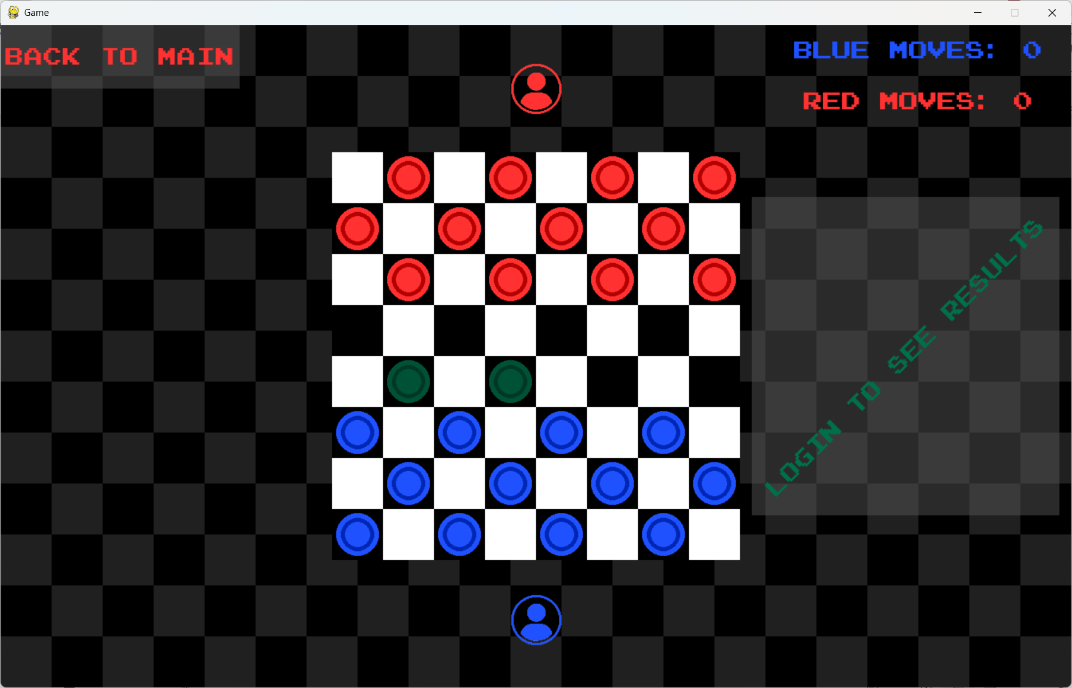

E.1.2
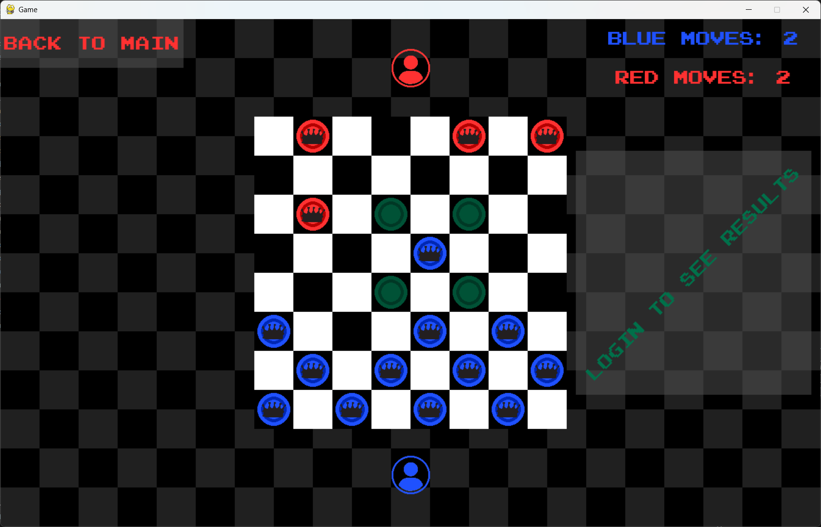

E.1.3
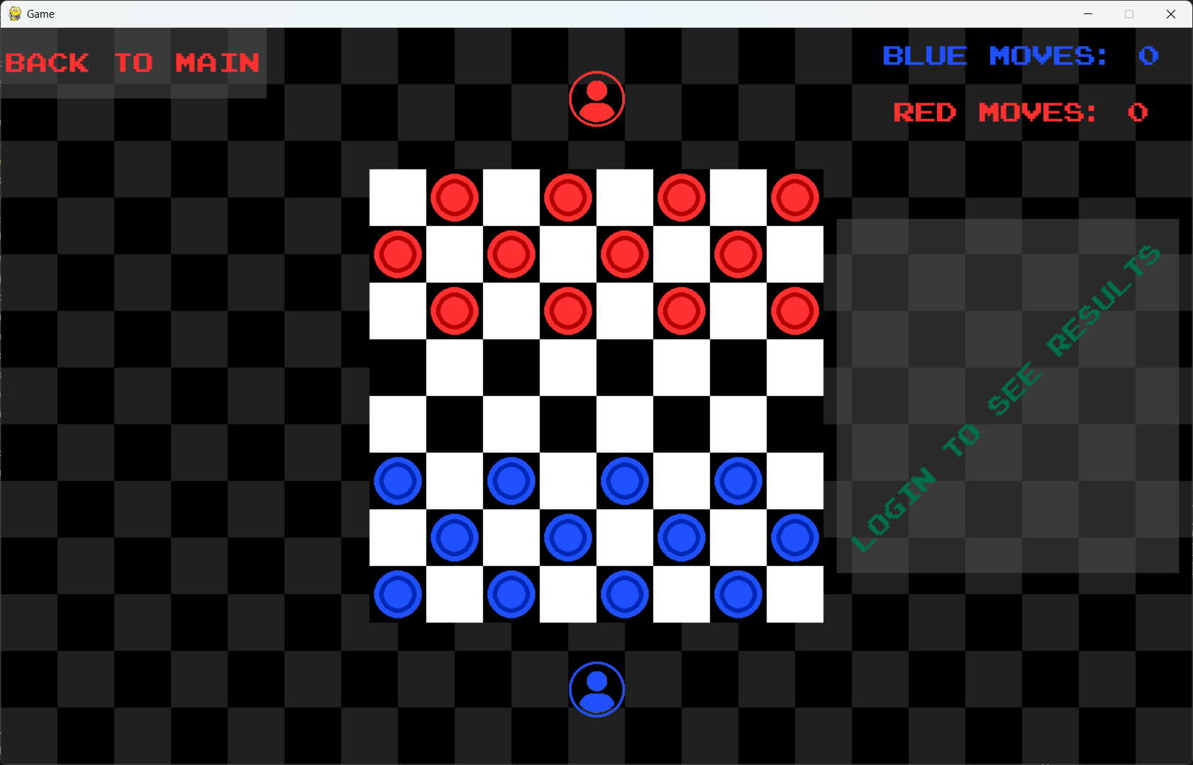

E.1.4
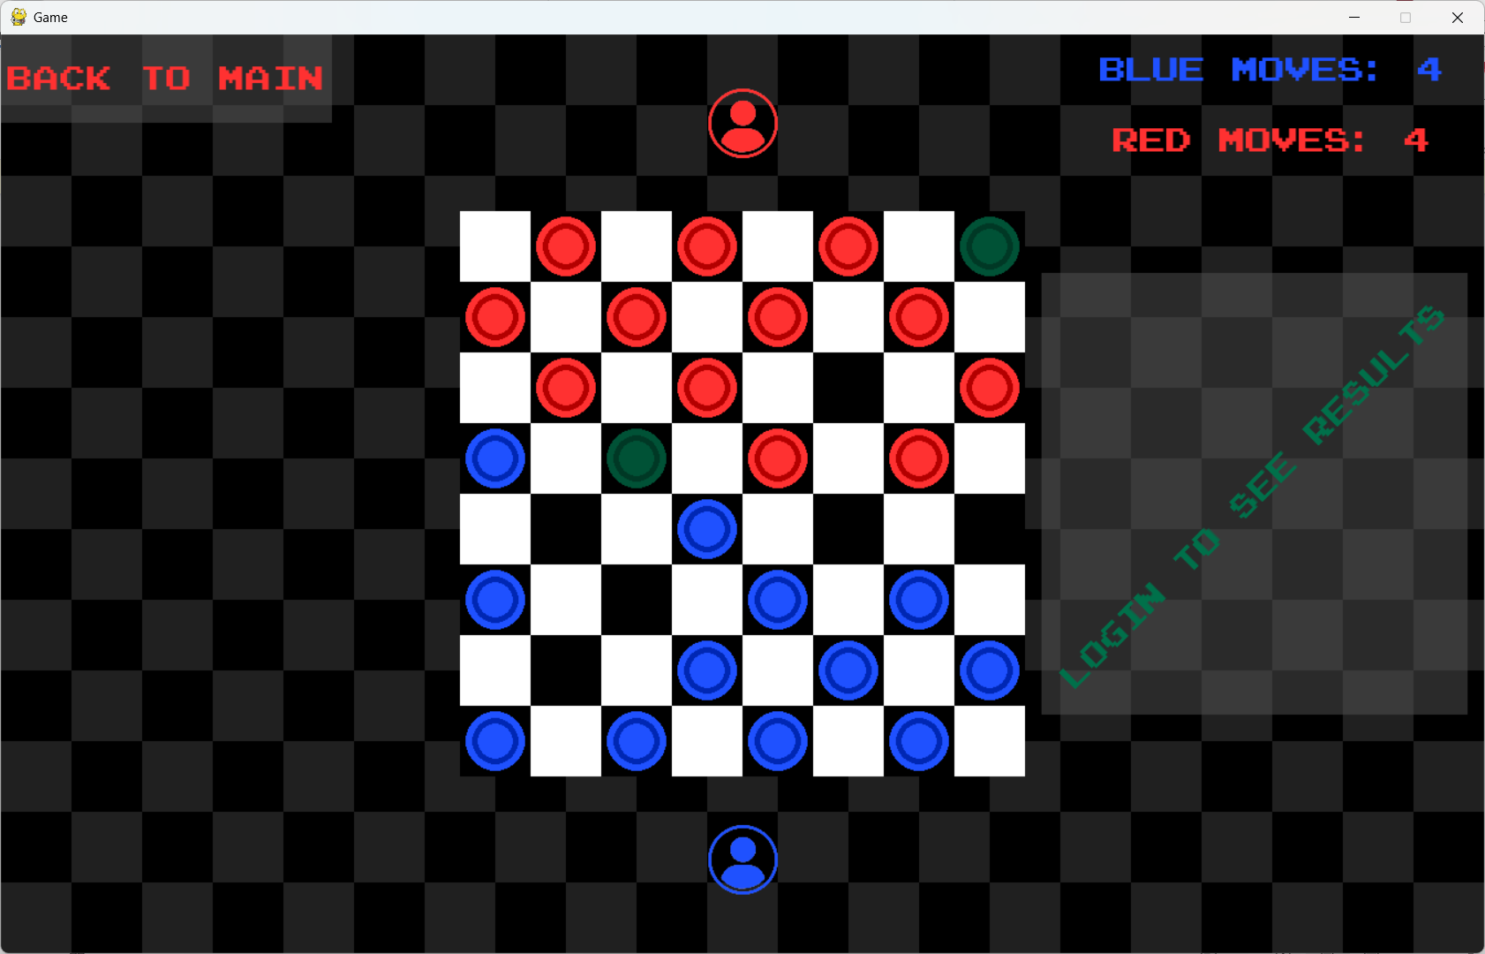

E.1.5
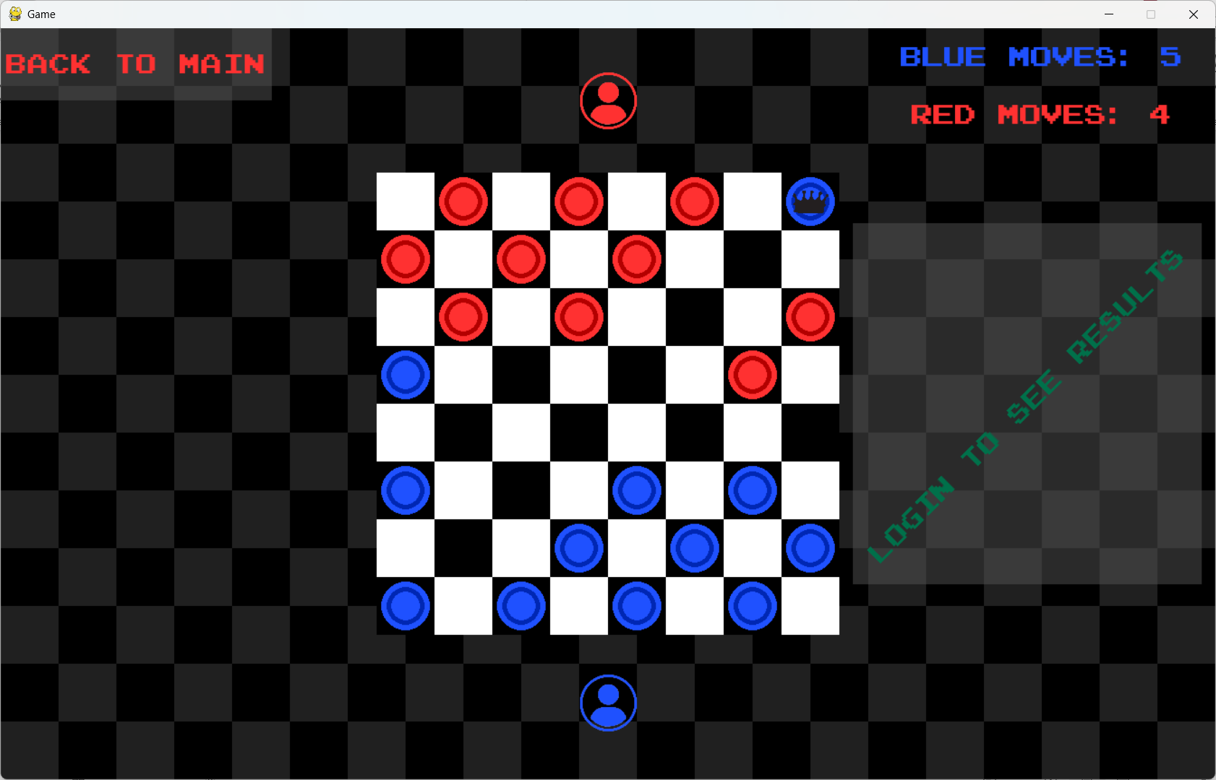

E.1.6
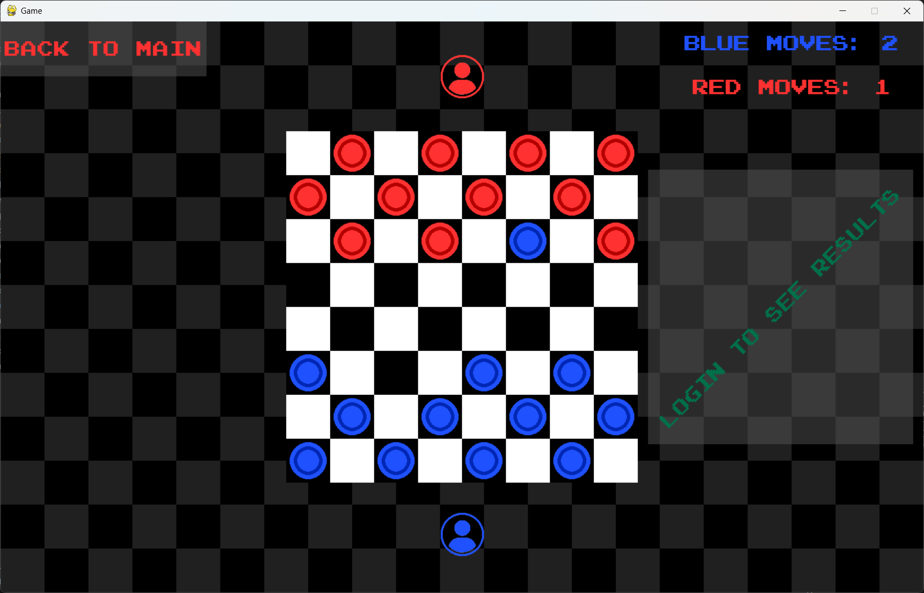

E.1.7
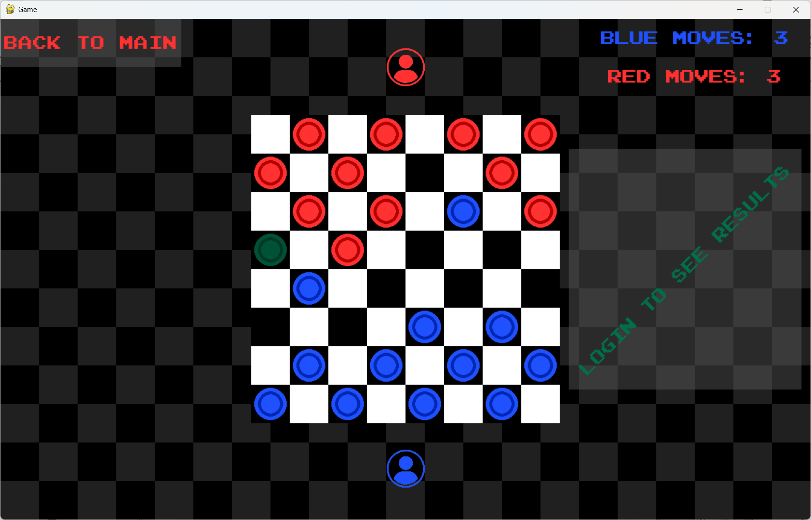

E.1.8
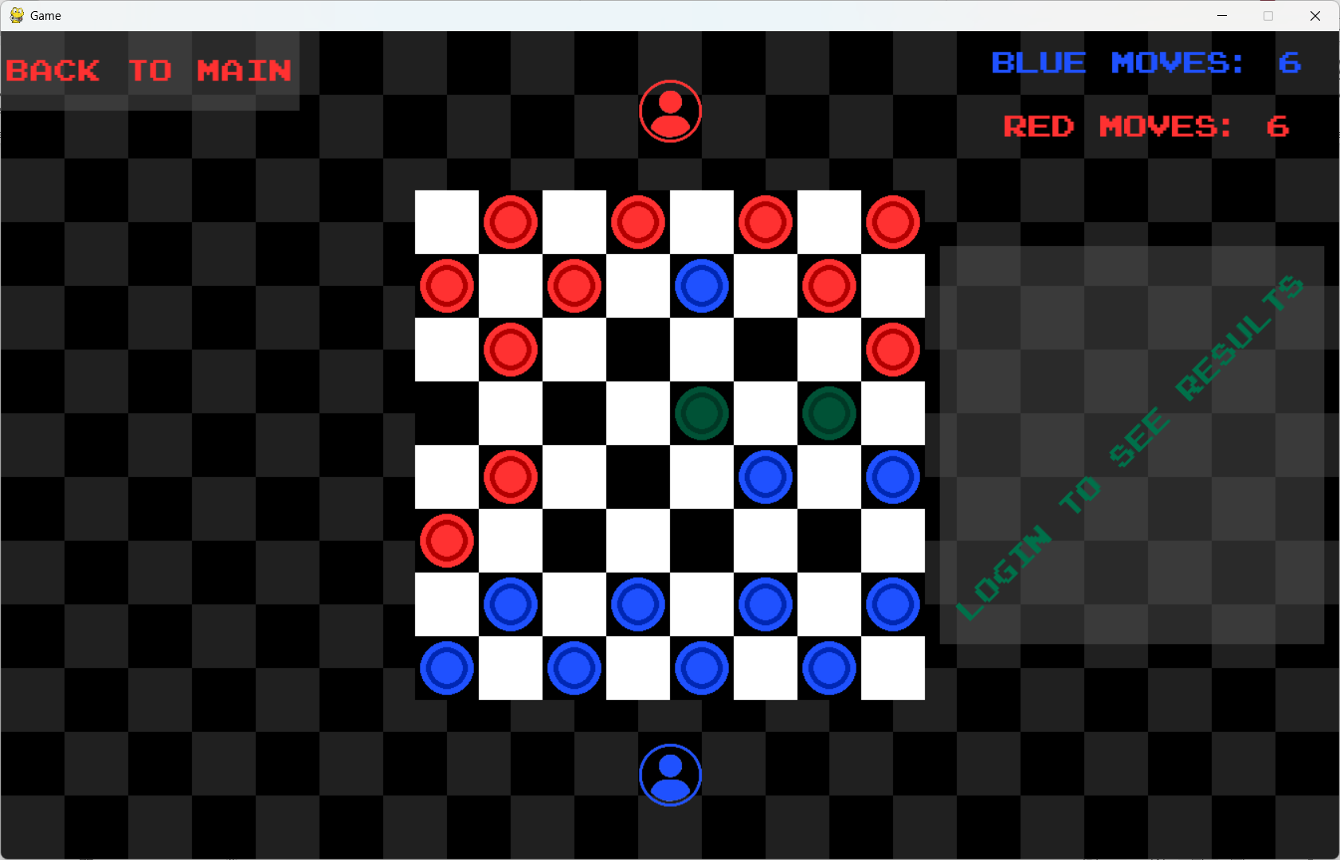

E.1.9
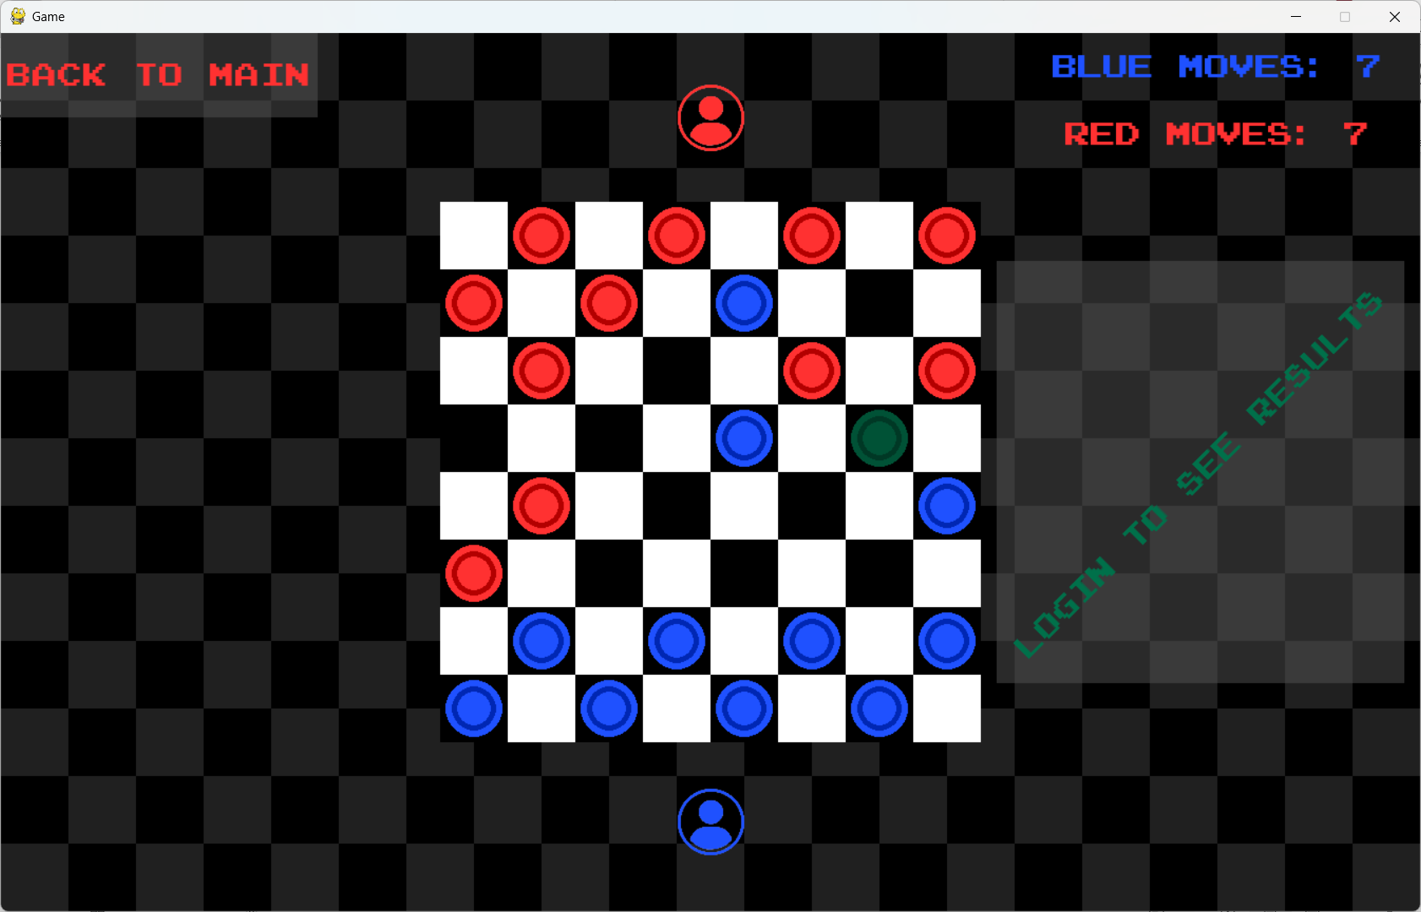

E.1.10
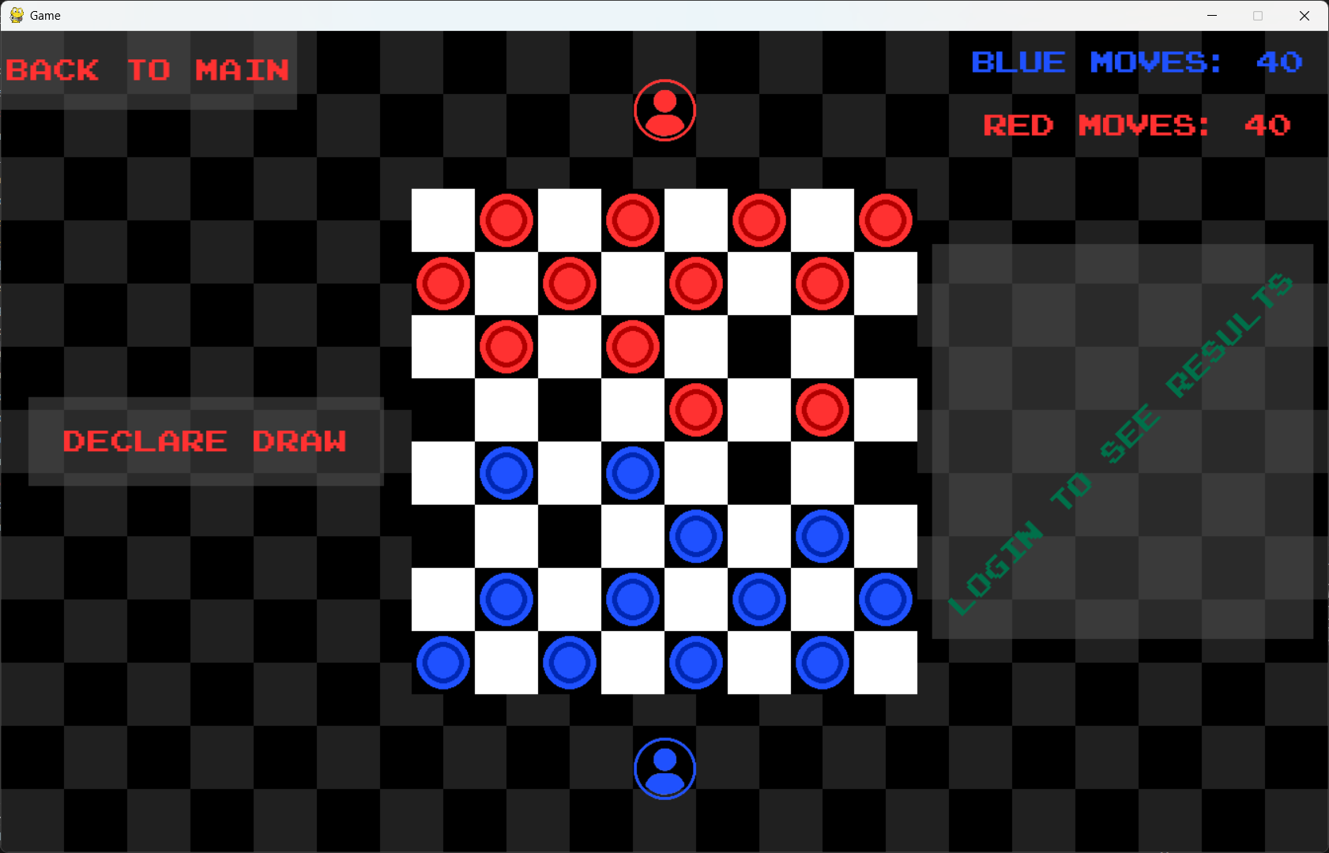

E.1.11
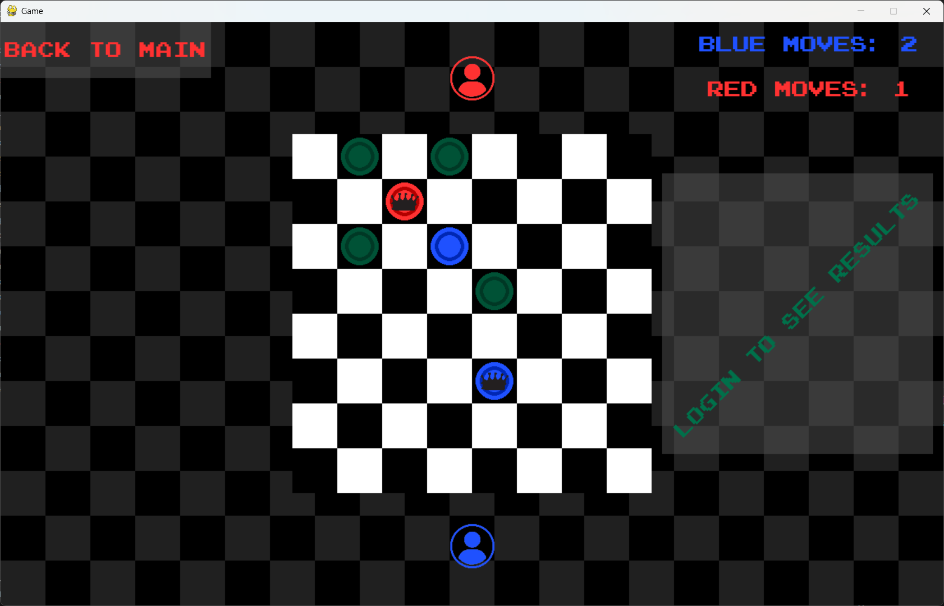

E.1.12
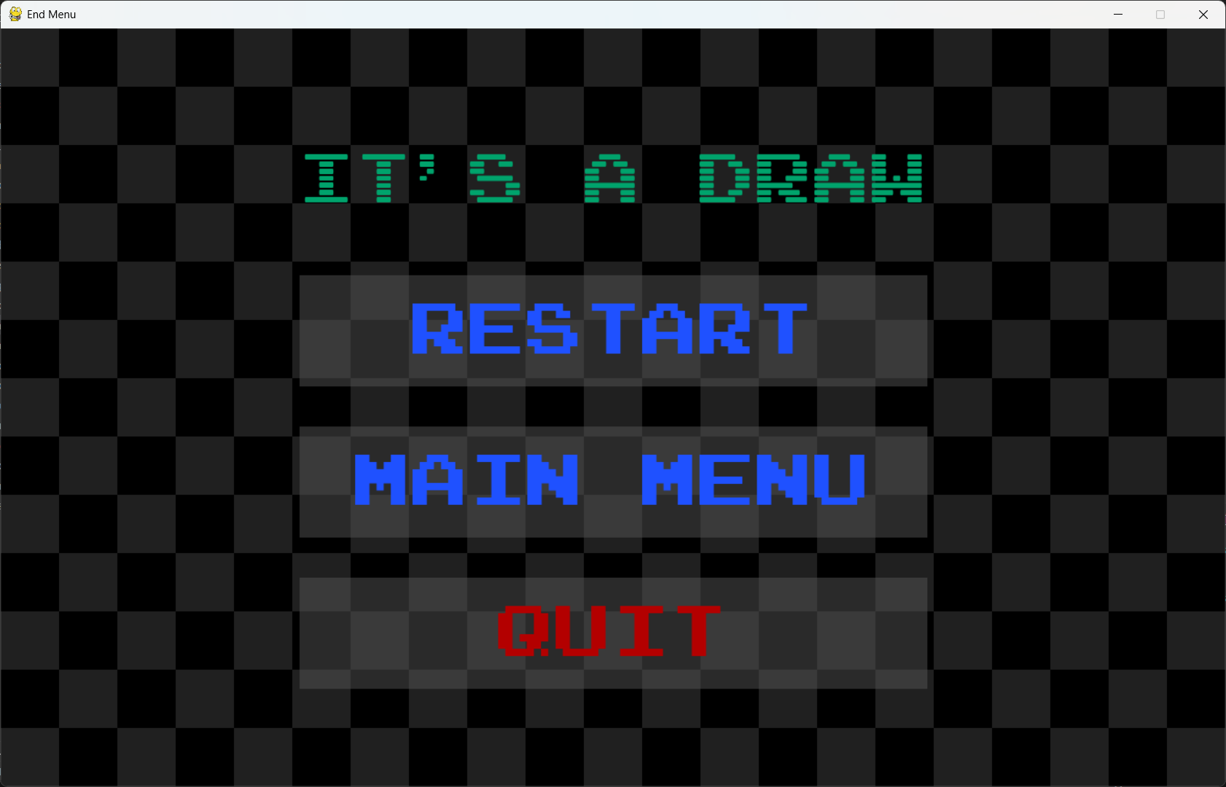

E.1.13

E.1.14
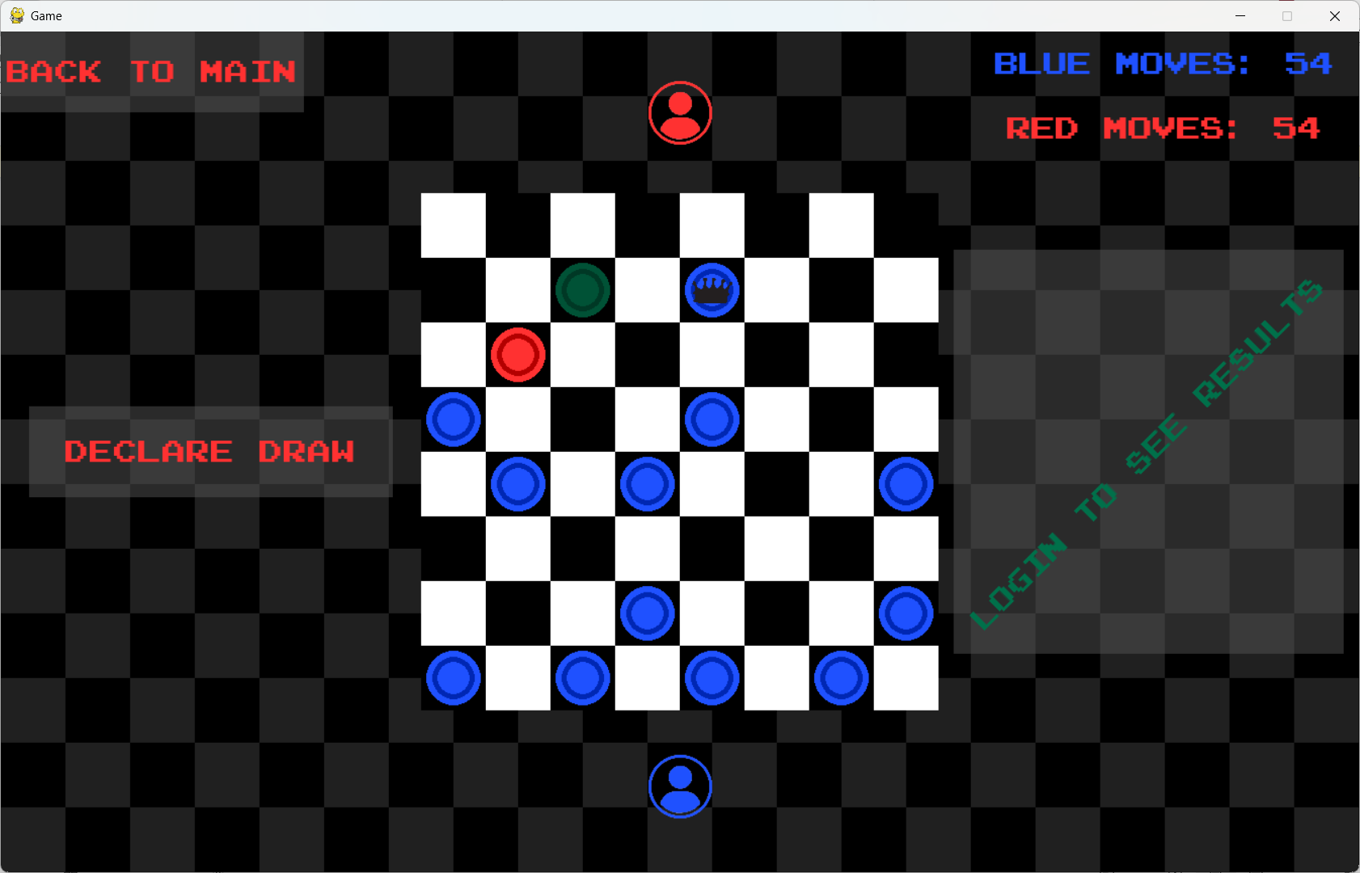

E.2.1
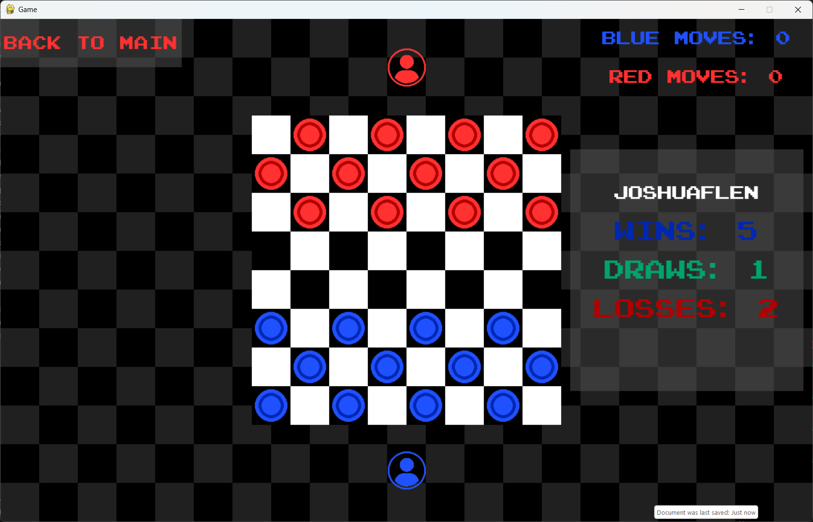

E.2.2
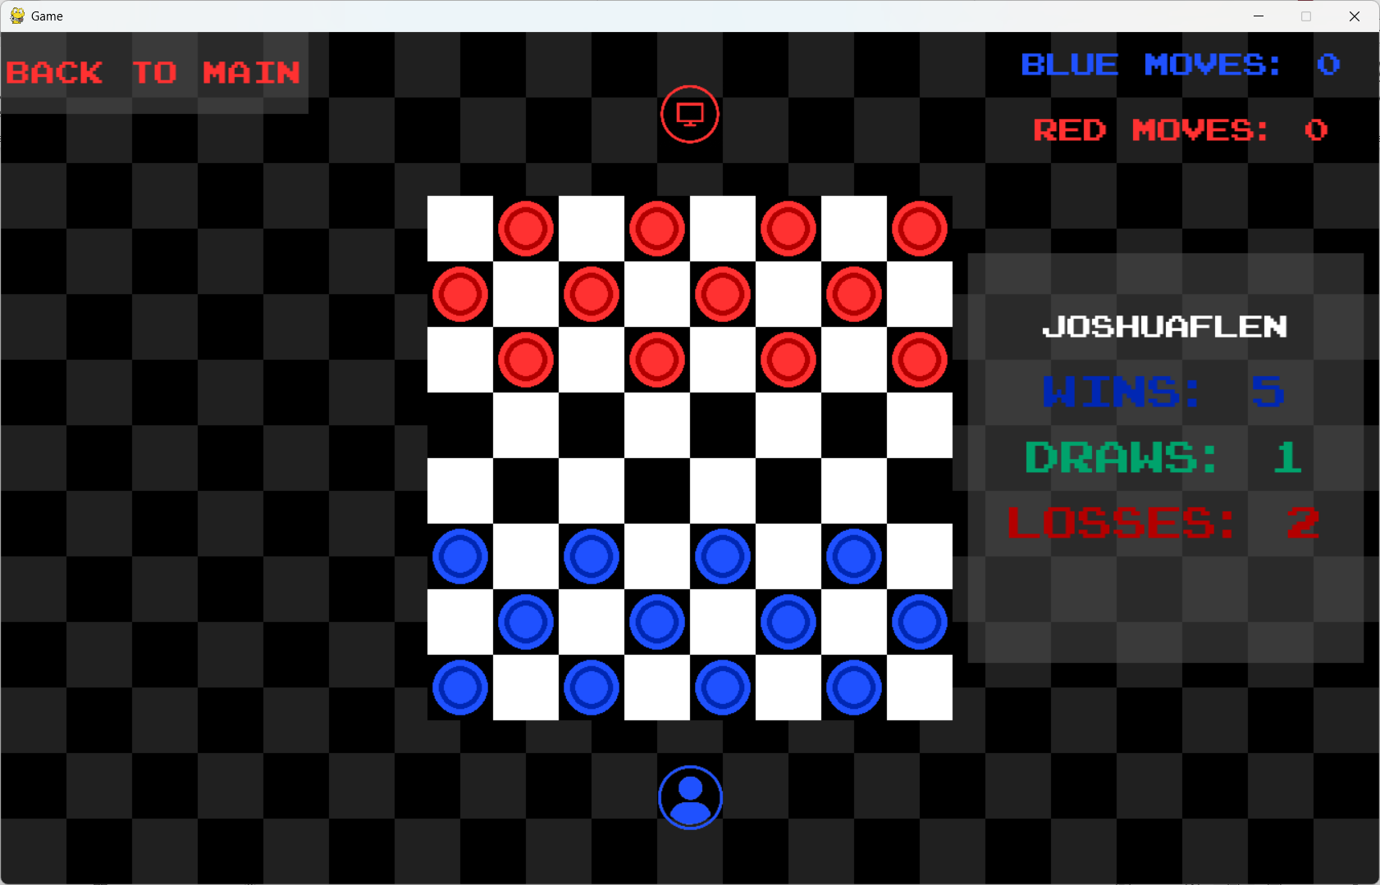

E.2.3
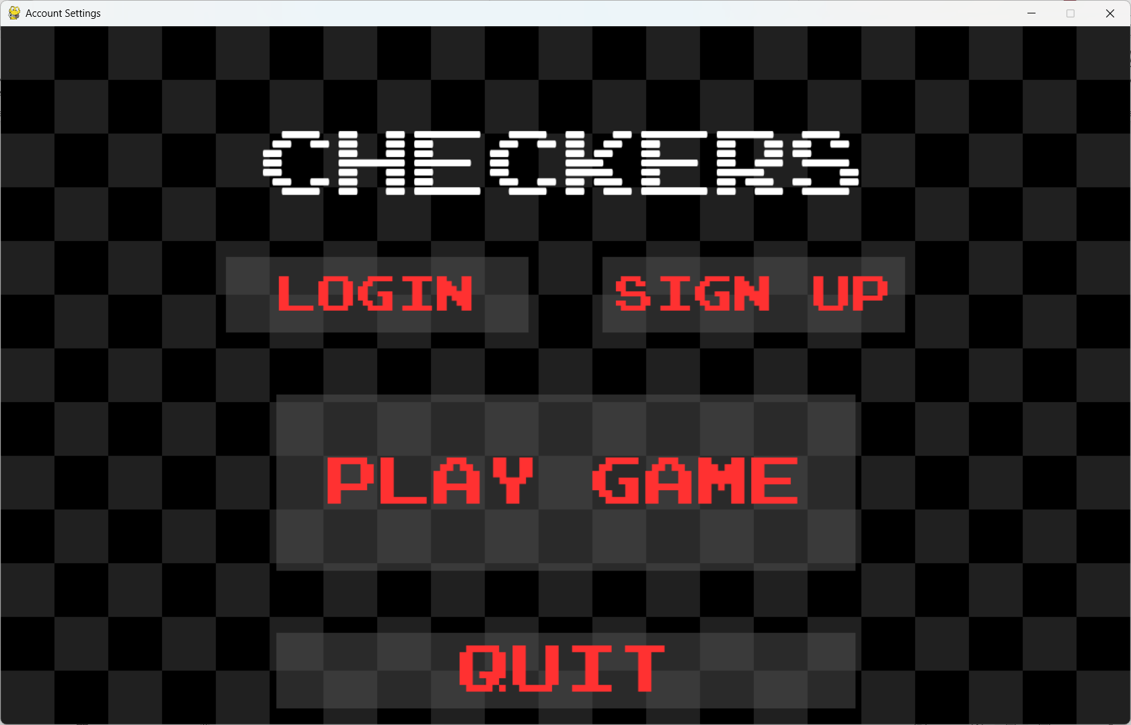

E.2.4
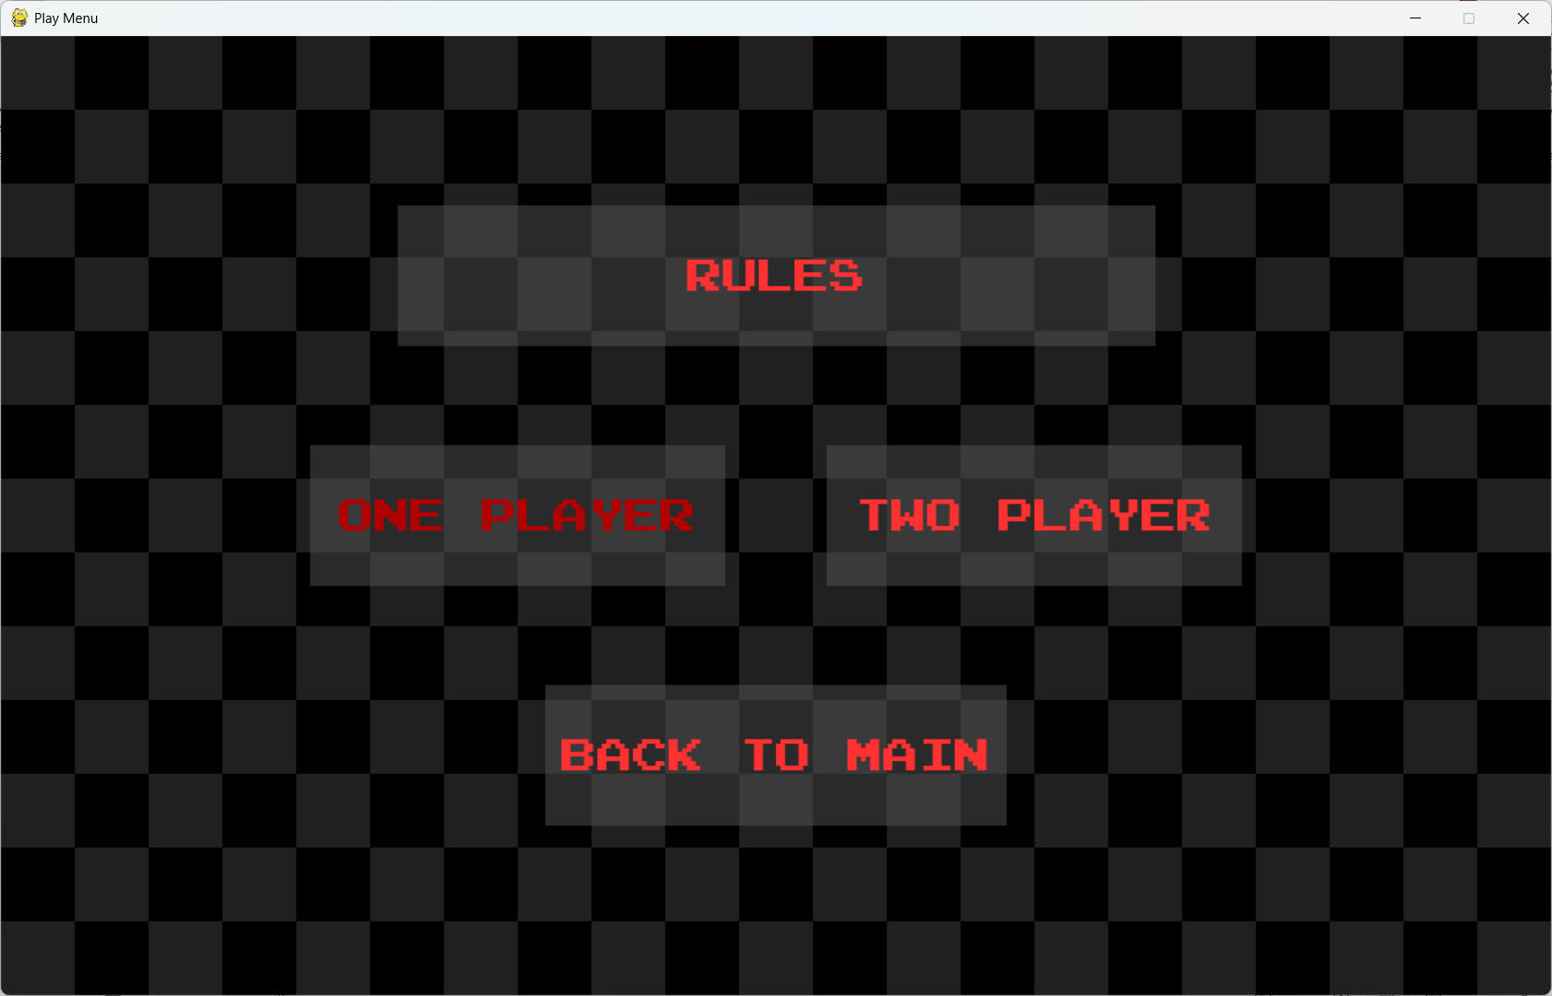

E.2.5
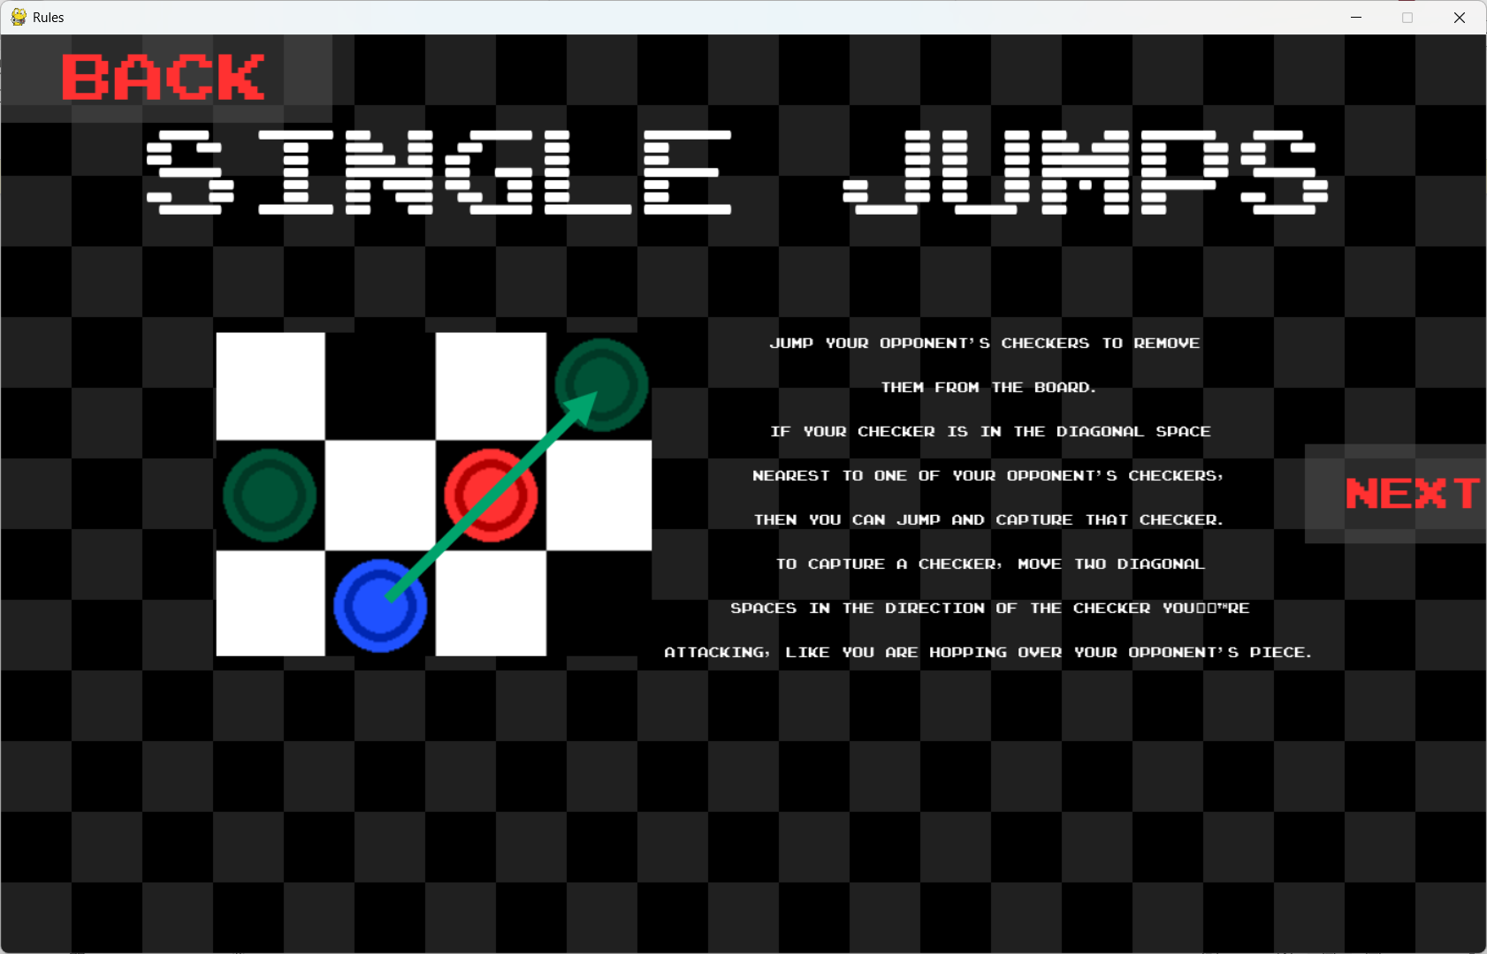

E.2.6
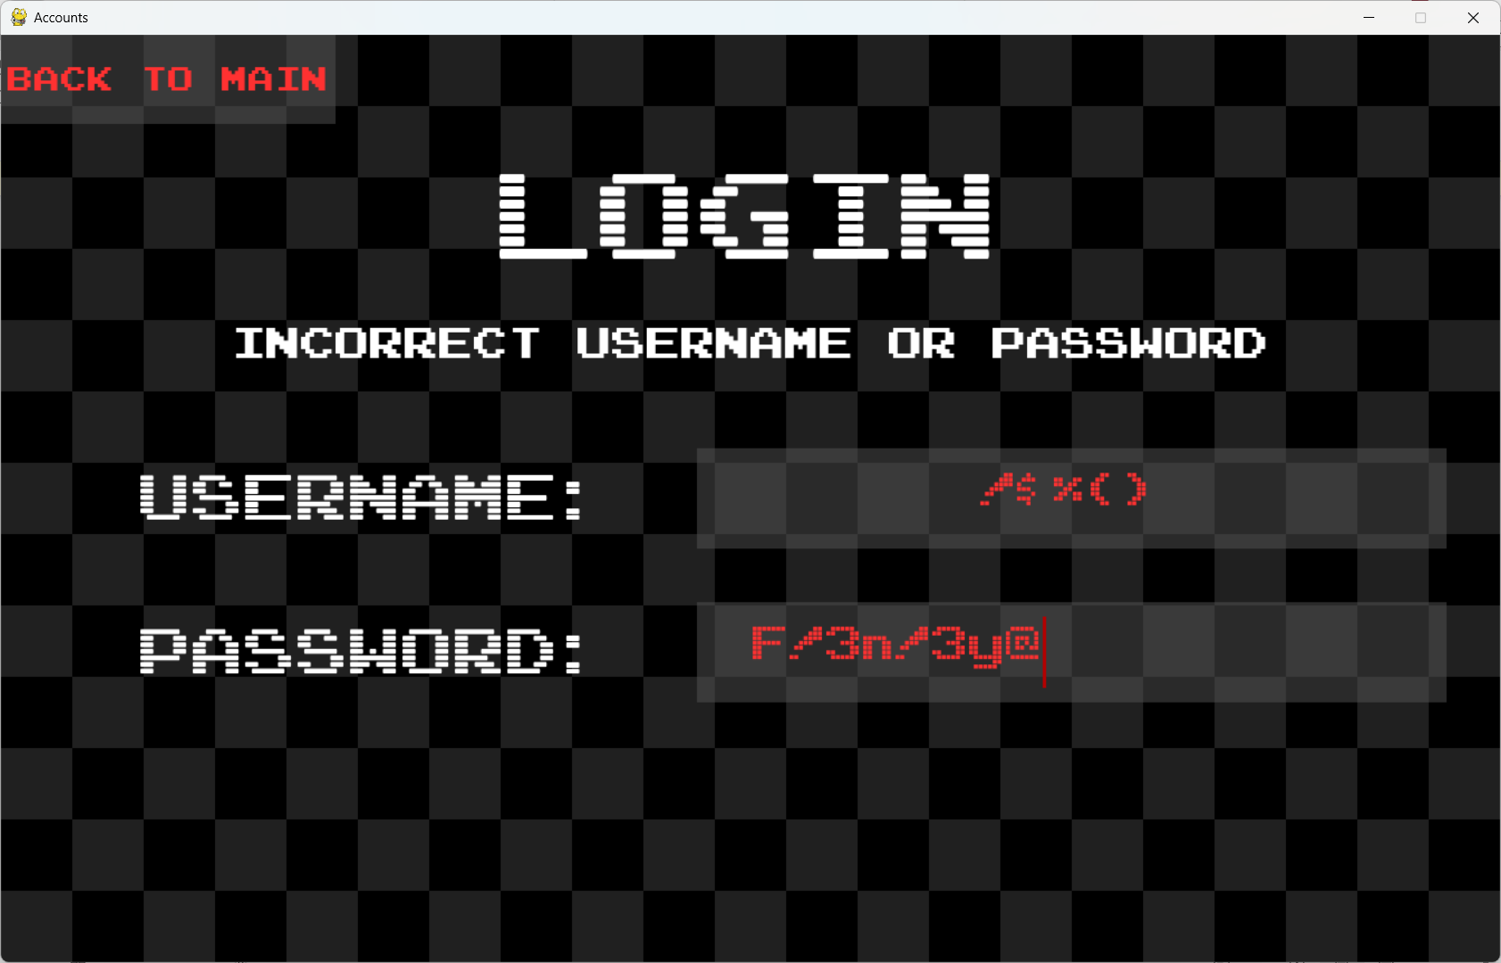

E.2.7
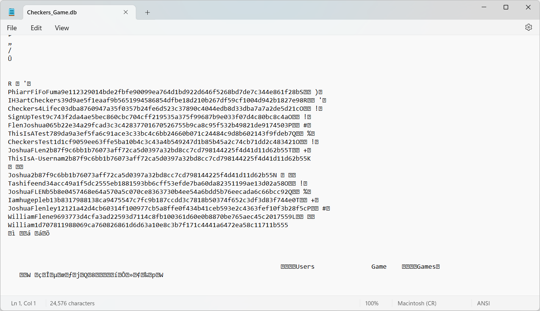

E.2.8
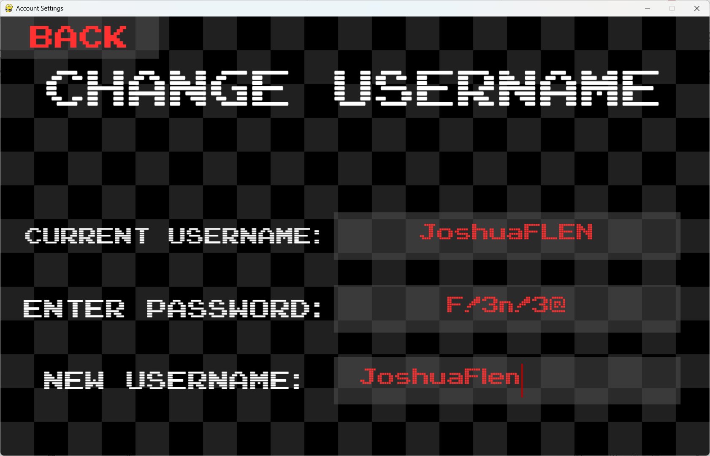

E.2.9
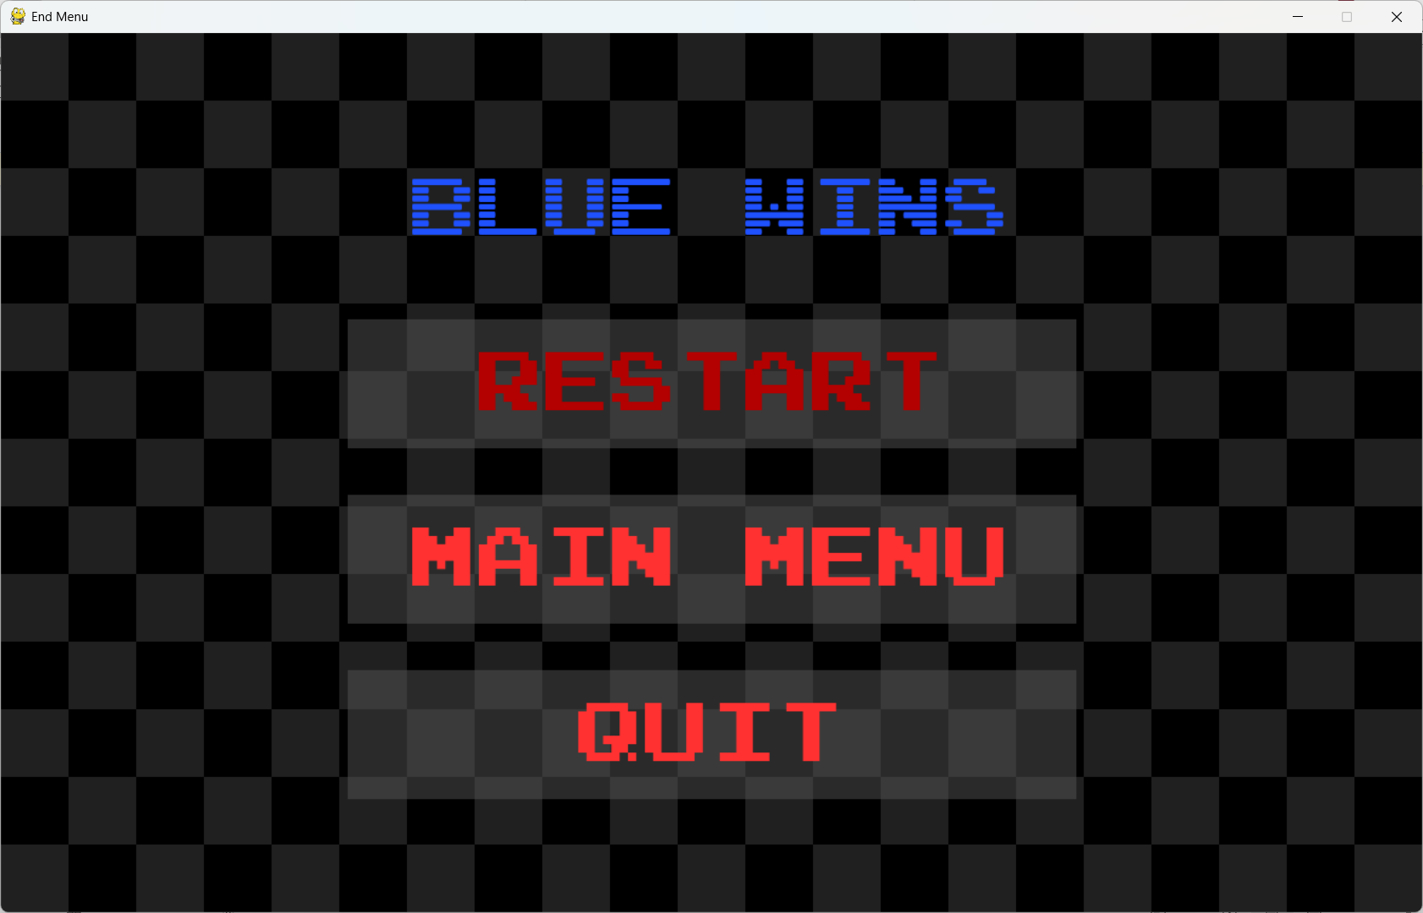

E.3.1
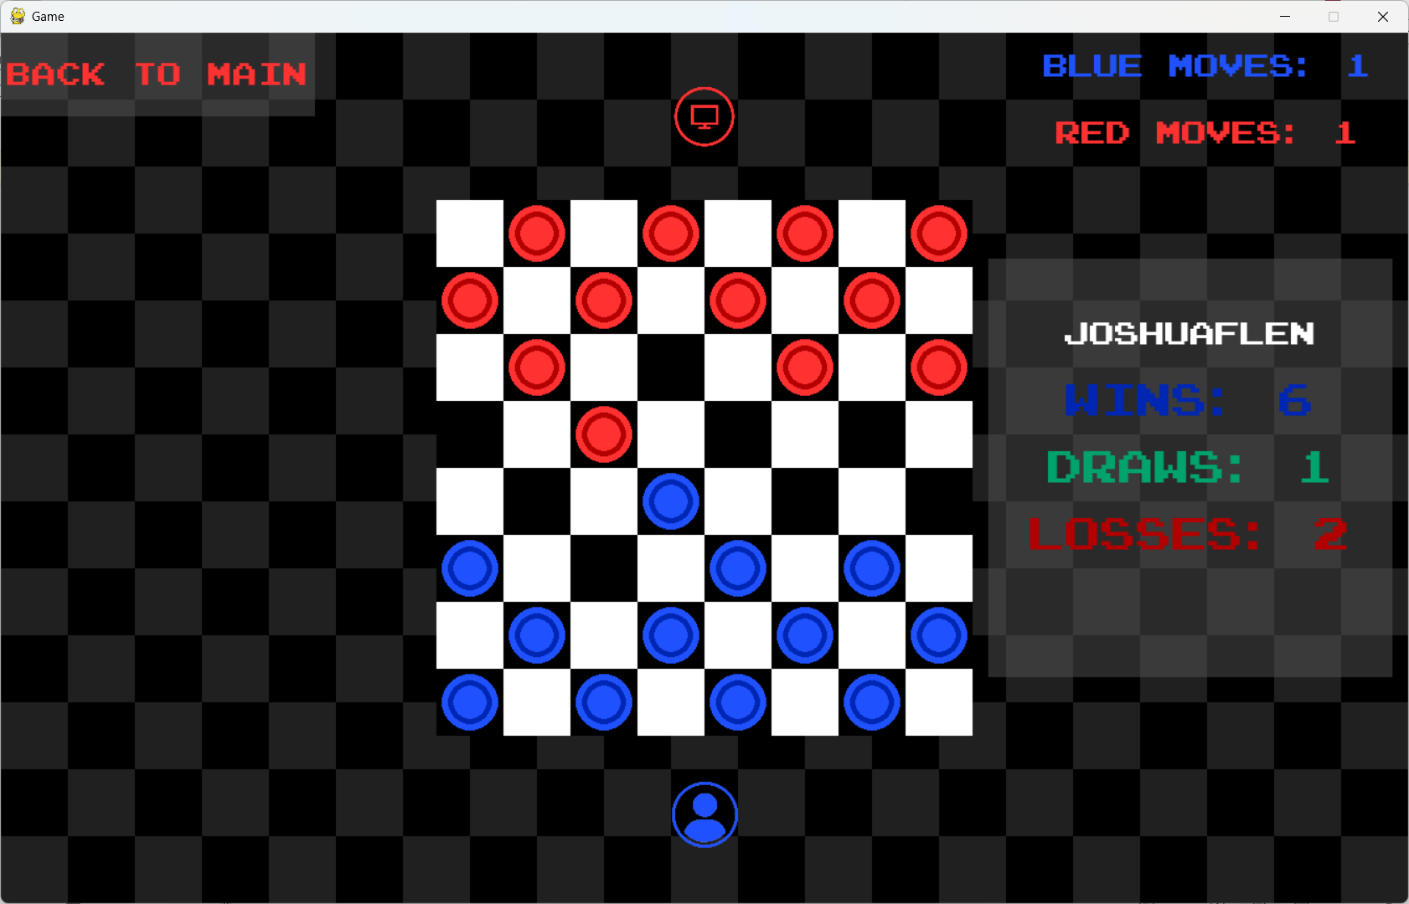

E.3.2
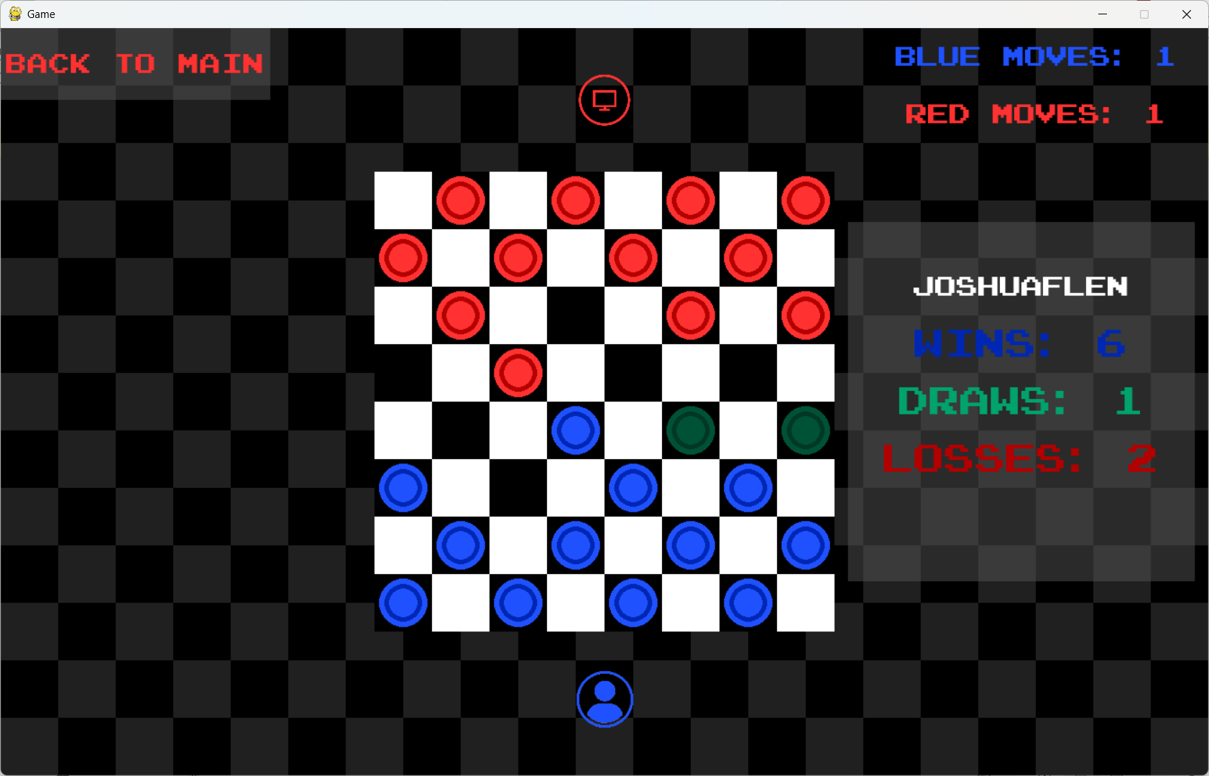

E.3.3
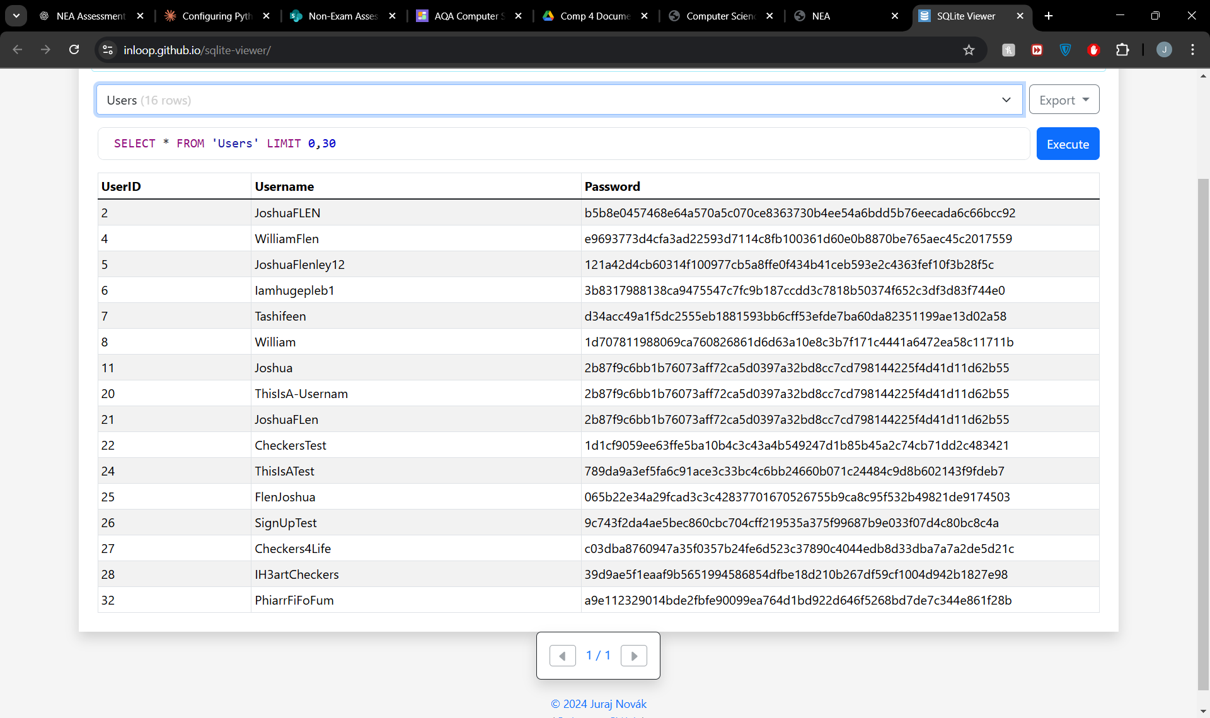

E.3.4
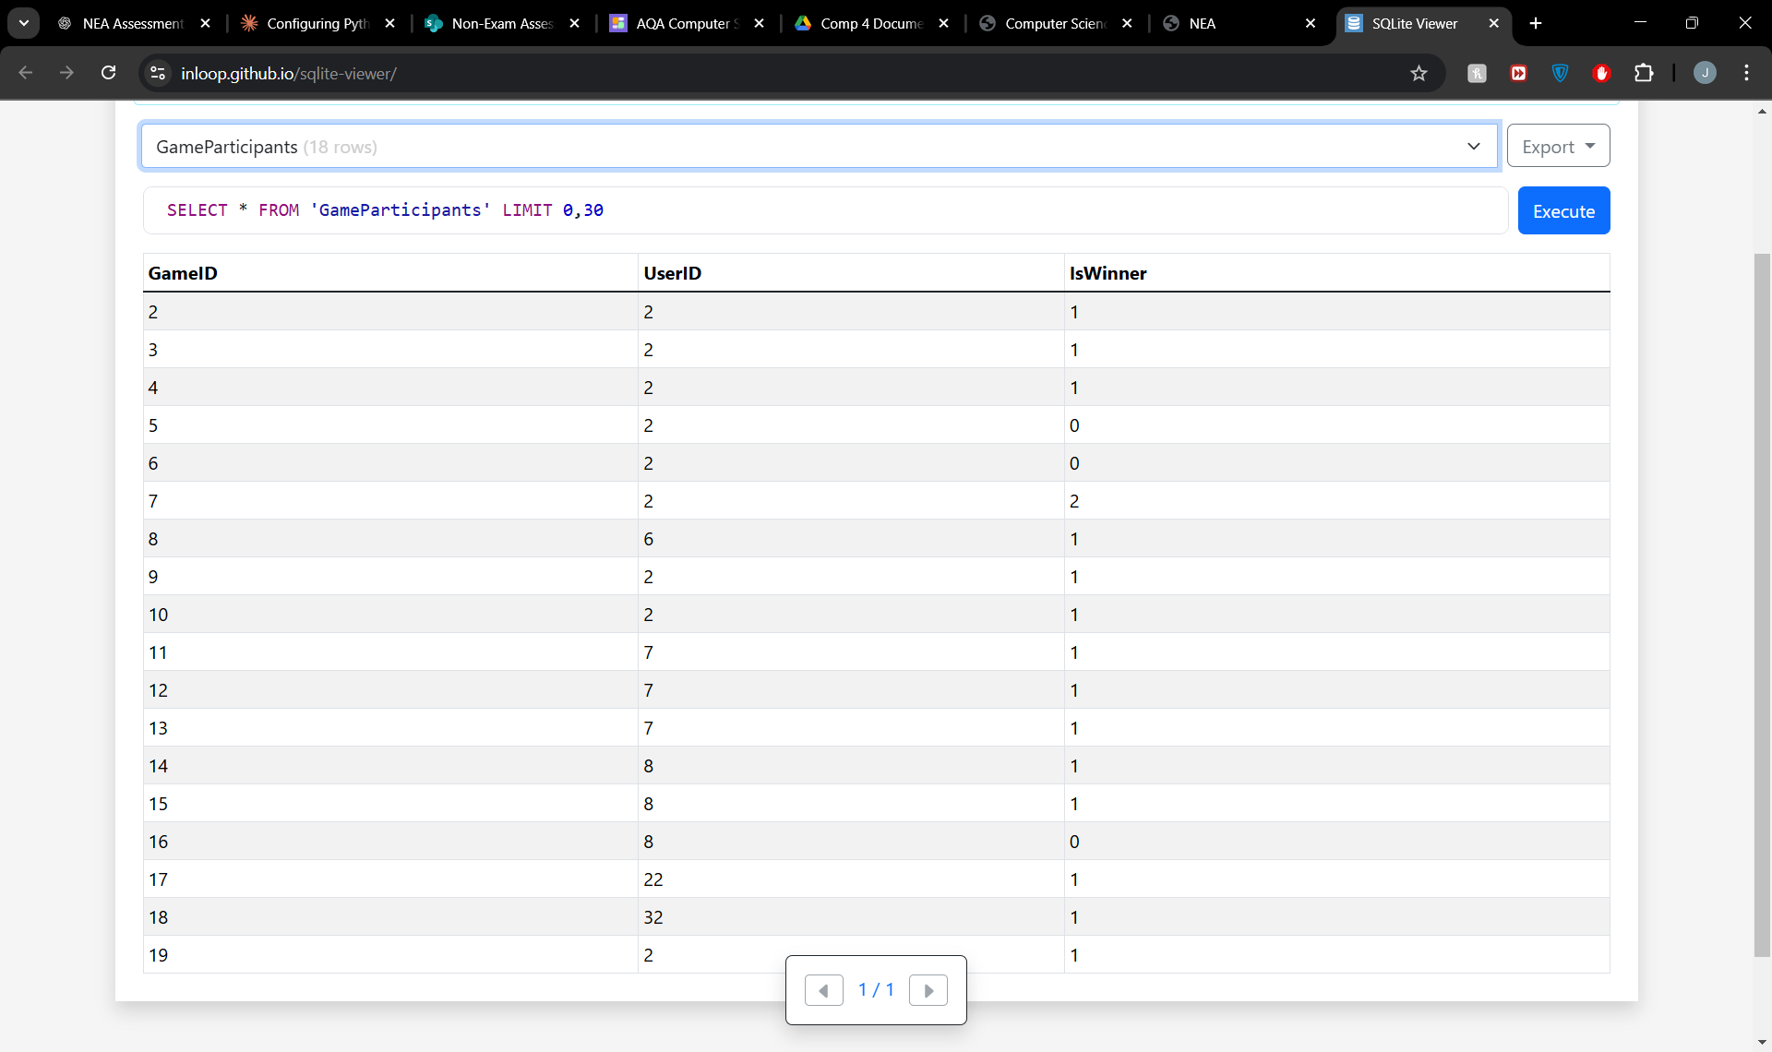

References
Dassanayake, D. (2024, 06 04). How to play checkers: Draughts rules and jumps explained. Retrieved from Dice Breaker board games category: https://www.dicebreaker.com/categories/board-game/how-to/how-to-play-checkers
gametable.org. (2024, 06 04). Checkers Game. Retrieved from gametable.org: https://gametable.org/games/checkers/#google_vignette
Liu, M. (2017, 10 11). General Game-Playing With Monte Carlo Tree Search. Retrieved from Monte Carlo Tree Applied to Letterpress: https://medium.com/@quasimik/monte-carlo-tree-search-applied-to-letterpress-34f41c86e238
Turk, Y. C. (2022, 3 21). Mini-Max. Retrieved from mini-max-acc8d6b88cb1: https://medium.com/analytics-vidhya/mini-max-acc8d6b88cb1
Wikipedia. (2024, 06 04). Blue and Gray (board game). Retrieved from Wikipedia The Free Encyclopedia: https://en.wikipedia.org/wiki/Blue_and_Gray_(board_game)
Wikipedia. (2024, 06 04). Checkers. Retrieved from Wikipedia: The Free Encyclopedia: https://en.wikipedia.org/wiki/Checkers
Wikipedia. (2024, 06 04). Cheskers. Retrieved from Wikipedia The Free Encyclopedia: https://en.wikipedia.org/wiki/Cheskers
Wikipedia. (2024, 06 04). Hexdame. Retrieved from Wikipedia The Free Encyclopedia: https://en.wikipedia.org/wiki/Hexdame
Wikipedia. (2024, 06 04). International draughts. Retrieved from Wikipedia The Free Encyclopedia: https://en.wikipedia.org/wiki/International_draughts
Wikipedia. (2024, 06 04). Russian Draughts. Retrieved from Wikipedia The Free Encyclopedia: https://en.wikipedia.org/wiki/Russian_draughts

