
  - Student Name : Majok Ali
  - Admission Number : BSCCS/2024/37636
  - Course/Class : bsc Computer Science
  - Unit Code: BIT 4139
  - Unit Name: Ethical Hacking
  - Lecturer Name : Mr Nyoro
  - Semester/Academic Year : Year 4 SEM II

Table of Contents
WEEK 1: 3
INSTALLATION OF NMAP AND WEB VULNERABILLITY SCANNING 3
WEEK 2: 5
DNS FOOTPRINTING 5
PORT SCANNING 6
WEEK 3: 7
WEEK 4 8
Fig 2: IP Address (dig sudoticket.com) 8
Fig 3: Technologies: [web server, framework] 8

WEEK 1:

INSTALLATION OF NMAP AND WEB VULNERABILLITY SCANNING
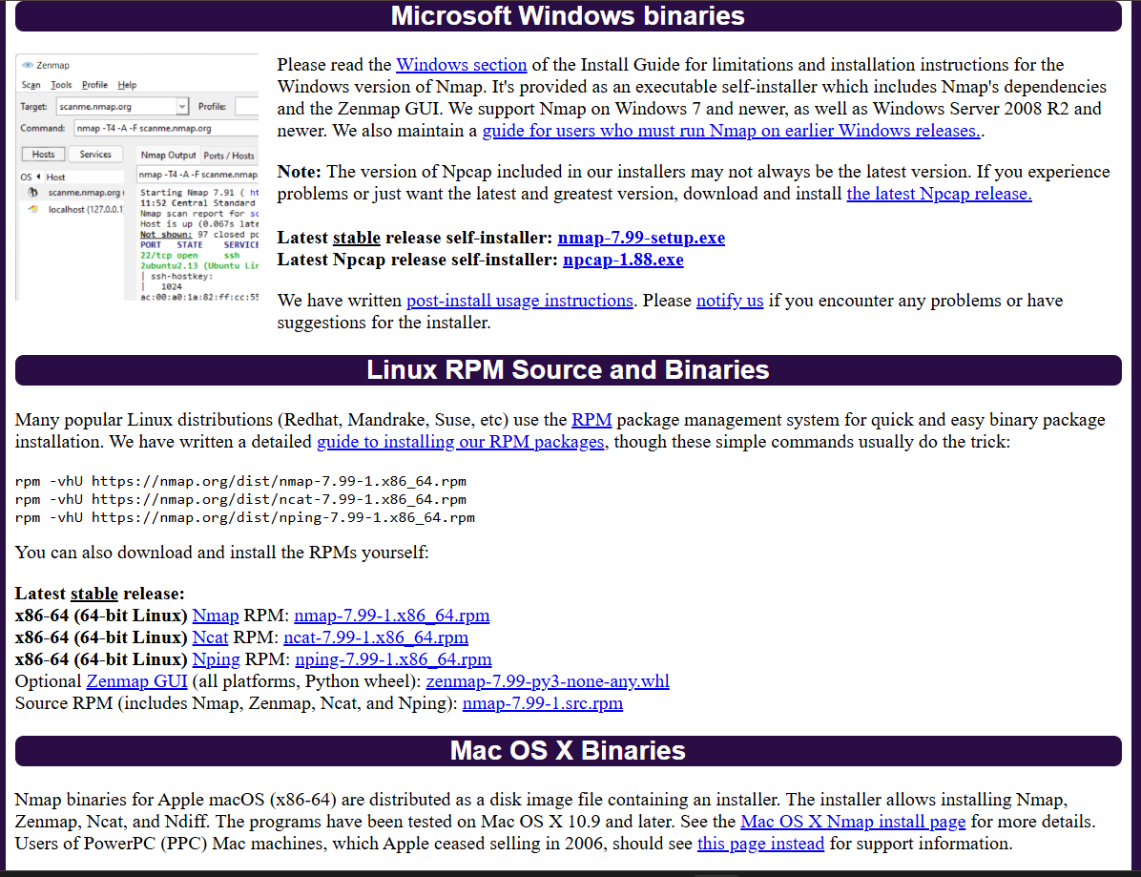
FIG 1:
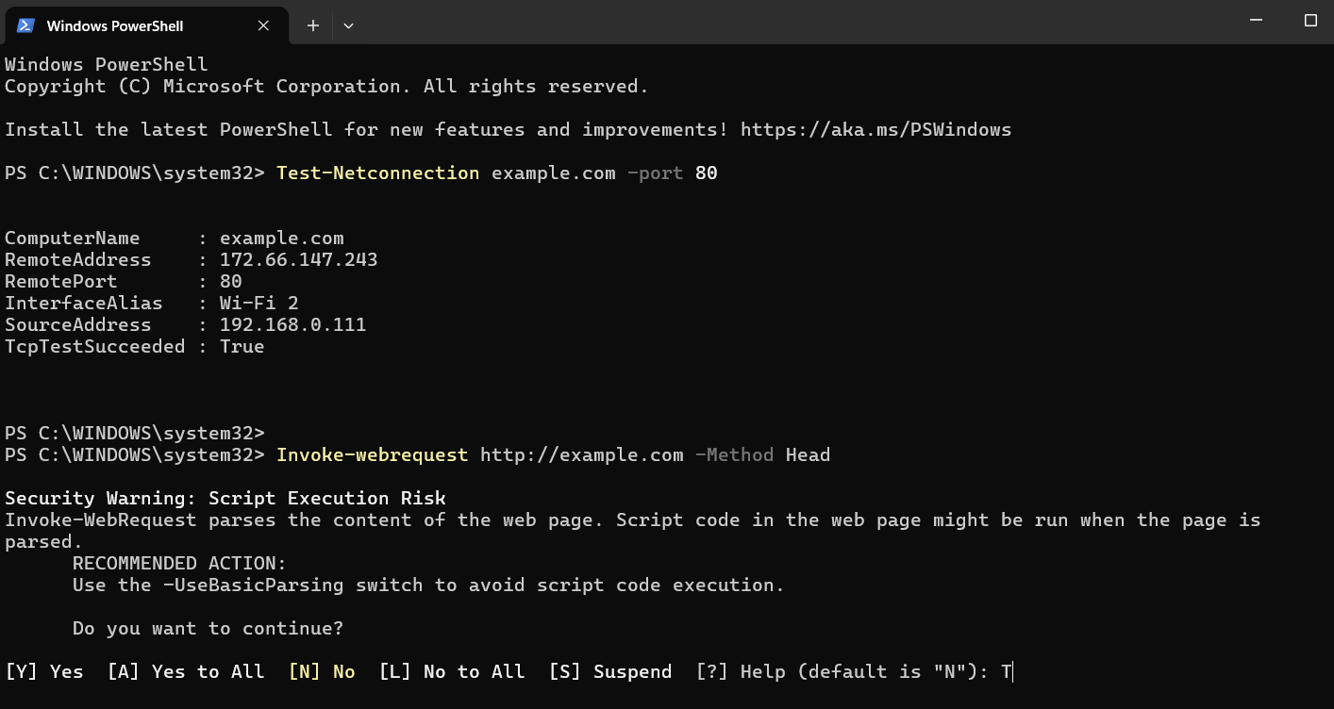

FIG 2:

WEEK 2:

DNS FOOTPRINTING
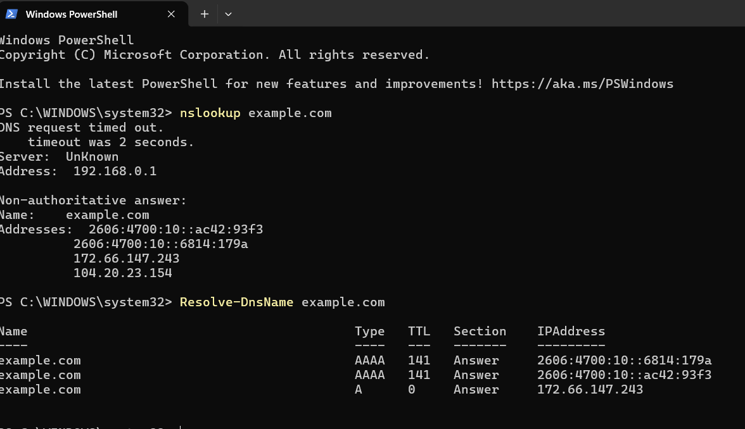
FIG 1:
-
-
-

PORT SCANNING

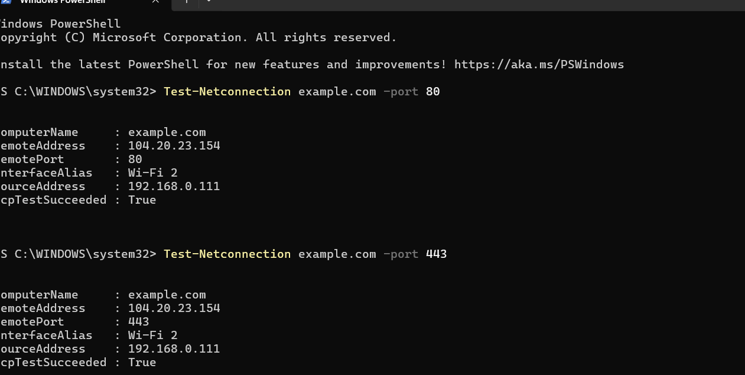
FIG 2:

WEEK 3:
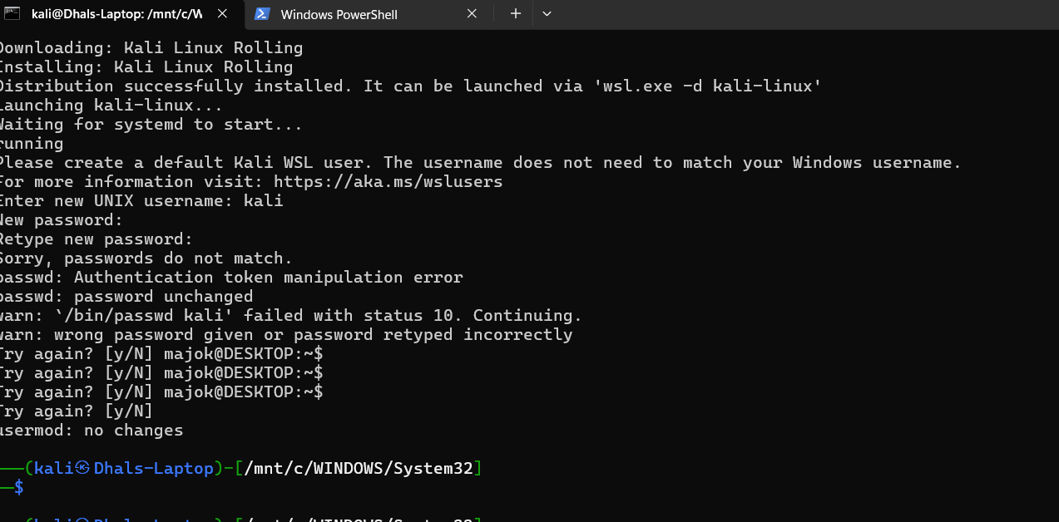
Fig : 1

WEEK 4

Fig 2: IP Address (dig sudoticket.com)
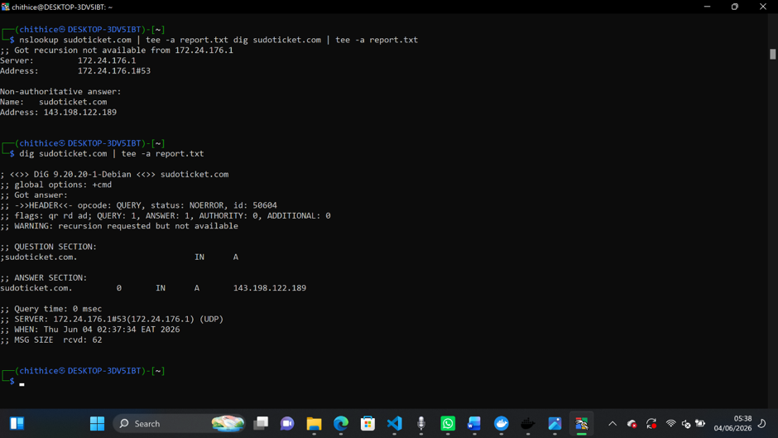

Fig 3: Technologies: [web server, framework]
