Instance name:

i-0abea8254c3ac0241

key: mn-awsdevkey

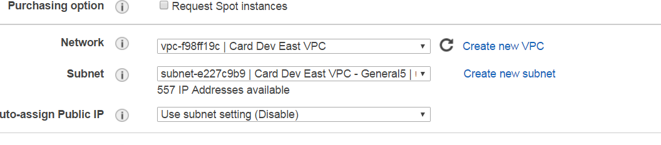

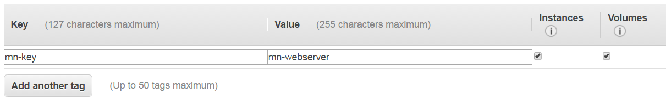

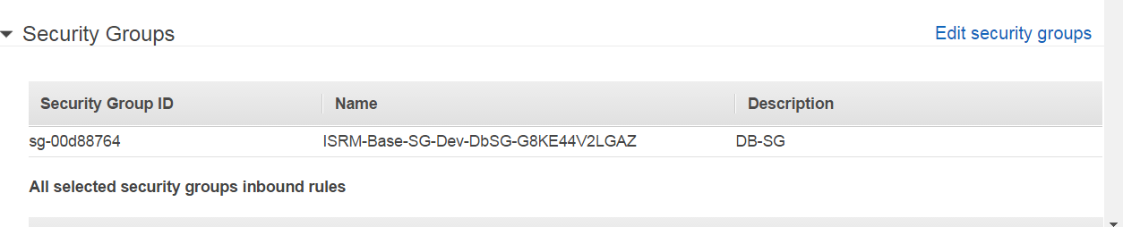

Security group

DB-SG

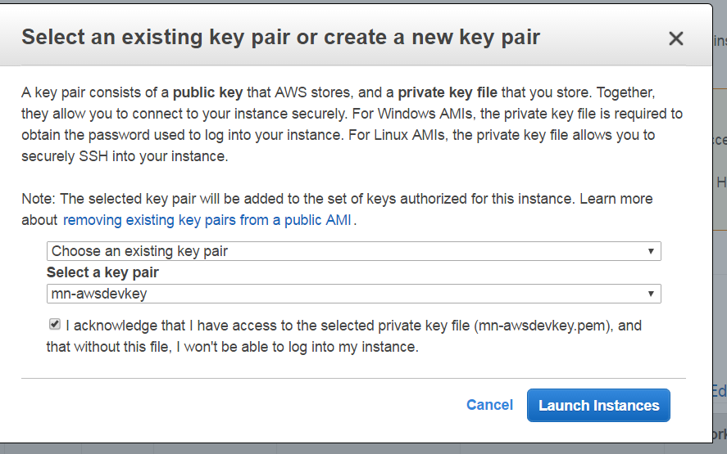

https://www.digitalocean.com/community/tutorials/how-to-install-linux-apache-mysql-php-lamp-stack-on-ubuntu

How to SSH from Ubuntu/jumpbox

Copy the downloaded “mn-awsdevkey.pem” file to Ubuntu. (send file to git repository and download from git)

Copy .pem file to dir. (~/Documents/awskey/..)

Change permission

$ sudo chmod 400 mn-awsdevkey.pem

Then ssh to

$ **ssh -i "mn-awsdevkey.pem" ubuntu@10.205.83.175**

NOTE: if you want a quick web test, install apache2 and hit the browser

$ sudo apt-get update

$ sudo apt-get install apache2

// get the instance ip. Same as

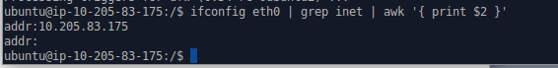

Open browser and enter : http://10.205.83.175

To create instance via command line we need have AWS CONFIGURE done

To do that get the config info

In aws, “Key Pairs” tab

Click “Import Key Pair” and select the file location from local machine

