Joseph Kinahans bank.java report

My bank.java program begins by asking the user to input the amount of accounts in the study/ bank. Using a Scanner object, it stores this in a variable <noOfAccounts>. A while loop ensures that the entry is in the requested range.

It then creates three arrays, all of whose lengths are determined by the <noOfAccounts> variable. These are:
- < int accNo [] > -- -- ---- this will give a unique number to each account
- < String accountName [] > -- -- this will assign a name to each account
- < double balance [] > -- -- this will store the account balance for each

Starting with the first, it loops through each, asking the user to input a string value for the <accountName>, and a double value for the <balance>. This results in the three arrays being aligned so that accountName[0] is the name associated with accNo[0], and also the related balance[0]; The same holds for accountName[1], accNo[1], and balance[1]....and so on....

below is the screenshot of the output after the names and balances have been entered, mostly made of System.out.print and looping through the accounts to output the variable in each array index:

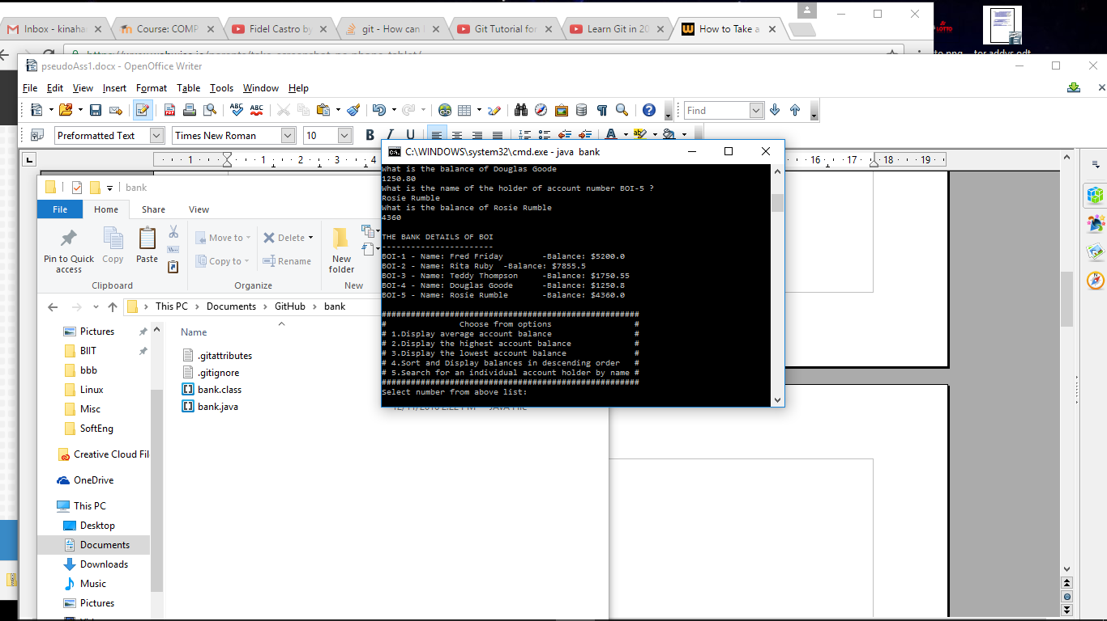

-The shot above displays the bank account details displayed after the user has entered them. It is followed by a menu, created basically with System.out.println to present the options to the user.

In this list are the options of using the 5 methods I have set up to probe and sort the account details for the bank.
I've used a switch statement to be implemented after the user replies to a prompt related to the displayed menu. When this reply has been legitimised, through a while loop, the switch statement can execute.

Below is a screenshot of the first two selections used, to show the average balance, and to display the highest balance.

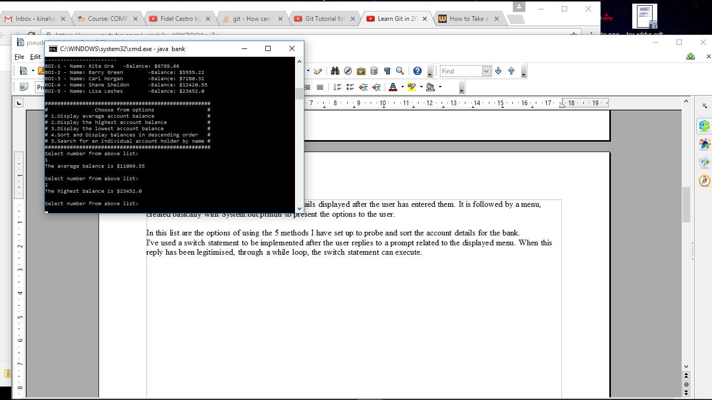

For the Average method <ave> I used a loop to add the elements in the <balance> array together before dividing this total by the length of the array.

For the Highest method <highest> I used a loop to compare each item in array to my <high> variable(intitialised at 0); where if its higher it becomes the new <high> for the next iteration. This will loop through each and by the end the highest one will be in <high> variable.

Below is a screenshot showing the next two options in the list being entered into the program, lowest and descending order sort.

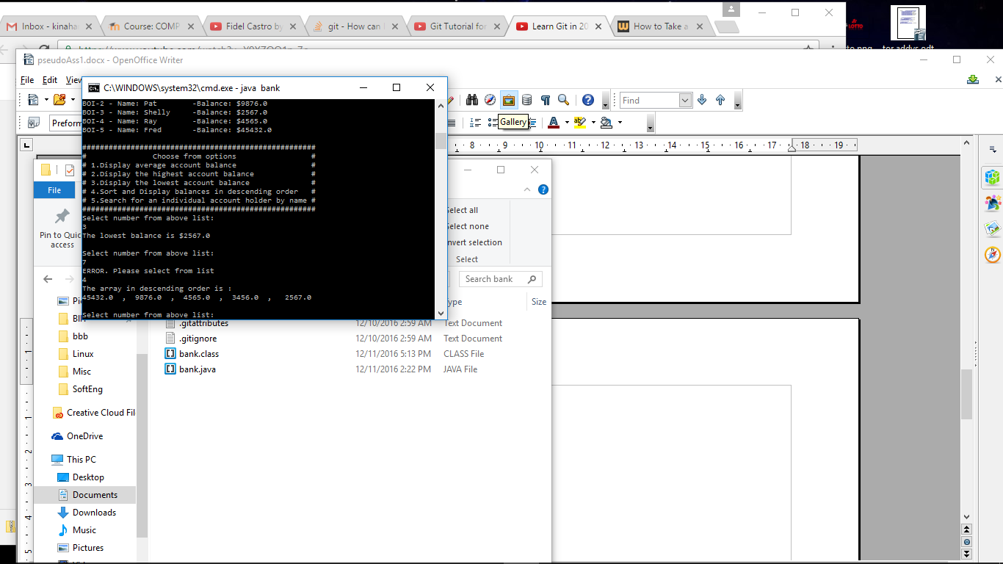

For the lowest sort method, I use the same kind of looping method as for the highest to isolate the lowest element in the array and print it.

For the descending sort method I used a loop with an inner loop to cycle through the pairs in the array, swapping the two if the higher entry is to the right of the element its compared to. This gives me the final result of a sorted array, in descending order, which i print then to screen using a for loop.

Below is the screenshot of a user selecting to search for an account by name. I prompt the user for a name, which has to match a name in the database(my accountName array). I use a for loop to loop through the names, comparing each to the input just received, using .equals(). If a match comes up, the loop stops and the bank details are read and outputted from that index in each of the arrays. For this reason, i needed to construct this method to accept in 3 arrays- a string[], an int[], and a double[];

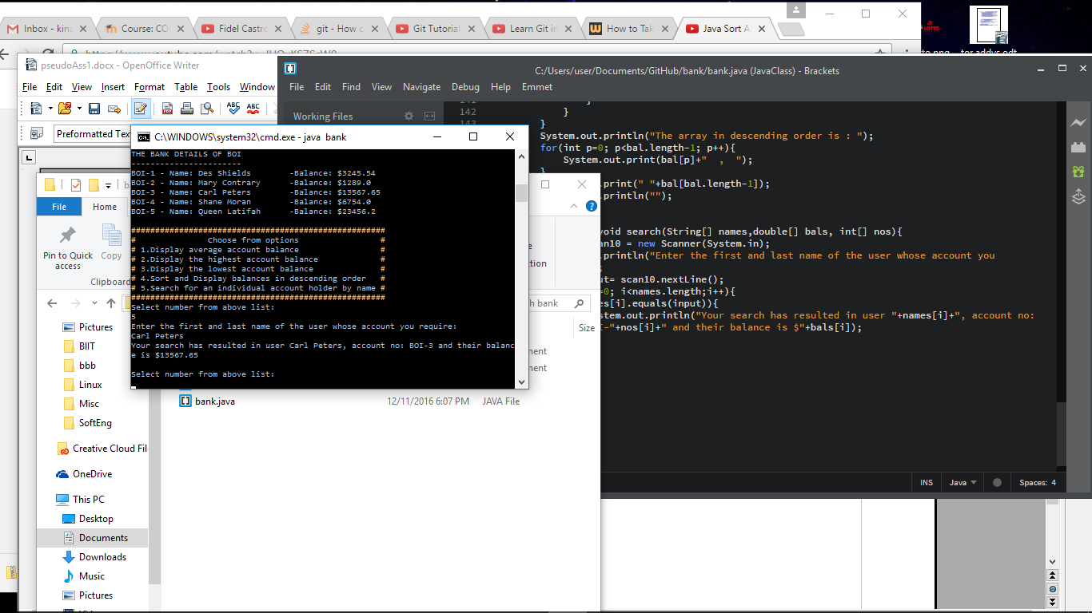

Resources Used: / Bibliography

Bates, Bert & Sierra, Kathy. 2005. Head First Java. 2nd Edition. O'Reilly: Sebastopol.

McGrath, Mike. 2014. JAVA in easy steps. 5th Edition. In Easy Steps Limited: Warwickshire.

www.stackoverflow.com

www.tutorialspoint.com

Lecture notes from ITB.

Self-study.

Java Diploma: Fitzwilliam Institute Dublin. Awarded June 2016

